Script-Controlled ACL – Restrict Record Access Based on Field Value

Description :

This lab demonstrates a script-controlled ACL for restricting record access.Users can view records only when they meet the specified conditions.EEE branch users can view records where the Branch field is set to EEE.Administrators have full access to all records.This ensures secure and controlled access to records.

Milestone-1: Creation of Users and Roles

User Creation:
- Log in to the ServiceNow instance with admin access.
- Create a test user:
  - Navigate to User Administration → Users
  - Click New
  - User ID: EEE User
  - First name: EEE
  - Last name: User
  - Email: eeeuser@gmail.com
  - Save the record
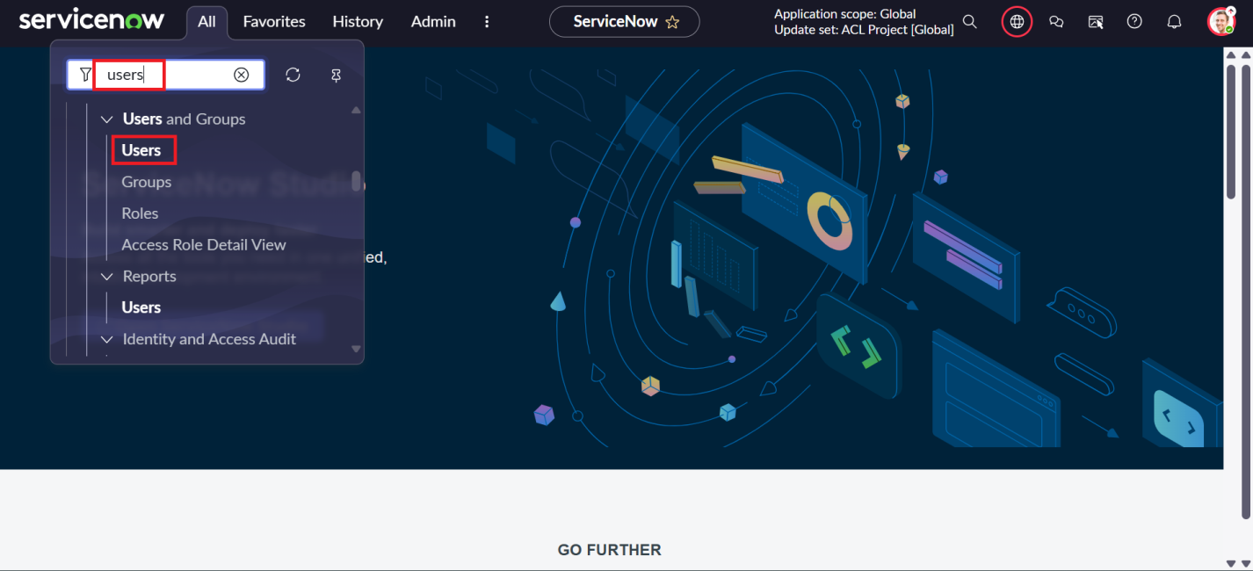
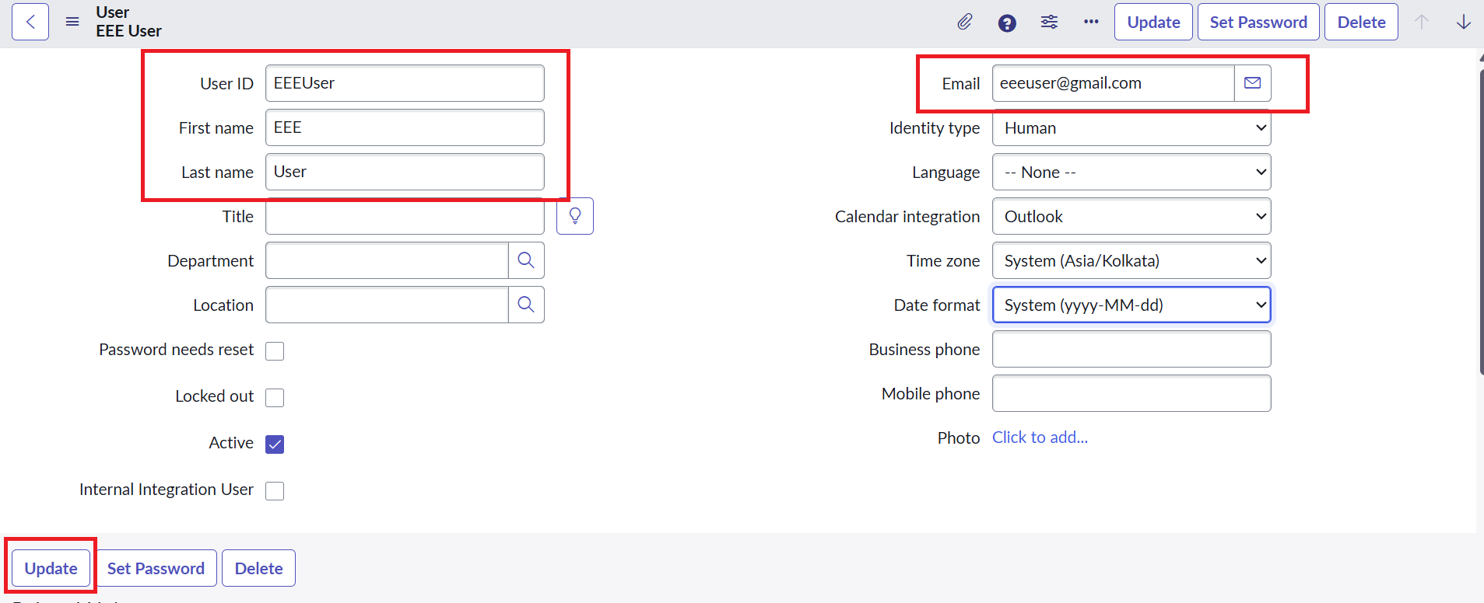

Role Creation
- Navigate to User Administration → Roles
- Click New
- Name: Enter role name as bb1
- Description: Brief role purpose
- Click Submit
- Create other roles also like bb2,bb3,bb4.(follow the same procedure)
- Assign all the roles to the EEE User
