Assignment_14.2
2303A510H6
Batch_30
Task Description 1 – (Landing Page Design)
Prompt:Create a simple landing page for a product or service. Include a
header, hero section, and footer.
Code:
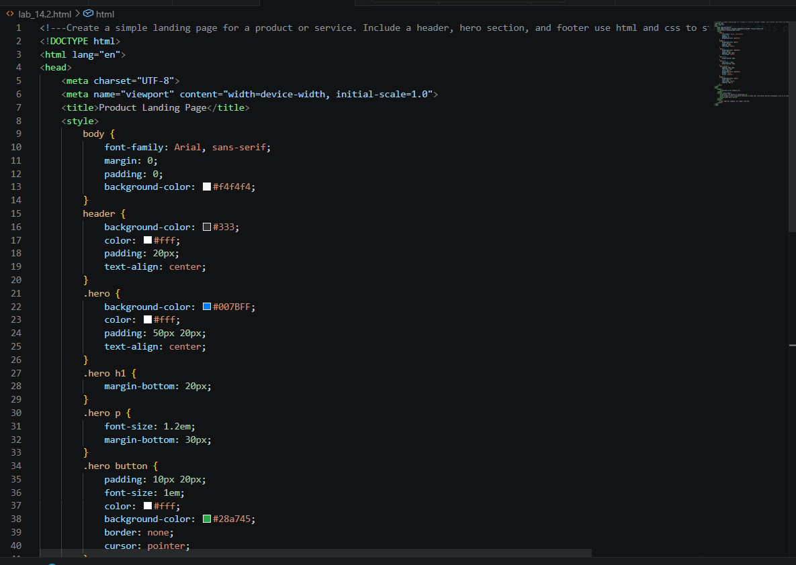

Task Description 2 – (Theme Toggle Feature)
Prompt:Provide a button to switch between light and dark themes..
Code:
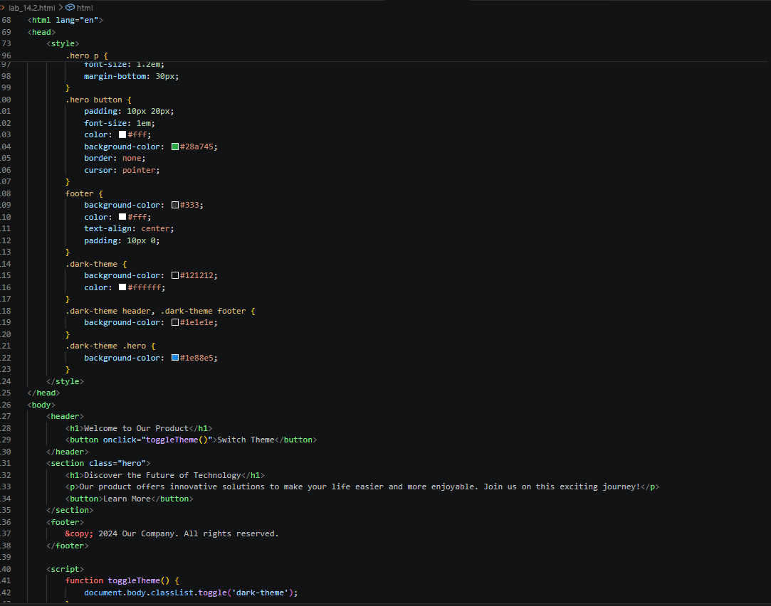

Task Description 3 – (User Feedback Form)
Prompt:Create a feedback form with fields: Username, Rating,
Comments.
Code:
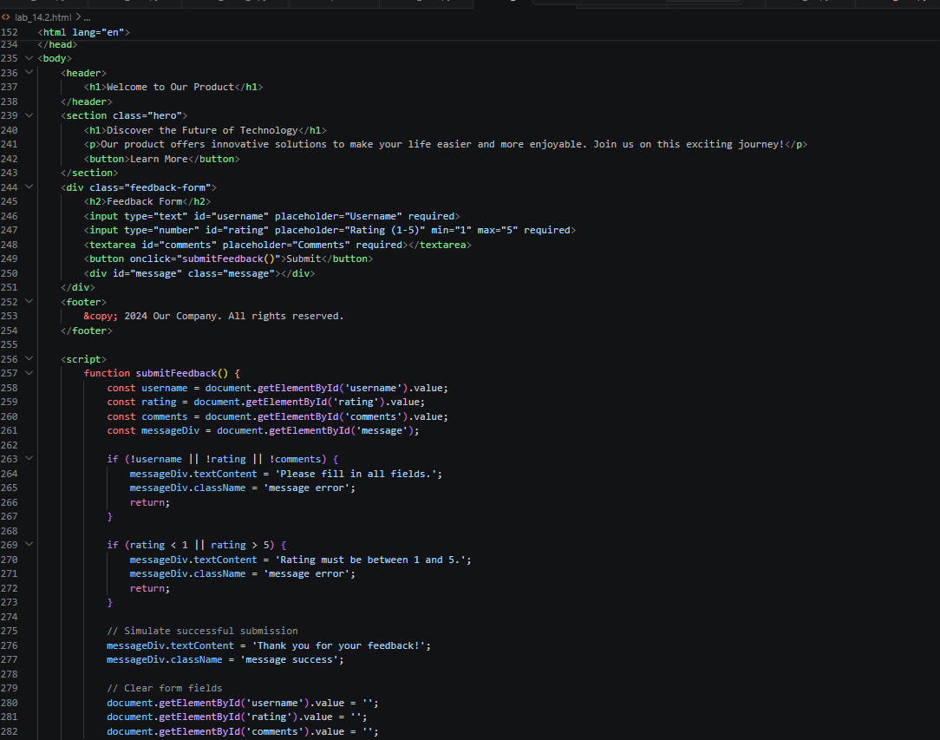

Task Description - 4 (Image Gallery with JavaScript)
Prompt:Display a small image gallery on a web page.
Code:
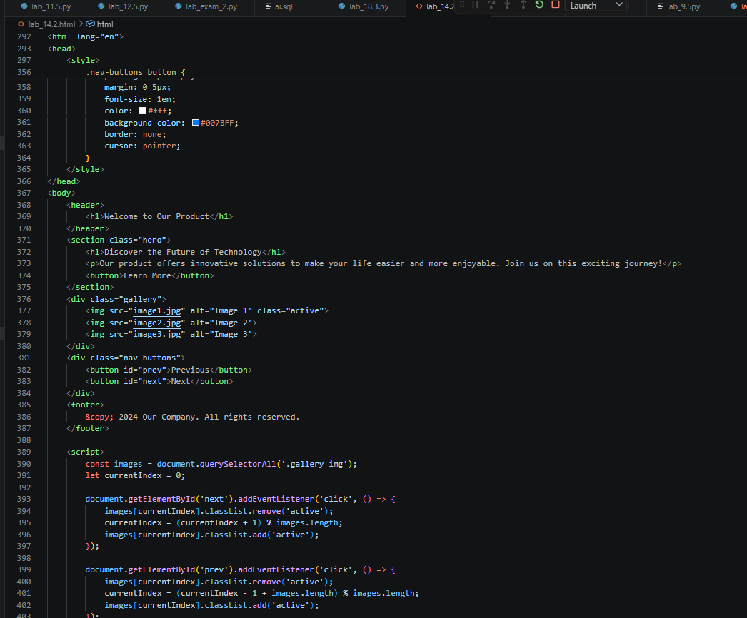

Task Description - 5: (Notification Banner)
Promt: Display a notification banner at the top of the page.
