LangChain Agent with Groq LLM

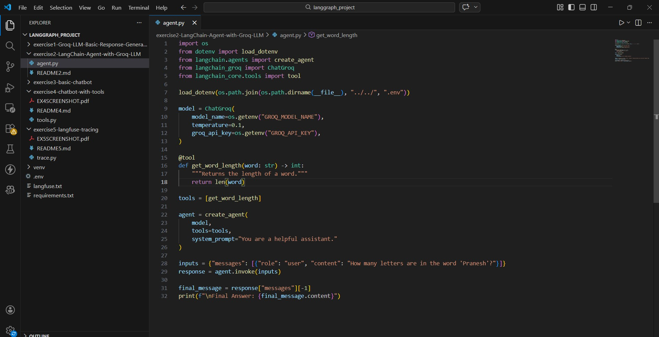

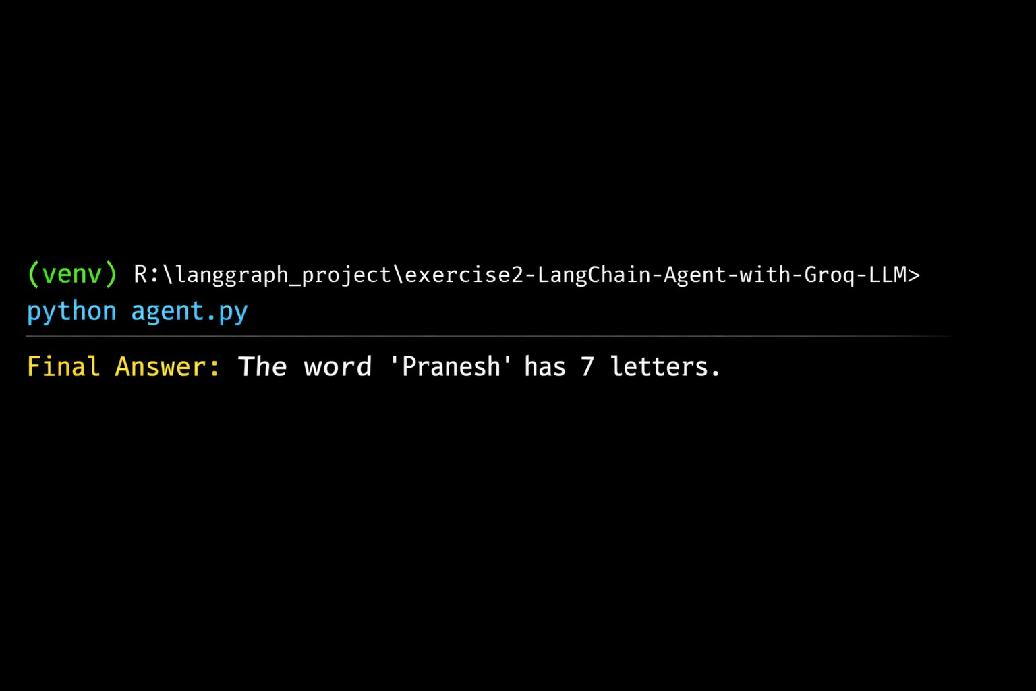

Megadarsana S (23ISR029)

