|  |  |
| --- | --- |
| **222168878** | **Amandeep Kaur SANDHU** |

**UNIT:** SIT782- Capstone Team Project (B)

**DolFin UI/UX Enhancement Market Research**

**Introduction**

The digital financial landscape is rapidly evolving, with user interface (UI) and user experience (UX) at the forefront of competitive differentiation. In this context, DolFin seeks to enhance its platform to better meet user needs, align with industry standards, and stand out among both banking and non-banking financial applications. This document outlines our market research findings, focusing on UI/UX best practices and features that contribute to a superior user experience in financial services.

The research focus on banking applications.

1. **General Comparison of Bank Apps**

This section presents a broad overview of the digital banking tools, fintech innovations, financial education, and security features offered by selected banks.

In the effort to enhance DolFin's UI/UX and align it with the industry's best practices, 5 banks are considered for their leadership in fintech innovation, comprehensive digital banking tools, commitment to financial education, and advanced security features. The selection includes:

* **Commonwealth Bank of Australia (CBA):** Chosen for its pioneering role in digital banking innovation in Australia, offering extensive user-friendly digital tools and leading fintech integration.
* **National Australia Bank (NAB):** Selected for its focus on creating customer-centric digital services and its investment in financial education, showcasing a comprehensive approach to financial wellbeing.
* **Australia and New Zealand Banking Group (ANZ):** Noted for its robust digital banking solutions and proactive adoption of fintech innovations, ANZ illustrates how traditional banks can adapt to new consumer expectations.

Table 1. summarize the general features of banking applications for financial well-being.

|  |  |  |  |  |
| --- | --- | --- | --- | --- |
| Bank | Digital Banking Tools | Fintech Innovation | Financial Education | Security Features |
| Commonwealth Bank (CBA) [1] | Extensive suite of tools for budgeting, savings, and spending tracking. | Leaders in adopting fintech innovations like blockchain and AI. | Wide range of educational resources available through the CommBank app and website. | Advanced security measures, including biometric login and real-time fraud monitoring. |
| National Australia Bank (NAB) [2] | Comprehensive tools for managing finances, including budgeting and savings goals. | Active in the fintech ecosystem with a focus on digital banking solutions. | Offers a range of financial education tools and resources for customers. | Robust security features, including advanced encryption and customized alerts |
| Australia and New Zealand Banking Group (ANZ) [3] | Offers tools for budgeting, saving, and spending analysis within its banking app. | Engages in fintech innovation through collaborations and internal development. | Provides financial education via online articles, videos, and workshops. | Employs strict security measures, including encryption and fraud monitoring. |

1. **UI/UX Specific Comparison of Bank Apps**

Focusing on the UI/UX, this section delves into the specifics of design quality, ease of navigation, accessibility features, personalization of the user experience, and the overall sense of professionalism and trust evoked by the app interfaces.

Table 2. summarize the design features of banking applications for financial well-being.

|  |  |  |  |  |  |
| --- | --- | --- | --- | --- | --- |
| Bank | UI Design | UX Best Practices | Navigation | Accessibility | Professionalism |
| Commonwealth Bank (CBA) [1] | Clean, intuitive design emphasizing ease of use. | Personalized financial insights, easy account management. | Streamlined navigation allowing quick access to all features. | High, with features for visually impaired users. | Highly professional, with a secure and trustworthy design. |
| National Australia Bank (NAB) [2] | Simple and practical, focusing on user needs. | Streamlined budgeting, savings, and debt management features.. | Easy-to-navigate, with emphasis on core banking features. | Strong focus on making financial services accessible to all. | Strong corporate identity, reassuring users of its reliability. |
| Australia and New Zealand Banking Group (ANZ) [3] | Clean, modern design; navigation could be improved. | Financial wellbeing tools, including wellbeing score. | User-friendly navigation, though some areas could be streamlined. | Adequate, but with room for improvement in accommodating diverse user needs. | Modern and professional, though some design elements could be enhanced. |

Screenshots of the feature ‘Financial Wellbeing’ offered by the banks are given below:

1. **Commonwealth Financial Wellbeing**

Link: 1 [Better understand your financial wellbeing - CommBank](https://www.commbank.com.au/banking/guidance/find-your-financial-wellbeing-score.html)

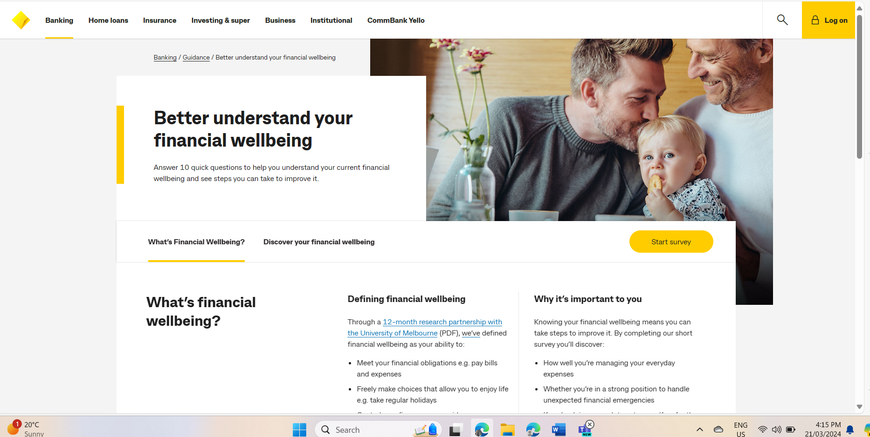

Figure 1. Homepage of financial wellbeing

Figure 2. Survey page of financial wellbeing for cwb

1. ANZ bank financial wellbeing

Link : [Financial wellbeing | ANZ](https://www.anz.com.au/about-us/esg/financial-wellbeing/)

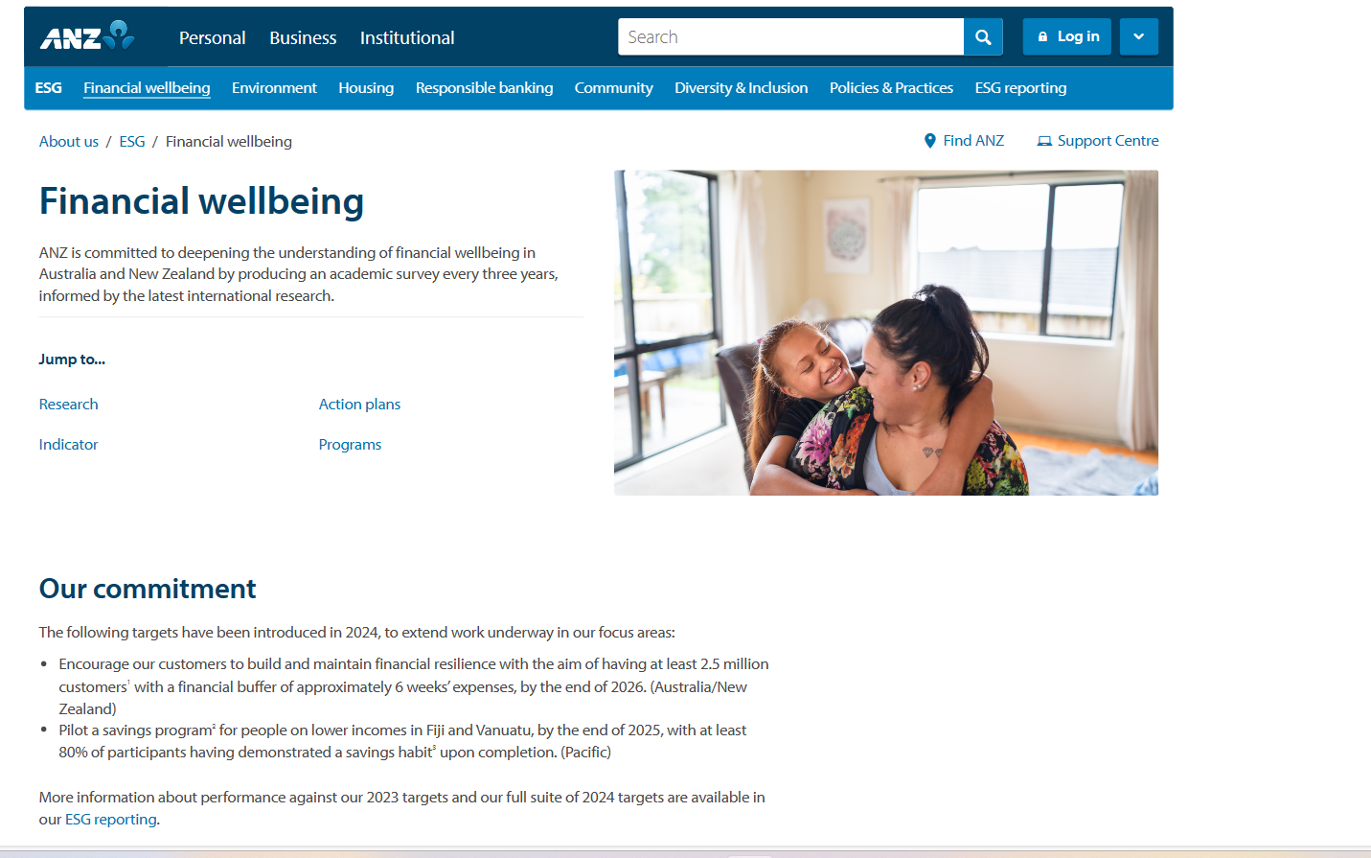

Figure 3. home page of financial wellbeing for ANZ bank.

1. National Australia Bank (NAB)

Link: [Practical support to improve your financial wellbeing - NAB](https://www.nab.com.au/help-support/financial-wellbeing)

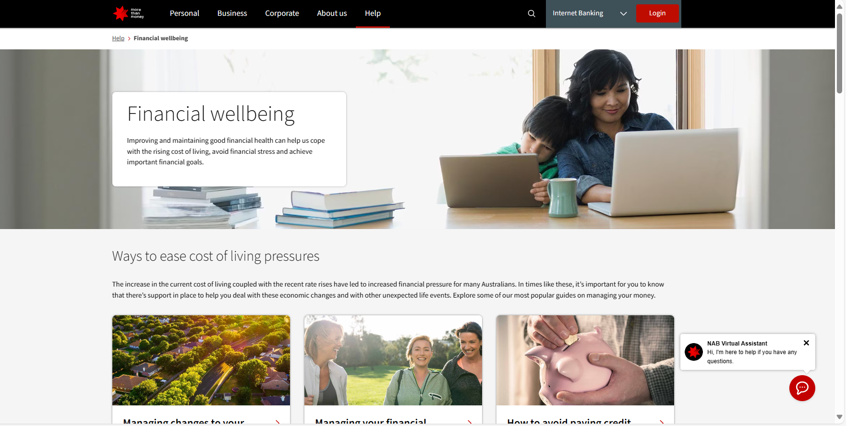

Figure 4. home page of financial wellbeing for NAB

Figure 5. chatbot feature of NAB.

1. **Gaps identified**

Upon reviewing the features provided by the banks, gaps have been identified that are outlined in the table below. It details the availability of specific financial wellbeing features across CBA, ANZ, and NAB, and highlights the corresponding opportunities for DolFin to enhance its service.

Table 3. Comparative Analysis of Financial Wellbeing Features and Enhancement Opportunities for DolFin

|  |  |  |  |  |
| --- | --- | --- | --- | --- |
| **Feature Category** | CBA | ANZ | NAB | DolFin Opportunity |
| Survey Accessibility and Engagement | Yes (direct survey on the page) | No (lacks interactive survey) | No (lacks interactive survey) | Implement an interactive financial wellbeing survey to engage users and provide personalized insights. |
| **Chatbot for Immediate Assistance** | No (lacks chatbot) | No (lacks chatbot) | Yes (features a chatbot) | Introduce a chatbot to provide real-time financial assistance and guide users through the platform. |
| **Educational Resources and Action Plans** | Unclear | Yes (focuses on academic research and action plans) | Unclear | Develop in-depth educational materials and clear action plans to enhance financial literacy and health. |
| **Tools for Financial Management** | Unclear | No (lacks prominent tools) | Yes (offers expense tracking and budget planning) | Create accessible and user-friendly financial management tools like budget planners and expense trackers. |

**Reference**

[1] *Better understand your financial wellbeing* (no date) *CommBank*. Available at: https://www.commbank.com.au/banking/guidance/find-your-financial-wellbeing-score.html (Accessed: 20 March 2024).

[2] *Financial wellbeing* (no date a) *NAB*. Available at: https://www.nab.com.au/help-support/financial-wellbeing (Accessed: 20 March 2024).

[3] *Financial wellbeing* (no date b) *ANZ*. Available at: https://www.anz.com.au/about-us/esg/financial-wellbeing/ (Accessed: 20 March 2024).