**MINOR PROJECT**

**END-TERM REPORT**

**ON**

**PATTERN RECOGNITION OF HANDWRITTEN NUMBERS**

# Submitted By

Aman Dalal Mugdha Srivastava Shivangi Goyal Utkarsh Malik

500046325 500045614 500045745 500046641

***Under the guidance of***

# Mr. P. Srikanth

**(Assistant Professor)**

Department of Systemic, School of Computer Science and Engineering



**School of Computer Science and Engineering, University of Petroleum & Energy Studies, Dehradun**



**CANDIDATE’S DECLARATION**

We hereby certify that the project work entitled **“ Handwritten Digit Recognition by computers using Neural Network ”** in partial fulfillment of the requirements for the award of the Degree of BACHELOR OF TECHNOLOGY in COMPUTER SCIENCE AND ENGINEERING with specialization in Open Source and Open Standards and submitted to the School of Computer Science and Engineering, University of Petroleum & Energy Studies, Dehradun, is an authentic record of my/our work carried out during a period from **Aug**, **2017** to **Dec**, **2017**  under the supervision of **Mr. Srikanth, Assistant Professor,School of Computer Science and Engineering.**

The matter presented in this project has not been submitted by me/us for the award of any other degree of this or any other University.

**(Aman Dalal)**

R100215007

**(Mugdha Srivastava)**

R100215044

**(Shivangi Goyal)**

R100215065

**(Utkarsh Malik)**

R100215076

This is to certify that the above statement made by the candidate is correct to the best of my knowledge.

Date: **(Mr. Srikanth)** Project Guide

**Dr. Ajay Prasad**

Program Head - B.Tech Computer Science S/W Open Source and Standards

Center for Information Technology

University of Petroleum & Energy Studies

Dehradun – 248 001 (Uttrakhand)

**ACKNOWLEDGEMENT**

We wish to express our deep gratitude to our guide **Mr. Srikanth**, for all advice, encouragement and constant support he has given us throughout our project work. This work would not have been possible without his support and valuable suggestions.

We sincerely thank to our respected Program Head of the Department, **Dr. Ajay Prasad**, for his great support in doing our project in **Handwritten Digit Recognition .**

We would like to thank all our **friends** for their help and constructive criticism during our project work. Finally we have no words to express our sincere gratitude to our **parents** who have shown us this world and for every support they have given us.

|  |  |  |  |
| --- | --- | --- | --- |
| **Aman Dalal** | **Mugdha Srivastava** | **Shivangi Goyal** | **Utkarsh Malik** |
| R100215007 | R100215044 | R100215065 | R100215076 |

# Project Title: To recognize pattern of a handwritten digit using Artificial Neural Networks

**ABSTRACT:**

In our daily life, the things we see are stored in our minds as interpreted images, every image is made-up with thousands of pixels that are stored in the form of a matrix. In this project we are making automated system to recognize handwritings. To do this Artificial Neural Networks are used which can decipher and differentiate one pattern from the other pattern. Handwritten digit recognition makes the computer capable to receive information from sources such as paper documentation, camera, and tablet. Handwritten digits are used in different type of data like cheque, post-mail, address on home’s name plate etc. Pattern recognition is a branch of machine learning that focuses on the recognition of patterns and regularities in data. Handwriting recognition is the ability of a computer to receive and interpret intelligible handwritten input from sources such as paper documents, photographs, touch-screens and other devices. It is concerned with a computer being able to understand human handwriting with efficiency. With handwritten digit recognition being an established and significant problem that is facing computer vision and pattern recognition, there has been a great deal of research work that has been undertaken in this area. It is not a trivial task because of the big variation that exists in the writing styles that have been found in the available data. In this project, the computer will extract the information given in the pixels and perform arithmetic and logical operation to give the required output.

**Keywords:** ***Neural networks, Machine learning, Pattern Recognition, Deep learning, Back-propagation, Feed forward.***

**TABLE OF CONTENTS**

**S No. Contents**

1. **Introduction**

**2**. **Previous works**

2.1. Existing System

2.2. Problem Statement

2.3. Objective

**3. Methodology**

3.1 System Requirements

3.2. Design

3.2.1. Package Diagram

3.2.2. Data Flow Diagram

3.2.3. Flow Chart Diagram

3.3. Implementation

**4. Output**

**5. Limitations and Future Enhancements**

**6. Conclusion**

**References**

**1. INTRODUCTION:**

The way of writing anything is changing from person to person and because of this, humans also face difficulty in the recognition of different writing styles and variations, may be the patterns shifted, scaled, distorted, with some skewed and even overwritten and therefore it is hard for computers to recognize the writing of a person.

1. **Pattern Recognition:** Since the domain of this proposed system is Pattern Recognition which is a section of machine learning which aims to systematize the patterns and precisions in pattern (data). And the grouping of patterns situated on the former observation of the patterns.

**ii.) Feed Forward** - A feed forward neural network is a biologically inspired classification algorithm It consist of a (possibly large) number of simple neuron-like processing units, organized in layers. Every unit in a layer is connected with all the units in the previous layer. These connections are not all equal: each connection may have a different strength or weight. The weights on these connections encode the knowledge of a network. Often the units in a neural network are also called nodes.Data enters at the inputs and passes through the network, layer by layer, until it arrives at the outputs. During normal operation, that is when it acts as a classifier, there is no feedback between layers. This is why they are called feed forward neural networks.

**iii.)** The basic algorithm used in the proposed system is:

**Back Propagation** - In order to train a neural network to perform some task, we must adjust the weights of each unit in such a way that the error between the desired output and the actual output is reduced. This process requires that the neural network computes the error derivative of the weights (EW). In other words, it must calculate how the error changes as each weight is increased or decreased slightly. The algorithm computes each EW by first computing the EA, the rate at which the error changes as the activity level of a unit is changed. For output units, the EA is simply the difference between the actual and the desired output. To compute the EA for a hidden unit in the layer just before the output layer, we first identify all the weights between that hidden unit and the output units to which it is connected.

**iv)Number recognition streams:** Number recognition has two streams.

1. **Recognition of number from GUI:** This process is converting automatically of text as written on a paper or on an electronic surface using a special device, where a sensor chooses digital pen activities as well as pen direction or angle substitution which is having (x, y) coordinates, is captured during the writing process. This process is called dynamic representation of handwriting.
2. **Recognition of browsed image:** Offline handwritten text recognition is the static representation of handwriting as with recognizing a scanned image and it is one of the most energetic areas of research in computer science. Offline documents are scanned images of pre-written text, generally on sheet or on paper. It is the process of converting offline handwritten text into a format that is understood by machine.

**2.PREVIOUS WORKS**

**2.1. EXISTING SYSTEM**

A neural network is a series of algorithms that attempts to identify underlying relationships in a set of data by using a process that mimics the way the human brain operates.

**Arild Nøkland.[1]** The back-propagation algorithm is widely used for learning in artificial neural networks. A challenge in machine learning is to create models that generalize to new data samples not seen in the training data. Recently, a common flaw in several machine learning algorithms was discovered: small perturbations added to the input data lead to consistent misclassification of data samples. This paper shows that adversarial training has a regularizing effect also in networks with logistic, hyperbolic tangent and rectified linear units

**A.T.C. Goh.[2]** This paper demonstrates the use of back-propagation neural networks to alleviate this problem. Backpropagation neural networks are a product of artificial intelligence research. First, an overview of the neural network methodology is presented. This is followed by some practical guidelines for implementing back-propagation neural networks.

**Geoffrey G. Towell.[3]** Hybrid learning methods use theoretical knowledge of a domain and a set of classified examples to develop a method for accurately classifying examples not seen during training. The challenge of hybrid learning systems is to use the information provided by one source of information to offset information missing from the other source. By so doing, a hybrid learning system should learn more effectively than systems that use only one of the information sources.

**Shih-Chung B. Lo , Matthew T. Freedman.[4]** We have developed several training methods in conjunction with a convolution neural network for general medical image pattern recognition. An unconventional method of using rotation and shift invariance is also proposed to enhance the neural net performance. The structure of the artificial neural network is a simplified network structure of the neocognitron.

**2.2.** **PROBLEM STATEMENT:**

To determine how a system for recognition of handwritten digits would be implemented on a modern system which do not recognize handwritten patterns.

**2.3. OBJECTIVES:**

**Main Objective:**

The purpose of this proposed work is to make computers recognize handwritten digits by using neural networks.

**2.3.1. SUB OBJECTIVES**

1. Make the system efficient enough to successfully accept a user's input.
2. Make a efficient program to successfully browse an image from the computer and recognise it.

**III**. To achieves the highest possible accuracy and recognise the number with the best possible probability.

**3. METHODOLOGY**

**3.1. SYSTEM REQUIREMENTS: (Software/Hardware)**

**Software Requirements:**

|  |  |  |
| --- | --- | --- |
| • | Programming Language | : C language |
| • | Operating System | : Ubuntu |
| • | Editor | : Atom, Sublime |
| • | System Requirements | : gcc-Compiler-7 |

**Hardware Requirements:**

* + Processor : Intel Core i5
  + Hard Disk : Minimum 20 GB
  + RAM : 8 GB

**3.2. DESIGN**.

**3.2.1. Package Diagram**

**Package diagram is UML structure diagram which shows packages and dependencies between the packages. Model diagrams allow to show different views of a system, for example, as multi-layered application - multi-layered application model.**

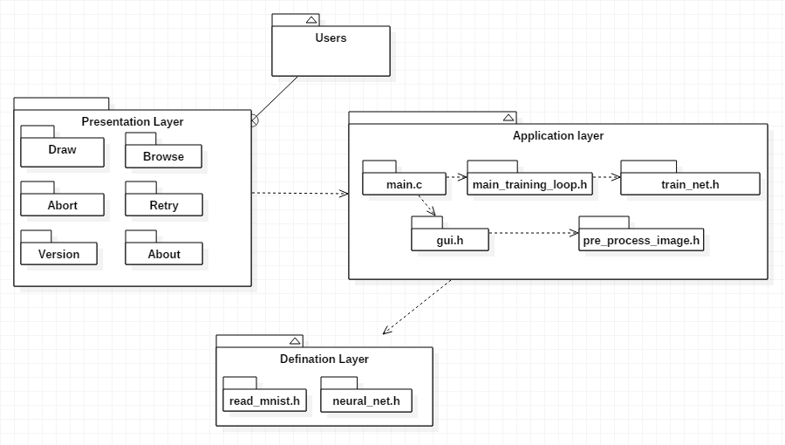

**3.2.2 DATA FLOW DIAGRAM**

A data flow diagram (DFD) is a graphical representation of the "flow" of data through an information system, modeling its process aspects. A DFD is often used as a preliminary step to create an overview of the system, which can later be elaborated. A DFD shows what kind of information will be input to and output from the system, where the data will come from and go to, and where the data will be stored.

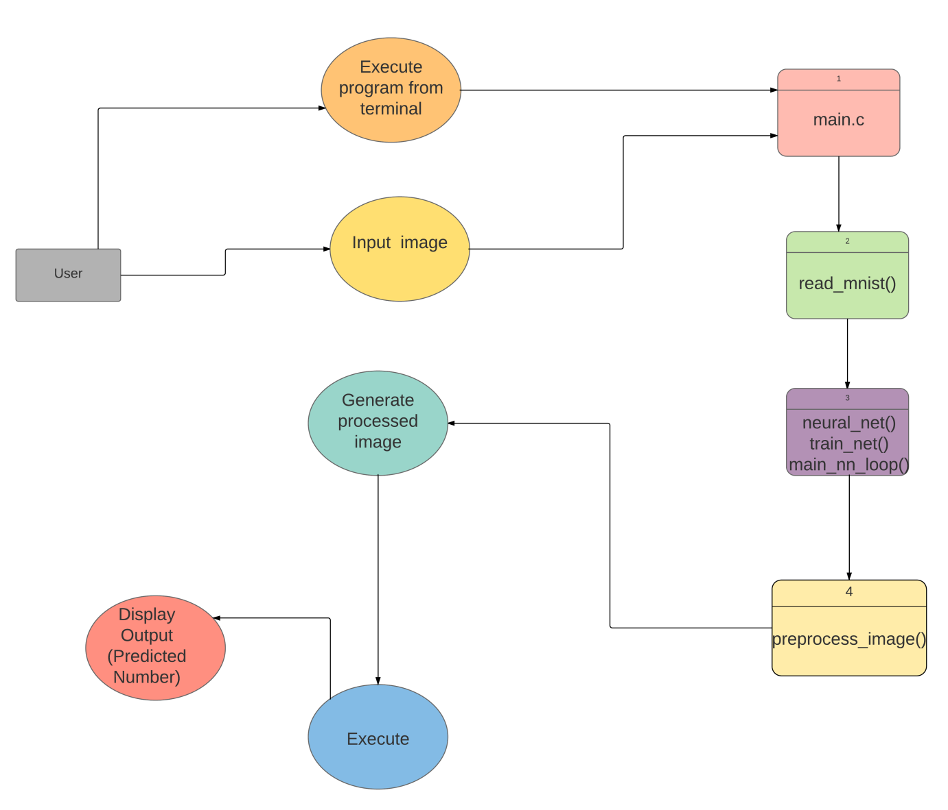

**3.2.3. FLOW CHART DIAGRAM**

A flowchart is a type of diagram that represents a workflow or process, showing the steps as boxes of various kinds, and their order by connecting them with arrows. In NLPTEXT program perform five different task starting with command line argument, lexical analyzing, Parsing, Execution, and storing the result for future calculation. Program also handle interrupts and exit request.

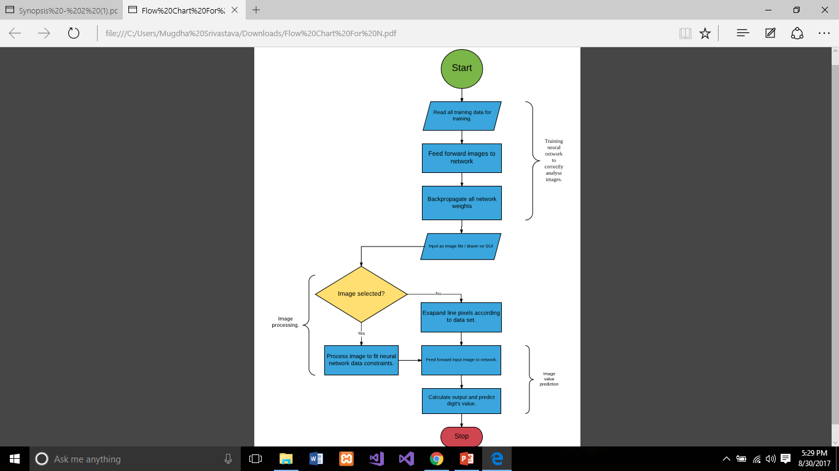

**3.3 IMPLEMENTATION**

**ALGORITHM**

**Back Propogation:-**

Input: ProblemSize, InputPatterns, iterationsMax, learningRate

Output: Network

Network = ConstructNetworkLayers()

NetworkWeights = InitializeWeights(Network,ProblemSize)

for(i=1 to iterationsMax):

  Pattern[i] = SelectInputPattern(InputPatterns)

  Output[i] = ForwardPropagate(Pattern[i],Network)

  BackwardPropagateError(Pattern[i],Output[i],Network)

  UpdateWeights(Pattern[i],Output[i],Network,learningRate)

End

return(Network)

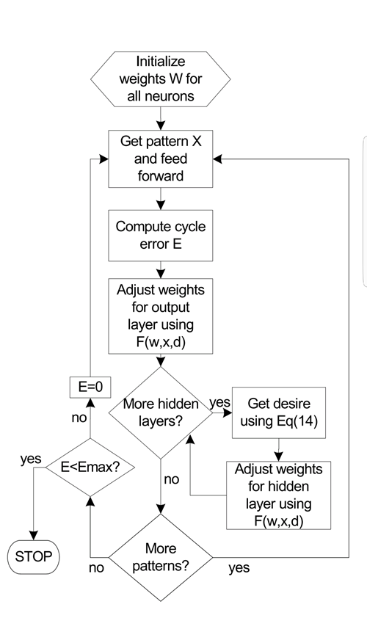

**THE TRAINING PROCESS:**

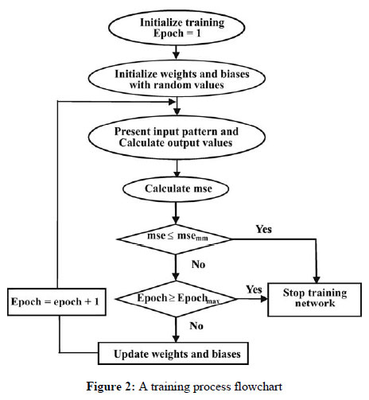

**Fig:** Flow diagram representing the methodology.

**4. RESULT**

Following are the results of our work

* **Commands to execute**

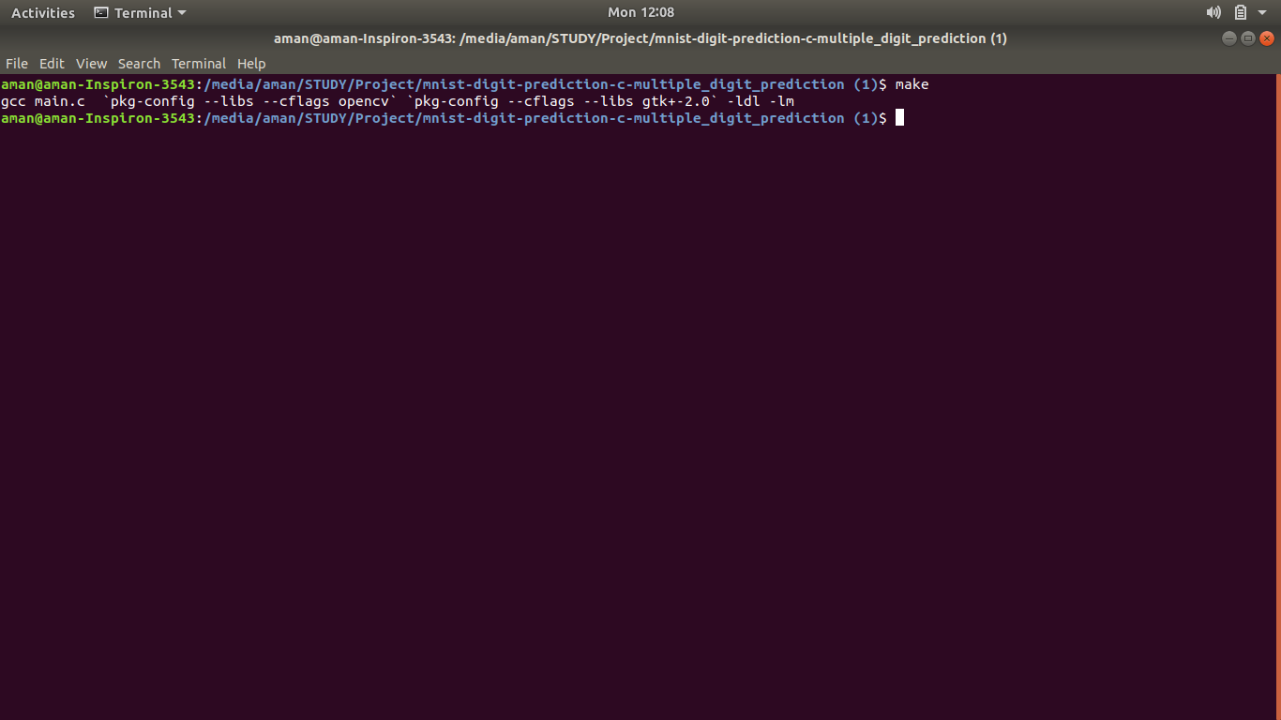

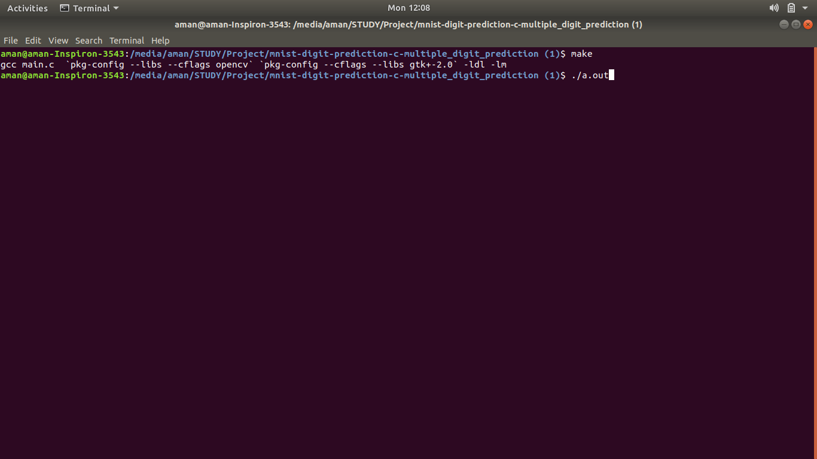

* **Traning of the Neural Network**

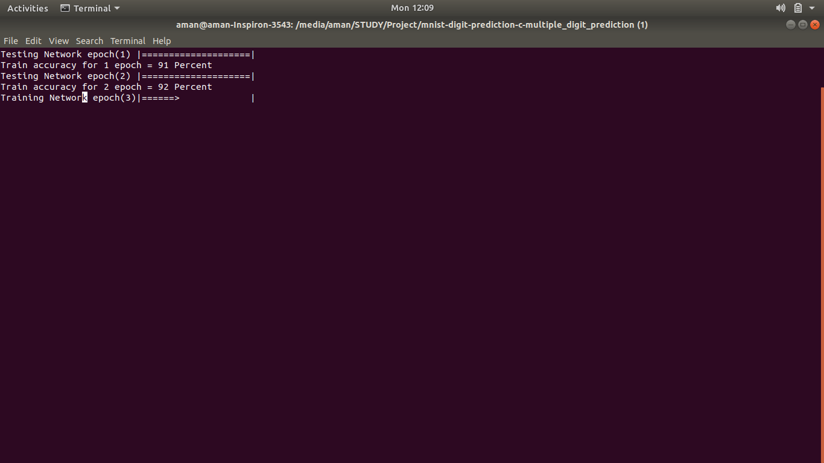

* **Drawing Area**

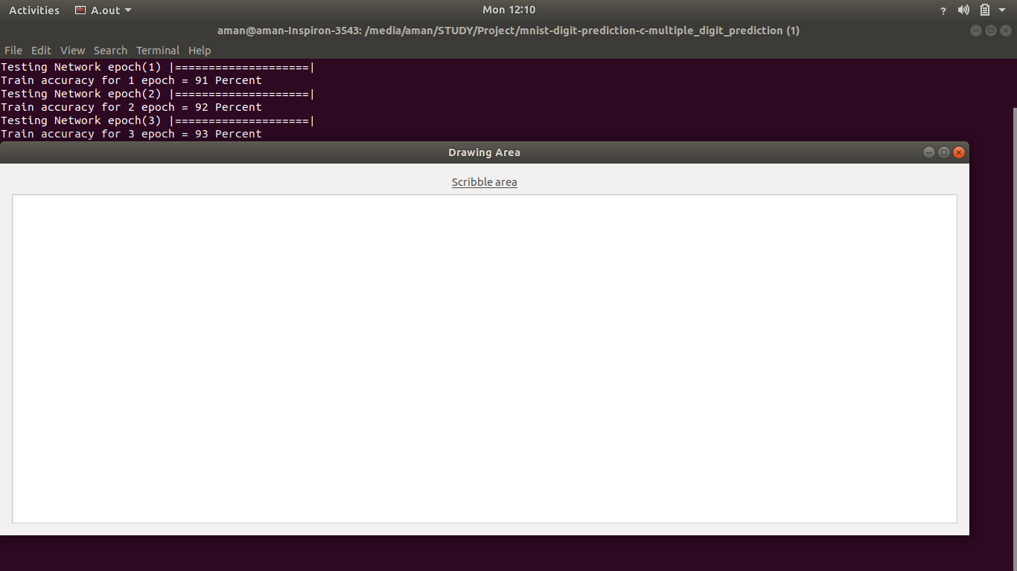

* **Draw what ever digit you want in the area provided**

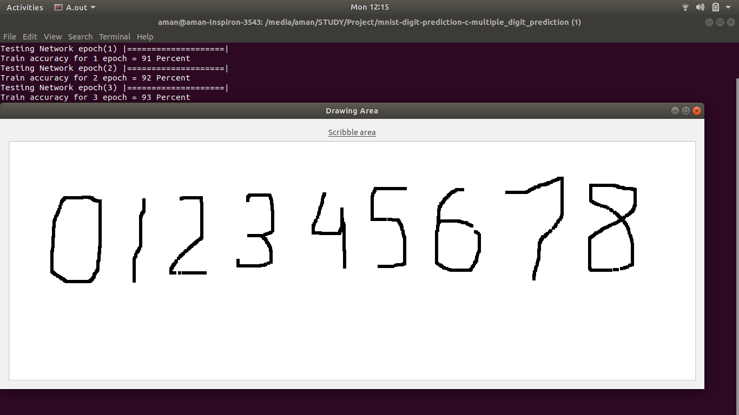

* **Results will be shown as follows**

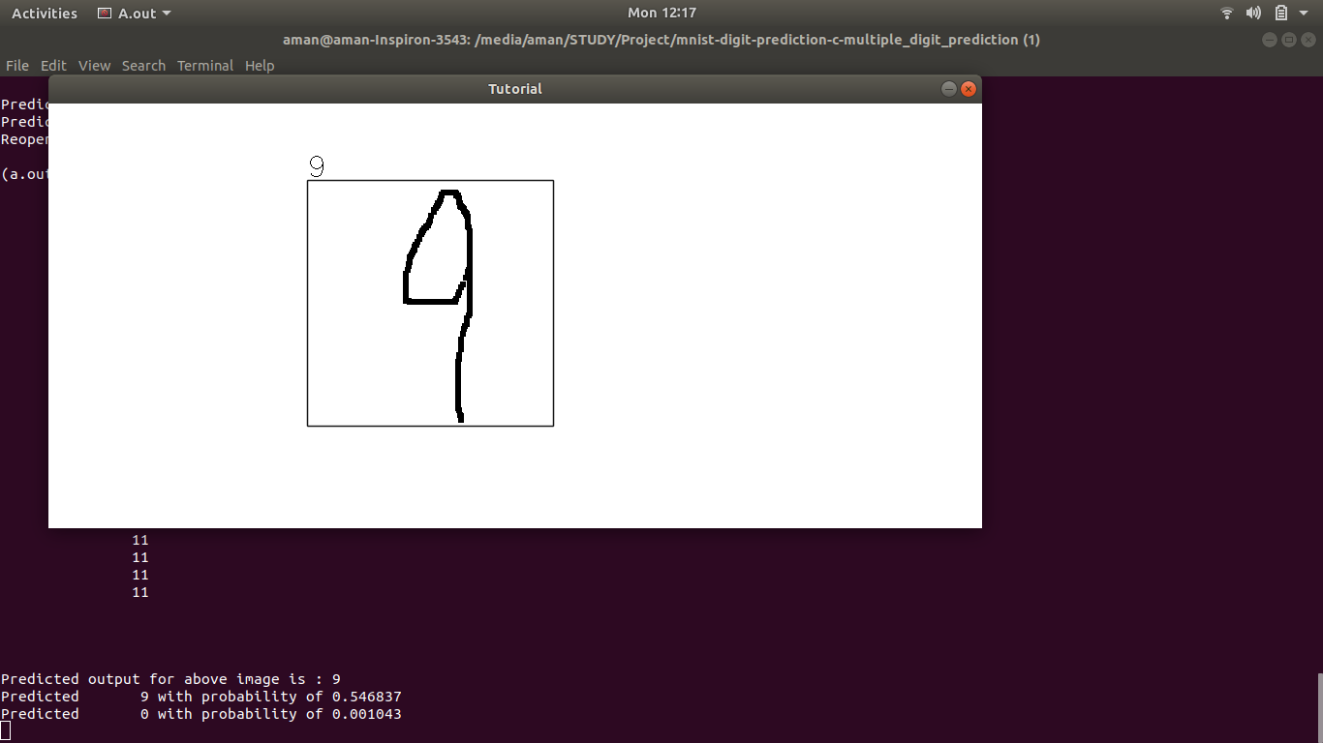

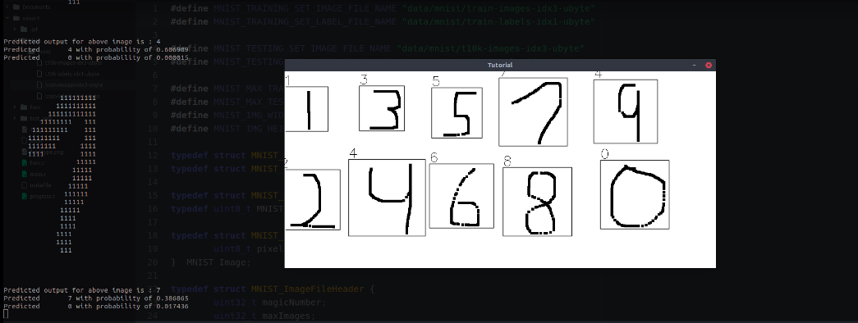

**Same digit drawn in different styles.**

**On terminal it shows the probability of every digit digit .**

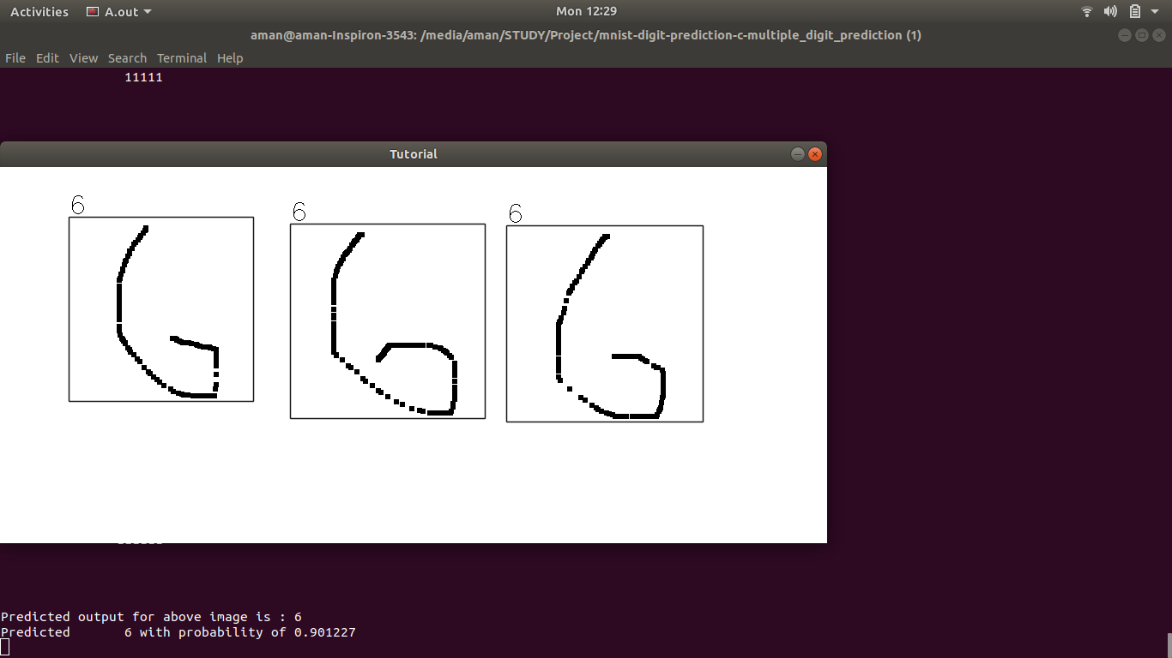

* **Browse Image**

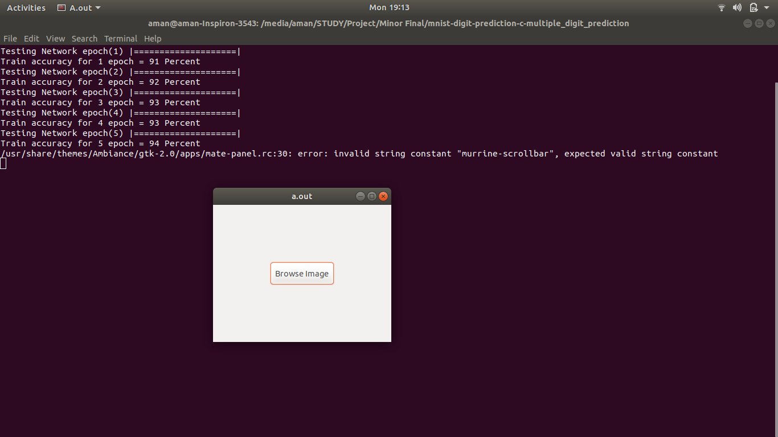

* **Choose image from the menu**

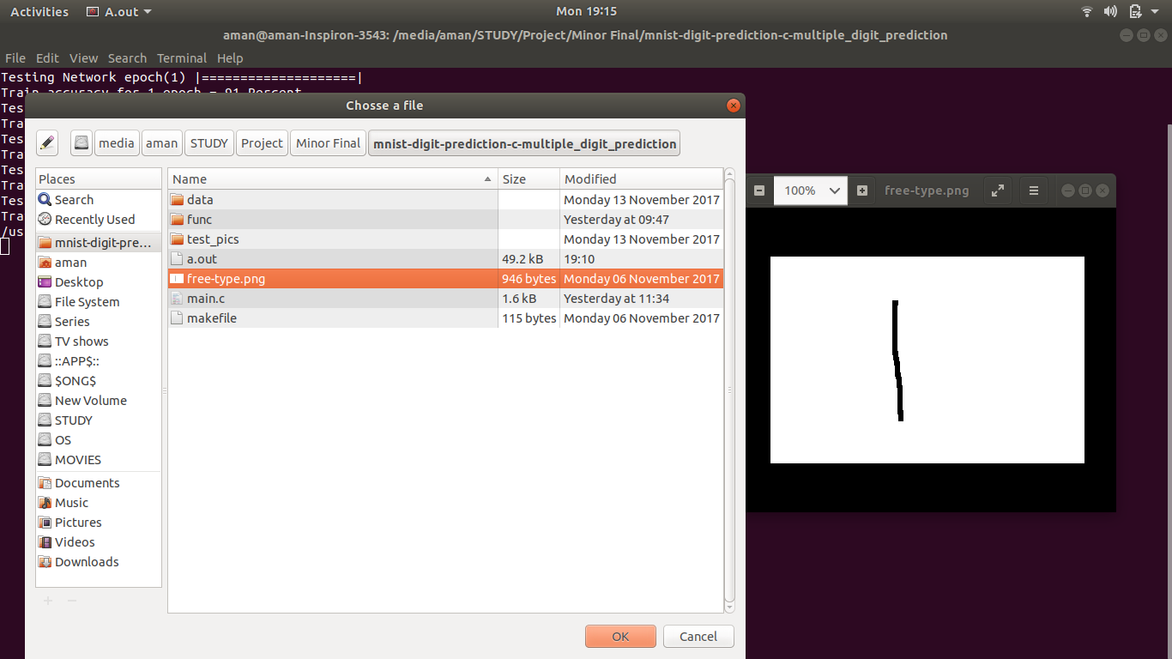

* **Result of the selected image**

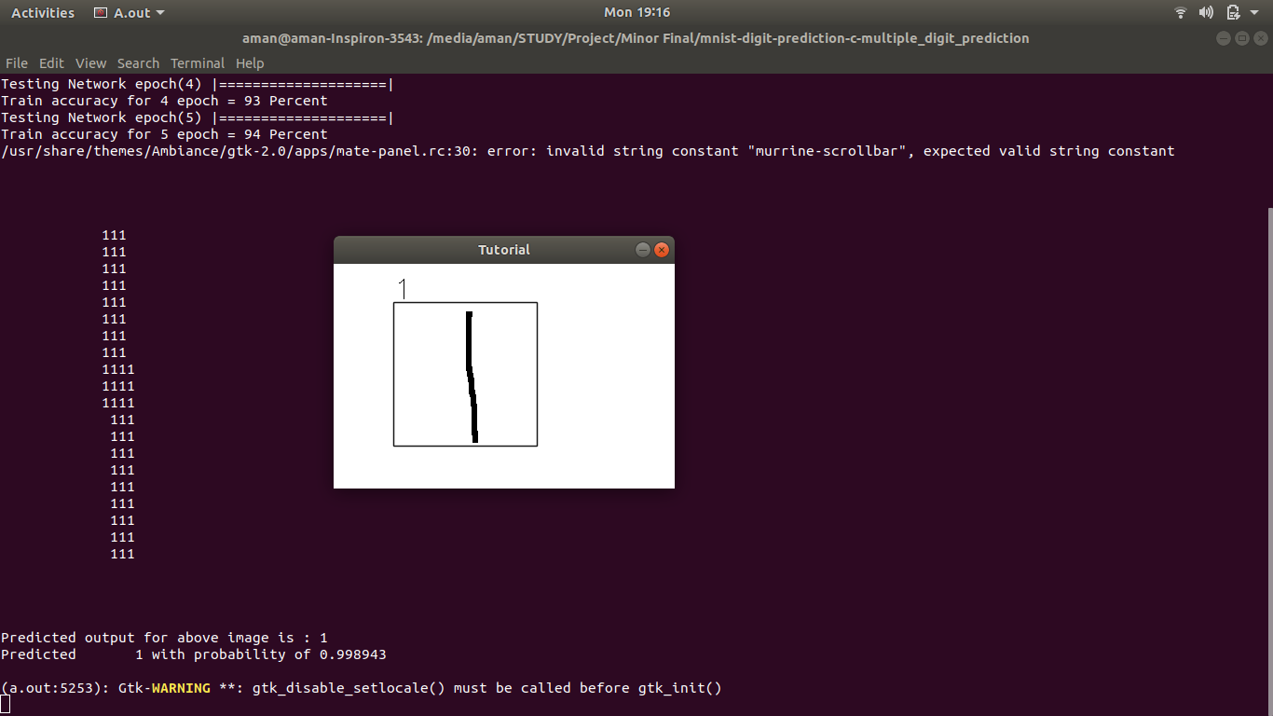

**6. CONCLUSION**

The system can continuously achieve the higher accuracy by training the neural networks with more improved data sets.

The activation functions - sigmoid, tanh, relu effectively helped in obtaining different values of accuracies with the accuracy of sigmoid function being the highest and amounting to a 98% (by recursive training). Testing the test set with the tanh function amounted to a value of 72% while relu amounted to an 82%.

It also made us realize that biological realism would impose entirely unnecessary constraints and hence, our system cannot be 100% accurate.

**REFERENCES:**

1. Arild Nøkland, “Improving Back-Propagation by Adding an Adversarial Gradient” – Cornell University Library

1. A.T.C. Goh, “Back-propagation neural networks for modeling complex systems”

(“Artificial Intelligence in Engineering” Volume 9, Issue 3, 1995, Pages 143-151), School of

Civil & Structural Engineering, Nanyang Technological University, Nanyang Avenue,

1. Geoffrey G. Towell, “Knowledge-based artificial neural networks” (“Artificial Intelligence” Volume 70, Issues 1–2, October 1994, Pages 119-165), University of Wisconsin, 1210 West Dayton St., Madison, WI 53706,

[4][Shih-Chung B. Lo](http://www.sciencedirect.com/science/article/pii/0893608095000615" \l "!) , [Matthew T. Freedman,](http://www.sciencedirect.com/science/article/pii/0893608095000615" \l "!) **“**Artificial convolution neural network for medical image pattern recognition” (“Neural Networks” Volume 8, Issues 7–8, 1995, Pages

1201-1214), 1-Georgetown University Medical Center, USA

2-University of Michigan Medical Center,

1. Yann Le Cun, “THE MNIST DATABASE of handwritten digits”, Courant Institute, NYU Corinna Cortes, Google Labs, New York Christopher J.C. Burges, Microsoft Research, Redmond

1. Web- Deep Learning Book <http://www.deeplearningbook.org/>

1. Web- Machine Learning Course<http://cs229.stanford.edu/>



## Approved By

|  |  |  |  |
| --- | --- | --- | --- |
| **(Name & Sign)** |  |  | **(Name & Sign)** |
| **Project Guide** |  |  | **Program Head** |