TroMate

Software Development Plan

Version 2.0

Team Information
Group 06 – TroMate Team
Student ID | Full name | Project role
24125008 | Nguyễn Gia Hào | Technical Lead
24125010 | Cao Quảng Hưng | QA / Tester
24125013 | Trịnh Võ Nam Kiệt | Scrum Master / Project Lead
24125015 | Phạm Hữu Nam | UI/UX Designer
24125020 | Huỳnh Chí Tôn | Product Owner / Business Analyst
Instructors: PhD Vu Nguyen, MS Phuoc-Loc Truong

Revision History
Date | Version | Description | Author
16/Oct/26 | 1.0 | Initial Software Development Plan for the TroMate MVP, based on PA0 course schedule, MVP Scope Decision Record, Team Roles and Jira SOP. | Hào Nguyễn Gia
27/Oct/26 | 2.0 | Updated via PA1 TA feedback, Vision v2.0 & team info:  - Page 2 (Team Info & Rev History): Added Team 06 roster & v2.0 change log.  - Page 3 (Table of Contents): Marked changed sections in blue.  - Page 4 (Sec 1 Introduction): Added Vision v2.0 reference & version note.  - Pages 4–5 (Sec 2.1–2.2): Added opt-out auto-accept & personal ledger/dashboard to scope and a payment-notification research note; updated objectives & assumptions.  - Pages 5–6 (Sec 2.3 Deliverables): Added v2.0 documents, use cases & research report.  - Pages 7–8 (Sec 3.2 Roles): Added cross-role task note.  - Pages 8–9 (Sec 4.1 Estimates): Re-estimated backlog 81 → 104 SP with a contingency plan.  - Pages 9–12 (Sec 4.2.1–4.2.2): Updated Sprints 2–5, WBS (4.9), milestones & releases.  - Pages 13–17 (Sec 4.2.3 Schedule): Added Figure 3, week-by-week plan with exit criteria & task breakdown with owners.  - Page 17 (Sec 4.2.4 Resourcing): Added research tools.  - Pages 18–20 (Sec 4.3.2–4.3.3): Added risks R12–R14 & re-rated R02; added spike-branch rule. | Hào Nguyễn Gia

Table of Contents
1. Introduction 4
2. Project Overview 4
2.1 Project Purpose, Scope, and Objectives 4
2.2 Assumptions and Constraints 5
2.3 Project Deliverables 5
3. Project Organization 6
3.1 Organizational Structure 6
3.2 Roles and Responsibilities 7
4. Management Process 8
4.1 Project Estimates 8
4.2 Project Plan 9
4.2.1 Phase and Iteration Plan 9
4.2.2 Releases 12
4.2.3 Project Schedule 13
4.2.4 Project Resourcing 17
4.3 Project Monitoring and Control 17
4.3.1 Reporting 17
4.3.2 Risk Management 18
4.3.3 Configuration Management 19

Software Development Plan

Introduction
This Software Development Plan (SDP) describes how the TroMate team will plan, organize, execute and control the development of TroMate, a Telegram-based shared-expense assistant for students and young professionals who rent rooms together. The plan covers the 10-week course project from 05/Oct/2026 to 13/Dec/2026 and follows the course's combined RUP and Scrum process: the RUP Inception, Elaboration and Construction phases are mapped onto five two-week Scrum sprints.
This plan is derived from, and should be read together with, the following project documents:
- PA0 – Group Registration & Tools Setup (course schedule, mandatory tools and repository structure).
- TroMate Project Decision Record & Detailed Feature Specification (MVP scope, target users and technical assumptions).
- Team Roles and Responsibilities.
- Jira Working Rules & Standard Operating Procedures (SOP).
- TroMate Vision Document v2.0 (revised after the PA1 TA feedback).
Section 2 summarizes the project's purpose, scope, assumptions and deliverables. Section 3 describes the team organization and responsibilities. Section 4 defines the management process: estimates, the phase and sprint plan, releases, schedule, resourcing, reporting, risk management and configuration management.
Version 2.0 adds the new Vision v2.0 features to the plan and gives a more detailed, week-by-week sprint plan. All changed or newly added content is shown in blue.

Project Overview

Project Purpose, Scope, and Objectives
Purpose. Roommates sharing rented rooms in cities such as Ho Chi Minh City and Hanoi (typically 2–5 people aged 18–26) make many small shared purchases and split monthly rent and utility bills. Today they log these by hand in Excel or Splitwise after paying, calculate shares manually, and have to ask each other for money directly, which is awkward. TroMate removes this friction inside the room's existing Telegram group: members log an expense by typing a natural-language message or sending a photo of a receipt, bill or meter; the bot calculates each person's share, simplifies debts, and helps members settle with a pre-filled VietQR code and polite automated reminders.
Scope. The MVP delivers the following features:
- Natural-language expense parsing in Vietnamese, including informal currency tokens (k, kđ, tr, xị, củ, ngàn).
- Receipt and rent-bill OCR parsing, including combined photo + text input.
- Electricity and water meter scanner and rent invoice breakdown.
- Confirmation protocol and transaction state machine (PENDING, confirmed, rejected) with per-group concurrency locks.
- Opt-out expense confirmation (auto-accept for text-logged expenses).
- Debt simplification engine (minimum cash flow).
- Dynamic VietQR settlement generation with Confirm Paid / Confirm Received flow.
- Group expense summary (/balance) with real-time net balances.
- Polite automated debt reminders with a 1-tap VietQR payment button.
- Telegram Mini App showing balances, transaction history and room configuration.
- Personal ledger and Webview dashboard.
Deferred to a later release: usage anomaly detector, monthly expense breakdown and meme-based reminder images. Out of scope: shared room fund ledger, chore and trash scheduler, and move-in asset and deposit checklist.
Under research. Automatic notification when a payment is received. The MVP keeps manual payment confirmation; the findings will be presented in a separate research report.
Objectives.
- Release a working MVP (v1.0) of the TroMate Telegram bot and Mini App by 13/Dec/2026 (end of Sprint 5, PA5).
- Let members log a shared expense from a text message or a photo without any manual spreadsheet entry.
- Ensure no transaction affects official balances until it is confirmed, either explicitly by the members involved or through the opt-out auto-accept window.
- Reduce settlement to the minimum number of transfers and allow 1-tap payment through VietQR.
- Give every member a clear view of their own expenses and balance.
- Practise professional teamwork with Jira, GitHub and Slack, following the team's Jira SOP and Definition of Done.
- Submit every course assignment (PA0–PA5) on or before its deadline.

Assumptions and Constraints
- Fixed schedule: 10 weeks (05/Oct/2026 – 13/Dec/2026), organized as 5 Scrum sprints of 2 weeks each. Assignment deadlines (PA0–PA5) are fixed by the course.
- Fixed team: 5 members; no members will be added during the project. Each member is assumed to contribute about 10 hours per week alongside other courses.
- Zero budget: only free tools and free service tiers are used (Telegram Bot API, Google Cloud Vision free quota or Tesseract, free hosting, Redis and PostgreSQL free tiers).
- Platform: Telegram Bot API + Telegram Mini App (Webview). No native mobile application is built.
- Technology: FastAPI / Node.js backend, Redis for transient state locks, PostgreSQL for the immutable ledger, and a background scheduler (Celery / Redis Queue / APScheduler) for reminders.
- Payments: settlement uses VietQR codes following the EMVCo / Napas standards. TroMate does not move money or integrate with bank APIs; payments are confirmed manually by members. Automatic notification of received payments is under research and is not assumed for the MVP.
- OCR quality: accuracy depends on photo quality, so extracted values are always shown for confirmation and editing before they are committed. OCR-parsed expenses are never auto-accepted.
- Freemium: the Free-tier limits in the Vision are implemented as configurable limits; billing for TroMate Pro is not built in the MVP.
- Mandatory tools (PA0): Moodle, the class Facebook group, Slack, Jira and GitHub with the required folder structure.
- Users: real-user testing is limited to pilot room groups recruited by the team, including the potential users interviewed for PA0.

Project Deliverables
The artifacts below are stored in the GitHub repository (/docs and /pa) and submitted to Moodle with the corresponding assignment.
No. | Deliverable | Owner | Sprint / PA | Target date
1 | Group registration, project proposal and evidence of ≥5 user interviews | Scrum Master (all) | S1 / PA0 | 11/Oct/2026
2 | Tools setup: Slack channel, Jira board, GitHub repository (/src, /docs, /pa) | Scrum Master, Tech Lead | S1 / PA0 | 11/Oct/2026
3 | MVP Scope Decision Record, Team Roles, Jira SOP | Product Owner, Scrum Master | S1 / PA1 | 18/Oct/2026
4 | Vision Document – v2.0 for the 2nd submission | Product Owner / BA | S1 / PA1 | 18/Oct/2026; v2.0: 25/Oct/2026
5 | Software Development Plan (this document) – v2.0 for the 2nd submission | Scrum Master | S1 / PA1 | 18/Oct/2026; v2.0: 25/Oct/2026
6 | Software Requirements Specification (use cases, user stories with acceptance criteria); use-case diagrams and specifications | Product Owner / BA | Baseline S1 / PA1; final S2 / PA2 | 18/Oct – 01/Nov/2026
7 | UI prototype (wireframes, chat flows, Mini App screens); updated for Vision v2.0 | UI/UX Designer | Baseline S1 / PA1; final S2 / PA2 | 18/Oct – 01/Nov/2026
8 | Initial architecture and technical spike reports (OCR, VietQR, Mini App); research report on automatic payment notification | Technical Lead | S2 / PA2 | 01/Nov/2026
9 | Software Architecture Document, UML models, detailed UI design | Technical Lead, UI/UX Designer | S3 / PA3 | 15/Nov/2026
10 | Test Plan | QA / Tester | S3 / PA3 | 15/Nov/2026
11 | Working software v0.1 (text logging → confirmation → ledger) | Technical Lead (dev team) | S3 / PA3 | 15/Nov/2026
12 | Beta v0.5, test cases and sprint test report | Technical Lead, QA | S4 / PA4 | 29/Nov/2026
13 | MVP v1.0 (bot + Mini App), release notes, user guide | Whole team | S5 / PA5 | 13/Dec/2026
14 | Final test report and final demo / presentation | QA, whole team | S5 / PA5 | 13/Dec/2026
15 | Sprint reports, weekly status reports and retrospective notes | Scrum Master | Every sprint | End of each sprint

Project Organization

Organizational Structure
TroMate is developed by a single five-person Scrum team. The Product Owner owns the product backlog and business decisions. The Scrum Master / Project Lead owns the process, the Jira board and this plan. The Technical Lead, UI/UX Designer and QA / Tester form the development team and are jointly responsible for delivering a Done increment every sprint.
The course instructor and TAs are the external review authority: they approve the project proposal and evaluate each PA submission. Pilot users (roommate groups) are stakeholders who give feedback through interviews, prototype reviews and the beta.
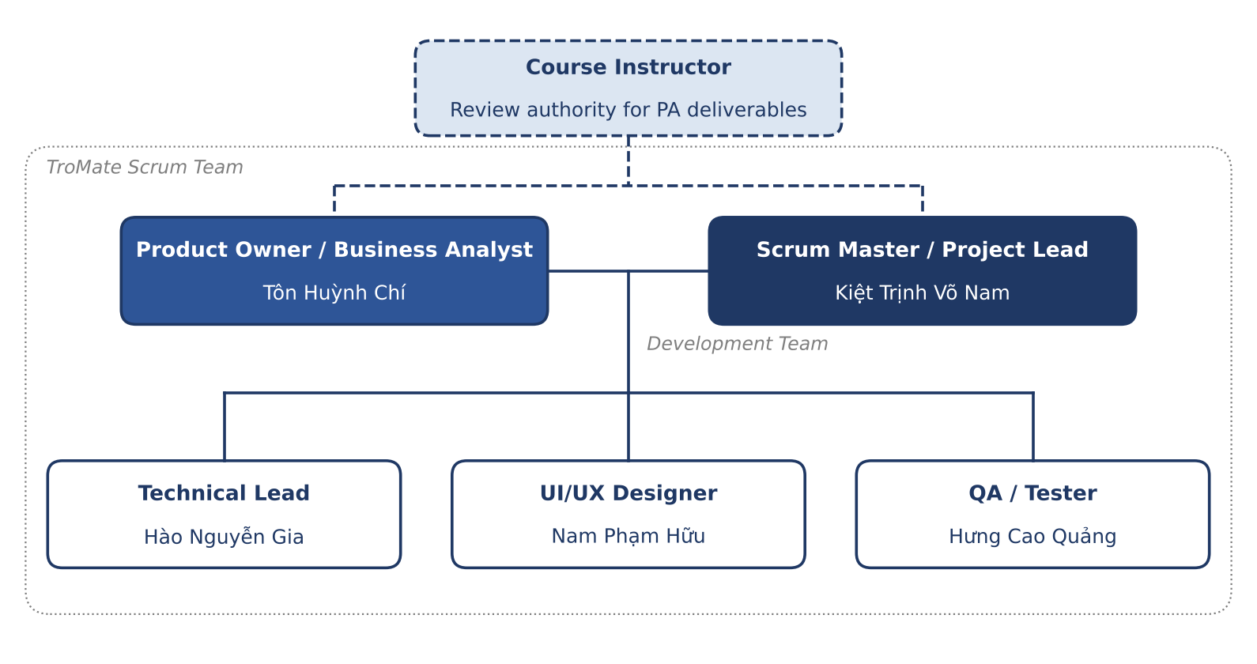
Figure 1. TroMate project organization
Decision authority: business and scope decisions – Product Owner; technical decisions – Technical Lead; process, schedule and due-date changes – Scrum Master together with the Technical Lead. Decisions are recorded in Jira or the repository.

Roles and Responsibilities
Person | Role | Responsibilities
Kiệt Trịnh Võ Nam | Scrum Master / Project Lead | Organize Sprint Planning, Daily Scrum, Sprint Review and Retrospective.  Maintain the Jira board; track sprint progress and deadlines.  Remove blockers and coordinate collaboration across the team.  Enforce the agreed workflow and Definition of Done.  Keep project plans and management documents up to date.
Tôn Huỳnh Chí | Product Owner / Business Analyst | Collect and clarify user needs and product requirements.  Define the MVP scope and prioritize the Product Backlog.  Write and review user stories and acceptance criteria.  Resolve business questions during design, development and testing.  Review delivered features against acceptance criteria.
Hào Nguyễn Gia | Technical Lead | Define the architecture, technology stack and coding standards.  Assess technical feasibility, dependencies and risks.  Break down technical work and support effort estimation.  Review code and support implementation and integration.  Coordinate with QA to investigate and resolve defects.
Nam Phạm Hữu | UI/UX Designer | Translate requirements into user flows and wireframes.  Design consistent, accessible screens and reusable components.  Cover loading, empty, error and success states.  Create prototypes and refine them with usability feedback.  Provide approved designs and assets for implementation.
Hưng Cao Quảng | QA / Tester | Plan testing and write test cases from acceptance criteria.  Test expense recording, balance calculation, settlement and error handling.  Report reproducible bugs in Jira with expected and actual results.  Retest fixes and run regression before demos and releases.  Report unresolved risks; verify testing requirements in the DoD.

Responsibility for each discipline and supporting process:
Discipline / supporting process | Responsible | Supporting
Project management (planning, sprint ceremonies, Jira, reports) | Scrum Master | All members
Requirements (interviews, Vision, SRS, user stories, acceptance criteria) | Product Owner / BA | UI/UX Designer, QA
Analysis & design (architecture, data model, UML) | Technical Lead | Product Owner
UI/UX design and prototype | UI/UX Designer | Product Owner, Technical Lead
Implementation (bot backend, OCR, debt engine, VietQR, auto-accept, Mini App and personal dashboard) | Technical Lead (coordinates) | All members implement backlog items
Testing and quality assurance | QA / Tester | Technical Lead; Product Owner for acceptance
Configuration & change management (GitHub, branches, releases) | Technical Lead | Scrum Master
Deployment and environments | Technical Lead | QA / Tester

Each member is primarily responsible for the assigned role but supports the rest of the team. The UI/UX Designer coordinates with the Product Owner and Technical Lead before finalizing designs, and QA is involved early in requirements and design discussions. Every member keeps their Jira issues up to date. Tasks may also be assigned across roles to balance the workload; assignments are agreed at each Sprint Planning and tracked in Jira.

Management Process

Project Estimates
Cost. This is a zero-budget project. All tools (Jira, GitHub, Slack, Telegram Bot API) and infrastructure (OCR, hosting, Redis, PostgreSQL) use free plans or free quotas.
Effort. Capacity is 5 members × about 10 hours/week × 10 weeks ≈ 500 person-hours, distributed by discipline as follows:
Discipline | Share | Estimated effort (person-hours)
Project management | 10% | 50
Requirements | 12% | 60
Analysis & design (incl. UI/UX) | 15% | 75
Implementation | 38% | 190
Testing | 17% | 85
Deployment & documentation | 8% | 40
Total | 100% | 500

Product backlog estimate. MVP epics are estimated in story points (SP) with Planning Poker (Fibonacci scale):
MVP epic | Priority | Story points | Planned sprint
Infrastructure: bot skeleton, Telegram webhook, CI pipeline, DB setup | High | 5 | Sprint 3
Natural-language expense parsing & currency normalization | High | 8 | Sprint 3
Confirmation protocol, state machine & concurrency control | High | 13 | Sprint 3
Opt-out auto-accept (Vision feature 11) | High | 5 | Sprint 3
Personal ledger – data (Vision feature 12) | High | 5 | Sprint 3
Receipt & rent-bill OCR + multimodal input | High | 13 | Sprint 4
Debt simplification engine | High | 8 | Sprint 4
Dynamic VietQR & settlement confirmation | High | 13 | Sprint 4
Group summary (/balance) | High | 3 | Sprint 4
Meter scanner & rent invoice breakdown | Medium | 8 | Sprint 5
Polite automated debt reminder | High | 5 | Sprint 5
Telegram Mini App (balances, history, room config) | Medium | 13 | Sprint 5
Personal ledger – dashboard (Vision feature 12) | High | 5 | Sprint 5
Research: automatic payment notification | Low | Time-boxed | Sprint 2
Total |  | 104 (S3: 36, S4: 37, S5: 31)

Basis of estimates: whole-team Planning Poker, technical breakdown by the Technical Lead, and the PO's priorities from the MVP Scope Decision Record. The plan assumes a development velocity of about 21–29 SP per sprint in Sprints 3–5. The v2.0 re-estimation raises the backlog from 81 to 104 SP (about 35 SP per sprint in Sprints 3–5). Contingency: if Sprint 3 velocity is below 30 SP, the Product Owner may move the Meter Scanner (8 SP) and the Mini App graphics (about 5 SP) to a later release.
Re-estimation happens at every Sprint Planning; after the Sprint 2 technical spikes (OCR, VietQR, Telegram Mini App); whenever the Product Owner approves a scope change; and whenever actual velocity deviates noticeably from the plan. As defined in the Jira SOP, due dates are never changed without approval from the Scrum Master / Technical Lead. The result of the automatic payment notification research is also a trigger.

Project Plan
The project follows the course schedule defined in PA0: RUP phases are mapped onto five two-week Scrum sprints. Each sprint starts on a Monday with Sprint Planning and ends on a Sunday with the Sprint Review, Retrospective and PA submission.

Phase and Iteration Plan
Phases
Phase (RUP) | Sprints | Start | End | Objectives | Milestone
Inception | Sprint 1 | 05/Oct/2026 | 18/Oct/2026 | Form the team and set up tools; validate the problem with ≥5 user interviews; agree on the vision, MVP scope and plan. | M1 – Lifecycle Objectives (PA1)
Elaboration | Sprints 2–3 | 19/Oct/2026 | 15/Nov/2026 | Complete requirements; define and validate the architecture; retire technical risks (OCR, VietQR, concurrency); detailed design and test plan; first working software. Research automatic payment notification. | M2 – Lifecycle Architecture (PA3, v0.1)
Construction | Sprints 4–5 | 16/Nov/2026 | 13/Dec/2026 | Implement and test the remaining MVP features; run the beta pilot; stabilize and release the MVP. | M3 – Initial Operational Capability (PA5, v1.0)

A full Transition phase (production rollout beyond pilot users) falls outside the 10-week course. The pilot, user guide and release activities in Sprint 5 cover the transition work needed for the MVP.
Iterations (sprints)
Sprint | Dates | Assignment | Sprint goal | Main objectives / backlog items
Sprint 1 (Inception) | 05/Oct – 18/Oct/2026 | PA0 (11/Oct), PA1 (18/Oct) | Project defined and team set up | Group registration and project proposal  ≥5 user interviews with evidence  Slack, Jira, GitHub setup  MVP scope decision, team roles, Jira SOP  Vision document and SDP  SRS and UI prototype baselines
Sprint 2 (Elaboration) | 19/Oct – 01/Nov/2026 | PA2 (01/Nov) | Requirements complete; initial design agreed; Vision and SDP revised (v2.0) | Use-case model, user stories and AC for all MVP epics (use-case diagrams & specifications)  Clickable UI prototype (chat flows, Mini App), updated for Vision v2.0  Initial architecture (webhook, backend, Redis, PostgreSQL)  Spikes: OCR engine comparison, VietQR payload, Mini App auth; research on automatic payment notification  Vision and SDP v2.0 (bot skeleton moved to Sprint 3)
Sprint 3 (Elaboration) | 02/Nov – 15/Nov/2026 | PA3 (15/Nov) | First working software: log an expense by text and confirm it; auto-accept and personal ledger working | Software Architecture Document, UML, DB schema  Test Plan  Decide on automatic payment notification (research result)  Bot skeleton, webhook, CI pipeline, DB setup (5 SP)  NL parsing + currency normalization (8 SP)  Confirmation protocol, state machine, Redis group lock (13 SP)  Opt-out auto-accept (5 SP)  Personal ledger – data (5 SP)  Release v0.1
Sprint 4 (Construction) | 16/Nov – 29/Nov/2026 | PA4 (29/Nov) | Log expenses from photos and settle debts | Receipt/bill OCR + multimodal input (13 SP)  Debt simplification engine (8 SP)  VietQR + settlement confirmation (13 SP)  /balance summary (3 SP)  Test cases, regression; Beta v0.5 to pilot rooms
Sprint 5 (Construction) | 30/Nov – 13/Dec/2026 | PA5 (13/Dec) | MVP complete and released | Meter scanner & rent breakdown (8 SP)  Polite automated reminders (5 SP)  Telegram Mini App (13 SP)  Personal ledger – dashboard (5 SP)  Pilot feedback fixes, full regression  User guide, release notes, final demo; v1.0

Work Breakdown Structure (WBS)
WBS ID | Work package | Owner
1 | Project management – planning, sprint ceremonies, Jira tracking, status reports | Scrum Master
2 | Requirements – interviews, Vision, SRS, user stories and acceptance criteria | Product Owner / BA
3.1 | Analysis & design – architecture, data model, UML, technical spikes, research on automatic payment notification | Technical Lead
3.2 | UI/UX – user flows, wireframes, prototype, Mini App design | UI/UX Designer
4.1 | Implementation – bot infrastructure, webhook, CI/CD | Technical Lead
4.2 | Implementation – natural-language parsing & currency normalization | Development team
4.3 | Implementation – OCR: receipts, rent bills, meters | Development team
4.4 | Implementation – transaction state machine & concurrency control & opt-out auto-accept | Development team
4.5 | Implementation – debt simplification engine & /balance | Development team
4.6 | Implementation – VietQR generation & settlement flow | Development team
4.7 | Implementation – reminder scheduler | Development team
4.8 | Implementation – Telegram Mini App incl. personal dashboard | Development team, UI/UX Designer
4.9 | Implementation – personal ledger (data) | Development team
5 | Testing – test plan, test cases, functional, regression and pilot/UAT testing | QA / Tester
6 | Deployment & release – environments, releases, release notes, user guide | Technical Lead

Major milestones
Milestone | Date | Achievement criteria
PA0 – Group registration & tools setup | 11/Oct/2026 | Group registered; proposal with evidence of ≥5 interviews approved by TAs; Slack, Jira and GitHub set up.
M1 – Lifecycle Objectives (PA1) | 18/Oct/2026 | Vision, SDP and MVP scope agreed by the team; SRS and UI prototype baselines in /docs; product backlog created in Jira.
PA2 – Requirements & initial design | 01/Nov/2026 | User stories with AC for all MVP epics reviewed by QA; prototype reviewed by PO; architecture and spike results documented. Vision and SDP v2.0 resubmitted; spike and research reports in /docs.
M2 – Lifecycle Architecture (PA3) | 15/Nov/2026 | Architecture documented and validated by v0.1 running end-to-end in Telegram (text → PENDING card → confirm → ledger); Test Plan approved. Opt-out auto-accept and personal ledger data work.
Beta (PA4) | 29/Nov/2026 | Photo logging, debt simplification, /balance and VietQR settlement work; no open Blocker/Critical bugs; beta used by pilot room(s).
M3 – Initial Operational Capability (PA5) | 13/Dec/2026 | All MVP features meet the Definition of Done; full regression passed; release notes and user guide published; final demo delivered. Personal dashboard available to every member.

Releases
Release | Date | Type | Content
UI Prototype | 18/Oct (baseline), 01/Nov/2026 (final) | Prototype / design demo (non-executable) | Chat interaction flows, confirmation card, settlement and reminder messages, Mini App screens.
v0.1 | 15/Nov/2026 | Internal demo (PA3) | Text expense logging with currency normalization, PENDING confirmation card, state machine, ledger persistence. Adds opt-out auto-accept and personal ledger data.
v0.5 Beta | 29/Nov/2026 | Beta for pilot room groups (PA4) | Adds receipt/bill OCR and multimodal input, debt simplification, /balance summary, VietQR settlement.
v1.0 MVP | 13/Dec/2026 | Final release and demo (PA5) | Adds meter scanner and rent breakdown, polite automated reminders, Telegram Mini App, and beta bug fixes. Adds the personal dashboard.

Each release is tagged on the main branch in GitHub (v0.1.0, v0.5.0, v1.0.0) and accompanied by release notes.

Project Schedule
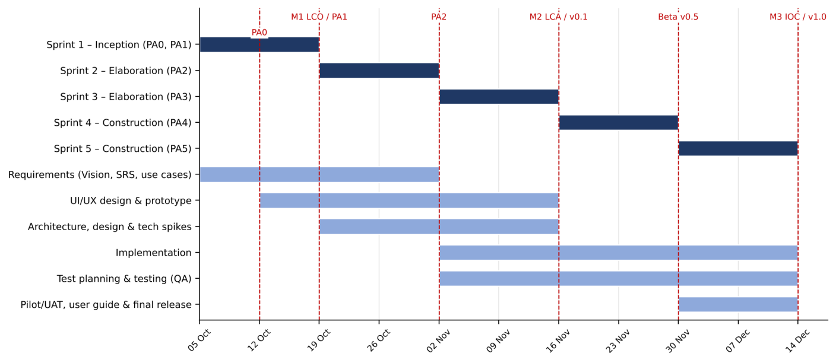
Figure 2. Project timeline (10 weeks, 5 sprints)
Sprint timeline
Sprint | Phase | Sprint Planning | Backlog refinement | Review, Retro & PA due | Release / milestone
Sprint 1 | Inception | Mon 05/Oct | Mon 12/Oct | Sun 18/Oct | PA0 (Sun 11/Oct), PA1, M1
Sprint 2 | Elaboration | Mon 19/Oct | Mon 26/Oct | Sun 01/Nov | PA2, final UI prototype
Sprint 3 | Elaboration | Mon 02/Nov | Mon 09/Nov | Sun 15/Nov | PA3, v0.1, M2
Sprint 4 | Construction | Mon 16/Nov | Mon 23/Nov | Sun 29/Nov | PA4, v0.5 Beta
Sprint 5 | Construction | Mon 30/Nov | Mon 07/Dec | Sun 13/Dec | PA5, v1.0, M3
Planned work by sprint (Sprints 2–5)
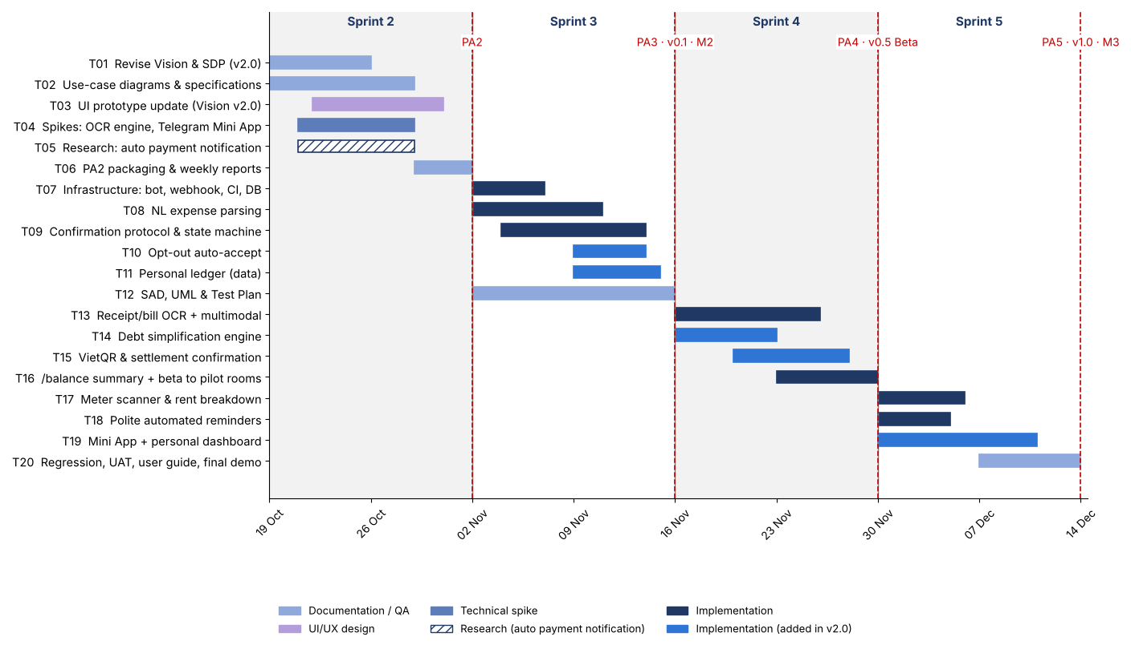
Figure 3. Planned work by sprint, Sprints 2–5 (bright blue = added in v2.0); task IDs T01–T20 are broken down below
Week-by-week plan with exit criteria
Each week ends with a check against its exit criteria at the Daily Scrum; a missed criterion is raised as a blocker and re-planned at the next Sprint Planning or backlog refinement.
Week | Dates | Planned work (task IDs) | Lead roles | Exit criteria
3 (S2) | 19–25/Oct | Revise Vision and SDP (T01); use-case diagrams (T02); start spikes (T04) and the research on automatic payment notification (T05) | PO, Technical Lead, QA | Vision and SDP v2.0 ready
4 (S2) | 26/Oct–01/Nov | Use-case specifications and user stories (T02); UI prototype update (T03); spike and research reports (T04, T05); weekly reports and PA2 package (T06) | PO, QA, UI/UX, Scrum Master | PA2 submitted; reports in /docs
5 (S3) | 02–08/Nov | Sprint 3 Planning incl. the research decision; infrastructure (T07); NL expense parsing (T08); architecture document and UML (T12) | Technical Lead, PO | Bot answers in Telegram; CI runs on every PR
6 (S3) | 09–15/Nov | Confirmation protocol and state machine (T09); opt-out auto-accept (T10); personal ledger data (T11); Test Plan and Sprint Review (T12) | Technical Lead, QA | v0.1 demo; PA3; M2
7 (S4) | 16–22/Nov | Receipt/bill OCR and multimodal input (T13); debt simplification engine (T14); start VietQR (T15) | Technical Lead, dev team | Photo expense reaches the ledger after confirmation
8 (S4) | 23–29/Nov | VietQR and settlement confirmation (T15); /balance, regression and beta to pilot rooms (T16) | Dev team, QA, PO | v0.5 Beta; PA4; no open Blocker/Critical bugs
9 (S5) | 30/Nov–06/Dec | Meter scanner and rent breakdown (T17); polite reminders (T18); Mini App and personal dashboard (T19) | Dev team, UI/UX | All MVP features merged
10 (S5) | 07–13/Dec | Personal dashboard finished (T19); regression, UAT, user guide, release notes and final demo (T20) | Whole team | v1.0; PA5; M3
Task breakdown and owners
Each bar in Figure 3 (T01–T20) is split into sub-tasks with exactly one owner. Owners are planned assignments; the Scrum Master may rebalance them at Sprint Planning.
ID | Task / sub-task | Owner | Week
T01 | Revise Vision & SDP (v2.0) |  | 3
T01.1 | Revise the Vision Document | Tôn | 3
T01.2 | Revise the Software Development Plan | Hào | 3
T02 | Use-case diagrams & specifications |  | 3–4
T02.1 | Use-case diagrams | Tôn | 3
T02.2 | Use-case specifications | Hưng | 3–4
T02.3 | User stories with acceptance criteria | Tôn | 4
T03 | UI prototype update (Vision v2.0) |  | 3–4
T03.1 | Chat flows: auto-accept and settlement confirmation | Kiệt | 3–4
T03.2 | Mini App screens: personal ledger and dashboard | Nam | 4
T04 | Spikes: OCR engine, Telegram Mini App |  | 3–4
T04.1 | Compare OCR engines on real receipts | Kiệt | 3–4
T04.2 | Initialize the Telegram Mini App and its authentication | Nam | 3–4
T04.3 | VietQR payload spike | Hào | 4
T05 | Research: automatic payment notification |  | 3–4
T05.1 | Research and write the feasibility report | Hưng | 3–4
T06 | PA2 packaging & weekly reports |  | 4
T06.1 | Weekly reports (weeks 3 and 4) | Nam | 4
T06.2 | Final review of PA2 documents | Kiệt | 4
T06.3 | Package and submit PA2 | Nam | 4
T07 | Infrastructure: bot, webhook, CI, DB |  | 5
T07.1 | Bot skeleton and Telegram webhook | Hào | 5
T07.2 | CI pipeline (GitHub Actions: lint and unit tests) | Hưng | 5
T07.3 | PostgreSQL and Redis setup, first DB schema | Kiệt | 5
T08 | NL expense parsing |  | 5–6
T08.1 | Parse amount, payer and payees from chat text | Hào | 5–6
T08.2 | Currency normalization (k, tr, củ …) | Kiệt | 5
T08.3 | Test corpus of real chat messages | Hưng | 5
T09 | Confirmation protocol & state machine |  | 5–6
T09.1 | PENDING state machine and ledger commit | Hào | 5–6
T09.2 | Confirmation card ([Agree] / [Reject] / [Edit]) | Nam | 6
T09.3 | Per-group Redis lock | Kiệt | 6
T10 | Opt-out auto-accept |  | 6
T10.1 | Auto-accept background job | Kiệt | 6
T10.2 | Per-member opt-out setting | Nam | 6
T11 | Personal ledger (data) |  | 6
T11.1 | Per-member share records in the ledger | Hào | 6
T11.2 | "My related expenses" query and retention rule | Tôn | 6
T12 | SAD, UML & Test Plan |  | 5–6
T12.1 | Software Architecture Document | Hào | 5–6
T12.2 | UML models (class, sequence, state) | Tôn | 5–6
T12.3 | Test Plan | Hưng | 5–6
T12.4 | Sprint 3 report and v0.1 release notes | Kiệt | 6
T13 | Receipt/bill OCR + multimodal |  | 7–8
T13.1 | OCR integration and image pre-processing | Kiệt | 7–8
T13.2 | Photo + text (multimodal) input | Hào | 7–8
T13.3 | OCR test set and accuracy check | Hưng | 7
T14 | Debt simplification engine |  | 7
T14.1 | Minimum cash flow algorithm | Hào | 7
T14.2 | Small-debt tolerance and carry-over | Tôn | 7
T14.3 | Unit tests for the engine | Hưng | 7
T15 | VietQR & settlement confirmation |  | 7–8
T15.1 | VietQR generation and banking deep-links | Kiệt | 7–8
T15.2 | Confirm Paid / Confirm Received and receipt upload | Nam | 8
T15.3 | Settlement test cases | Hưng | 8
T16 | /balance summary + beta to pilot rooms |  | 8
T16.1 | /balance command | Tôn | 8
T16.2 | Recruit pilot rooms and run the beta | Tôn | 8
T16.3 | Regression run and bug triage | Hưng | 8
T16.4 | Sprint 4 report and v0.5 release notes | Kiệt | 8
T17 | Meter scanner & rent breakdown |  | 9
T17.1 | Meter digit OCR | Kiệt | 9
T17.2 | Rent invoice breakdown | Tôn | 9
T18 | Polite automated reminders |  | 9
T18.1 | Reminder scheduler (24 h / 48 h) | Hào | 9
T18.2 | Reminder message templates with the VietQR button | Nam | 9
T19 | Mini App + personal dashboard |  | 9–10
T19.1 | Mini App API endpoints and authentication | Hào | 9
T19.2 | Room overview and history screens | Nam | 9
T19.3 | Personal dashboard screens | Nam | 9–10
T20 | Regression, UAT, user guide, final demo |  | 10
T20.1 | Full regression and UAT with pilot rooms | Hưng | 10
T20.2 | User guide | Tôn | 10
T20.3 | Release notes and v1.0 tag | Hào | 10
T20.4 | Final demo and presentation | Kiệt | 10

Project Resourcing
Staffing. The team has 5 members for the whole project, each contributing about 10 hours per week. Effort shifts by sprint as shown below; during Sprints 3–5 every member also takes implementation sub-tasks under the Technical Lead's coordination.
Member | Role | Main focus by sprint
Kiệt Trịnh Võ Nam | Scrum Master / Project Lead | All sprints: ceremonies, Jira board, plans and status reports.
Tôn Huỳnh Chí | Product Owner / BA | S1–S2: interviews, Vision, SRS, user stories. S3–S5: backlog priorities, acceptance reviews, pilot coordination.
Hào Nguyễn Gia | Technical Lead | S2–S3: architecture, spikes, infrastructure. S3–S5: implementation, code review, releases.
Nam Phạm Hữu | UI/UX Designer | S1–S3: flows, wireframes, prototype, detailed UI. S4–S5: Mini App UI, usability fixes.
Hưng Cao Quảng | QA / Tester | S1–S2: requirement reviews. S3: Test Plan. S4–S5: test execution, regression, pilot/UAT.

Tools and infrastructure (free tiers): Telegram Bot API and Mini App; Google Cloud Vision free quota or Tesseract for OCR; free cloud hosting for the backend; Redis and PostgreSQL free tiers; GitHub, Jira, Slack, Moodle and the class Facebook group. For the research only: banking API test accounts.

Project Monitoring and Control

Reporting
Project status is reported through the following channels:
- Daily Scrum (15 minutes, in a call or asynchronously in the group Slack channel): what was done, what is next, and blockers. Items at risk of missing their due date are raised here and explained in a "Reason for Delay" comment on the Jira ticket.
- Sprint Planning (first Monday of each sprint): agree on the sprint goal and backlog; assignees break work into sub-tasks with due dates.
- Sprint Review (end of sprint): demo the increment to the Product Owner, and to the instructor/TAs when the PA requires it.
- Sprint Retrospective (end of sprint): agree on improvements; notes stored in /docs/management.
- Weekly status report by the Scrum Master in /docs/management: progress against plan, burndown, risks and blockers.
- Jira board and burndown chart as the single source of truth for progress; PR links are attached to tickets.
- Slack group channel for day-to-day discussion; Moodle and the class Facebook group for course notices and submissions.
Work items follow the team's Jira SOP:
- Issue types: Epic (one per MVP feature), User Story (with acceptance criteria), Task, Sub-task and Bug.
- Every active Story, Task and Sub-task has a due date; a sub-task's due date cannot exceed its parent's.
- Workflow: To Do → In Progress → In Review → Done. No ticket in progress or in review may be unassigned.
- Definition of Done: code approved and merged; QC verified with no open Blocker/Critical/Major bugs; all sub-tasks done; documentation updated.

Risk Management
Probability is rated from 0.1 (rare) to 0.9 (almost certain) and impact from 1 (negligible) to 10 (critical). Risk exposure = Probability × Impact. Risks are sorted by exposure (priority 1 = highest).
Risk ID | Risk description | Proba-bility | Impact | Risk exposure | Priority | Mitigation strategy or contingency plan
R01 | OCR misreads amounts on low-quality or crumpled receipts, bills and meter photos. | 0.7 | 8 | 5.6 | 1 | Compare OCR engines on real receipts in the Sprint 2 spike; preprocess images; always show the extracted amount on the PENDING card with [Edit Amount]; nothing is committed without confirmation. OCR-parsed expenses are never auto-accepted.
R02 | MVP scope (104 SP after Vision v2.0) is too large for 3 implementation sprints with a part-time team. | 0.7 | 8 | 5.6 | 2 | Strict backlog priority; Medium-priority items (meter scanner, Mini App) are scheduled last and can move to a later release with PO approval; track velocity each sprint. Contingency items listed in Section 4.1.
R03 | Member availability drops because of other courses and exams. | 0.6 | 6 | 3.6 | 3 | Mandatory due dates and Daily Scrum early warnings; pair members on critical work for cover; keep buffer in Sprint 5.
R04 | Ambiguous Vietnamese chat input (slang, currency tokens, mentions) is parsed incorrectly. | 0.6 | 6 | 3.6 | 4 | Build a test corpus from interviews and pilot chats; default to equal split; confirmation card with edit before commit.
R05 | Race conditions when several members send expenses at the same time. | 0.5 | 7 | 3.5 | 5 | Per-group Redis lock (Group_State_Lock, TTL 300 s); concurrency tests in Sprint 3.
R06 | Incorrect VietQR payload (bank BIN, amount, CRC) leads to failed or wrong transfers. | 0.3 | 9 | 2.7 | 6 | Follow EMVCo / Napas specification; unit-test payload and CRC; test with several banking apps; debts clear only after [Confirm Received].
R12 | Members forget or dispute manual payment confirmation. | 0.5 | 5 | 2.5 | 7 | Both parties confirm; optional receipt upload; polite reminders.
R07 | Team lacks experience with FastAPI/Node.js, Redis and Telegram Mini Apps. | 0.5 | 5 | 2.5 | 8 | Technical spikes in Sprint 2; Technical Lead pairing, coding standards and code review.
R08 | Free-tier limits (OCR quota, hosting cold starts) disrupt demos or the pilot. | 0.4 | 6 | 2.4 | 9 | Tesseract fallback; monitor quota; warm up services before demos.
R09 | Telegram constraints (group privacy mode, webhook limits, Mini App authentication). | 0.4 | 6 | 2.4 | 10 | Validate in the Sprint 2 spike; configure bot permissions; verify Mini App initData on the backend.
R10 | Leakage of financial data or bank account details. Personal spending history is stored per member. | 0.3 | 8 | 2.4 | 11 | Store minimal data; keep secrets out of the repository; HTTPS only; restrict access to group members.
R13 | Auto-accept commits a wrong expense before members notice it. | 0.4 | 6 | 2.4 | 12 | Reject / Edit within the auto-accept window; members can opt out; OCR expenses excluded; reversing ledger entry.
R14 | Automatic payment notification proves infeasible within the course scope. | 0.6 | 3 | 1.8 | 13 | MVP does not depend on it (manual confirmation); decision at Sprint 3 Planning.
R11 | Reminders feel intrusive, reducing adoption. | 0.3 | 5 | 1.5 | 14 | Review reminder wording with pilot users; limit reminders to the 24h/48h schedule; allow the room to adjust frequency.

The Scrum Master reviews this register at every Sprint Planning and Retrospective, updates probabilities and impacts, and records new risks in Jira. Version 2.0 added R12–R14 and re-rated R02.

Configuration Management
- Source code and documents: a GitHub repository with the structure required by PA0: /src (bot backend and Mini App); /docs/management, /docs/requirements, /docs/analysis and design, /docs/test; and /pa with one subfolder per PA submission.
- Branching: main (protected; releases only, tagged v0.1.0, v0.5.0, v1.0.0), develop (integration), and short-lived feature/<JIRA-KEY>-description and bugfix/<JIRA-KEY>-description branches.
- Spike code lives in spike/<JIRA-KEY>-description branches and is merged only after the related change request is approved.
- Code review: every change is merged through a pull request with at least one approval (peer or Technical Lead); the PR link is attached to the Jira ticket and commit messages start with the Jira issue key.
- Continuous integration: GitHub Actions runs linting and unit tests on every pull request.
- Secrets: bot tokens, database credentials and OCR keys are kept in environment variables / GitHub Secrets and never committed.
- Documents: drafts may be co-edited in Google Drive; approved versions are exported to /docs and versioned in GitHub. UI prototype source files are linked from /docs/analysis and design.
- Backlog and change control: all requirements, tasks, bugs and change requests are tracked in Jira; scope changes require Product Owner approval and are recorded in Jira and the MVP decision record.
- Environments: Local (developers), Testing (QC verification after PR approval) and Demo/Pilot (bot used by pilot rooms and for PA demos).

