**Mongo-DB-Checkpoint**

* ***Create a database called "contact"***

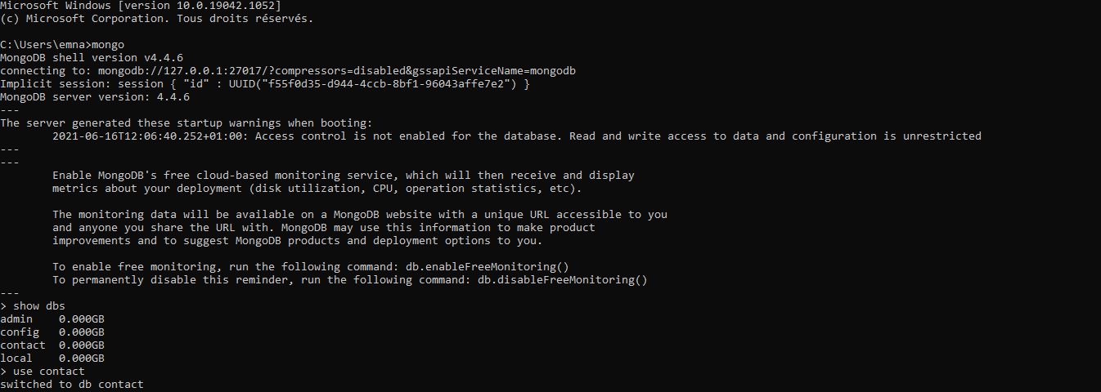

***Create a collection called "contactlist" + Insert these documents  in "contactlist"***

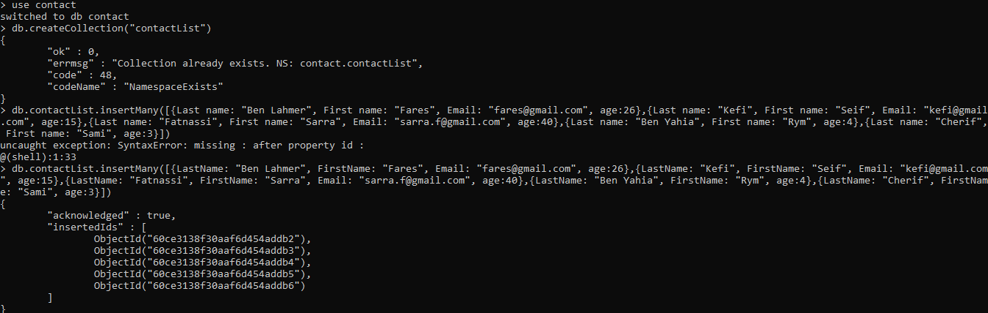

***Display all of the contacts list***

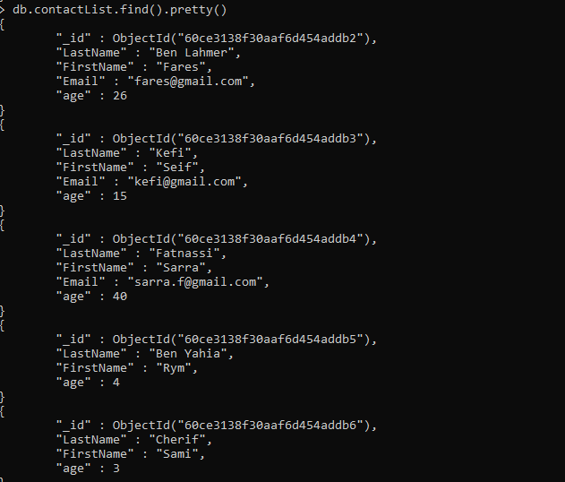

***Display all the information about only one person using his ID***

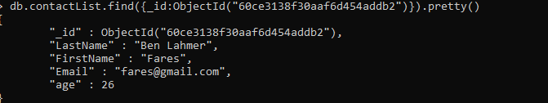

***Display all the contacts with an age >18***

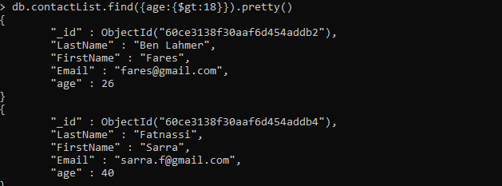

***Display all the contacts with an age>18 and name containing "ah"***

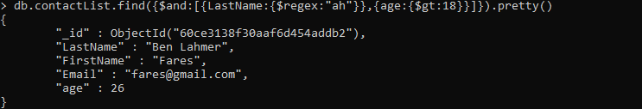

***Change the contact's first name from"Kefi Seif" to "Kefi Anis"***

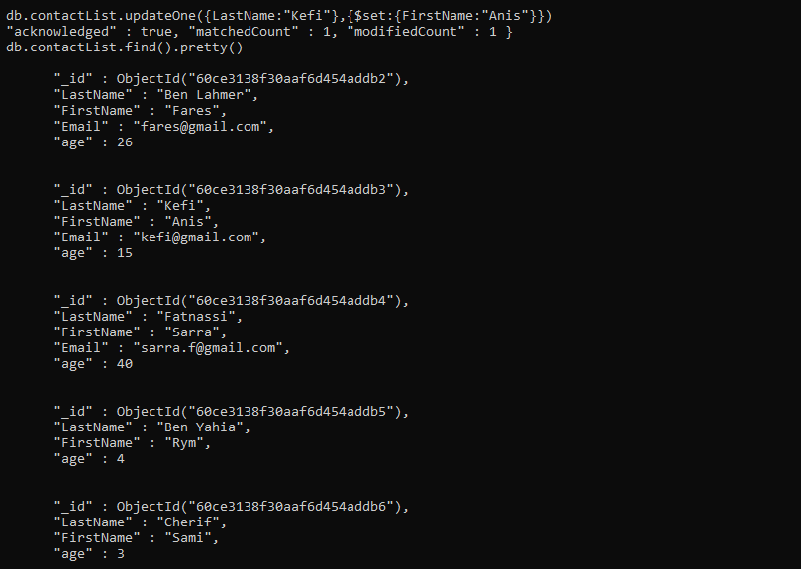

***Delete the contacts that are aged under <5***

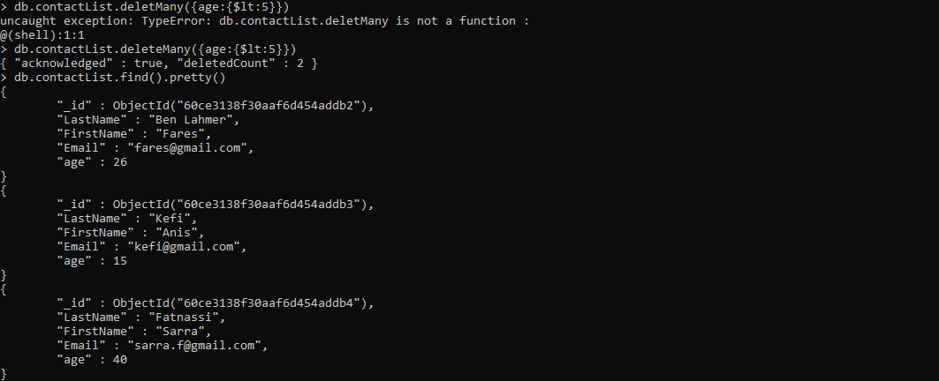

***Display all of the contacts list***

