Ety



OPERATING SYSTEM LAB

MINI PROJECT
STUDENT MANAGEMENT SYSTEM

23F-0811 | Amna Noor
23F-0628 | Rao Waleed

CODE:
#!/bin/bash

# File to store student records
DATA_FILE="student_records.txt"
# Teacher credentials set by default
TEACHER_USERNAME="teacher"
TEACHER_PASSWORD="fast123"

# Function to calculate grade based on obtained marks and total marks
calculate_grade() {
obtained=$1
total=$2
percentage=$(( (obtained * 100) / total ))

if [ $percentage -ge 90 ]; then
echo "A"
elif [ $percentage -ge 80 ]; then
echo "B"
elif [ $percentage -ge 70 ]; then
echo "C"
elif [ $percentage -ge 60 ]; then
echo "D"
else
echo "F"
fi
}

# Function to add a new teacher
add_new_teacher() {
echo "Enter new teacher username: "
read username

# Check if username already exists
if grep -q "^$username," teacher_records.txt; then
echo "Error: Username '$username' already exists! Please choose a different username."
return
fi

echo "Enter new teacher password: "
read -s password # -s hides input while typing
echo # line break

echo "$username,$password" >> teacher_records.txt
touch "${username}.txt"
echo "New teacher added successfully! File '${username}.txt' created."
}

# Function to save student details to file
save_student() {
local data_file=$1
local roll=$2
local password=$3
local name=$4
local cgpa=$5
local subjects=$6 # subjects is comma-prefixed string like: ,subject1(...),subject2(...)
echo "$roll,$password,$name,$cgpa,$subjects" >> $data_file
}

# Function to view student record
view_student_record() {
local data_file=$1
echo "Enter Roll Number: "
read roll

# Search for student record
record=$(grep "^$roll," "$data_file")
if [ -z "$record" ]; then
echo "No record found."
else
# Extract fields, skipping the password field
roll=$(echo "$record" | cut -d',' -f1)
name=$(echo "$record" | cut -d',' -f3)
cgpa=$(echo "$record" | cut -d',' -f4)

echo "Roll Number: $roll"
echo "Name: $name"
echo "CGPA: $cgpa"
echo "Subjects & Marks:"

# Extract the part of the record after CGPA (all subjects)
subjects_part=$(echo "$record" | cut -d',' -f5-)

# Use grep -oP to extract each subject entry (like r(12,30,F))
echo "$subjects_part" | grep -oP '[^,]+?\([^)]+\)' | while read -r subject_entry; do
subject_name=$(echo "$subject_entry" | cut -d'(' -f1)
inside_brackets=$(echo "$subject_entry" | grep -oP '\(.*\)' | tr -d '()')
obtained_marks=$(echo "$inside_brackets" | cut -d',' -f1)
total_marks=$(echo "$inside_brackets" | cut -d',' -f2)
grade=$(echo "$inside_brackets" | cut -d',' -f3)

if [ "$obtained_marks" == "-" ] || [ -z "$obtained_marks" ]; then
echo " $subject_name - Marks not assigned yet."
else
echo " $subject_name: $obtained_marks / $total_marks Grade: $grade"
fi
done
fi
}

# Function to add a new student
add_student() {
local data_file=$1
echo "Enter Roll Number: "
read roll
echo "Enter Name: "
read name

subjects=()
total_cgpa_points=0
subject_count=0

# While loop to add subjects
while true; do
echo "Do you want to add a subject? (y/n)"
read choice
if [ "$choice" = "y" ]; then
echo "Enter Subject Name: "
read subject_name
echo "Enter obtained marks (or '-' if not assigning now): "
read obtained_marks
echo "Enter total marks (or '-' if not assigning now): "
read total_marks
grade="-"

# Calculate grade if marks are valid
if [[ "$obtained_marks" =~ ^[0-9]+$ && "$total_marks" =~ ^[0-9]+$ ]]; then
grade=$(calculate_grade "$obtained_marks" "$total_marks")
grade_point=$(grade_to_cgpa "$grade")
total_cgpa_points=$(echo "$total_cgpa_points + $grade_point" | bc)
subject_count=$((subject_count + 1))
fi

subjects+=("${subject_name}(${obtained_marks},${total_marks},${grade})")
else
break
fi
done

# Calculate CGPA if subjects were added
if [ "$subject_count" -gt 0 ]; then
cgpa=$(echo "scale=2; $total_cgpa_points / $subject_count" | bc -l)
else
cgpa="-"
fi
# Save student record
echo "$roll,"-",$name,$cgpa,${subjects[*]}" >> "$data_file"
echo "Student added successfully."
}

# CGPA based on grade
grade_to_cgpa() {
grade=$1
case $grade in
A) echo "4.0";;
B) echo "3.0";;
C) echo "2.0";;
D) echo "1.0";;
F) echo "0.0";;
*) echo "0.0";;
esac
}

# Function to load student data file, creating it if necessary
load_students() {
local data_file=$1
if [ ! -f $data_file ]; then
echo "Not present such file yet but we created a new one for you"
touch $data_file

fi
}

# Function to delete a student record
delete_student() {
local data_file=$1
echo "Enter Roll Number to delete: "
read roll
grep -v "^$roll," $data_file > temp && mv temp $data_file
echo "Student record deleted if existed."
}

# Function to assign marks to students
assign_marks() {
local data_file=$1
echo "Enter Roll Number to assign marks: "
read roll

# Search for student record using roll number
student=$(grep "^$roll," "$data_file")

if [ -z "$student" ]; then
echo "Student not found!"
return
fi

# Split student data into an array using ',' as delimiter
IFS=',' read -ra fields <<< "$student"
total_cgpa_points=0
subject_count=0

for (( i=4; i<${#fields[@]}; i++ )); do
subject_name=$(echo "${fields[i]}" | cut -d'(' -f1)
inside_brackets=$(echo "${fields[i]}" | grep -oP '\(.*\)' | tr -d '()')
obtained_marks=$(echo "$inside_brackets" | cut -d',' -f1)
total_marks=$(echo "$inside_brackets" | cut -d',' -f2)
grade=$(echo "$inside_brackets" | cut -d',' -f3)

# Check if marks are not assigned (i.e., "-" present in obtained_marks or total_marks)
if [ "$obtained_marks" == "-" ] || [ "$total_marks" == "-" ]; then
echo "Subject: $subject_name"

# Prompt for obtained marks and total marks if not already entered
if [ "$obtained_marks" == "-" ]; then
echo "Enter obtained marks for $subject_name: "
read new_obtained
obtained_marks="$new_obtained"
fi

if [ "$total_marks" == "-" ]; then
echo "Enter total marks for $subject_name: "
read new_total
total_marks="$new_total"
fi

# Validate the obtained and total marks
if [[ "$obtained_marks" =~ ^[0-9]+$ && "$total_marks" =~ ^[0-9]+$ ]]; then
grade=$(calculate_grade "$obtained_marks" "$total_marks")
grade_point=$(grade_to_cgpa "$grade")
total_cgpa_points=$(echo "$total_cgpa_points + $grade_point" | bc)
subject_count=$((subject_count + 1))
else
echo "Invalid marks entered, skipping subject."
continue
fi
fi

# Update the fields with new obtained marks, total marks, and grade
fields[i]="${subject_name}(${obtained_marks},${total_marks},${grade})"
done

# Calculate the new CGPA if subjects were updated
if [ "$subject_count" -gt 0 ]; then
cgpa=$(echo "scale=2; $total_cgpa_points / $subject_count" | bc -l)
else
cgpa="-"
fi

# Update the student record with the new CGPA and subject details
updated_record="${fields[0]},${fields[1]},${fields[2]},$cgpa"
for (( i=4; i<${#fields[@]}; i++ )); do
updated_record+=","${fields[i]}
done

# Update the file with the new record
awk -v roll="$roll" -v new_record="$updated_record" -F',' '
BEGIN { OFS="," }
$1 == roll { print new_record; next }
{ print }
' "$data_file" > temp && mv temp "$data_file"

echo "Marks assigned and CGPA updated for student $roll."
}

# Function to add new subjects if needed
add_more_subjects() {
local data_file=$1
echo "Enter Roll Number to add subjects: "
read roll
student=$(grep "^$roll," "$data_file")

if [ -z "$student" ]; then
echo "Student not found!"
return
fi

IFS=',' read -ra fields <<< "$student"
total_cgpa_points=0
subject_count=0

for (( i=4; i<${#fields[@]}; i++ )); do
inside_brackets=$(echo "${fields[i]}" | grep -oP '\(.*\)' | tr -d '()')
obtained_marks=$(echo "$inside_brackets" | cut -d',' -f1)
total_marks=$(echo "$inside_brackets" | cut -d',' -f2)
grade=$(echo "$inside_brackets" | cut -d',' -f3)

if [[ "$obtained_marks" =~ ^[0-9]+$ && "$total_marks" =~ ^[0-9]+$ ]]; then
grade_point=$(grade_to_cgpa "$grade")
total_cgpa_points=$(echo "$total_cgpa_points + $grade_point" | bc -l)
subject_count=$((subject_count + 1))
fi
done

while true; do
echo "Do you want to add a new subject for $roll? (y/n)"
read choice
if [ "$choice" = "y" ]; then
echo "Enter Subject Name: "
read subject_name
echo "Enter obtained marks (or '-' if not assigning now): "
read obtained_marks
echo "Enter total marks (or '-' if not assigning now): "
read total_marks
grade="-"

if [[ "$obtained_marks" =~ ^[0-9]+$ && "$total_marks" =~ ^[0-9]+$ ]]; then
grade=$(calculate_grade "$obtained_marks" "$total_marks")
grade_point=$(grade_to_cgpa "$grade")
total_cgpa_points=$(echo "$total_cgpa_points + $grade_point" | bc)
subject_count=$((subject_count + 1))
fi

fields+=("${subject_name}(${obtained_marks},${total_marks},${grade})")
else
break
fi
done

# Calculate the new CGPA
if [ "$subject_count" -gt 0 ]; then
cgpa=$(echo "scale=2; $total_cgpa_points / $subject_count" | bc)
else
cgpa="-"
fi

updated_record="${fields[0]},${fields[1]},${fields[2]},$cgpa"
for (( i=4; i<${#fields[@]}; i++ )); do
updated_record+=","${fields[i]} # Append each subject record to the updated record
done

# Update the student record in the file
awk -v roll="$roll" -v new_record="$updated_record" -F',' '
BEGIN { OFS="," }
$1 == roll { print new_record; next }
{ print }
' "$data_file" > temp && mv temp "$data_file"

echo "Subjects added and CGPA updated for student $roll."
}

# Function to list students sorted by CGPA
list_students_sorted() {
local data_file=$1
echo "1. Ascending order by CGPA 2. Descending order by CGPA"
read choice
if [ "$choice" -eq 1 ]; then
sort -t',' -k4 -n "$data_file" | awk -F',' '{print $1, $3, $4}' | column -t
else
sort -t',' -k4 -nr "$data_file" | awk -F',' '{print $1, $3, $4}' | column -t
fi
}

# Function to list students who passed (CGPA >= 2.0)
list_passed_students() {
local data_file=$1
echo "Passed Students (CGPA >= 2.0):"
awk -F',' '$4 >= 2.0 {print $1, $3, $4}' "$data_file" | column -t
}

# Function to list students who failed (CGPA < 2.0)
list_failed_students() {
local data_file=$1
echo "Failed Students (CGPA < 2.0):"
awk -F',' '$4 < 2.0 {print $1, $3, $4}' "$data_file" | column -t
}

# Function to handle student login
student_login() {
echo "Enter your Roll Number: "
read roll

teachers=$(cut -d',' -f1 teacher_records.txt)

found=0
for teacher_username in $teachers; do
data_file="${teacher_username}.txt"
if [ -f "$data_file" ]; then
student_line=$(grep "^$roll," "$data_file")
if [ ! -z "$student_line" ]; then
password_field=$(echo "$student_line" | cut -d',' -f2)

# If no password is set, the student to set one
if [ "$password_field" = "-" ]; then
echo "It looks like you haven't set a password yet. Please set your new password: "
read -s newpass
if [ -z "$newpass" ]; then
echo "Password cannot be empty. Try logging in again."
return
fi

temp_file="temp.txt"
awk -F',' -v roll="$roll" -v newpass="$newpass" 'BEGIN{OFS=","}
{if($1 == roll) $2 = newpass; print}' "$data_file" > "$temp_file"
mv "$temp_file" "$data_file"
echo "Password set successfully! Please login again with your new password."
return
else
echo "Enter your Password: "
read -s pass
student=$(grep "^$roll,$pass," "$data_file")
if [ ! -z "$student" ]; then
found=1
echo "Welcome! You are logged in from $teacher_username's records."

while true; do
echo ""
echo "Student Panel:"
echo "1. View Name"
echo "2. View Subject Records"
echo "3. View CGPA"
echo "4. Logout"
read ch
case $ch in
1)
name=$(echo "$student" | cut -d',' -f3)
echo "Your Name: $name"
;;
2)
echo "Your Subjects Details:"
# Get subject data from 5th column onwards
subject_data=$(echo "$student" | cut -d',' -f5-)

# Extract all subject records that follow subjectName(obtained,total,grade) pattern
subjects=$(echo "$subject_data" | grep -oP '[a-zA-Z0-9]+?\([0-9]+,[0-9]+,[A-Z]\)')

# Loop through all extracted subjects and print
while IFS= read -r subject_entry; do
subject_name=$(echo "$subject_entry" | cut -d'(' -f1)
inside_brackets=$(echo "$subject_entry" | grep -oP '\(.*\)' | tr -d '()')
obtained_marks=$(echo "$inside_brackets" | cut -d',' -f1)
total_marks=$(echo "$inside_brackets" | cut -d',' -f2)
grade=$(echo "$inside_brackets" | cut -d',' -f3)

echo "Subject: $subject_name, Obtained Marks: $obtained_marks, Total Marks: $total_marks, Grade: $grade"
done <<< "$subjects"
;;

3)
cgpa=$(echo "$student" | cut -d',' -f4)
echo "Your CGPA: $cgpa"
;;
4)
echo "Logging out..."
break
;;
*) echo "Invalid choice";;
esac
done
break
fi
fi
fi
fi
done

if [ $found -eq 0 ]; then
echo "Student record not found or incorrect credentials!"
fi
}

# Function to handle teacher login
teacher_login() {
echo "Enter username: "
read uname
echo "Enter password: "
read -s pass

# Check teacher credentials by searching for the username and password in the teacher records file
record=$(grep "^$uname,$pass" teacher_records.txt)
if [ -z "$record" ]; then
echo "Invalid credentials!"
return
fi

# If credentials are valid, assign the teacher's data file and load student records
data_file="${uname}.txt"
load_students $data_file
echo "Login Successful!"

while true; do
echo ""
echo "Teacher Panel for $uname:"
echo "1. Add Student"
echo "2. Delete Student"
echo "3. Assign Marks"
echo "4. List Passed Students"
echo "5. List Failed Students"
echo "6. View Student Record"
echo "7. List Students (Sort by CGPA)"
echo "8. Add More Subjects to a Student Record"

echo "9. Logout"
read ch
case $ch in
1) add_student $data_file;;
2) delete_student $data_file;;
3) assign_marks $data_file;;
4) list_passed_students $data_file;;
5) list_failed_students $data_file;;
6) view_student_record $data_file;;
7) list_students_sorted $data_file;;
8) add_more_subjects "$data_file" ;;

9) break;;
*) echo "Invalid choice";;
esac
done
}

main_menu() {
while true; do
echo ""
echo "===== Student Management System ====="
echo "1. Teacher Login"
echo "2. Student Login"
echo "3. Add New Teacher"
echo "4. Exit"
read choice
case $choice in
1) teacher_login ;;
2) student_login ;;
3) add_new_teacher ;;
4) echo "Exiting..."; break ;;
*) echo "Invalid option, please try again." ;;
esac
done
}

main_menu

Output:
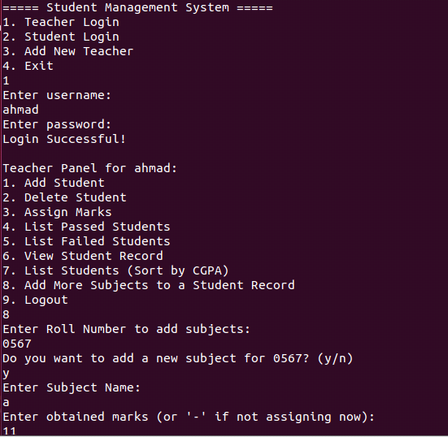
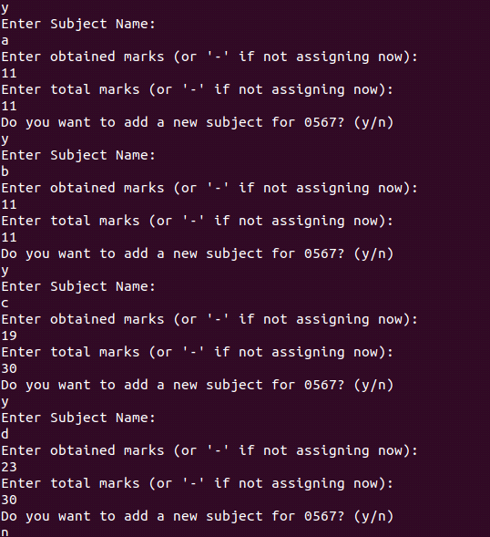
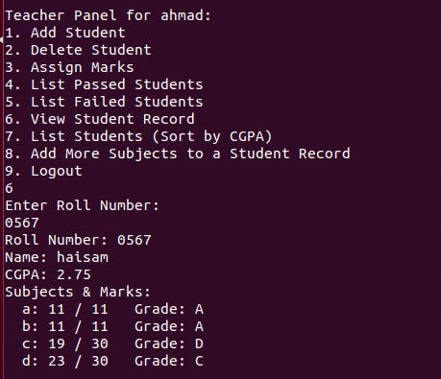
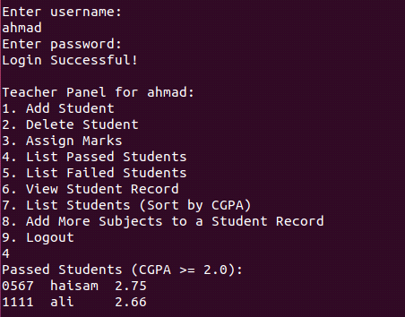
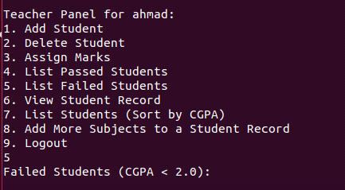
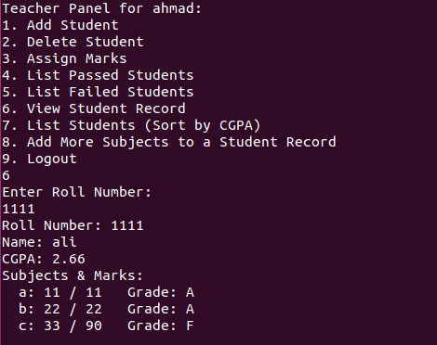
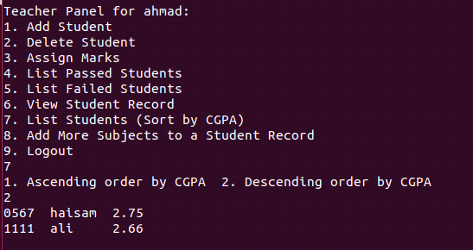
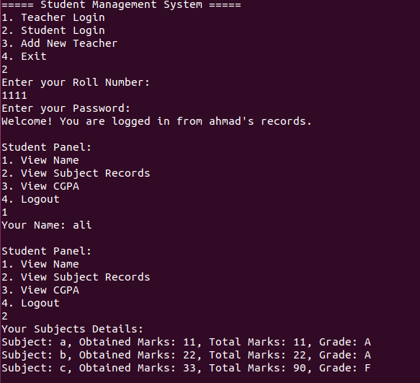
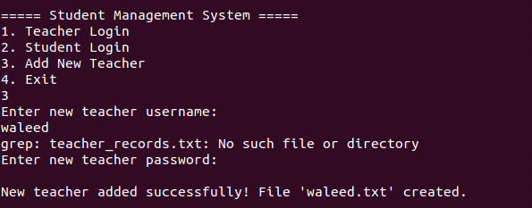
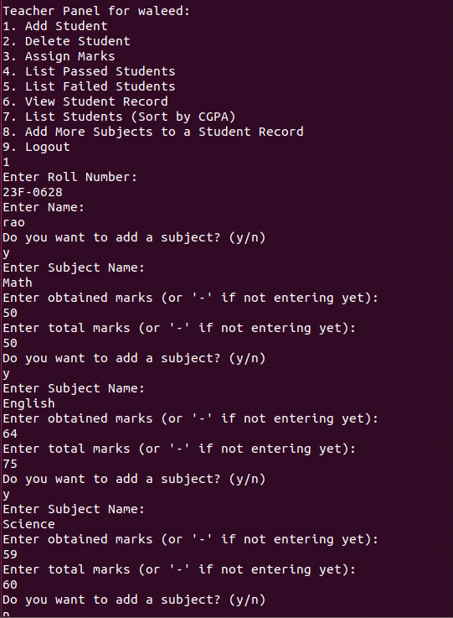
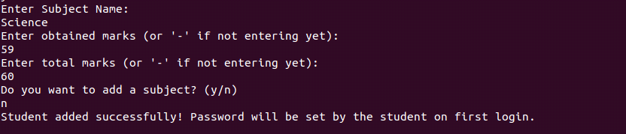
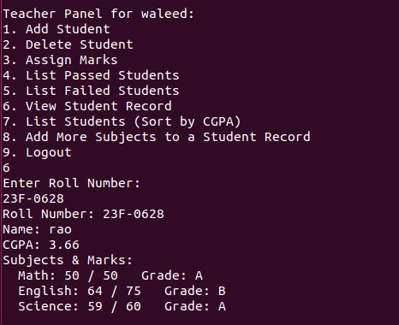
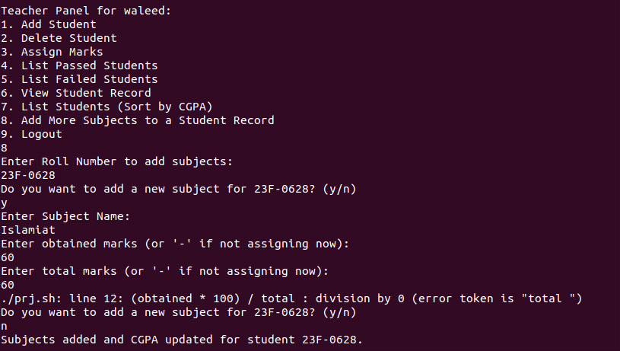
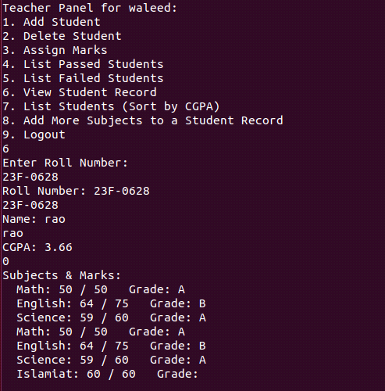
Explanation:
When you enter in student management system:
- Teacher Login – Allows a teacher to log in using a username and password.
- Student Login – Allows students to log in (not shown in this image).
- Add New Teacher – Registers a new teacher account.
- Exit – Closes the program.

Teacher Panel Functionalities:
Once logged in, the teacher can perform various tasks:
- Add Student – Registers a new student in the system.
- Delete Student – Removes a student from the database.
- Assign Marks – Assigns marks to students for different subjects.
- List Passed Students – Displays students who have passed.
- List Failed Students – Displays students who have failed.
- View Student Record – Shows detailed records of a particular student.
- List Students (Sort by CGPA) – Displays all students sorted by their CGPA.
- Add More Subjects to a Student Record – Adds additional subjects and marks to an existing student record.

- Logout – Logs the teacher out of the system.

This is a student grading system that stores marks for multiple subjects
It allows users to assign and track student performance subject-wise.
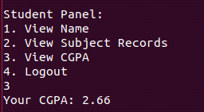
Explanation:
In student login function you enter , set your password then login successfully.
Student panel functionalities:
- View Name
- View Subject Records
- View CGPA
- Logout
In this student can see their subject records, CGPA.
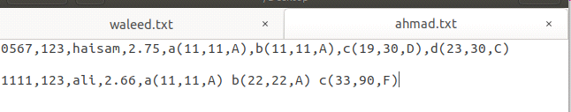
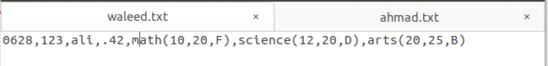
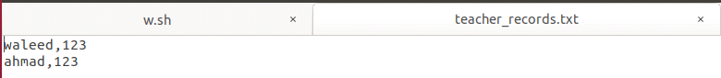

Explanation:
1. ahmad.txt
Stores student records under the teacher "ahmad."
2. waleed.txt
Contains student data under another teacher "waleed".
3. teacher_records.txt
Store teacher login credentials.

Conclusion:
The system manages student records under different teachers.
Teachers have their own files (ahmad.txt, waleed.txt) containing student information and grades.
teacher_records.txt stores teacher login credentials.

