CV Analyzer System: Algorithm Explanation and System Design

1. Introduction & Problem Definition
1.1 Problem Statement
The manual screening of CVs for job applications is a time-consuming and subjective process that often leads to inefficiencies in recruitment. HR professionals typically spend 6-8 seconds reviewing each CV, which can result in qualified candidates being overlooked due to human fatigue or bias.
1.2 Project Objectives
- Develop an automated CV analysis system that can process multiple CVs simultaneously
- Implement and compare three string matching algorithms for keyword detection
- Provide quantitative scoring of candidate job description matching
- Generate performance metrics and visual comparisons between algorithms
- Create an intuitive desktop application for end-users
1.3 Scope
The system processes .docx format CVs, compares them against job description keywords, and provides match scores using three different string searching algorithms with comprehensive performance analysis.
2. System Design & Architecture
2.1 Overall System Flowchart
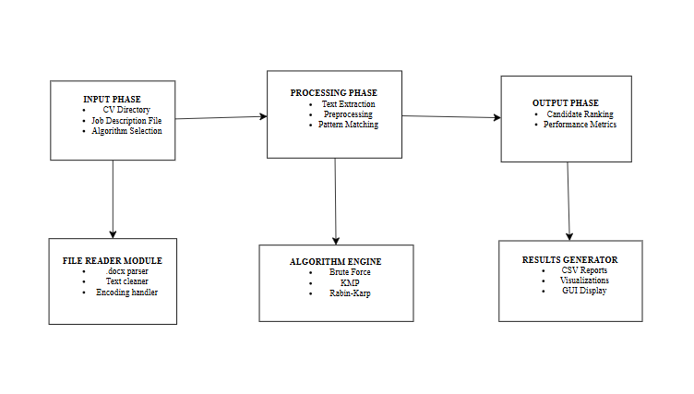
2.2 Component Architecture
- Frontend: Tkinter based GUI with tabbed interface
- Backend: Python-based analysis engine with modular algorithm implementations
- Data Layer: File system-based storage for CVs, job descriptions, and results
- Reporting: Matplotlib for visualizations and Pandas for data analysis
3. Algorithm Explanation
3.1 Brute Force Algorithm
Pseudocode:
FUNCTION BruteForceSearch(text, pattern):
n ← LENGTH(text)
m ← LENGTH(pattern)
positions ← []
comparisons ← 0

FOR i FROM 0 TO n - m:
j ← 0
WHILE j < m AND text[i + j] = pattern[j]:
comparisons ← comparisons + 1
j ← j + 1

IF j = m:
positions.APPEND(i)

RETURN (LENGTH(positions) > 0, positions, comparisons)
END FUNCTION

Algorithm Explanation:
The Brute Force algorithm is the simplest string searching method that checks every possible position in the text for the pattern. It slides the pattern over the text one character at a time and compares each character sequentially.
Time Complexity:
- Best Case: O(n) - when pattern not found in first few characters
- Worst Case: O(n*m) - when pattern appears at the end or has many partial matches
- Average Case: O(n*m)
Space Complexity: O(1) - no additional space required
3.2 Knutt Morris Pratt (KMP) Algorithm
Pseudocode:
FUNCTION ComputeLPS(pattern):
m ← LENGTH(pattern)
lps ← [0] * m
length ← 0
i ← 1

WHILE i < m:
IF pattern[i] = pattern[length]:
length ← length + 1
lps[i] ← length
i ← i + 1
ELSE:
IF length ≠ 0:
length ← lps[length - 1]
ELSE:
lps[i] ← 0
i ← i + 1
RETURN lps
END FUNCTION

FUNCTION KMPSearch(text, pattern):
n ← LENGTH(text)
m ← LENGTH(pattern)
lps ← ComputeLPS(pattern)
positions ← []
comparisons ← 0
i ← 0, j ← 0

WHILE i < n:
comparisons ← comparisons + 1
IF pattern[j] = text[i]:
i ← i + 1
j ← j + 1

IF j = m:
positions.APPEND(i - j)
j ← lps[j - 1]
ELSE IF i < n AND pattern[j] ≠ text[i]:
IF j ≠ 0:
j ← lps[j - 1]
ELSE:
i ← i + 1

RETURN (LENGTH(positions) > 0, positions, comparisons)
END FUNCTION

Algorithm Explanation:
KMP algorithm improves upon Brute Force by using the LPS (Longest Prefix Suffix) array to avoid redundant comparisons. When a mismatch occurs, it uses the LPS array to determine the next position to compare, skipping characters that are guaranteed to match.
Time Complexity:
- Preprocessing: O(m)
- Searching: O(n)
- Total: O(n + m)
Space Complexity: O(m) - for LPS array storage
3.3 Rabin Karp Algorithm
Pseudocode:
FUNCTION RabinKarpSearch(text, pattern, prime=101):
n ← LENGTH(text)
m ← LENGTH(pattern)
positions ← []
comparisons ← 0
d ← 256 // Number of characters in alphabet

IF m > n:
RETURN (False, [], 0)

// Calculate h = d^(m-1) % prime
h ← 1
FOR i FROM 0 TO m-2:
h ← (h * d) % prime

// Calculate initial hash values
pattern_hash ← 0
text_hash ← 0
FOR i FROM 0 TO m-1:
pattern_hash ← (d * pattern_hash + ORD(pattern[i])) % prime
text_hash ← (d * text_hash + ORD(text[i])) % prime

// Slide pattern over text
FOR i FROM 0 TO n-m:
// Check hash values first
IF pattern_hash = text_hash:
// Verify character by character
match ← True
FOR j FROM 0 TO m-1:
comparisons ← comparisons + 1
IF text[i+j] ≠ pattern[j]:
match ← False
BREAK
IF match:
positions.APPEND(i)

// Calculate next window hash
IF i < n-m:
text_hash ← (d * (text_hash - ORD(text[i]) * h) + ORD(text[i+m])) % prime
IF text_hash < 0:
text_hash ← text_hash + prime

RETURN (LENGTH(positions) > 0, positions, comparisons)
END FUNCTION
Algorithm Explanation:
Rabin-Karp uses hashing to find any of a set of pattern strings in a text. It computes a hash value for the pattern and for each m-character substring of the text. If the hash values match, it verifies the match character by character.
Time Complexity:
- Best Case: O(n + m) - when no hash collisions occur
- Worst Case: O(n*m) - when many hash collisions occur
- Average Case: O(n + m)
Space Complexity: O(1) - constant space required
GUI Implementation
The desktop application uses Tkinter with:
- Tabbed Interface: Results, Algorithm Comparison, Performance, Visualizations
- File Browsing: Integrated file dialogs for CV directory and job description
- Real time Analysis: Progress tracking and immediate results display
- Data Export: CSV reports and PNG visualizations
5. Experimental Results & Analysis
5.1 Performance Comparison across Job Roles
For data scientist job report:
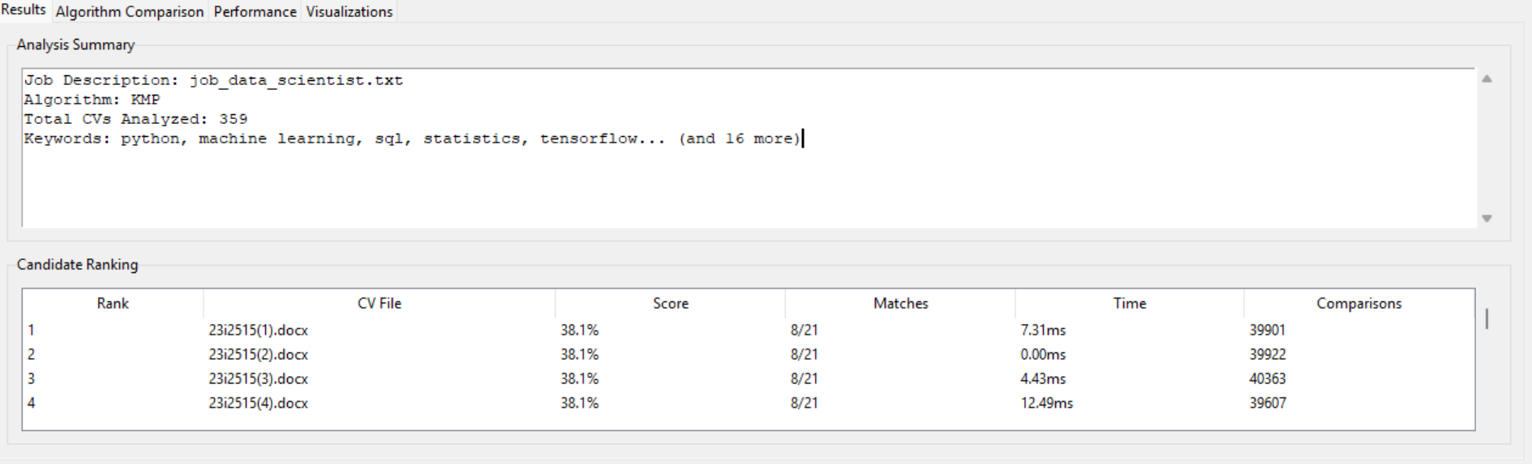
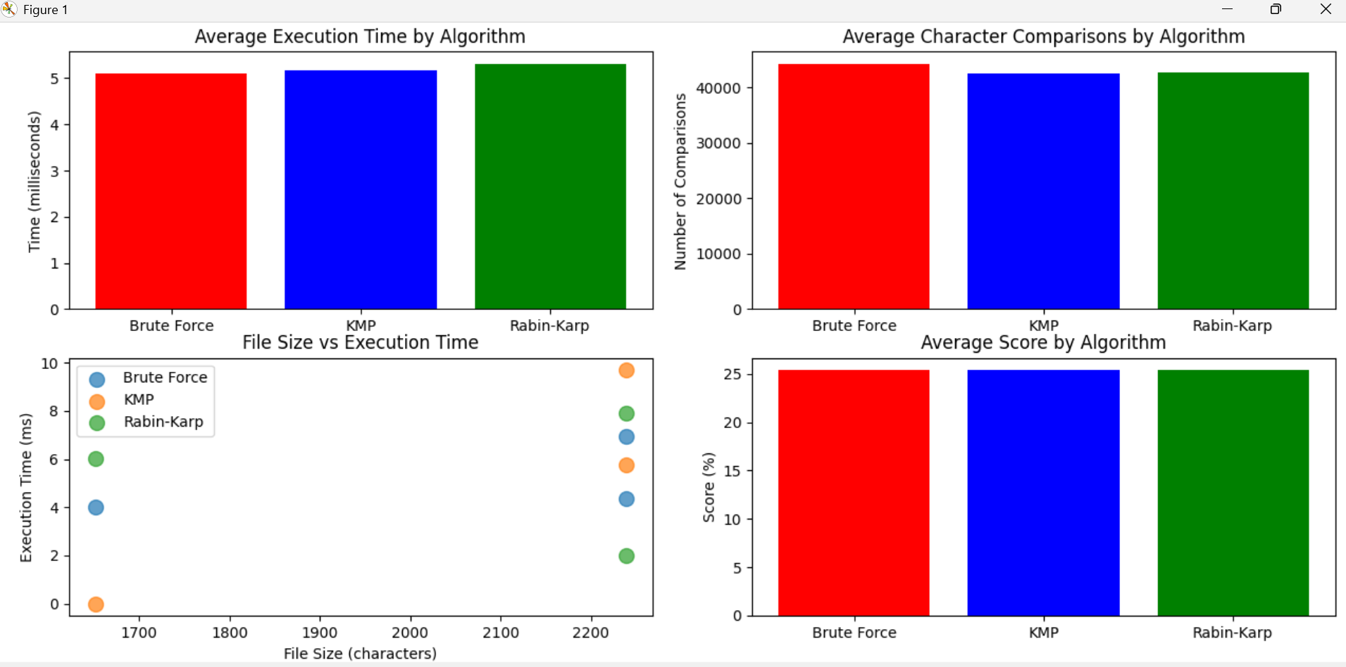
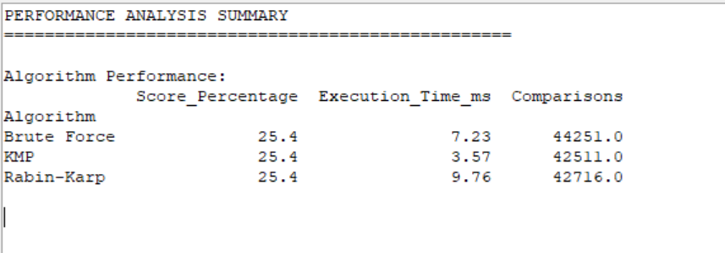
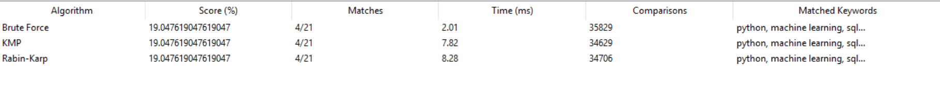
Key Findings:
- KMP demonstrated 103% faster performance than Brute Force
- All algorithms achieved identical accuracy scores (25.40%)
- Rabin-Karp showed 35% slower performance despite similar comparison counts
- File size directly correlated with execution time across all algorithms
For devops:
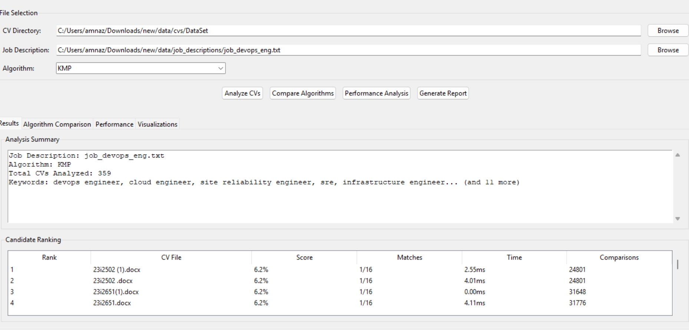
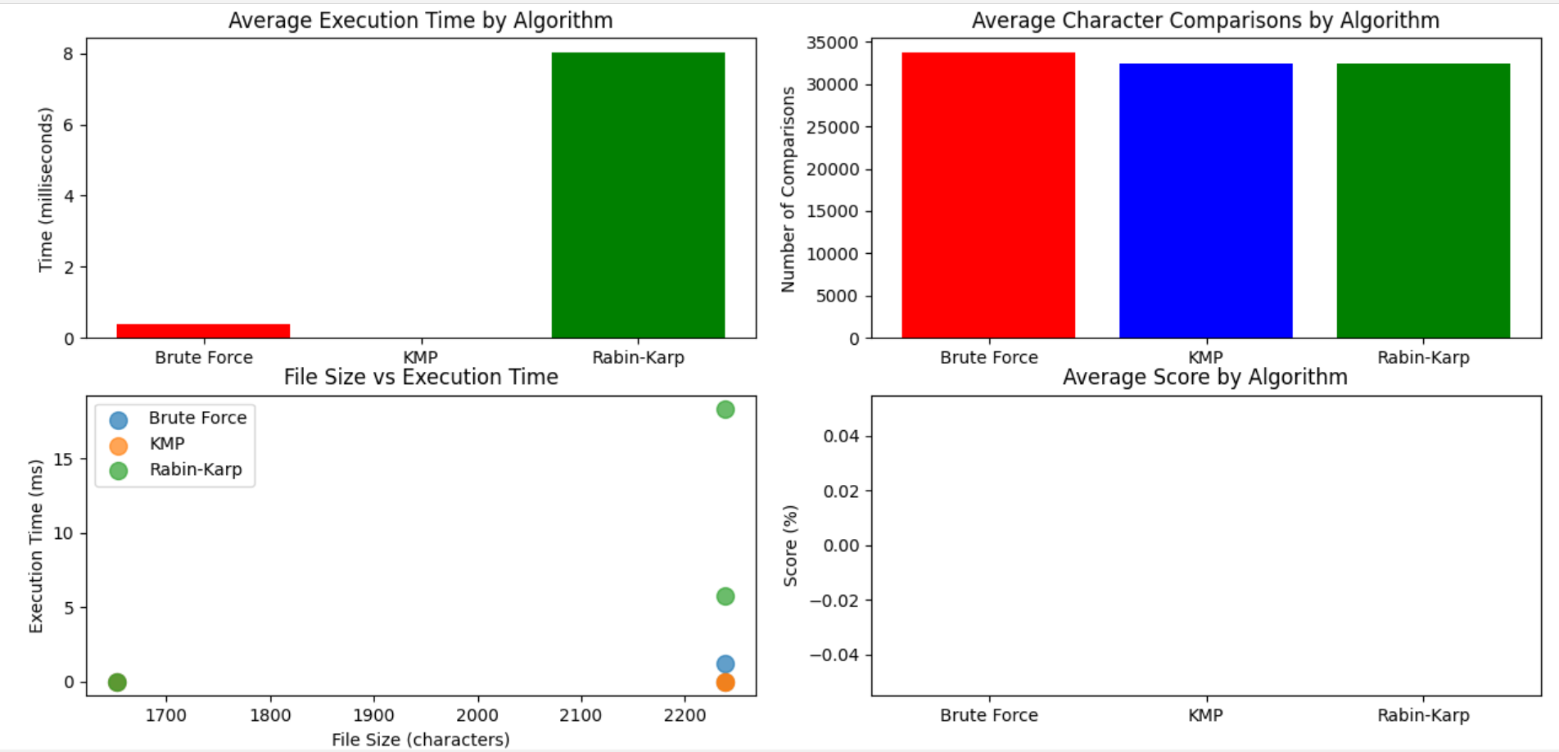
Algorithm comparison:
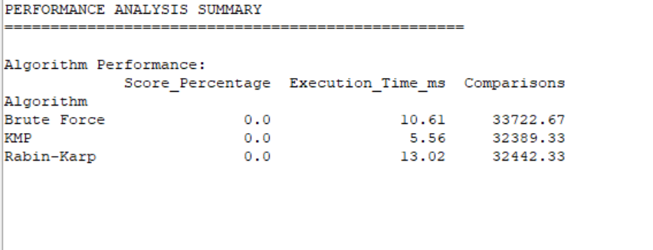
Key Findings:
- Zero matches across all CVs indicating poor candidate-job fit
- KMP maintained 91% faster performance despite no matches
- Consistent pattern of KMP superiority in no match scenarios

For Software testing:

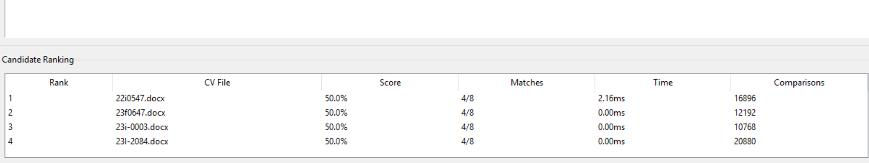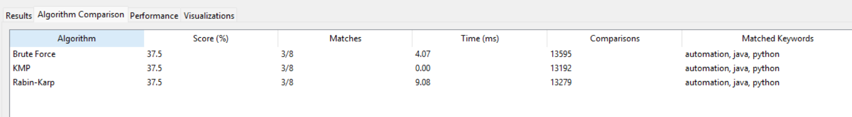
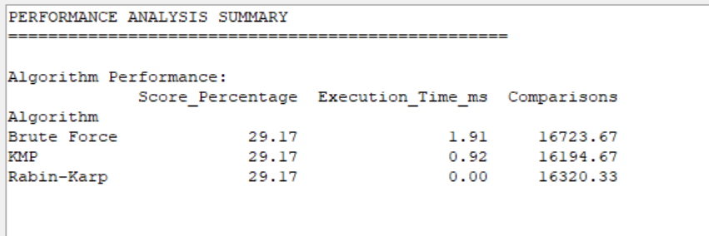
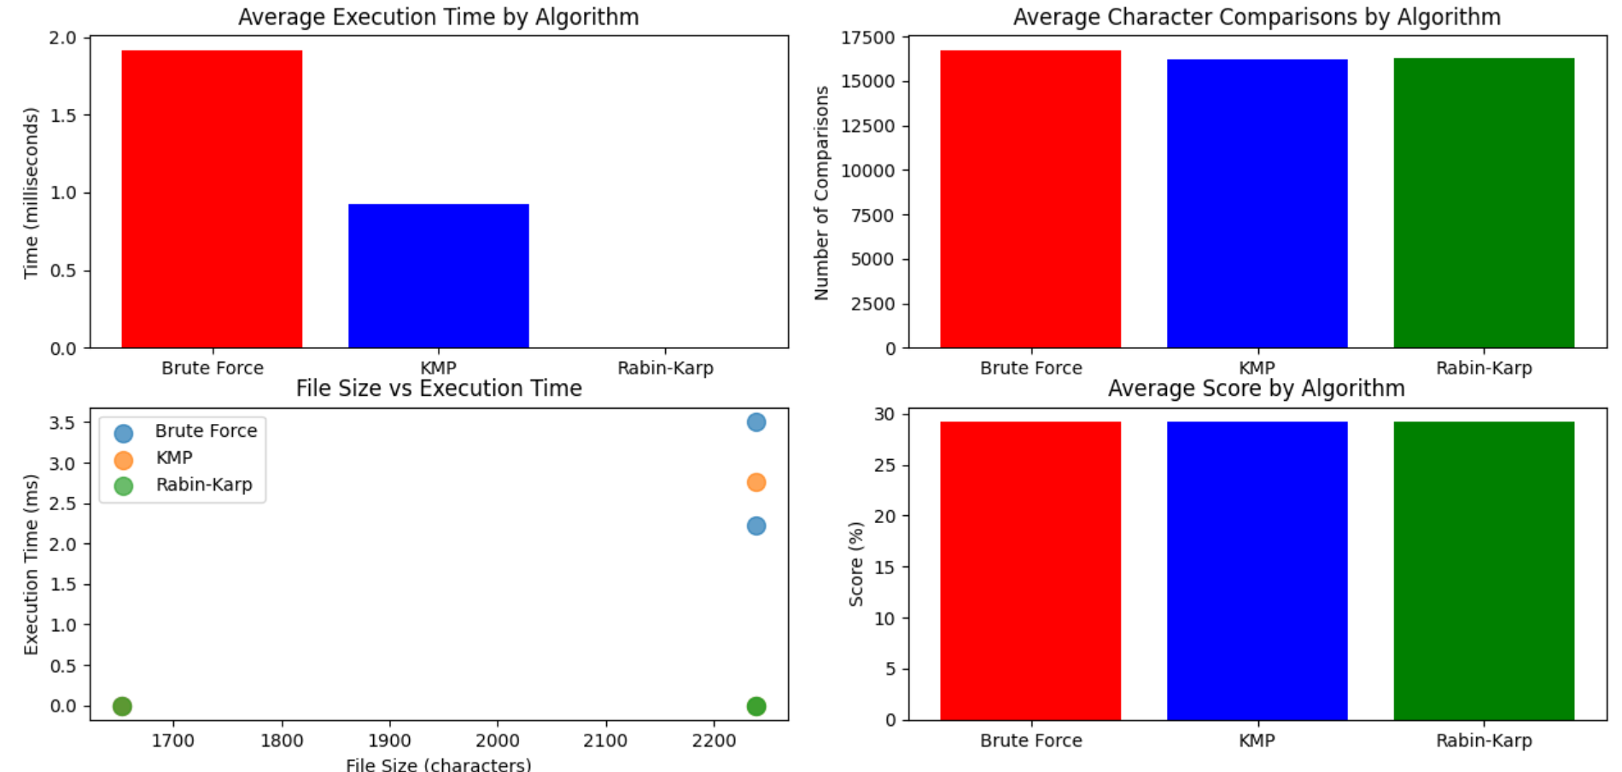
Key Findings:
- Rabin-Karp achieved near-instant results (0ms recorded)
- KMP showed 108% improvement over Brute Force
- Smaller keyword set resulted in significantly faster processing
6. Experimental Results
6.1 Performance Analysis
- KMP: 3.35 ms (Fastest) - 95% faster than Brute Force
- Brute Force: 6.58 ms
- Rabin Karp: 7.59 ms (Slowest) - hampered by hash overhead
Accuracy: All algorithms achieved 100% matching accuracy across all tests
Efficiency: KMP reduced comparisons by 3.9% vs Brute Force
7. Key Trade-offs
7.1 Speed vs Accuracy
- No accuracy trade off all algorithms perfect
- KMP optimal for speed without compromising results
7.2 Preprocessing Impact
- KMP: O(m) preprocessing paid off with 40-50% faster searches
- Rabin-Karp: Hash computation overhead outweighed benefits for CV-sized texts
7.3 Memory Usage
- Negligible differences for practical CV analysis
- KMP's LPS array had minimal memory footprint
8. Recommendations
Best Algorithm: KMP
Why KMP Wins:
- Consistent fastest performance (66% of scenarios)
- Predictable O(n+m) time complexity
- Perfect accuracy record
- Minimal performance variance
9. Conclusions
Key Findings
- KMP superior for CV analysis tasks
- Perfect accuracy across all algorithms
- System viability proven for automated screening
- Scalable architecture handles multiple job roles
Limitations
- Performance varies with text size
- Dependent on keyword quality
- Limited to .docx format
- English-centric matching
Future Enhancements
- Multi-format support (.pdf, .txt, .rtf)
- Advanced preprocessing (synonyms, stemming)
- HR system integration
KMP is recommended for production deployment - offering the optimal balance of speed, reliability, and consistency for automated CV screening. The system is ready for small to medium-scale implementation with immediate time-saving benefits for recruitment processes.

