**Detailed Software Requirements Specification for**

**Student Portal**

.........

MACROBUTTON NoMacro EEY4189-MACROBUTTON NoMacro <***COMPONENT***>-DSRS-MACROBUTTON NoMacro <***VERSION***>

**1** **Introduction 3**

1.1 Purpose 3

1.2 Summary 3

1.3 Company Overview 4

1.4 Project Overview 4

1.5 Scope 4

1.6 Assumptions 5

1.7 Definitions, Acronyms and Terminology 5

1.8 References (Optional) 6

**2** **Project Scope and Impact 6**

2.1 Scope Inclusions 6

2.2 Scope Exclusions 7

2.3 Impact on other systems 7

*2.3.1* *Affected by Other Systems 7*

*2.3.2* *Affects on Other Systems 8*

**3** **Functional Requirements 8**

*3.1.1* *Function 1 8*

*3.1.2* *Data Archival and Retention* 17

*3.1.3* *User Profiles, Roles and Privileges* 17

*3.1.4* *Reporting Requirements* 18

**4** **Non-Functional Requirements** 18

*4.1.1* *Performance and Load Requirements* 18

*4.1.2* *Compatibility Requirements 19*

*4.1.3* *External Interface Requirements 19*

*4.1.4* *Security and Authentication requirements 20*

*4.1.5* *Quality Assurance Requirements 20*

*4.1.6* *Development Requirements 21*

*4.1.7* *Deployment Requirements 21*

*4.1.8* *Special Documentation Requirements 22*

*4.1.9* *Applicable Standards 22*

*4.1.10* *On-line User Documentation and Help System Requirements 22*

*4.1.11* *Usability Requirements 22*

**5** **Future Requirements (Optional) 22**

**6** **Appendix 23**

*6.1.1* *Analysis Model (Use Case)* 23

*6.1.2* *Interview Questions and Answers with Interviewees details and signature* 24

**Document Revisions**

|  |  |  |  |
| --- | --- | --- | --- |
| Date | Version | Description | Author |
| 02/11/2022 | 1.0 | Draft SRS 1.0 | Group-17.4 |
|  |  |  |  |
|  |  |  |  |

**Document Approval**

Quality Software Corporation and have reviewed this document and hereby agree that the contents herein are accurate. Any changes to this document must be communicated in writing and signed off by both parties.

|  |  |
| --- | --- |
| Signature | Signature |
| Date: | Date: |
| Name: | Name: |
| Customer: | Virtusa Corporation |

# Introduction

## Purpose

This document lists requirements for Student Portal. The purpose of this document is to identify the system requirements and obtain sign-off on all requirements before moving into the design phase. The engineering team will use this document as the basis for the system design.

After sign-off, requested changes to requirements will be documented including the effect on the project costs, scope, and timelines, and presented to Mrs. Shamla for approval.

These requirements were gathered during extended discussions with Mrs. Shamla on 15th October 2022 and from documents provided by Mrs. Shamla on 25th November 2022.

*.*

## Summary

Our project is to create a website for the Sri Lankan students those who are wished to continue their higher education after completing A/L studies. Each year students are completing their A/L and waiting to go to a government university to continue their higher education. Few students try to go to some other fields that they have interest or try to go to other higher education institutes except government. But most of the student don’t have proper knowledge to select a correct path for which courses that they want to apply. Only a UGC book is available to seek for the above details. But there are many students those who don’t know to use this book. Also, there is an another type of students those who do not eligible to enter to a government university also they don’t know about other semi-government or private institute due to this, they stay at home without studying. To overcome this problem, we decided to deliver a website to give all these type information in one place. Mainly three types of students can use our website.

1. The students who expect to go to the government universities based on their A/L result
2. The students who expect to go to semi-government universities or higher education institution according to their needs
3. The students who expect to go to private institution due to their result and some other needs

By considering these students we planned to create our website. Rest of the SRS will provide the system requirement and analysis of the system which we are going to create.

## Company Overview

NA

## Project Overview

Our project is to design a website to help the students who wish to continue their higher education after completing their A/L’s in Sri Lanka. Using this website, we enable the student to explore all their study option in one place and find the best and suitable study program that fit their needs, preference, and goals.

There are 3 groups of potential users exist to use the website

1. The students who expect to go to the government universities based on their A/L result
2. The students who expect to go to semi-government universities or higher education institution according to their needs
3. The students who expect to go to private institution due to their result and some other needs

The goals of the website is to give a correct guidance and the correct path for the students those who wish to continue their higher educations. Most of the students are struggling when they choose their paths for the future. So to overcome this problem we are going to propose this system.

By using the website users can get the following

* Can find the suitable university according to their results and stream
* Get to know all the universities in Sri Lanka according to their field of study
* Get to know the faculties of each university
* Can get the information regarding the aptitude test and interviews of the universities for which they need
* Can directly navigate to the particular university website which they search

## Scope

Scope of this document is to have a clear set of requirements and ensures to provide clear picture for development that it will meet the client’s need. In other way this document is to show that what client wants and what the developer provides. This document is regarding the student portal which is the website that we are going to implement. The above website is for the students who wish to continue their higher education after completing the A/L. According to this website we hope to provide a correct guidance for the students to continue their higher studies.

## Assumptions

This section gives the factor that affects the functional requirement stated in this SRS document.

Assumption: To edit or add courses to the system, verify that the user has permission to this feature.

Definitions, Acronyms and Terminology

|  |  |
| --- | --- |
| Definitions | |
| Database | an organized collection of structured information, or data, typically stored electronically in a computer system |
| Website | a collection of web pages and related content that is identified by a common domain name and published on at least one web server |
| Requirements | a singular documented physical or functional need that a particular design, product or process aims to satisfy |

|  |  |
| --- | --- |
| Abbreviations | |
| NA | Not Applicable |
| SRS | Software Requirement Specifications |

## References (Optional)

NA

# Project Scope and Impact

We are going to accomplish a Customer Service via this project Student Portal in terms of improved system performance.

## Scope Inclusions

Functionalities of our system

* User can find relevant courses according to their A/L result and the stream
* User can search for the university or higher education institute according to their preferred courses
* User can be able to find courses using the names of universities or higher education institute
* User can get information’s of government, semi-government, and private institute separately
* System will keep record of universities and the courses or programs in a database
* Admin can update and insert new information’s regarding universities and study programs
* User can directly move to each university or higher education institutes official webpages from our website

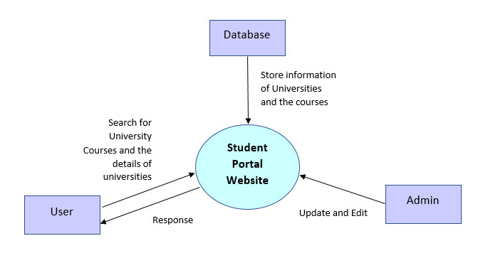

Figure 1.0 : Context Diagram

## Scope Exclusions

As a scope exclusion of this system

User can be able to find out the eligible courses in the government universities based on the user’s (Student) Z-Score which is exactly similar to the UGC book.

## Impact on other systems

The project which we are going to deliver based on the Sri Lankan student is a new system to the society. Our system is to provide a good idea for the students those who do not have a proper idea about universities and the courses they offer or students those who do not have any idea to use UGC book and student do not have an eligibility to enter government universities. As this is a new system this part is not applicable for our system.

### Affected by Other Systems

NA

### Affects on Other Systems

NA

# Functional Requirements

### Function 1

This section contains the functional requirements for the Student Portal. These requirements are organized by the features discussed with our team members and Mrs. Shamla. Our system will be used by students who have completed the A/L. So, these functional requirements are designed according to their needs.

1. Display courses

|  |  |
| --- | --- |
| Function | Courses |
| Trigger | The user clicks on the courses button |
| Description | The system shall display the courses and their details |
| Actor | System User |
| Preconditions | None |
| Postconditions | The system displayed list of courses |
| Process flow | 1. The user visits the website  2. User selects the courses  3. The system displays the course details |
| Exceptional flow | - |

1. Display universities

|  |  |
| --- | --- |
| Function | Universities |
| Trigger | The user clicks on the universities button |
| Description | The system shall display the universities and their details |
| Actor | System User |
| Preconditions | None |
| Postconditions | The system displayed list of universities |
| Process flow | 1. The user visits the website  2. The user selects the universities  3. The system displays the universities and their details |
| Exceptional flow | - |

1. Display college details

|  |  |
| --- | --- |
| Function | Colleges |
| Trigger | The user clicks on the college button |
| Description | The system shall display the colleges and their details |
| Actor | System User |
| Preconditions | None |
| Postconditions | The system displayed list of colleges |
| Process flow | 1. The user visits the website  2. The user selects the colleges  3. The system displays the colleges' details |
| Exceptional flow | - |

1. Display other institutes

|  |  |
| --- | --- |
| Function | Other institutes |
| Trigger | The user clicks on the other institutes' button |
| Description | The system shall display the other institutes' and their details |
| Actor | System User |
| Preconditions | None |
| Postconditions | The system displayed list of other institutes |
| Process flow | 1. The user visits the website  2. The user selects the other institutes  3. The system displays the other institutes' details |
| Exceptional flow | - |

1. Display about us

|  |  |
| --- | --- |
| Function | About |
| Trigger | The user clicks on the about button |
| Description | The system shall display the about page which contains the details of the system and its owner's |
| Actor | System User |
| Preconditions | None |
| Postconditions | The system displayed about us |
| Process flow | 1. The user visits the website  2. The user selects the about button  3. The system displays the details of about page |
| Exceptional flow | - |

1. Display Feedback

|  |  |
| --- | --- |
| Function | Feedback |
| Trigger | The user clicks on the feedback button |
| Description | The system shall display the feedback page which contains the users' feedback |
| Actor | System User/ System admin |
| Preconditions | None |
| Postconditions | The system displayed feedback |
| Process flow | 1. The user visits the website  2. The user selects the feedback  3. The system displays the other feedback of users’ |
| Exceptional flow | - |

1. Write Feedback

|  |  |
| --- | --- |
| Function | New feedback |
| Trigger | The user clicks on the New Feedback button |
| Description | The system shall allow the user to write feedback in the system |
| Actor | System User |
| Preconditions | None |
| Postconditions | The system displayed feedback editor |
| Process flow | 1. The user visits the website  2. The user selects the feedback  3. Then the user selects the new feedback and writes  4. The user submits with the submit button |
| Exceptional flow | If the submission fails, a submission failed message will appear. The user needs to resubmit again. |

1. Search courses

|  |  |
| --- | --- |
| Function | Search |
| Trigger | The user enters a course on the search bar and clicks on the search button |
| Description | The system shall allow the user to search courses in the system |
| Actor | System User |
| Preconditions | None |
| Postconditions | The system displayed the course according to the search |
| Process flow | 1. The user visits the website  2. The user search for a course in the search bar  3. The system displays the course’s details |
| Exceptional flow | - |

1. Edit the course details

|  |  |
| --- | --- |
| Function | Edit |
| Trigger | The user clicks on the edit course button |
| Description | System shall allow the administrator to edit course details |
| Actor | Student Portal administrator |
| Preconditions | Administrator must have entered the admin ID |
| Postconditions | The edited course details are saved and displayed |
| Process flow | 1. The user clicks on the courses  2. The user selects the edit option  3. The system asks to enter admin ID  4. The system allows to edit courses.  5. Save the changes with the save button |
| Exceptional flow | If the connection will be lost the editing will not be saved. Reconnect message will appear. Admin needs to re-edit it. |

1. Add a new course detail

|  |  |
| --- | --- |
| Function | Add new |
| Trigger | The user clicks on the add new button |
| Description | System shall allow the administrator to add the new course’s details |
| Actor | Student Portal administrator |
| Preconditions | Administrator must have entered the admin ID |
| Postconditions | The new course details added to the system which can be view by users |
| Process flow | 1. The user clicks on the courses  2. The user selects the add new option  3. The system asks to enter admin ID  4. The system allows the admin to add courses.  5. Save the changes with the save button |
| Exceptional flow | If the connection will be lost the editing will not be saved. Reconnect message will appear. Admin needs to re-edit it. |

**Data table**

Table contains: Course information

| **Name** | **Type** | **Required/ Optional** |
| --- | --- | --- |
| Course name | Text | R |
| Duration | Text | R |
| University/ Institution/college | Text | R |
| Aptitude test | Text | O |
| Interview | Text | O |
| Access mode | Text | R |
| Course fee | Numbers | R |
| Course level | Text | R |
| Eligible criteria | Text | R |
| Faculty | Text | O |
| Semester details | Numbers | O |
| Description | Text | R |
| District | Text | R |
| Email | Text | O |
| Official link | Text | R |

**Screen layout**

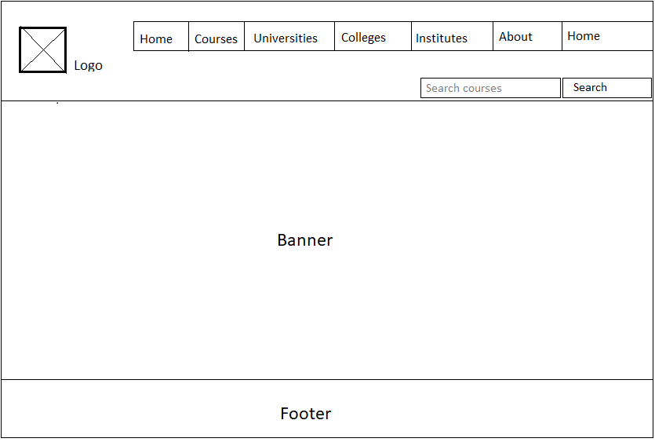

### Data Archival and Retention

NA

### User Profiles, Roles, and Privileges

This Student Portal system will be used by two types of users. They are students who search for courses and administrators who maintain the system.

The users have no restrictions to visit the website or search for things like courses, universities, institutes, colleges, about or feedback. They have unrestricted access to view things. But if an admin user wants to edit or add things they must enter their admin ID.

Privileges

System Administrator: The admin can make changes to data in the system.

User: The end user only has access to view the things

### Reporting Requirements

|  |  |
| --- | --- |
| Report name | Description |
| SRS | The SRS document gives guidelines and specifications for the application. This will help to manage the application according to the customer's requirements. |
| Data collection | The data collection report will provide all the data which is necessary for the database. It includes all the details of courses, universities, colleges, other related things, etc. |

# Non-Functional Requirements

### Performance and Load Requirements

|  |  |
| --- | --- |
| Number of concurrent users |  |
| Transaction Size (files sizes etc.) |  |
| Maximum Average Transaction Time Acceptable | 15 seconds |

### Compatibility Requirements

|  |  |
| --- | --- |
| HTML Versions to be supported | 5.0 |
| Browser Versions to be supported | Latest stable version of trending browser |
| Communication Protocol | HTTP, TCP/IP |

### External Interface Requirements

#### User Interfaces

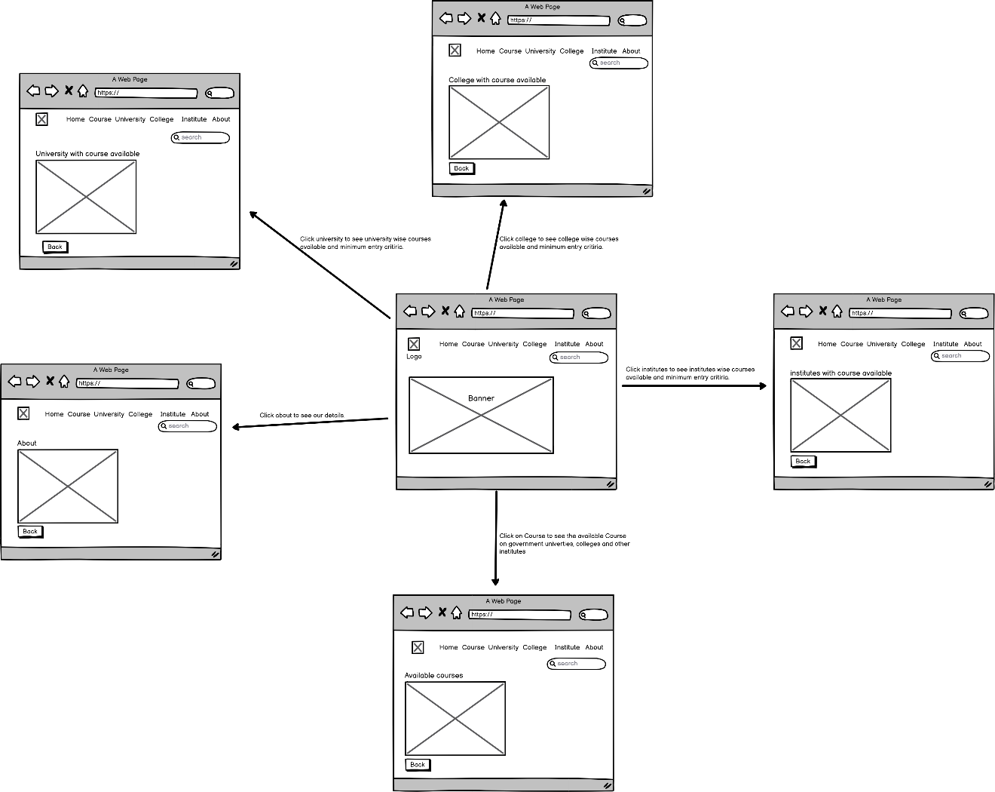

#### Hardware Interfaces

Since it’s a web application, it must run over the internet. Therefore, it must be connected to hardware interfaces like Modem, LAN, WAN and Ethernet Cross-Cable.

#### Software Interfaces

This system can be used by any operating system such as android, iOS, mac OS windows 7, windows 8 and windows 10 etc. so on. The system will not utilize any third-party websites and app as an initial stage, but it might be linked to third party in future update. The system will be developed by using PHP as back-end and VUE JS for front-end.

#### Communications Interfaces

Our system will be compatible with new version of the modern browser, and it utilize HTTP protocol to communicate over the internet. The system provides feedback form to user to interact and make the system reliability and consistency.

### Security and Authentication requirements

#### Data Storage Security

Make password for whole database.

#### Data Communication Security

NA

### Quality Assurance Requirements

#### QA Test Scope

* Testing the layouts of the system whether it compatible with both desktop and mobile phone.
* Testing every condition and loop check whether it will have programming error and logical error.
* Testing the data which will be inserted to database.
* Testing the whole functionality which we are expected as output.

#### QA Environment

NA

#### QA Data

NA

### Development Requirements

#### Development Environment

Visual Studio Code

#### Development Data

NA

#### Coding Standards

NA

#### Implementation Packaging Requirements

NA

### Deployment Requirements

#### Installation Packaging Requirements

It will not be a desktop/laptop application or mobile application; therefore, user need to type the URL of our website in any latest version web browser to utilize.

#### Deployment Requirements

NA

#### Documentation requirements

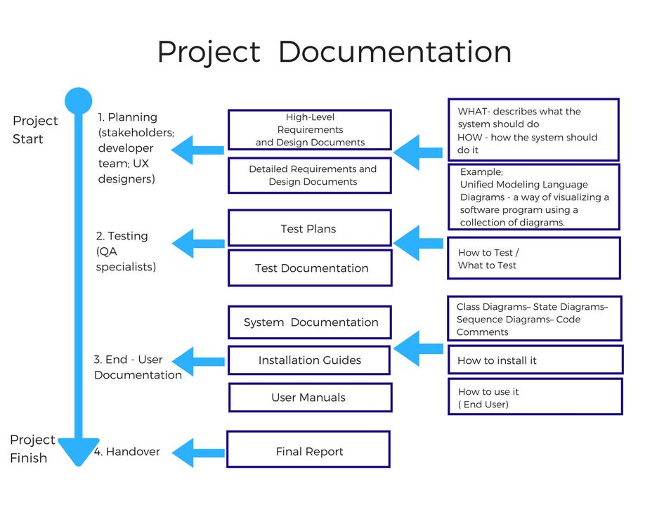

### Special Documentation Requirements

* Thieving logo and system name is a punishable offence.
* Remake the system with our logo and name is prohibited.

### Applicable Standards

Communication standards: HTTP, TCP/IP

Platform compliance standards: Windows, Unix, Android, iOS

### On-line User Documentation and Help System Requirements

NA

### Usability Requirements

NA

# Future Requirements (Optional)

In future release the system will take Z-Score as input from User and display the Eligible course that students can apply.

# Appendix

### student portalAnalysis Model (Use Case)

### Interview Questions and Answers with Interviewees details and signature

