**Task 1 – Child Well-Being Monitor**

1. INTRODUCTION

**‘LEAVE NO ONE BEHIND’** is the call expressed in Sustainable Development Goals (SDGs) to eradicate poverty and improve human development by 2030. Poverty affects children severely more than any other age group. Therefore, it is essential to improve children’s lives to make this vision a reality.

 is a unique longitudinal inquiry made into the lives of children in the first two decades of the 2lst century. The UK government’s Department for International Development initiated the study to improve the prospects of children. The information collected by this study includes detailed information on a wide range of topics – including health, nutrition, education, time use and psychosocial wellbeing from 12,000 boys and girls living in diverse areas across the four study countries. It was conducted in Ethiopia, India, Peru, and Vietnam. These countries were selected because they reflect a range of issues facing the developing world. The sample is so large and diverse, it is very likely to apply the findings to other countries as well.

In **India**, Young Lives was originally established in what was then the state of Andhra Pradesh. Now divided into two states, Andhra Pradesh and Telangana. Many households and children remain excluded from basic services and quality of service remains a concern. For education, there has also been a rapid increase in parents and children opting to use private over government schools. Of the Young Lives countries, India is where discrimination against girls and women is the most prominent and most entrenched. Scheduled Tribes and Scheduled Castes also face consistent discrimination and children from these groups are very disadvantaged and have less access to services than other children.

**Ethiopia** is highly vulnerable to drought and is one of the poorest countries. Nevertheless, in recent decades the country has had one of the fastest-growing economies in Africa. However, like most other countries in this period, income inequality has increased, and basic health problems persist, including high rates of child stunting. The government is faced with considerable challenges of resourcing as Ethiopia has a high fertility rate and half its population is aged less than 18 years (UNICEF, 2017) resulting with continued growth in the size of the youth population.

After more than 15 years of research, the evidence now spans the first two decades of life, from ages 1 to 22 years. Our goal is to bring these data into actionable insights by developing a reporting tool called **Child Well-Being Monitor** to analyze child poverty in India and Ethiopia using Power BI Report Builder and Power BI. Thereby, the project aims to improve understanding of the causes and consequences of childhood poverty and to inform people about the development of future policies and to target child welfare interventions more effectively. It is our hope that these insights can support efforts by countries to meet the challenges set out in the Sustainable Development Goals (SDGs; UNGA, 2015).

1. DATA PREPARATION

The steps are given below:

1. Connected Microsoft Azure to SQL Server.

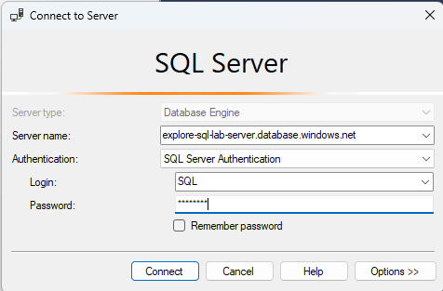

1. After downloading the dataset, it was uploaded into Young Lives database.
2. Created several tables and Views to make relationships and for easy access. The views were made according to the information present in (Briones, 2018).

# SQL Code snippets are as follows:

* Labelled the ClusterIDs of Ethiopia by referencing ‘ETH-SurveyDesign-Factsheet’.And the ClusterIDs of India by referencing ‘INDIA-UAP-SurveyDesign-Factsheet’.

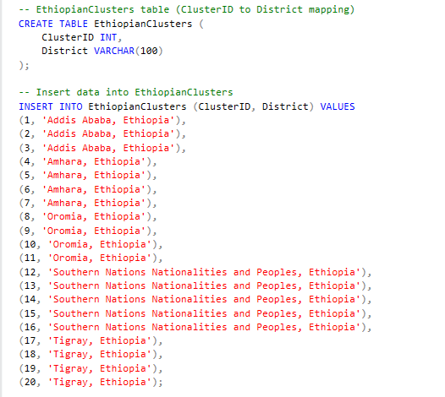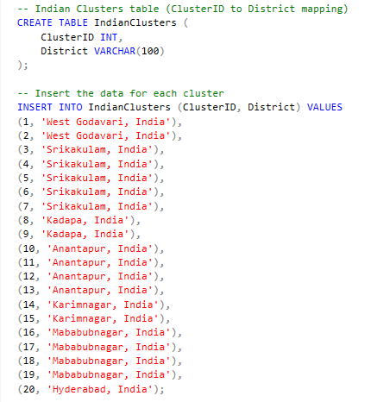

* The clusters were joined with the respective tables and child identification table was made.

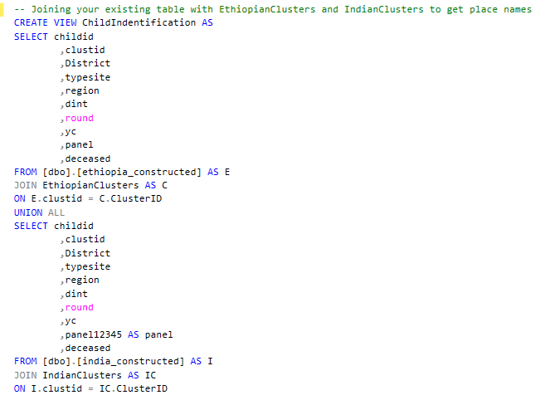

Table 1. Identification Table

* The rest of the tables created, included all columns by joined data from both the countries.

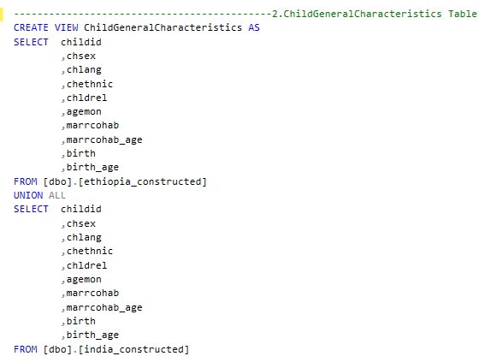

Table 2. Child General Characteristics Table

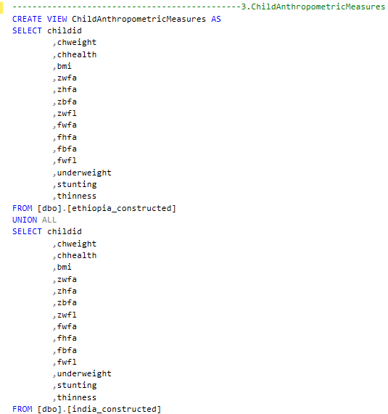

Table 3. Child Anthropometric Measures Table

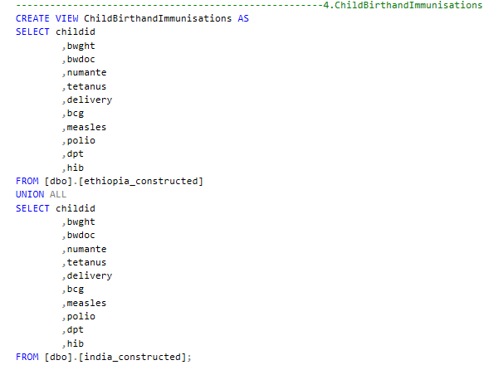

Table 4. Childbirth and Immunizations Table

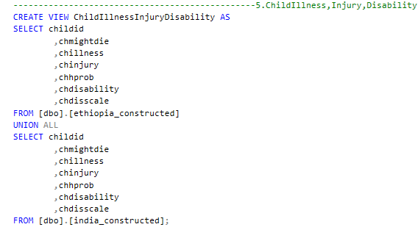

Table 5. Child Illness, Injury and disability Table

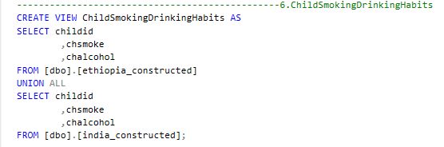

Table 6. Child Smoking and Drinking Habits

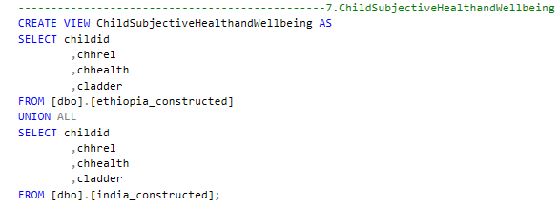

Table 7. Child Subjective Health and Well-being Table

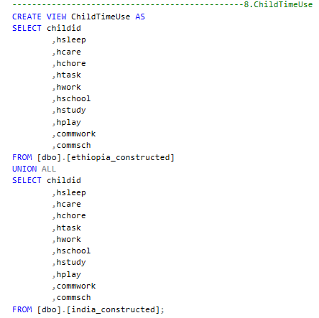

Table 8. Child Time Use Table

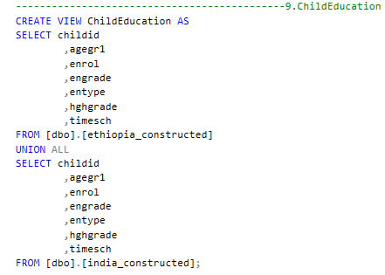

Table 9. Child Education Table

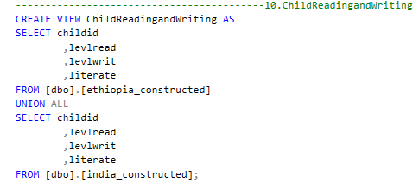

Table 10. Child Reading and Writing Table

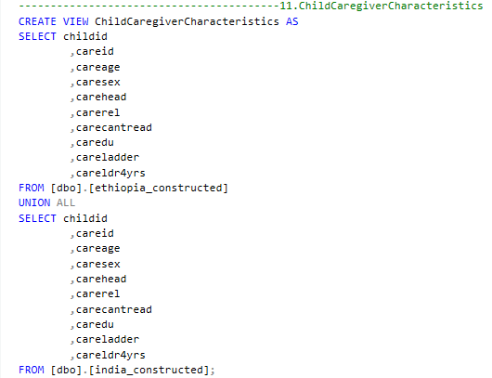

Table 11. Child Caregiver’s Characteristics Table

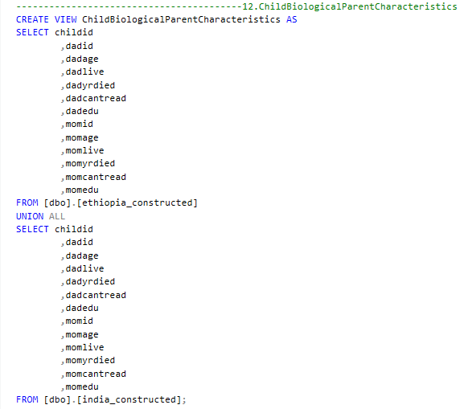

Table 12. Child Biological Parent Characteristics Table

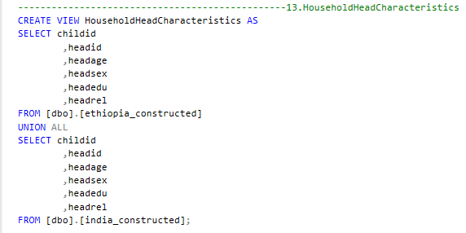

Table 13. Household Head Characteristics Table

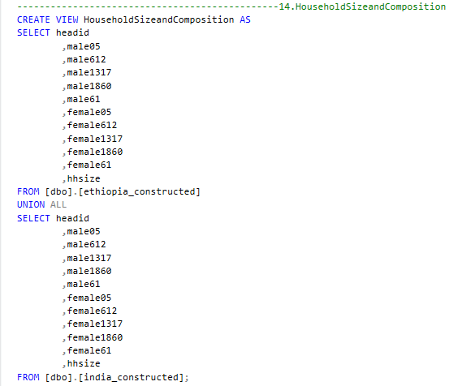

Table 14. Household Size and Composition Table

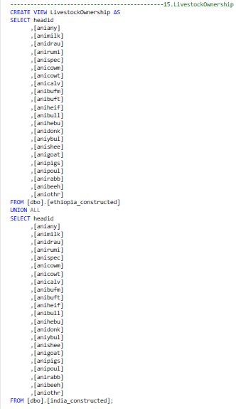

Table 15. Livestock Ownership Table

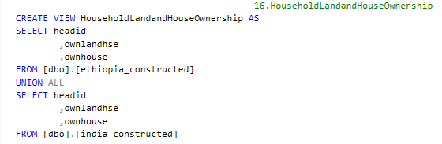

Table 16. Household Land and House Ownership Table

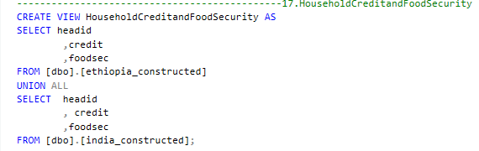

Table 17. Household Credit and Food Security Table

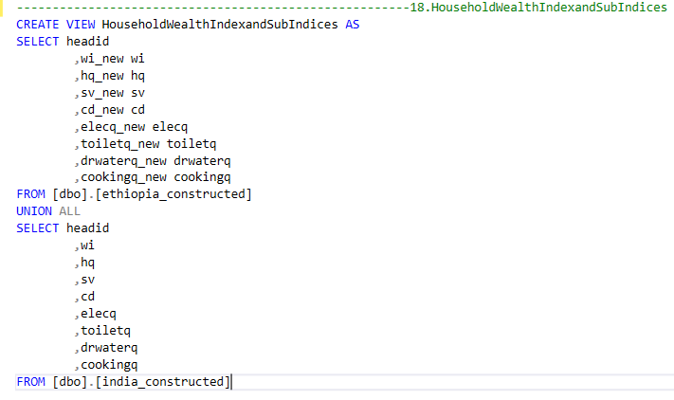

Table 18. Household Wealth Index and Sub indexes

1. Connected Azure SQL database to Power BI and imported the dataset, where it was cleaned. The process involved removing unwanted columns, removing NULLs and replacing values. For example, Food situation variable was labelled as,

**Value = 1.0**  
**Label:** *Well-fed and satisfied*  
*(We always eat enough of what we want)*

**Value = 2.0**  
**Label:** *Well-fed, but limited variety*  
*(We eat enough but not always what we would like)*

**Value = 3.0**  
**Label:** *Occasionally underfed*  
*(We sometimes do not eat enough)*

**Value = 4.0**  
**Label:** *Frequently underfed*  
*(We frequently do not eat enough)*

The variable labels were taken from data dictionaries document present in the dataset.

1. The next step involved creating relationships between tables:

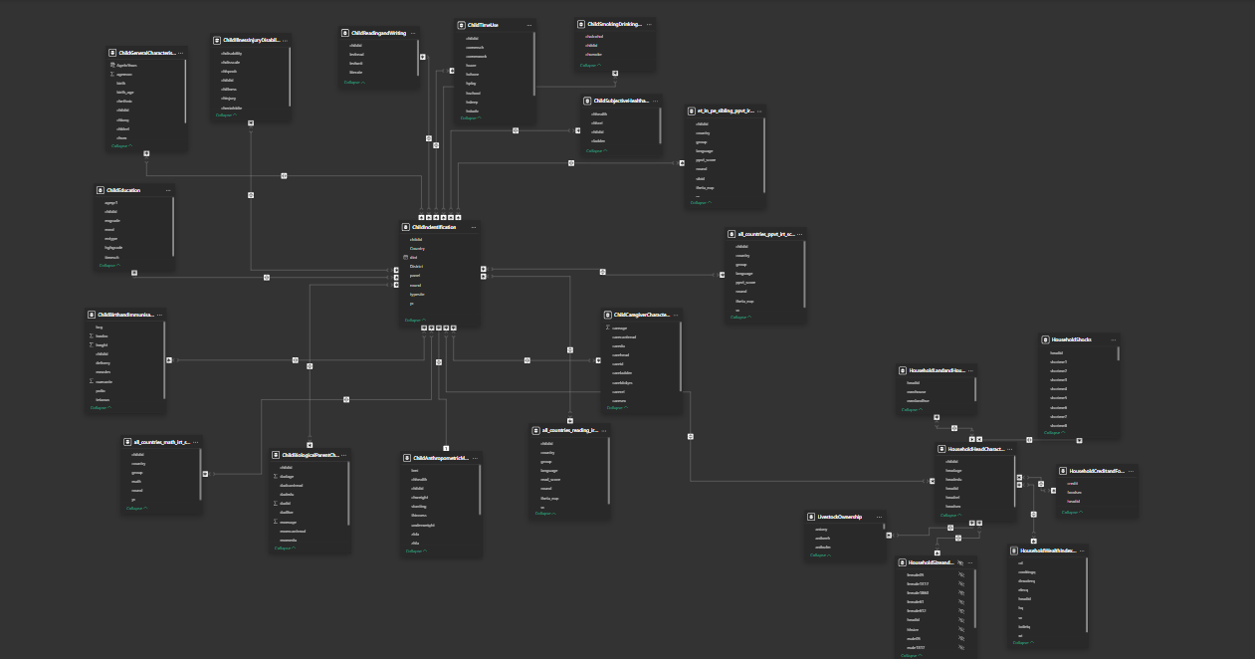

1. Created calculated Tables to convert age in months to age in years.

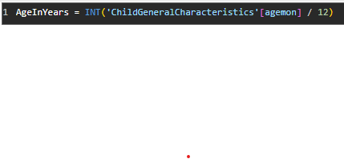

Created calculated measures for visualization such as:



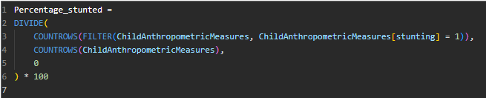

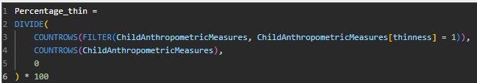

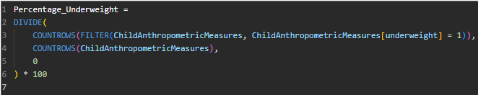

1. The Child well-being monitor dashboard was created in Power BI.
2. This was exported to Microsoft Fabric to create paginated reports.
3. DATA INSIGHTS
4. Overview Page

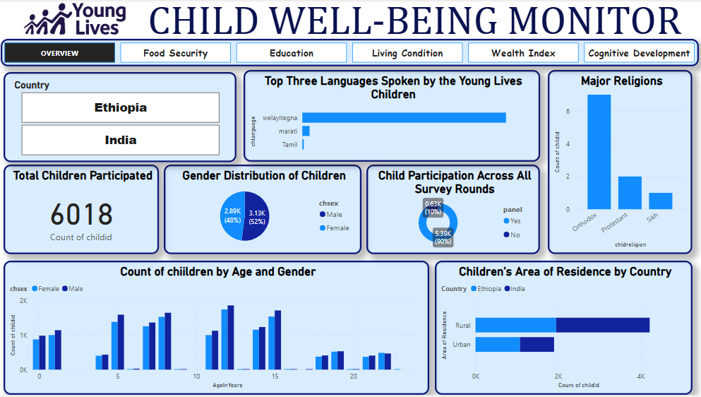

The **CHILD WELL-BEING MONITOR** analyzes the data of Ethiopia and India. The total children participated in the study are *6018* including males and females of similar composition. In addition, Gender composition for different age ranges too was equal. Most children were present throughout the study from 2002-2017. The number of children from rural areas doubled the number of children from urban areas. This suggests that the study was mainly focused on children from rural areas. Moreover, many of them spoke European language called as Welayitegna, marati and Tamil.

1. Second Page: Food Security

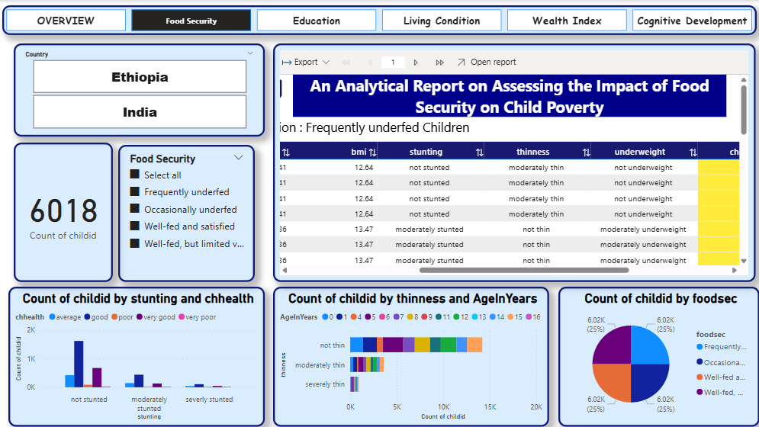

This page summarizes the food impact of children on child Poverty. The composition of frequently underfed, occasionally underfed, Well-fed and satisfied and Well-fed bit limited variety were of the same composition. The paginated report gives data for food security for children by their stunting, thinness, and underweight. According to the column chart most of the not stunted children have good health. Thinness is the variable for Low BMI for age. We can see that most of the children aren’t thin and their age ranges thereby. User can download the report by each food securities and the gender of children’s.

1. Third Page: Education

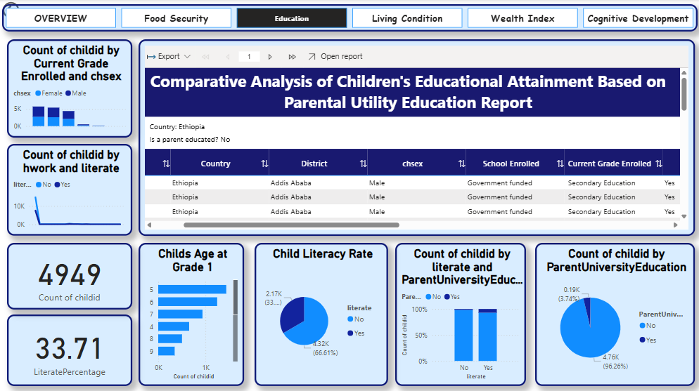

This report shows that most of the parents were not university educated. Only university educated children were literate. The literacy rate was only 33.71%. Most children’s school education did not start at the right age.

1. Fourth Page: Living Condition

The living conditions of the children were analyzed in this.

1. Fifth Page: Wealth Index

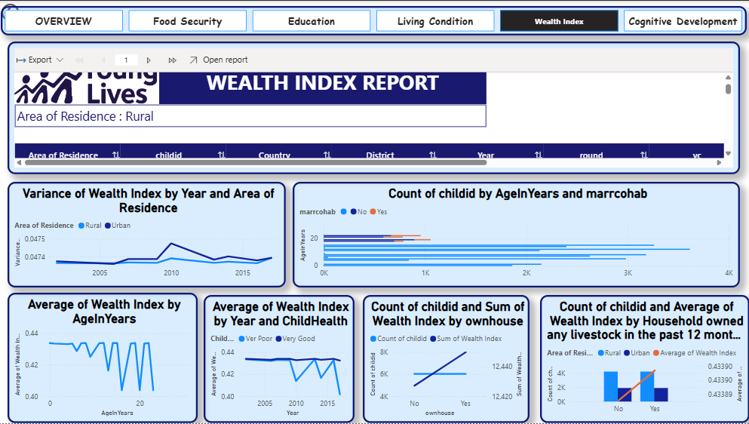

The wealth Index(WI) of Urban areas was higher than that of rural. The increment of wealth index was same for both rural and urban areas. 25th percentile was selected to

label the wealth index as poor and not poor. We can see that very poor health children have unstable WI while children’s in good health have stable WI. And can see early childhood have good WI while in age 20 range it seems to decline. The decline seems to be because of marriages as this this age. Moreover, good WI owns a house.

1. Sixth Page: Cognitive Development

This analyzes the impact of health on cognitive development of children. DAX measures were used to calculate PPVT score average, above average etc. Most of the children with good health achieved good math scores while the affected children had average math marks. Most of the students’ PPVT Score and read score were above average.

CONCLUSION

The CHILD WELL-BEING MONITOR report presents a comprehensive analysis of children's health, cognitive development, and socio-economic conditions in Ethiopia and India, based on data from 6018 participants over 15 years. The study highlights the disproportionate focus on rural areas and the influence of food security, parental education, and living conditions on child well-being. Notably, only 33.71% of children were literate, with literacy strongly linked to parents' university education. The report also shows that children's cognitive abilities, such as math and reading scores, are positively impacted by good health, while those in poorer health show average performance. Wealth index stability further correlates with health and living conditions. Furthermore, the paginated reports in each page are optimized for printing data of children.

1. REFERENCES
2. Briones, K. (2018). *A Guide to Young Lives Rounds 1 to 5 Constructed Files*. [online] Available at: https://www.younglives.org.uk/sites/default/files/migrated/YL%20Technical%20Note%2048%20A%20Guide%20to%20R1%20to%205%20Constructed%20Files.pdf [Accessed 15 Oct. 2024].