ForenVison: Style Guidelines for Final Year Project Reports3D Crime Scene Reconstruction

Final Year Project Proposal

Session 2022-2026

A 4th Year Student

A project submitted in partial fulfillment of the
COMSATS University Degree
of
BSc. (Hons.)BS in Computer Science / Software Engineering (CUI)



Department of Computer Science
COMSATS University Islamabad, Lahore Campus
12 April 2025

Project Registration
Project ID (for office use)
Type of project |  |  | [ X ] Traditional [ ] Industrial [ ] Continuing
Nature of project |  |  | [ X ] Development [ ] Research & Development
Sustainable Development Goals(SDGs) |  |  | [ ] Good Health and Well-Being [ ] Quality Education  [ X ] Industry, Innovation, and Infrastructure [ ] Gender Equality  [ ] Decent Work and Economic Growth [ ] Climate Action
Area of specialization |  |  | [ X ] Artificial Intelligence (AI) [ ] Data Science and Analytics  [ ] Internet of Things (IoT) [ ] Blockchain  [ X ] Mobile App Development [ ] Web Development [ ] Cybersecurity  [X ] Game Development [ ] Natural Language Processing (NLP)
Project Group Members
Sr.# | Reg. # | Student Name |  | CGPA | Email ID | Phone # | Signature
(i) | FA22-BSE-141 | Amna Bukhari |  | 3.13 | fa22-bse-141@cuilahore.edu.pk | 03344358314 | 
(ii) | FA22-BSE-013 | Maham Naveed |  | 3.40 | fa22-bse-013@cuilahore.edu.pk | 03072477722 | 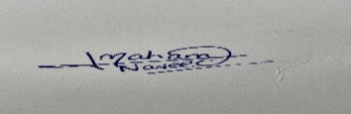
Declaration: FYP group members have cleared all prerequisite courses For FYP-I as per their degree requirements.
For BS(Computer Science)
(CSC241 Object Oriented Programming, CSC291 Software Engineering Concepts, CSC371 Database Systems-I, HUM102 Report Writing Skills)
For BS(Software Engineering)
(CSC241 Object Oriented Programming, CSE291 Introduction to Software Engineering , CSC371 Database Systems-I , HUM102 Report Writing Skills)

Plagiarism Free Certificate
This is to certify that, I am __________________Amna Bukhari______ D/o _______Zulqurnain Bukhari________________, group leader of FYP under registration no CUI /_____FA22-BSE-141____________/LHR at the Computer Science Department, COMSATS Institute of Information Technology, Lahore. I declare that my FYP proposal is checked by my supervisor and the similarity index is ________% that is less than 20%, an acceptable limit by HEC. The report is attached herewith as Appendix A.
Date: ______14/03/2025______ Name of Group Leader: _______Amna Bukhari_________________
Name of Supervisor: _____________________ Co-Supervisor (if any):____________________
Designation: _____________________ Designation: _____________________
Signature: _____________________ Signature: _____________________

Project Abstract
The latest research on homicide rates stands at approximately 5.61 per 1000,000 inhabitants by the United Nations Office on Drugs and Crime (UNODC) in 2022. [1] As per increasing rates of crimes, the failure rate of investigating these crimes also increased both in developed and developing countries because of lack of resources, modern tools, human errors, untrained professionals hired in forensic agencies, and lack of collaboration between teams so these failures lead to unsettled, pending cases and loss of justice. This defeat lost people's trust and they refused to unite with the police. Mainly in Pakistan, in forensic agencies, investigators use manual processes to compute the results which is very time-consuming and cannot accurately judge the spatial relationships between the evidence. So, by analyzing these difficulties, we provide ForenVision, an AI-driven 3D crime scene reconstruction. It will use advanced technology Artificial Intelligence and Computer Vision to reconstruct crime scenes and help investigators analyze them virtually in addition it will help to detect the objects at crime scenes using various object detection techniques like deep learning. Furthermore, ForenVision can analyses blood splatter analysis using CNN-based models. The system will also allow investigators to analyze the crime scene from different angles. The system’s user-friendly interface reduces investigation time and increases case-solving efficiency by enabling law enforcement organizations to navigate and interact with 3D crime scenes in real time. This initiative intends to transform crime scene analysis in Pakistan by bridging the gap between forensic science and AI, giving investigators the resources they need to solve crimes more precisely and successfully. We can present the crime scenes in court in front of Judges and juries making it easier to make decisions accurately rather than relying on evidence generated by forensic experts and surely give strength to cases. The suggested system might greatly improve forensic investigations, which would ultimately help the nation’s criminal justice system become more dependable and effective.

Introduction
In Pakistan, the ratio of crime scenes has increased as major city Lahore reported 379 murders in 2019 investigation leads to an endpoint because of several reasons such as fabricated evidence due to pressure, misinterpretation of crime scenes, lack of law enforcement training, and no use of AI and advanced technology.
Crime scene investigation is an important part of modern forensic science because it allows law enforcement authorities to precisely construct events and evaluate evidence. Traditional techniques of crime scene documentation, such as photographs, and sketches can lack the depth of precision required for thorough investigation. As technology advances, digital forensic techniques are becoming a valuable asset in crime scene reconstruction. The project, termed “ForenVision,” seeks to use artificial intelligence(AI) and 3D modeling techniques to develop a sophisticated forensic tool capable of reconstructing crime scenes in three dimensions, detecting objects with the scene, and analyzing relevant forensic evidence.
ForenVision’s major goal is to create an AI-powered system that improves crime scene investigation by offering a digital interactive, and highly details representation of crime scenes. This will enable forensic experts to investigate the crime scene virtually, resulting in a more comprehensive and accurate examination of the evidence, The project's main features are 3D crime scene reconstruction, object detection, and forensic analysis.
To successfully achieve these goals in ForenVision we’ll present an AI trained Model that will capture evidence from crime scene images, videos, and CCTV footage using cameras, drones, and LiDAR (if applicable), then we’ll convert these 2D images, videos and all data in 3D scenes using computer vision techniques and 3D modeling algorithms will be applied. There is another exciting feature of Object detection that will detect all objects like weapons, knives, etc. used at crime scenes using Machine Learning and will extract blood patterns to analyze the angles of suspects and victims. As the complexity of this feature, its feasibility will be assessed throughout the project development.
ForenVision can be enhanced in the future in many different ideas you can use ForenVision to create a 3D model for accident reconstruction, to identify persons in natural disasters forensic, you can predict 3D model of an area that is damaged by earthquake to find where trapped bodies may be, also Virtual Reality (VR) can be used to predict crime scenes, Augmented reality(AR) can be implemented to enhance forensic data during investigations.
This will be a 3D mobile app that will use technologies Artificial Intelligence AI, computer vision, machine learning, and deep learning to predict crime scene possibilities, 2D to 3D conversion, suspect movements, object detection, bullet trajectories, analyze forensic evidence.

Success Criterion
To assure the effectiveness of ForenVision, the project’s success will be evaluated using the following criteria:
- Accuracy of 3D Reconstruction: The system must successfully generate a detailed and precise representation of a crime scene.
- Effectiveness of Object Detection: The accuracy and dependability of AI-driven object identification at the crime scene.
- User Interface and Usability: Forensic specialist access to and ease of usage with the system-related

Related work

Sketchfab
Sketchfab is a famous platform for sharing and visualizing 3D models online. Users can engage in 3D reconstruction of crime scenes in a web-based environment by uploading them. Sketchfab helps work with forensic teams or present crime scenes in court because it supports VR and AR. However, it lacks advanced forensic analysis features such as object and bloodstain detection. ForenVision on the other hand, offers a more complete solution for forensic investigations since it incorporates AI-driven object detection and angle analysis in addition to 3D display. [2]

FARO
FARO offers complete and thorough crime scene documentation as well as accident reconstruction. It uses laser scanners for highly precise 3D representations. FARO is an excellent source of gathering spatial data, but its requirement for specific equipment may not be available in Pakistan, where there are very limited resources available. ForenVision intends to convert conventional 2D images into 3D models using Artificial Intelligence and affordable photogrammetry, to make it more scalable for law enforcement organizations. [3]

AgiSoft MetaShape
AgiSoft MetaShape is used to produce 3D photos from 2D photos. It is commonly used in different disciplines which include architecture, archaeology, and forensics, as it has high precision and texture mapping capabilities. AgiSoft MetaShape is an excellent tool for building 3D models, but it does not offer anything else, such as forensic analysis for object detection. ForenVision on the other hand, not only offers to create 3D models but also allows the investigators to use sophisticated forensic tools. [4]

RealityCapture
RealityCapture uses 3D scans and photographs to create 3D models. It is known for processing large datasets in very little time and producing high-quality reconstructions, in addition to using virtual reality for forensic investigations. But, it also fails to offer forensic analysis tools for crime scenes just like AgiSoft MetaShape. ForenVision offers a better solution by integrating forensic analysis tools with 3D scene reconstructions, which will help investigators analyze the crime scene with greater precision. [5]

Landscape Study of 3D Crime Scene Scanning Devices (OJP)
This article is a thorough study of 3D crime scene scanning devices. The report provides law enforcement organizations with useful insights by highlighting the strengths and weaknesses of certain gadgets. The study assesses current methods, but it makes no recommendations for a single, comprehensive approach to crime scene analysis. By integrating 3D reconstruction, AI-powered analysis, and intuitive navigation into a single, cohesive system made especially for forensic investigations, ForenVision fills this gap. [6]

Project Rationale
Investigating crime scenes is essential to investigating crimes, but conventional techniques like photography and sketching are laborious, prone to mistakes, and do not maintain the spatial links between pieces of evidence. These issues impede investigations and jeopardize justice in Pakistan, where resources are few. By creating a 3D crime scene reconstruction system driven by AI, ForenVision hopes to address these problems. The need for a scalable and reasonably priced solution with good forensic efficiency is the reason that stimulated this initiative. Through this, we seek to progress forensic science and understand how cutting-edge technologies may be adapted to contexts with limited resources.

Aims and Objectives
ForenVision wants to improve forensic investigations in Pakistan by developing an AI-powered 3D crime scene reconstruction system. Important goals consist of:
- Create an artificial intelligence model for 3D reconstruction from photos of crime scenes.
- To detect objects (such as weapons or footprints), use computer vision.
- Provide a user-friendly interface for virtual crime scene navigation.
- Provide an analysis from many perspectives.

Scope of the Project
The scope of ForenVision includes:
- 3D Reconstruction of crime scenes.
- Allow investigators to virtually navigate the scenes.
- Detect and highlight key forensic elements such as footprints and weapons.
- A functional system with a user-friendly interface.
- Focus on cost-effective solutions using open-source tools.

Proposed Methodology and Architecture
For our forensic crime scene reconstruction project, we will use Scrum methodology to ensure an adaptive and efficient development process. Scrum’s iterative approach will help us break down complex tasks, such as AI-driven image processing, 3D visualization, and forensic data analysis into manageable increments. Regular team collaboration, continuous feedback, and flexibility will allow us to refine our AI models, improve system accuracy, and integrate new findings.

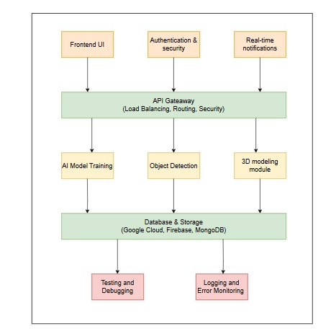
Figure 1: architecture diagram

Individual Tasks
Table I : Task Distribution Among Team Members
Team Member | Activity | Timeline
Maham & Amna | Conduct a literature review on forensic AI, 3D reconstruction, and object detection. | Month 1-2
Maham | Gather and pre-process datasets for training AI model. | Month 2-3
Amna | Design system architecture and define software requirements. | Month 2-3
Maham | Implementation of 3D crime scene reconstruction using Meshroom, Open3D, and Blender API. | Month 4-6
Amna | Implement object detection using YOLO, TensorFlow, and OpenCV. | Month 4-6
Maham & Amna | Integrate object detection into 3D crime scene reconstruction. | Month 6-7
Maham | Develop forensic Analysis Features. | Month 7-8
Amna | Implement real-time notifications using Firebase/Twillio | Month 7-8
Maham & Amna | Develop frontend and UI using Flutter. | Month 8-9
Maham | Set up cloud storage and database. | Month 9-10
Amna | Implement authentication and security. | Month 9-10
Maham & Amna | Perform system testing, debugging, and performance improvements. | Month 10-11
Maham & Amna | Prepare project documentation, reports, and final presentation. | Month 11-12

Gantt Chart

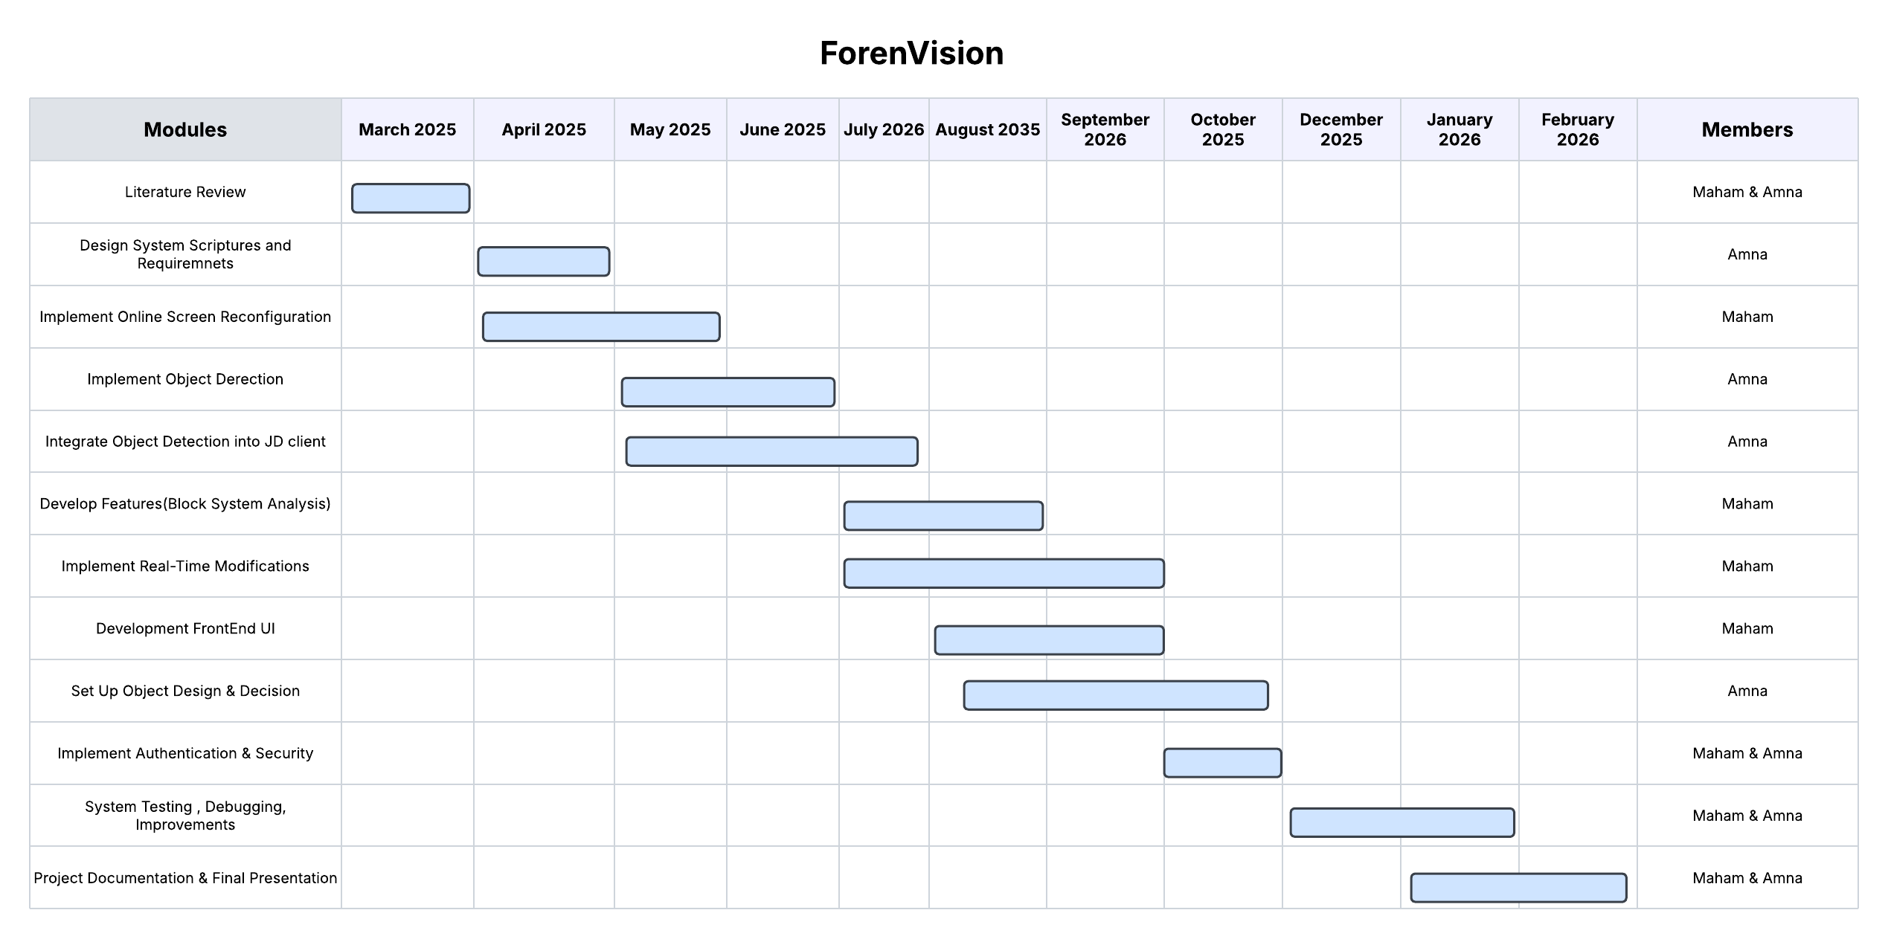
Figure 2: Gantt chart

Tools and Technologies
The ForenVision project will guarantee effective application by using a mix of cutting-edge tools and technology.
- Programming Languages:
- Python: Used for AI models, data processing, and computer vision tasks.
- Machine Learning:
- TensorFlow: Used for training and deploying object detection models.
- OpenCV: Used for image processing, feature extraction, and computer vision tasks.
- YOLO (You Only Look Once): Implemented for real-time object detection at the crime scene.
- 3D Reconstruction Technologies:
- Blender: Used for creating 3D models for crime scenes.
- Unity: Considered for rendering interactive three-dimensional settings.
- Data Collection and Processing Tools:
- Depth Cameras: Used for capturing spatial information for 3D modeling.
- Image and Video Processing: Techniques for reconstructing crime scenes using accessible film.
- LiDAR Scanners: For high-precision depth mapping of crime scenes (if applicable).
- Forensic Analysis Technologies:
- Custom AI Model: Designed to help with forensic data analysis and the identification of crime scene items.
- Cloud and Storage Solutions:
- Google Cloud: Used for model training, storage, and cloud-based computing.
- MongoDB: Considered for storing both structured and unstructured forensic datasets.

- FrontEnd DashBoard:
- Flutter: For cross-platform mobile apps with 3D graphics.
- Notification Systems:
- Twilio API: For SMS and Whatsapp notifications.
- Firebase: To push real-time notifications.

- Development and Collaboration tools:
- GitHub: Version control for code management and team collaboration
- Trello: Project management tools to track progress.

References

[1] | G. Waly, “United Nations,” 2022. [Online]. Available: https://www.unodc.org/unodc/en/data-and-analysis/global-study-on-homicide.html. [Accessed 09 March 2025].
[2] | A. Denoyel, “Sketchfab,” 2012. [Online]. Available: https://sketchfab.com/. [Accessed 11 March 2025].
[3] | D. Semyonov, “AgiSoft,” 2006. [Online]. Available: https://www.agisoft.com/. [Accessed 11 March 2025].
[4] | N. I. o. J. (NIJ), “Landscape Study on 3D Crime Scene Scanning Devices,” 15 April 2022. [Online]. Available: https://www.ojp.gov/library/publications/landscape-study-3d-crime-scene-scanni. [Accessed 11 March 2025].
[5] | E. Games, “CaptureReality,” March 2021. [Online]. Available: https://www.capturingreality.com/. [Accessed 11 March 2025].
[6] | S. R. a. G. Fraser, “Faro,” 1981. [Online]. Available: https://www.faro.com/. [Accessed 11 March 2025].

