***Digital3***

***HomeWork2***

* ***Group’s Name:***
* ***Student Name: Amna Khdair (آمنة عبدالرحيم خضيرخضير).***

***Student ID: 11819646.***

***Section: 1.***

***Lectures Time: 9:30-11AM.***

* ***Student Name: Sana’ Zetawi (سناء أحمد مصطفى زيتاوي ).***

***Student ID: 11820600.***

***Section: 1.***

***Lectures Time: 9:30-11AM.***

* ***Instructor: Dr. Suleiman Abu Kharmeh.***

***In this assignment we ask to implement Flash ADC for 4 bit, so to implement this we need to use 15 amplifiers and Digital encoding stage, for the digital encoding (priority Encoder 16 to 4) we using 16 to 4 encoder without priority and we using xor for the priority.***

***In first part we implement 2-input XOR, by using transmission gate and CMOS inverter.***

* ***Simulation for 2-input XOR gate:***

***We using xor gate from pervious assignment but we delete one input as following figure:***

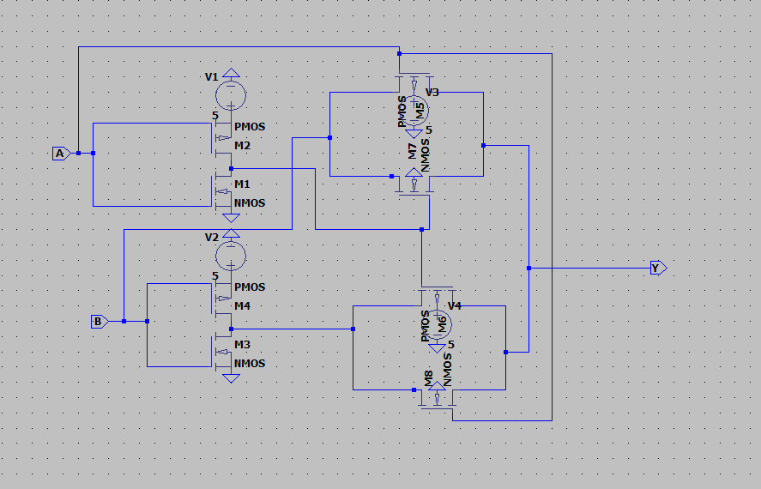

***Fig.1: 2-input XOR, using transmission gate.***

* ***Simulation for 8-input OR:***

***To implement this gate we use 8input nor and inverter and we use it for the encoder.***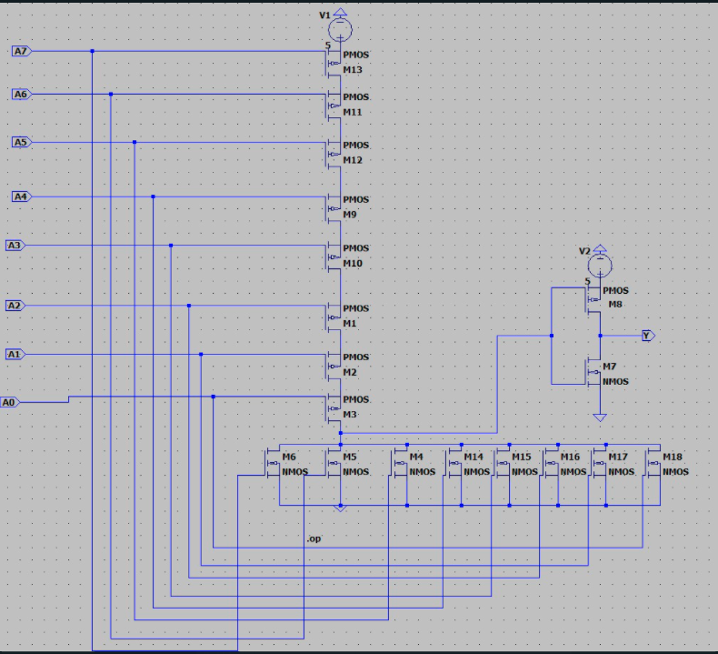

***Fig.2: OR gate (NOR gate with inverter).***

* ***After this we put it in box and use it as component, then we draw the truth table for 16 to 4 encode, and found the Boolean function from 8 input OR gate as following below:***

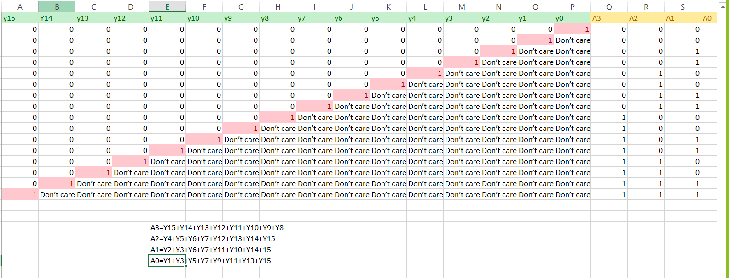

***Fig.3: Truth Table for 16 to 4 encoder.***

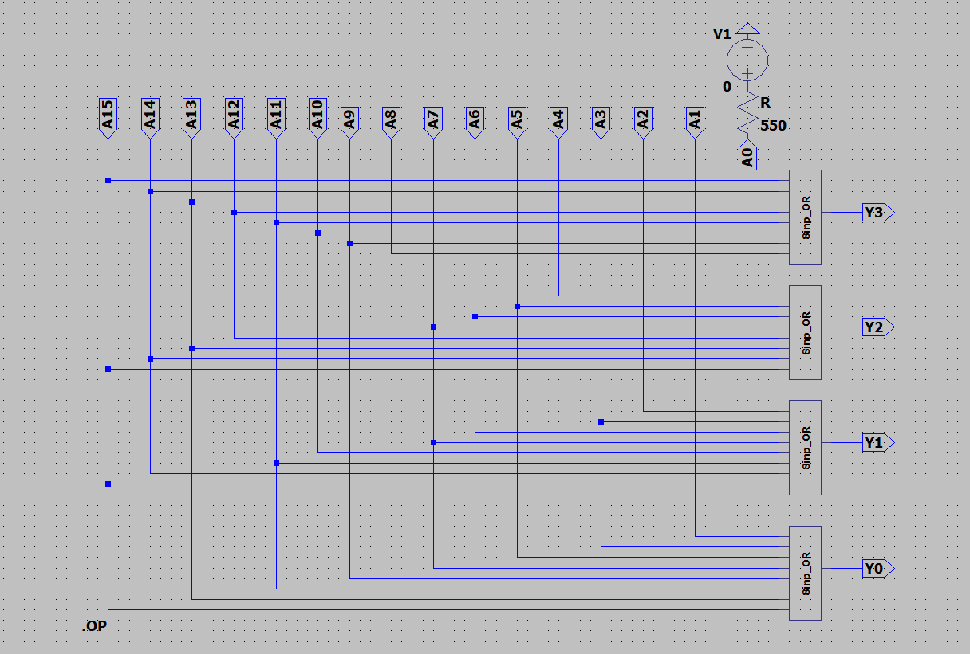

***Fig.4: The circuit for 16 to 4 encoder.***

* ***Now, we put the encoder in box, then we connect the xor for priority.***
* ***Then we connect all this with amplifiers and resistors to build ADC.***
* ***To find the value for analog input voltage levels to our ADC from 0 to 43,125mv as following below:***

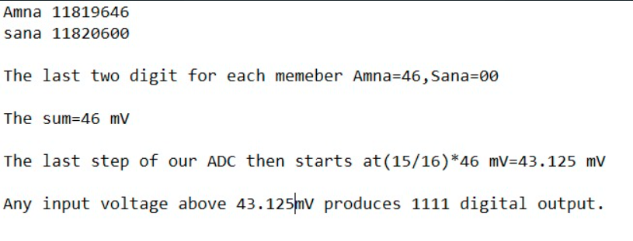

***Fig.5: The calculations for the analog input voltage levels.***

* ***So the final result to represent Flash ADC as in figure below:***

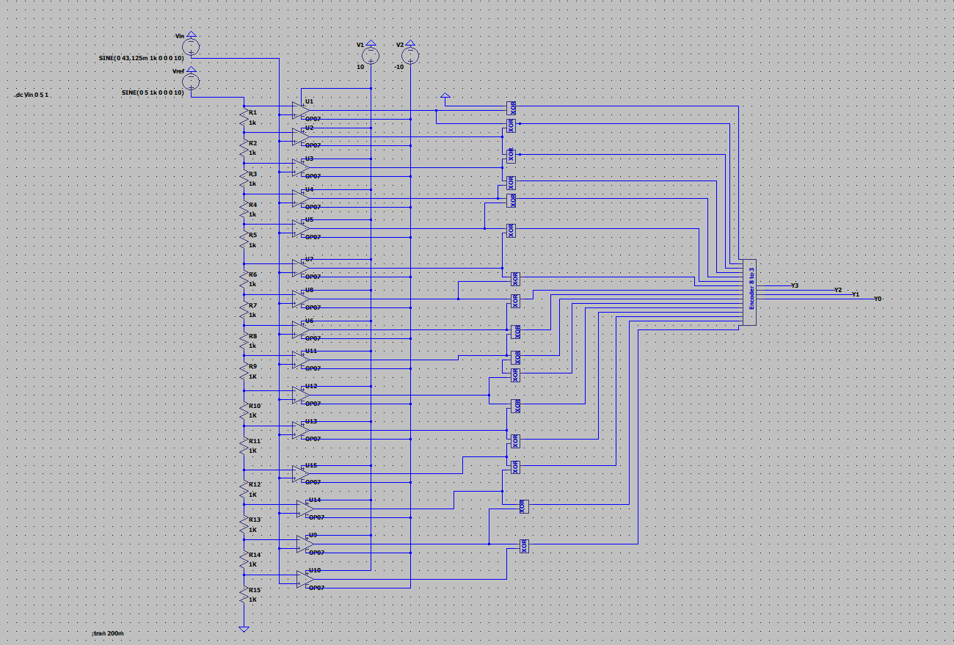

***Fig.6: The circuit for Flash ADC.***

* ***Simulation for ADC Flash as following below:***

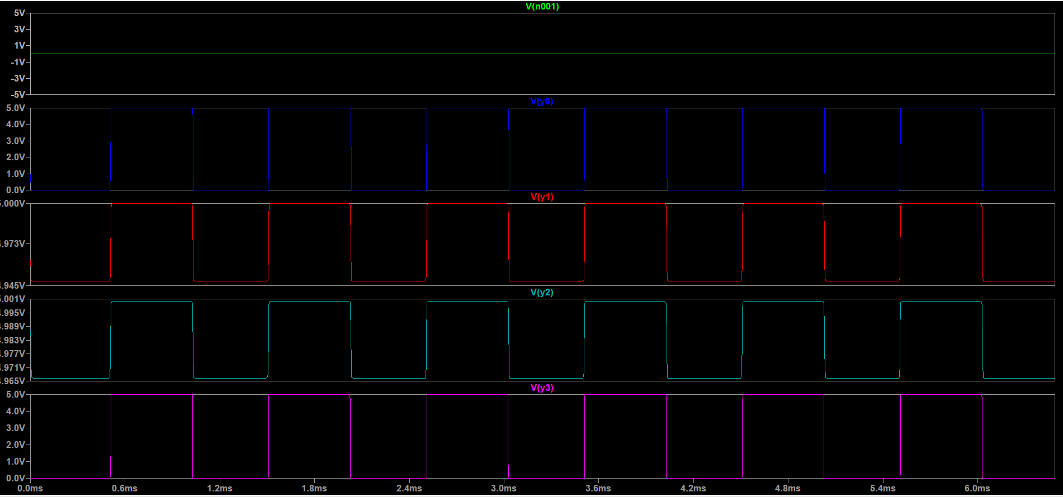

***Fig.7: The simulation for Flash ADC using transient analysis.***

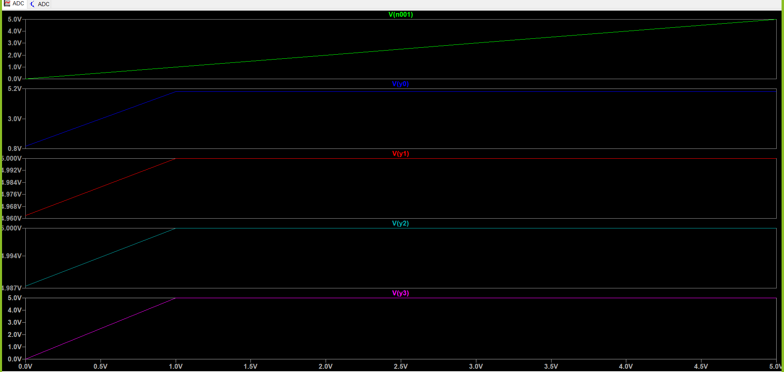

***Fig.8: The simulation for Flash ADC using DC sweep.***

* ***The calculations for total number of transistors:***
* ***The number of CMOS transistors:***

***-18 transistor for 8 input OR.***

***-we use 4 (8 input OR), so the total number for the encoder is 18*4=72 transistors.***

***-8 transistor for 2input XOR.***

***-we use 16 (2input XOR), so the total number=128 transistors.***

***-we use 15 amplifier.***

***- so the total number for transistor and amplifier is =215.***