DEMO

TEAM NAME: ID:
- AMNA MUSTAFA ALWANI F24CSC048
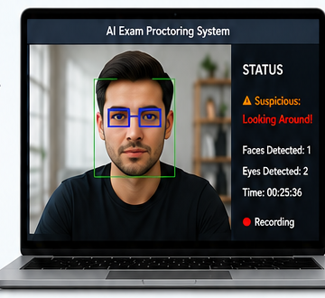
- ANOSH ASHRAF F24BSE019

