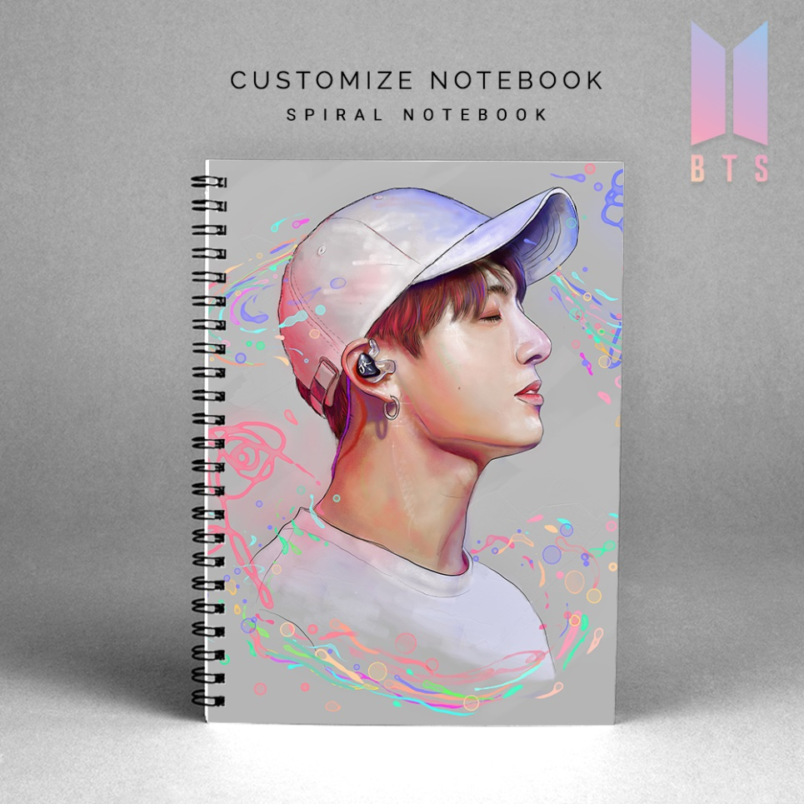

**The use of personalized pieces characterizes the current age as a fashion statement. Notebooks are precious. Whether you are using it for office or college, you will have a special bond with your notebook. RyanaCalendars is here to value your special bond and give an image. We customize notebooks, as per your designs so that you can show what you feel. Buy customized notebooks and make a statement. We provide the finest quality customized notebooks in Pakistan. Other than that, we also have ready-to-go designs for instant delivery. RyanaCalendars offers a wide range of notebooks to pick from. From covers of motivational quotes to your favorite characters, we got it all. Our high-quality products are durable, so you do not have to worry about loose spirals, poor quality paper, or faded printing. We take complete care of all the things for you.**