**DOCUMENTATION:**

**CPISM PROJECT**



## **Auctions Table.**

**Ms. Amna Nihal (1525122)**

**Ms. Rooman Mubarak (1524688)**

**Ms. Huda Abdul Rahman (1525114)**

**Ms. Aliza Azhar (1523369)**

**Table Of Contents**

DOCUMENTATION: 0

**Auctions Table.** 0

Table Of Contents 1

Acknowledgment 3

problem statement 5

PROPOSED SOLUTION 6

customer requirement 7

Work Analysis 8

algorithm 9

**Home:** 9

**About Us:** 10

User Interaction 11

screenshots 12

**Account:** 12

12

**<Code>** 13

**Navigation Bar:** 14

**<Code>** 15

**Footer:** 16

**<Code>** 17

**Home:** 18

**<Code>** 19

**Categories:** 21

**<Code>** 22

**Latest Auctions:** 23

**<Code>** 24

**Finished Auctions:** 25

**<Code>** 26

**Current Auctions:** 27

**<Code>** 27

**Reviews:** 28

**<Code>** 29

**Gallery:** 30

**<Code>** 31

**About Us** 32

**SECTION-1** 33

**SECTION-2** 34

**<Code>** 35

**Disclaimer** 39

**<Code>** 40

**Privacy Policy.** 41

**<Code>** 42

**Terms and Conditions:** 43

**<Code>** 44

**Frequently Asked Questions:** 45

**<Code>** 45

conclusion 46

**Acknowledgment**

We are truly grateful to our teacher and mentor Miss Laraib, to help us achieve the completion of our project in due time without any hurdles or difficulties. She helped us through the way and cleared our confusions and helped boost our ideas.

Her ability to collaborate and communicate effectively with team members has been invaluable, fostering a positive and productive work environment.

This project wouldn’t have reached its end without the help, co-operation and efforts of our teachers, Sir Abdullah and Miss Laraib and our group members.

We thank our teachers for teaching us contents of this course thoroughly and guiding us all the way.

We would also like to thank our friends and respondents for the support and willingness directly or indirectly to spend some time with us to fill in the questioner.

**CERTIFICATE Of COMPLETION**

**2024**

# **This Acknowledges That e-project,**

# **Auctions Table Team**

# **Has Successfully Completed The Project.**

# **Project: Dreamweaver**

**problem statement**

AuctionsTable is an organization selling valuable items and goods through auctions. They have a vast experience of organizing auctions for past 25 years. Now with the client base expanding, they want to provide e-services for auctions. Hence they want a website to be created with proper auction features.

**Requirement Specification:**

The Web site is to be created based on the following requirements.

1. The home page must be designed with beautiful color combination with all the required links defined properly. Also all the section of the webpage must be in used to avoid the blank space.
2. Home page should display all available items available for auction as a slide show.
3. Menu should provide links to various auctions. Categorization of items should be done viz. Furniture, Paintings etc.
4. On moving to any particular category, it should list various items available for auction.
5. Clicking on any item should display the details of item along with the base price of the item.
6. Menu should also provide link to completed auctions displaying the final price of product/item.
7. About us, Contact Us, Disclaimer must be included.
8. Creating an account facility can also be added.
9. Dummy procedure for placing bid to be added.
10. Sitemap must be added.
11. Navigation of the project must be made smooth.

**PROPOSED SOLUTION**

Auctions Table is an online auction organizing platform that allows user to bid and win antique products in reasonable price, without the need to physically attend a live auction.

Auctions Table is a user friendly website that allows user to easily take part in auctions and win authentic products without any complications and difficulties whatsoever.

The user friendly interface of our website allows user to bid and track their progress by creating an account.

This website provides all necessary info and status.

**customer requirement**

|  |  |
| --- | --- |
| Requirement | Status |
| Home Page (Color combination). | Done |
| About Us Page | Done |
| Gallery | Done |
| Disclaimer | Done |
| Bidding system (dummy) | Done |
| Auctioned Products | Done |
| Login and Signup | Done |
| Site map | Done |
| Product Slideshow. | Done |

**Work Analysis**

|  |  |  |
| --- | --- | --- |
| Phases | Days | Group Members |
| Analysis | 7 March 2024 – 9 March 2024 | * Huda Abdul Rahman * Amna Nihal * Aliza * Rooman |
| Planning | 10 March 2024 – 13 March 2024 | * Huda Abdul Rahman * Amna Nihal * Aliza * Rooman |
| Designing | 14 March – 21 March | * Huda Abdul Rahman * Amna Nihal * Aliza * Rooman |
| Testing | 21 March – 28 March | * Huda Abdul Rahman * Amna Nihal * Aliza * Rooman |
| Implementation | 21 March – 28 March | * Huda Abdul Rahman * Amna Nihal * Aliza * Rooman |

**algorithm**

# **Home:**

**User Interaction**

**screenshots**

# **Account:**

# 

* User can easily log in or create an account to track their progress.

## **<Code>**

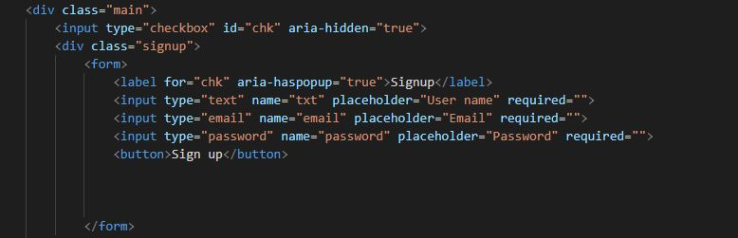

* Login and signup, collecting user’s data to allow users to access their account.

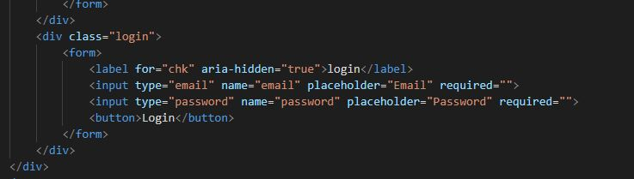

# **Navigation Bar:**



* Allowing users to navigate through the website on one click.



* Navigation bar view on phone and tablets.

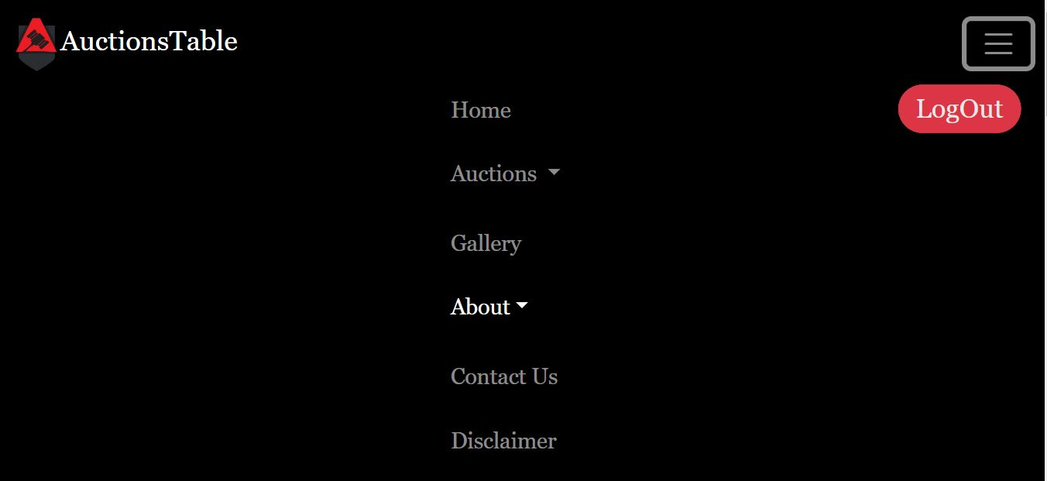

## **<Code>**

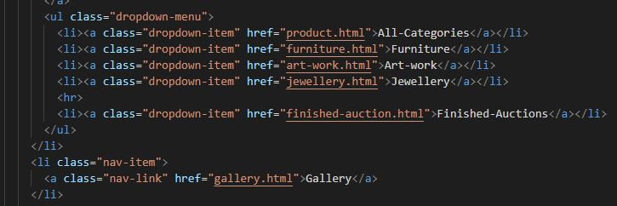

* Navigation bar, listing available options for users to access.

# **Footer:**

* Newsletter
* 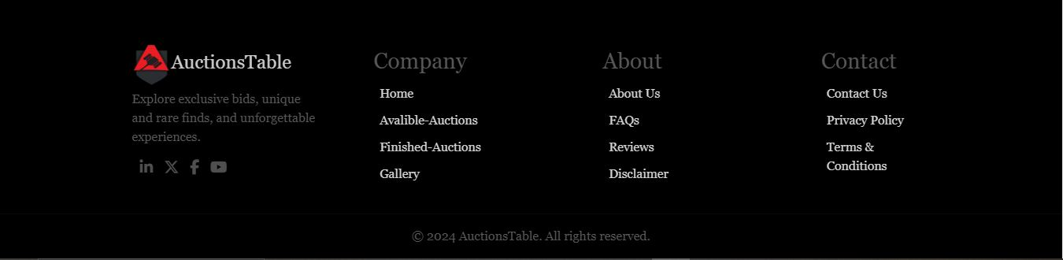Footer

**Sitemap**

## **<Code>**

* 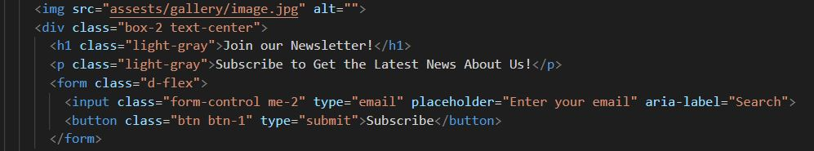Newsletter:
* Newsletter allows users to subscribe to our website for latest updates.
* 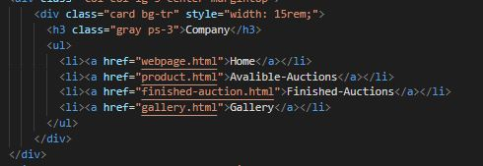Footer:

# **Home:**

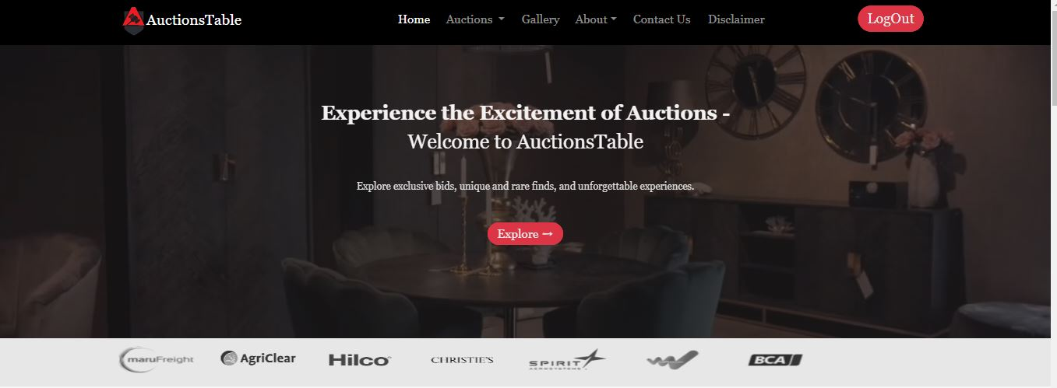

**Sponsors, supporting our organization.**

## **<Code>**

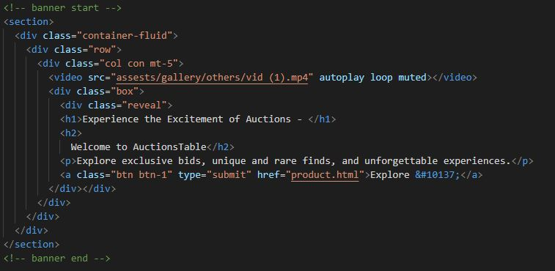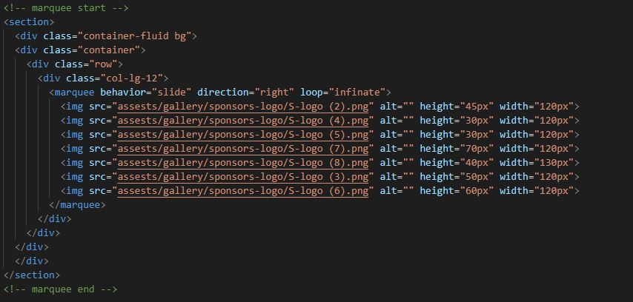

**Different categories of auctions**

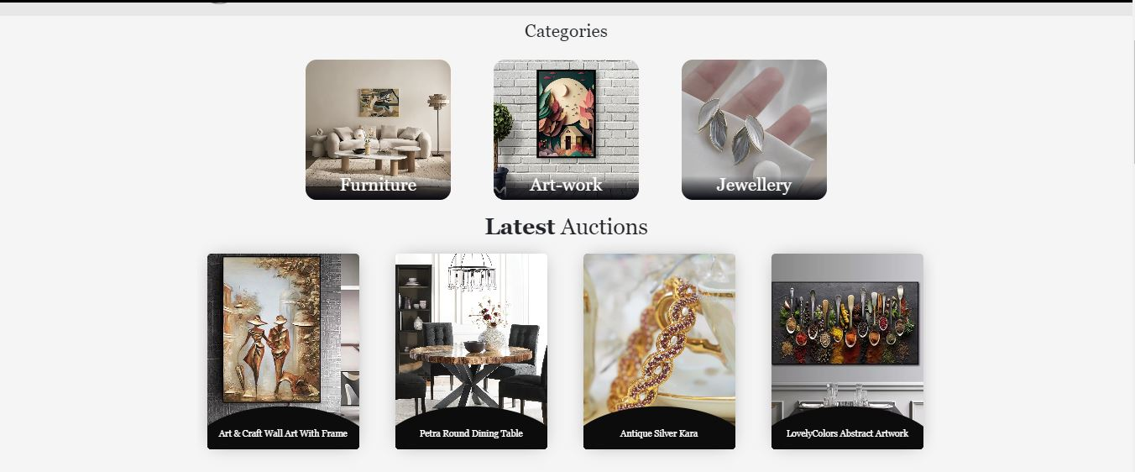

**All the latest products for auction**

# **Categories:**

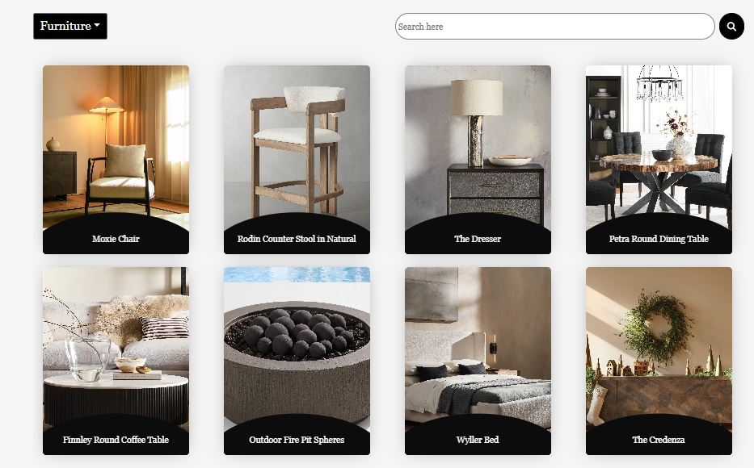

* Each category contains related products that are available for auctions and allows users to move from one category to another and bid on the desired product.

## **<Code>**

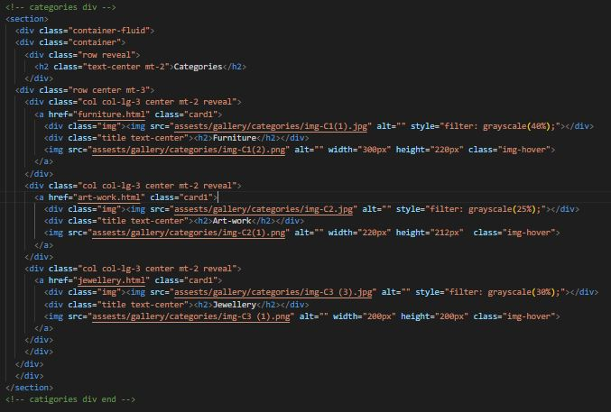

# **Latest Auctions:**

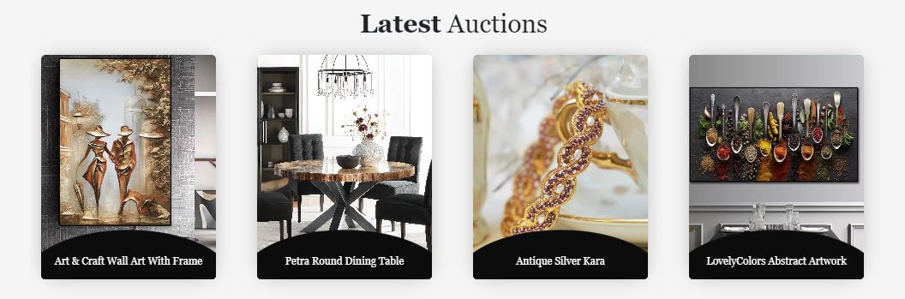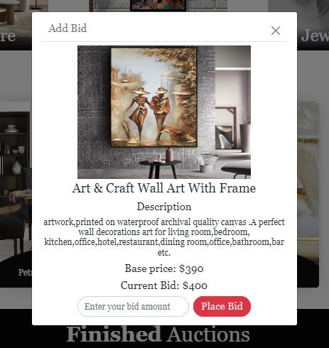

**Allowing users to place a price of their choice to bid on the product.**

## **<Code>**

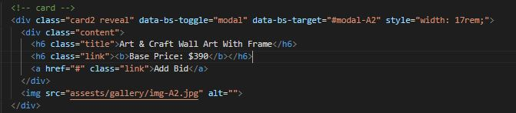

# **Finished Auctions:**

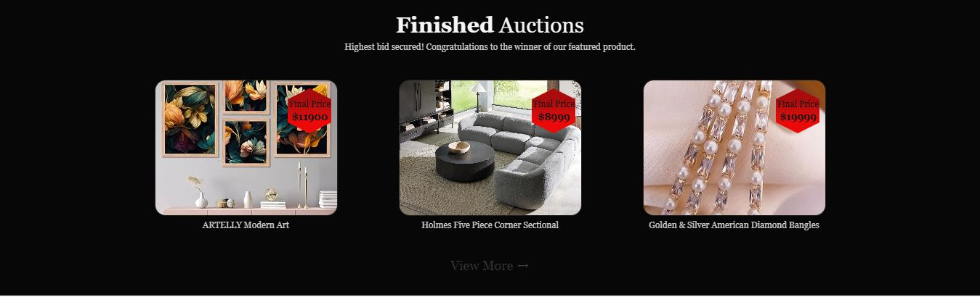

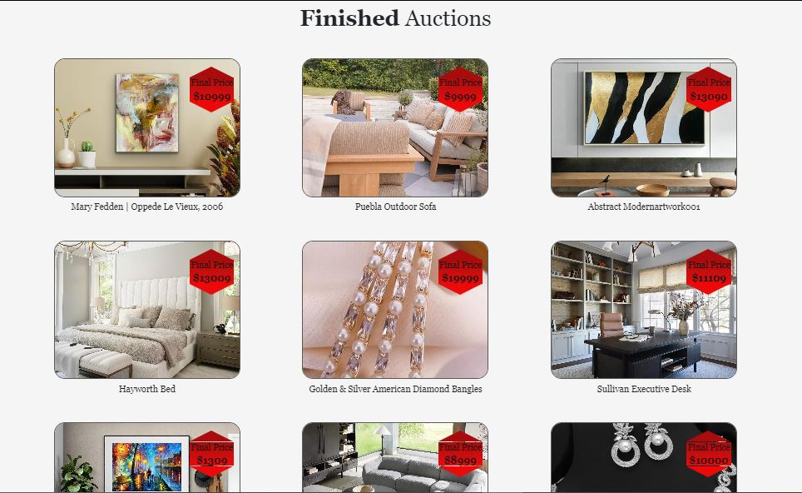

* Finished auctions of products on display with their final price, that are won by the participants and are no longer available.

## **<Code>**

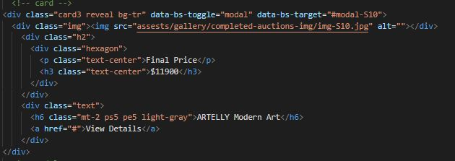

# **Current Auctions:**

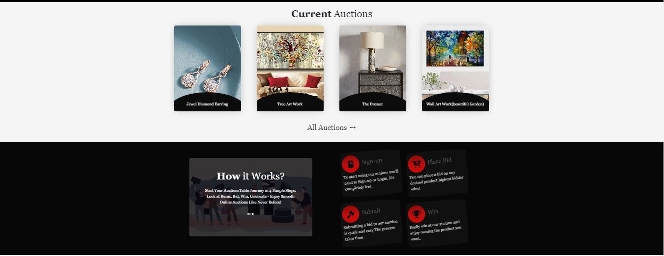

* ‘Current Auctions’ display all the available products for auction.
* ‘How it Works’ section provides a complete step to step guide, on how to bid on products, provide a user friendly experience to our users.

## **<Code>**

# **Reviews:**

* Reviews page displaying authentic testimonials of user’s experience of our website.

## **<Code>**

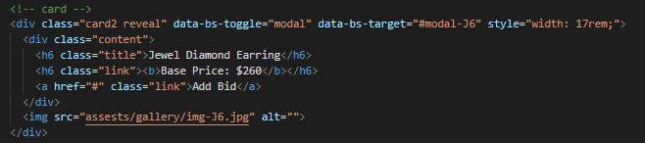

# **Gallery:**

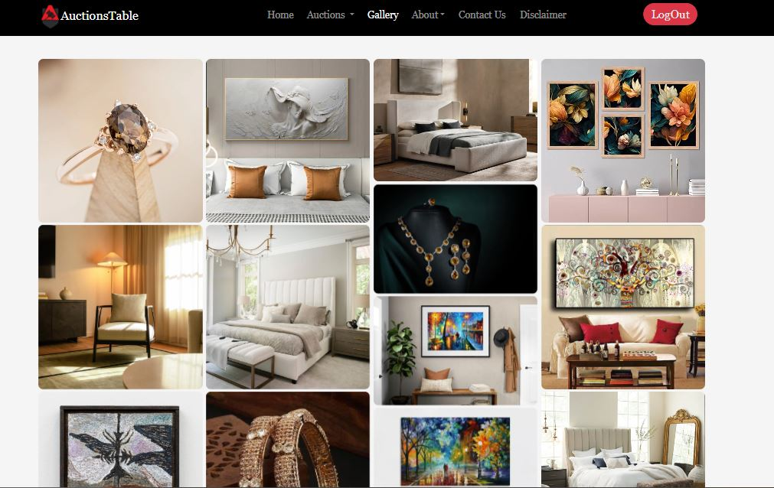

* Gallery displaying all the potential and current products, diverse in options, making it users to vary their choices as per their desire.

## **<Code>**

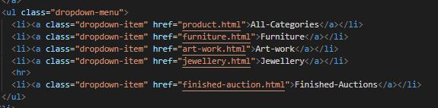

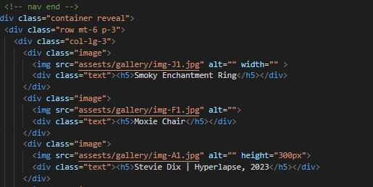

**Logo**

**Account Access**

# **About Us**

**Navigation Bar**

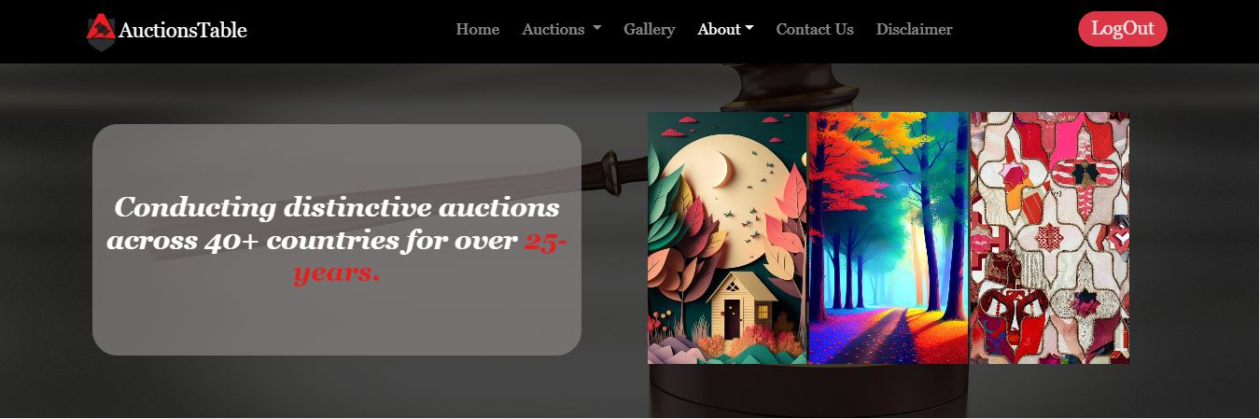

## **SECTION-1**

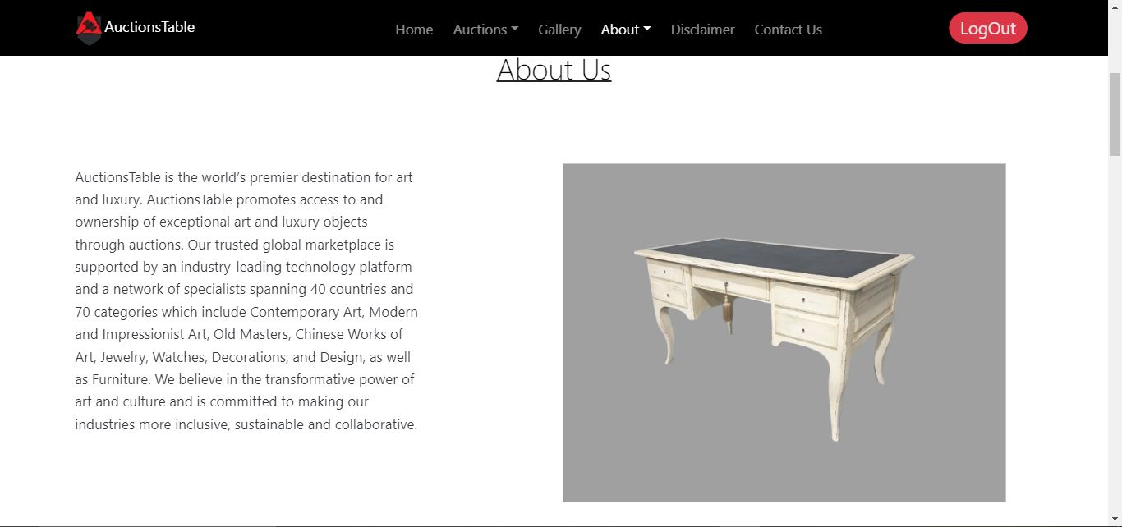

**Website Information**

**Available Products**

## **SECTION-2**

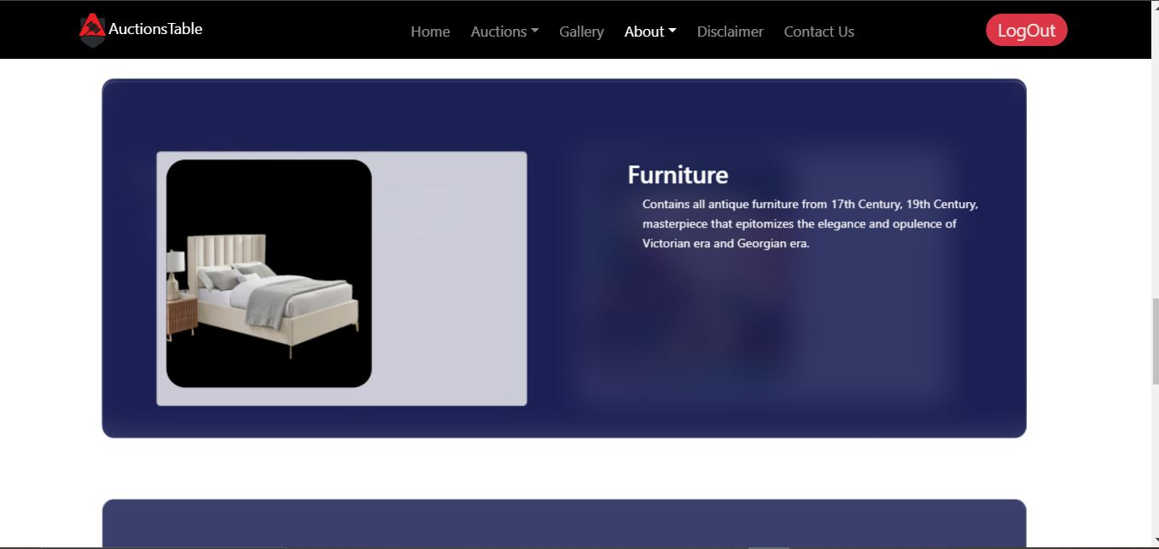

* Cards displaying product categories with summarized information, allowing user to easily find the category required as per their choice.

## **<Code>**

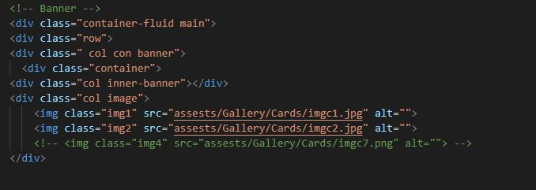

* ‘Inner-banner’ containing a banner background image in Css.
* ‘Image’ <div> containing foreground images in the banner.

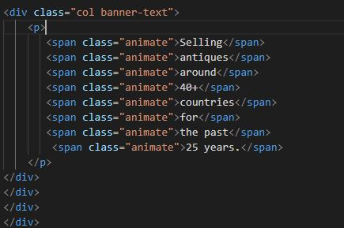

* Banner heading.

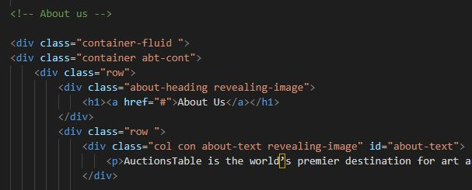

* Body and website information.
* Product display on slideshow.

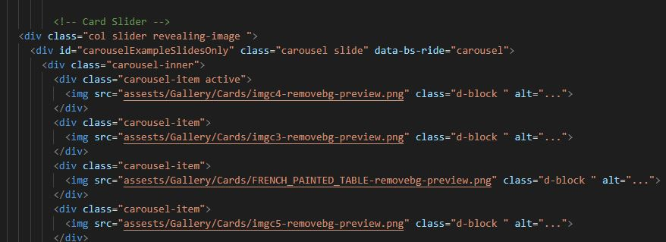

* Cards displaying product categories with summarized information 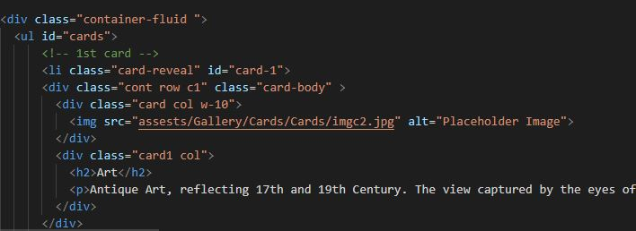

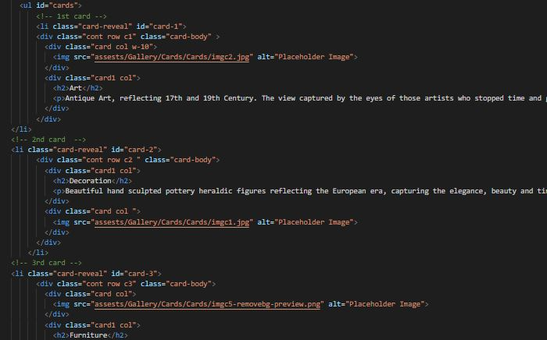

# **Disclaimer**

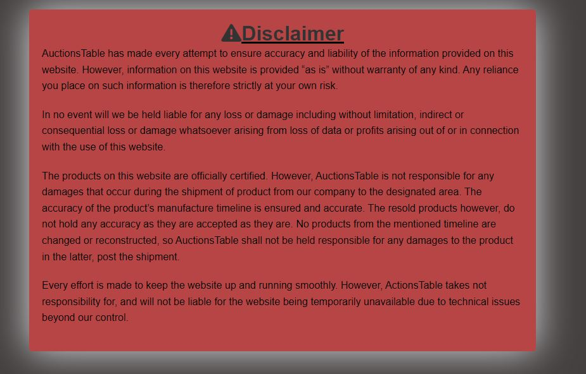

* Contains all the account and website related (law related) information.

## **<Code>**

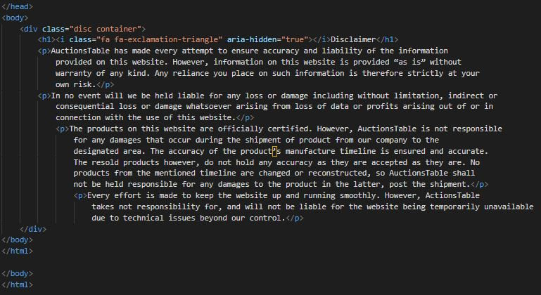

# **Privacy Policy.**

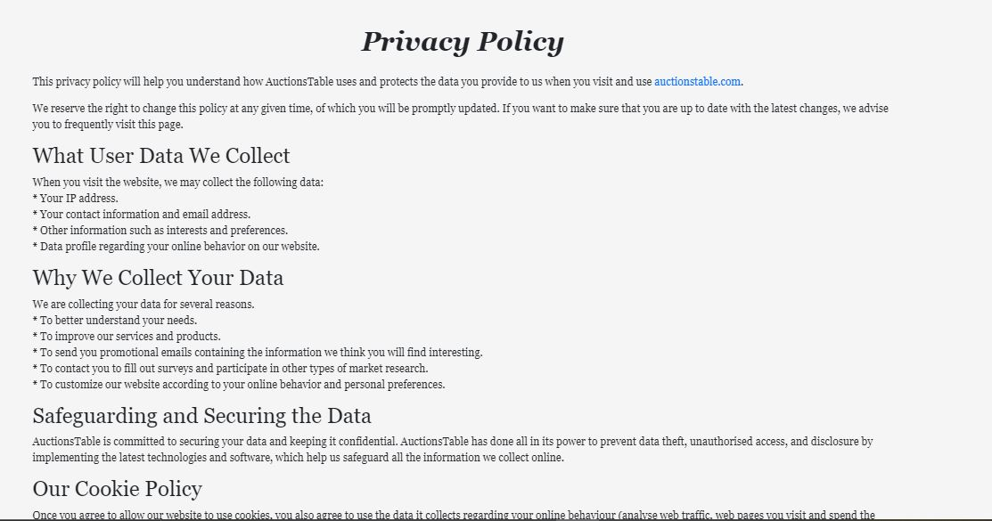

* Contains Website Privacy conditions and data collection information.

## **<Code>**

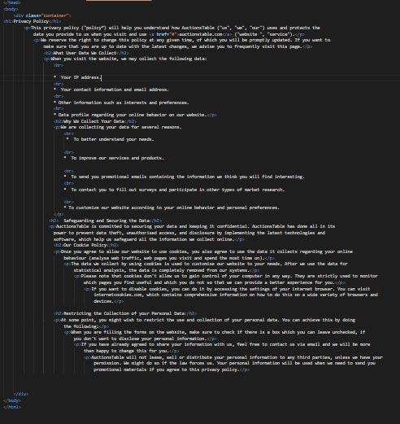

# **Terms and Conditions:**

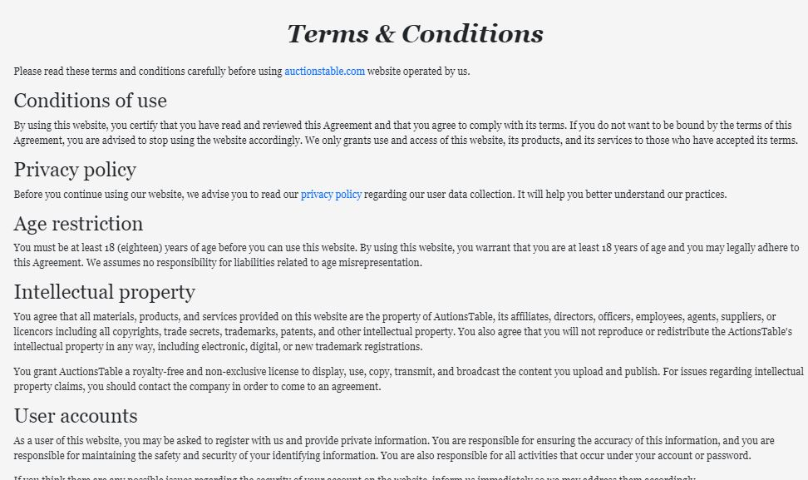

* Contains website’s terms of use, requirements and restrictions.

## **<Code>**

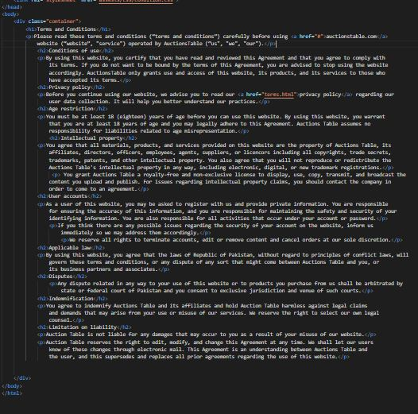

# **Frequently Asked Questions:**

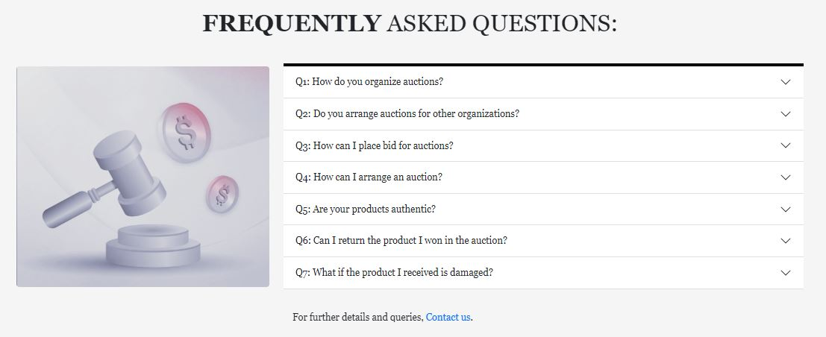

## **<Code>**

**conclusion**

AuctionsTable is an organization, dedicated to provide best services and authentic products that are rare and unique. AuctionsTable focuses on the diversity of businesses and industries that provide the best services and products.

AuctionsTable ensures the authenticity of their products and quality according to client’s desired choice. We ensure law safety and our products authenticity, approved by the American Society of Appraisers (ASA).

The quality of our products is ensured by through checking and so our services at online and onsite auctions.

AuctionsTable provides a wide range of products according to latest variety, allowing our clients to select from the diverse range of choices, as per their desire. We provide furniture, jewelries, art and other diverse options varying from color, types, sizes and so on.

We provide fair trade of auctions and services, with prices at client’s reach. Our team provides safe transportation of products from our organization to required destination avoiding any damage.

Our services at AuctionsTable ensures products and seller’s authenticity and provides comfortable service without any complications.

In summary, AuctionsTable provides and ensures a safe experience for clients to obtain the best products from worldwide as per their range of price with ensured product quality.