

**Software Engineering II**

**Assignment# 02**

**Submitted To: Sir Muhammad Kamran**

**Submitted By: Amna Tabassum**

**Date: 25-04-2019**

Initial Git status:



After adding one file into the local directory:

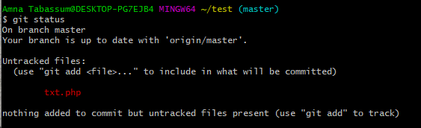

After adding file to staging area:

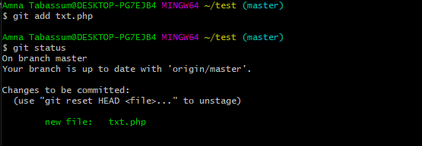

After committing the file in staging area:

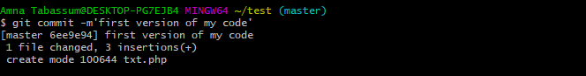

Gitlog:

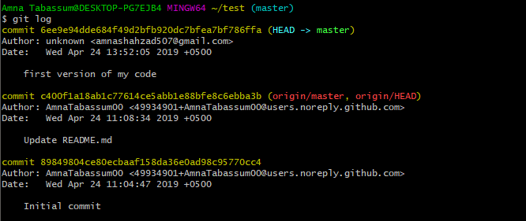

Git Status after committing:

