CYBERSECURITY INTERNSHIP
WEEK 1 — COMPLETE REPORT
Security Assessment of OWASP Juice Shop

Student Name | Amna Zainab Malik
Student ID | DHC-1687
Institute | National University of Technology
Internship Type | Online Cybersecurity Internship
Application Tested | OWASP Juice Shop v19.2.1
Submission Deadline | 15th May, 2026

TASK 1: UNDERSTAND THE APPLICATION

1.1 Application Overview
OWASP Juice Shop is a deliberately insecure web application created by OWASP (Open Web Application Security Project). It is specifically designed for cybersecurity training, penetration testing practice, and security awareness. It contains numerous real-world vulnerabilities that are safe and legal to test.

Detail | Information
Application Name | OWASP Juice Shop
Version | 19.2.1
GitHub Repository | https://github.com/juice-shop/juice-shop
Technology Stack | Node.js, Angular, SQLite
Local URL | http://localhost:3000
Purpose | Security Testing Practice

1.2 Setup Process

Commands Used
The following commands were executed in sequence to set up the application:

Step | Command | Description
1 | git clone https://github.com/AmnaZainabMalik/Developers-Hub-intership-1 | Clone repository from GitHub
2 | cd cybersecurity-internship-project | Navigate into project directory
3 | npm install | Install all required dependencies
4 | npm start | Launch the application on port 3000

Setup Result
The application was successfully installed and launched. Some deprecation warnings appeared during npm install — these are non-critical warnings about older package versions and did not affect the installation.
- Application launched successfully at http://localhost:3000
- No critical errors during installation
- All pages accessible via browser
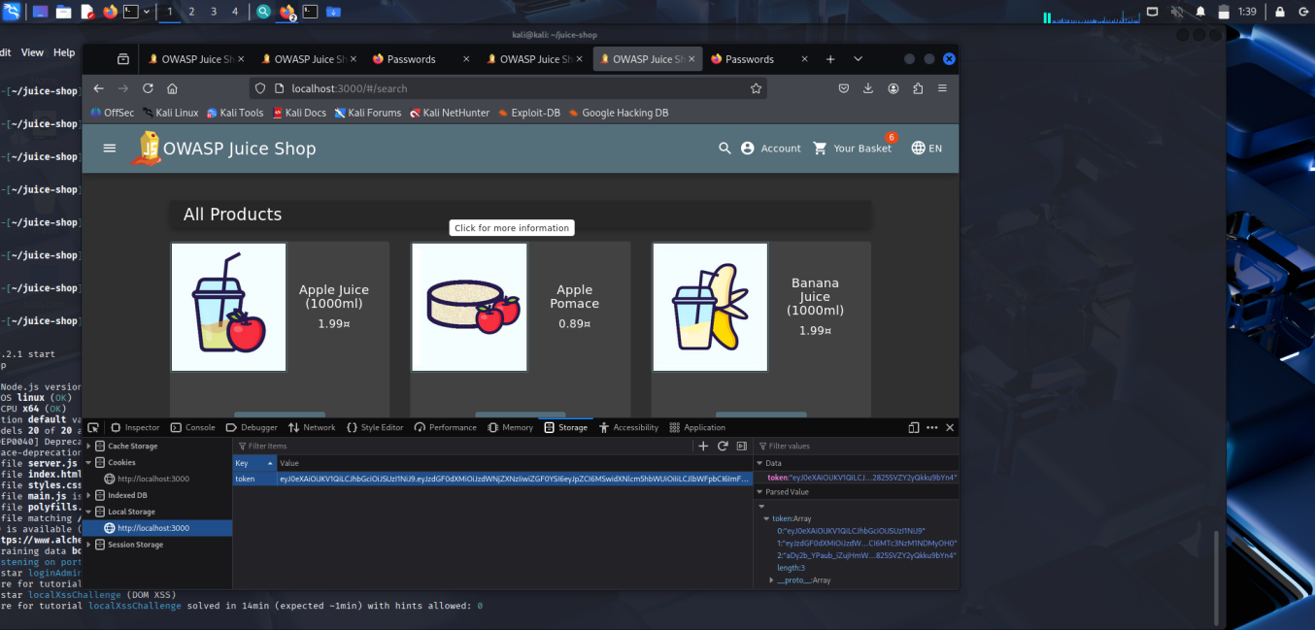
Figure 1:Juice Shop Homepage running on http://localhost:3000

1.3 Application Exploration

Signup Page — http://localhost:3000/#/register
- Accepts any email format without strict validation
- Weak passwords like 123456 are accepted without restriction
- No CAPTCHA or bot protection present
- Security question answers stored without encryption
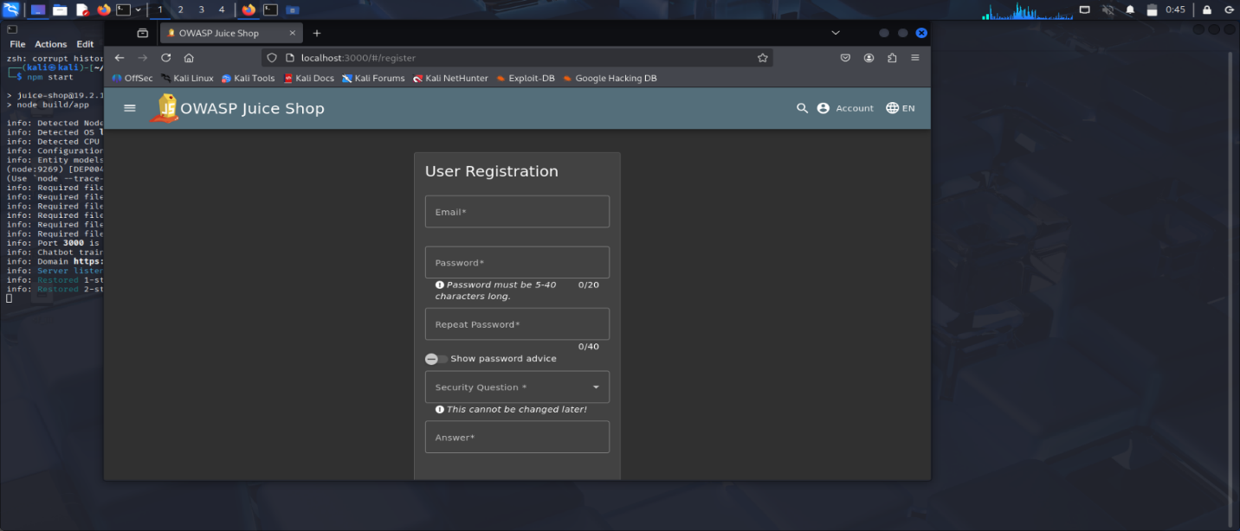
Figure 2:Signup Page Exploration

[ Screenshot:]

Login Page — http://localhost:3000/#/login
- No limit on failed login attempts — brute force possible
- Error messages reveal whether an email exists in the system
- No multi-factor authentication (MFA) implemented
- No account lockout policy after multiple wrong attempts
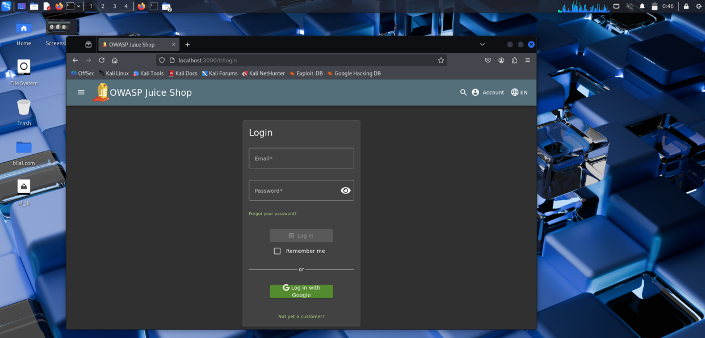
Figure 3:Login Page Exploration

[ Screenshot:]

Profile Page — http://localhost:3000/#/profile
- User data loaded and displayed after authentication
- Input fields present for updating user information
- No visible input sanitization on profile update fields
- Sensitive user data visible in plain text
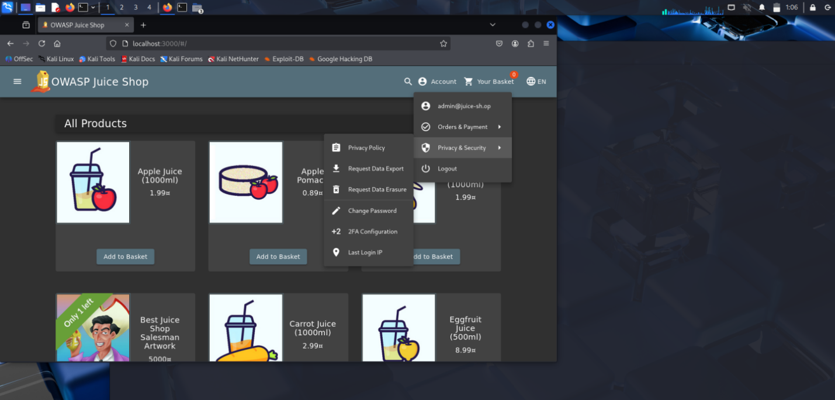
Figure 4:Profile Page Exploration

[ Screenshot:]

TASK 2: BASIC VULNERABILITY ASSESSMENT

2.1 SQL Injection Test

What is SQL Injection?
SQL Injection is an attack where malicious SQL code is inserted into input fields to manipulate the database query. This can allow attackers to bypass authentication, access unauthorized data, or destroy database records.

Test Performed
Field | Input Used
Email Field | ' OR 1=1--
Password Field | Anything
Target Page | http://localhost:3000/#/login

How It Works
The normal database query is:
SELECT * FROM users WHERE email='input' AND password='input'
After SQL Injection input, the query becomes:
SELECT * FROM users WHERE email='' OR 1=1-- AND password='...'
Since 1=1 is always TRUE, and everything after -- is treated as a comment, the authentication is completely bypassed.

Result
- STATUS: VULNERABLE — SQL Injection Successful
- Admin account accessed without valid credentials
- Complete authentication bypass achieved
- Risk Level: CRITICAL
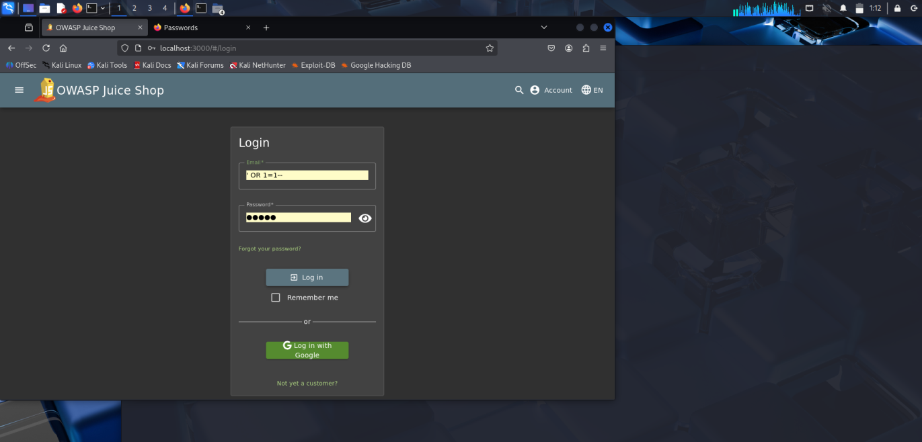
Figure 5:SQL Injection — Input in Login Fields

[ Screenshot:]

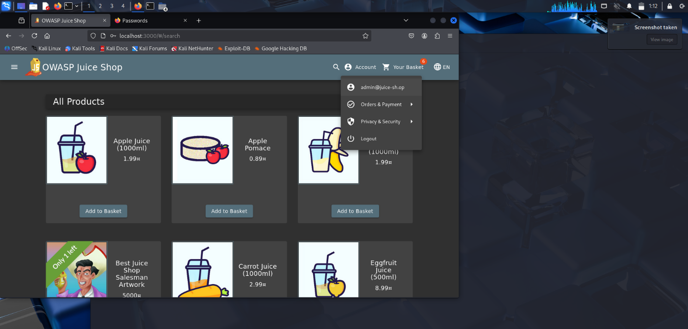
Figure 6:SQL Injection — Successful Admin Login Result

2.2 Cross-Site Scripting (XSS) Test

What is XSS?
Cross-Site Scripting (XSS) is an attack where malicious scripts are injected into web pages. When other users view the page, the malicious script executes in their browser. This can be used to steal cookies, session tokens, or redirect users to malicious websites.

Test Performed
Field | Input Used
Search Bar | <iframe src="javascript:alert(`xss`)">
Target Page | http://localhost:3000/#/search
Also Tested On | Contact/Feedback Page

Result
- STATUS: VULNERABLE — XSS Attack Successful
- Malicious script executed in the browser
- Alert box appeared confirming script injection
- In a real attack, session cookies could be stolen
- Risk Level: HIGH
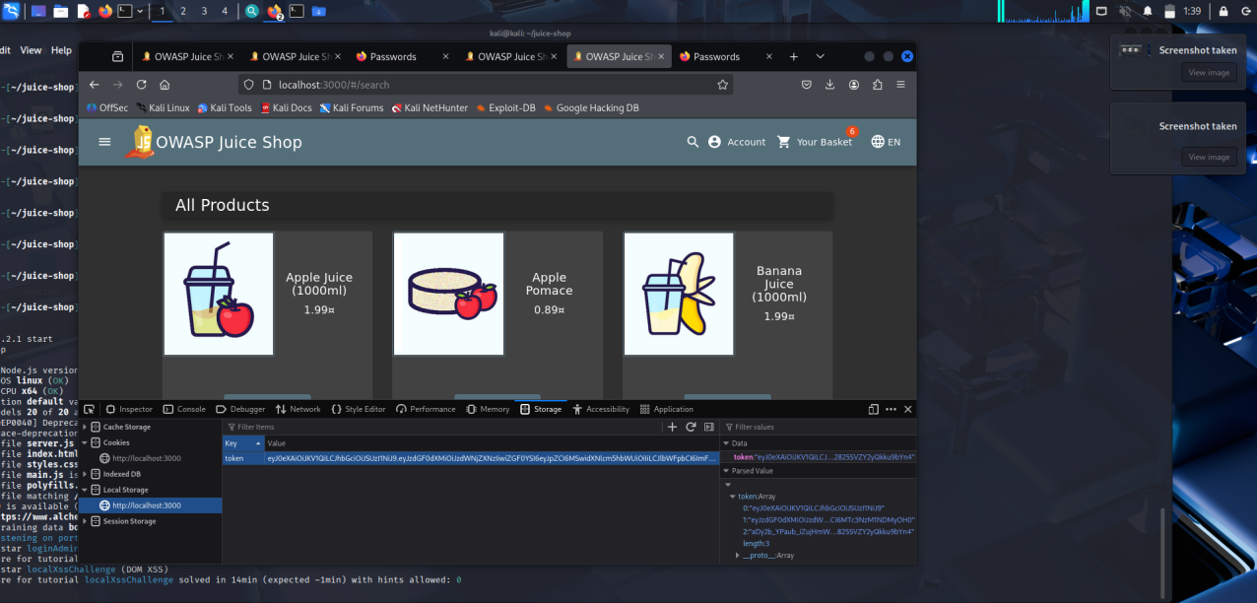
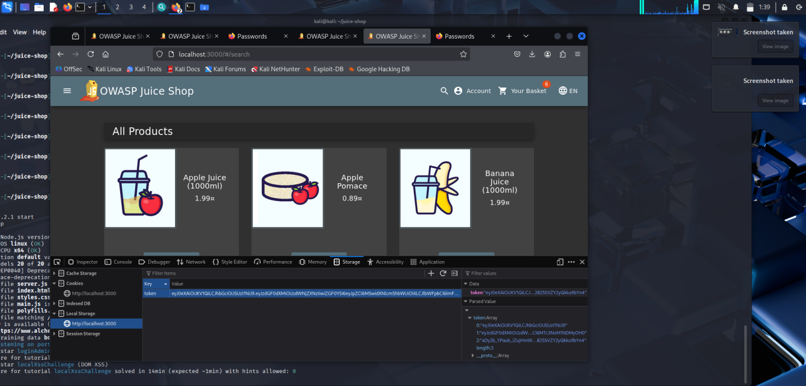
Figure 7:XSS — Malicious Input in Search Bar

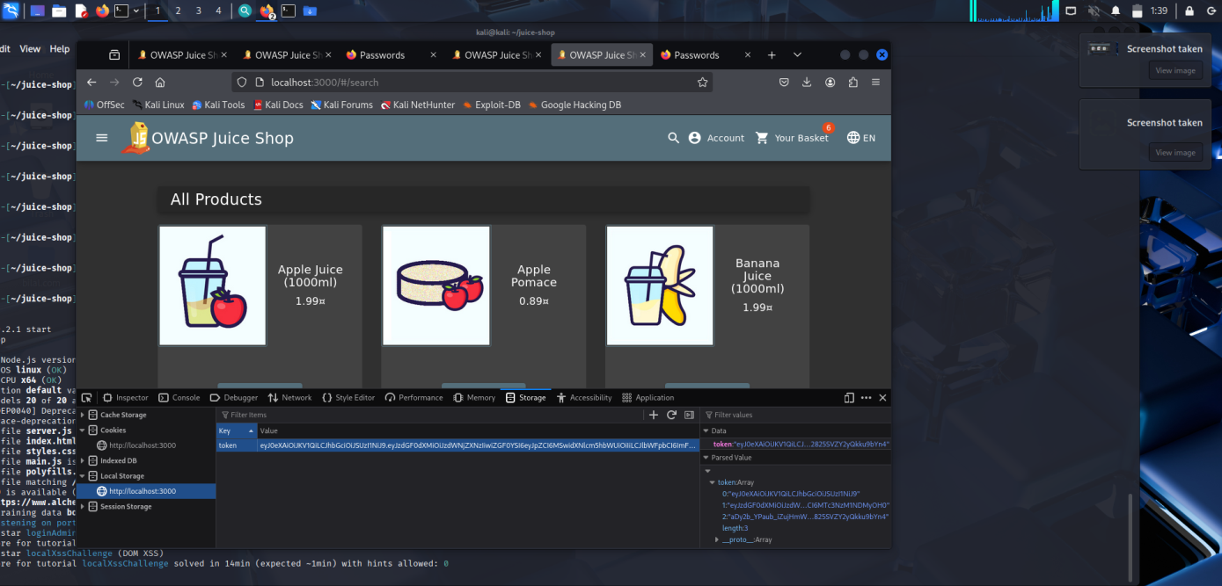
Figure 8:XSS — Alert Box Appearing (Script Executed)

2.3 Weak Password Policy Test

What is Weak Password Storage?
A weak password policy allows users to set easily guessable passwords. This makes accounts vulnerable to brute force attacks and dictionary attacks where attackers try common passwords to gain unauthorized access.

Test Performed
Test | Input | Result
Weak password on signup | 123456 | Account created successfully
Login with weak password | 123456 | Login successful
No complexity requirement | Abc | Accepted by application

Result
- STATUS: VULNERABLE — Weak Password Policy Confirmed
- Password '123456' accepted without any warning
- No minimum complexity requirements enforced
- No password strength indicator shown to user
- Risk Level: MEDIUM
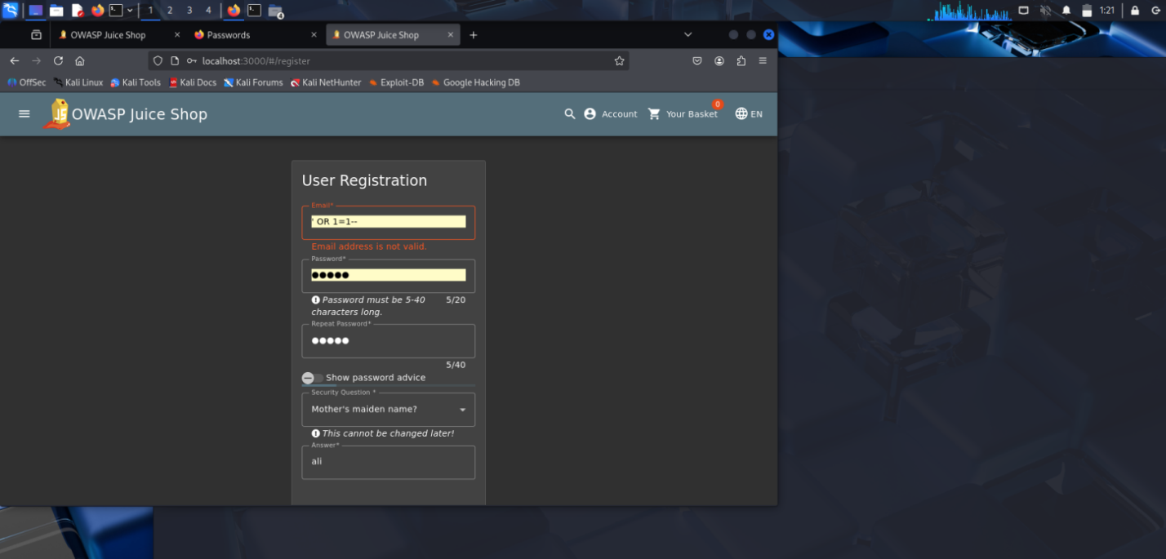
Figure 9:Weak Password — Signup with 123456

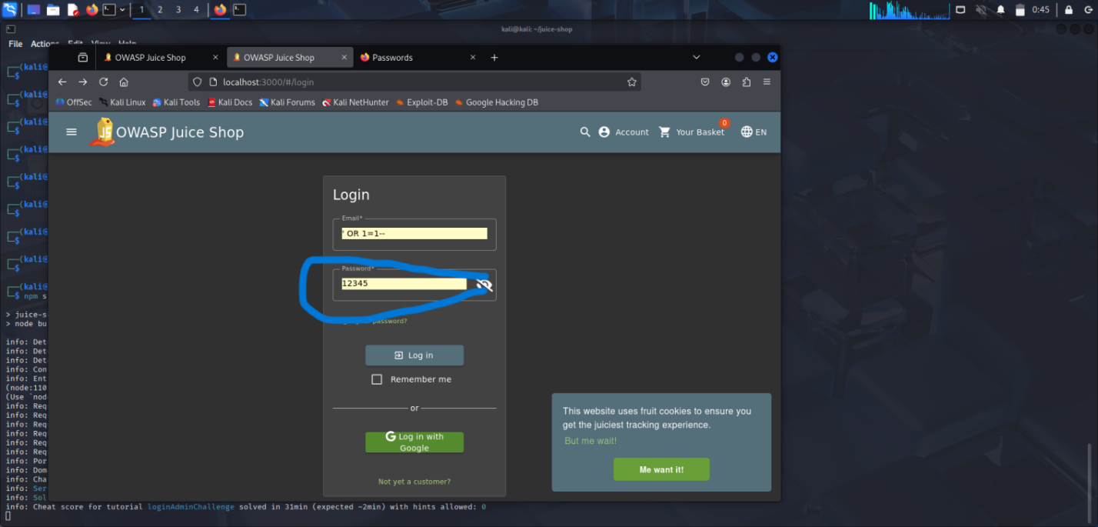
Figure 10:Weak Password — Successful Login with 123456

2.4 Sensitive Data Exposure Test

What is Sensitive Data Exposure?
Sensitive Data Exposure occurs when an application stores or transmits sensitive information (like authentication tokens, passwords, or personal data) in an insecure manner that can be easily accessed by unauthorized parties.

Test Performed
Browser Developer Tools (F12) were used to inspect the application storage:
Location | Data Found | Risk
Local Storage | JWT Token stored in plain text | HIGH
Application Tab | User session data visible | MEDIUM
Network Requests | Sensitive data in request headers | MEDIUM

Result
- STATUS: VULNERABLE — Sensitive Data Exposed
- JWT authentication token stored in plain text in Local Storage
- Anyone with physical access to browser can steal the token
- Token can be used to impersonate the user without password
- Risk Level: HIGH
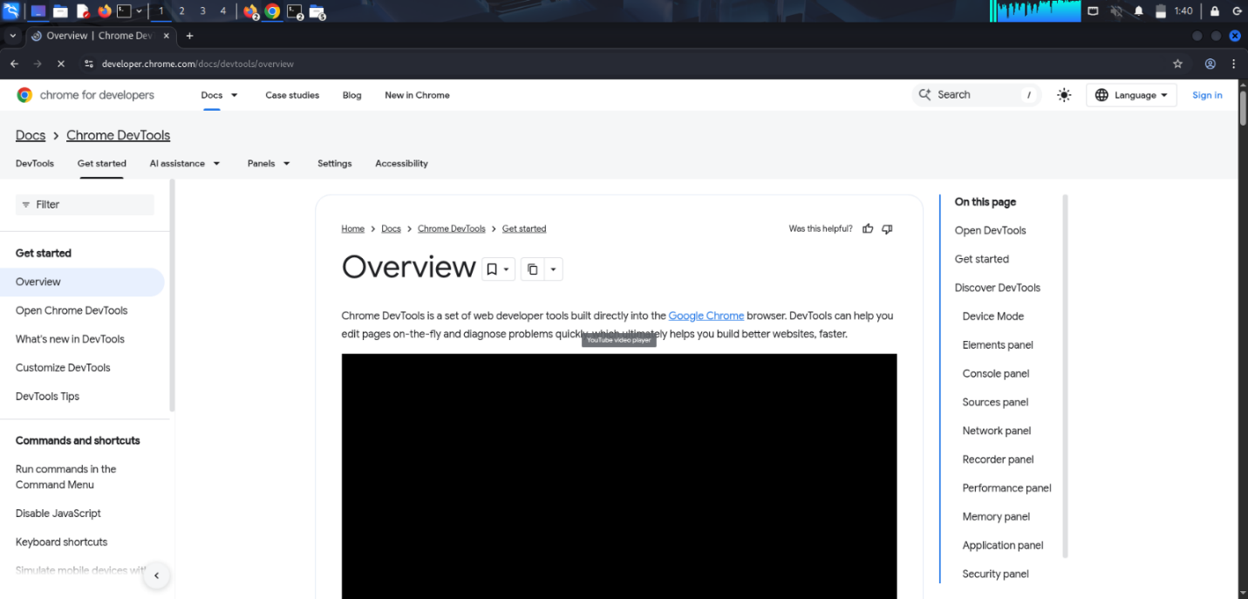
Figure 11:DevTools — Local Storage showing JWT Token in plain text

TASK 3: DOCUMENT FINDINGS

3.1 Complete Vulnerabilities Summary
The following vulnerabilities were identified during the security assessment of OWASP Juice Shop:

# | Vulnerability | Location | Risk Level | Status
1 | SQL Injection | Login Page | CRITICAL | Confirmed
2 | Cross-Site Scripting (XSS) | Search Bar / Contact Page | HIGH | Confirmed
3 | Weak Password Policy | Signup / Login Page | MEDIUM | Confirmed
4 | Sensitive Data Exposure | Browser Local Storage | HIGH | Confirmed
5 | No Brute Force Protection | Login Page | HIGH | Identified
6 | Missing Security Headers | All Pages | MEDIUM | Identified
7 | Verbose Error Messages | Login Page | LOW | Identified

3.2 Areas of Improvement

1. Fix SQL Injection
- Use parameterized queries or prepared statements
- Never concatenate user input directly into SQL queries
- Implement input validation on all database-connected fields
- Use ORM (Object Relational Mapping) frameworks

2. Fix XSS Vulnerabilities
- Sanitize and encode all user inputs before displaying
- Implement Content Security Policy (CSP) headers
- Use trusted libraries like DOMPurify for input sanitization
- Validate input on both client and server side

3. Strengthen Password Policy
- Enforce minimum 8 character password length
- Require mix of uppercase, lowercase, numbers and symbols
- Implement password strength indicator on signup
- Use bcrypt for secure password hashing and storage

4. Protect Sensitive Data
- Store tokens in HttpOnly cookies instead of Local Storage
- Implement token expiry and refresh mechanisms
- Use HTTPS for all data transmission
- Encrypt sensitive data before storing

5. Additional Security Improvements
- Implement account lockout after 5 failed login attempts
- Add CAPTCHA on login and signup pages
- Use Helmet.js to set secure HTTP headers
- Enable multi-factor authentication (MFA)
- Implement proper session management

3.3 Risk Assessment Matrix
Risk Level | Count | Description | Priority
CRITICAL | 1 | Immediate action required | Fix First
HIGH | 3 | Serious security risk | Fix ASAP
MEDIUM | 2 | Moderate security risk | Fix Soon
LOW | 1 | Minor security concern | Fix Later

3.4 Conclusion
The security assessment of OWASP Juice Shop revealed multiple critical and high-severity vulnerabilities. The most serious findings include SQL Injection which allows complete authentication bypass, and Cross-Site Scripting which can lead to session hijacking and data theft.
These vulnerabilities represent common real-world security issues found in web applications. The findings demonstrate the importance of secure coding practices, input validation, and proper data storage mechanisms.
All identified vulnerabilities will be addressed in Week 2 through implementation of appropriate security measures including input sanitization, password hashing, token-based authentication, and secure HTTP headers.

