CYBERSECURITY INTERNSHIP
WEEK 4 — COMPLETE REPORT
Advanced Security Audits & Final Deployment

Student Name | Amna Zainab Malik
Student ID | DHC-1687
Institute | National University of Technology
Submission Deadline | 9th June, 2026

Overview
This report documents the complete implementation of all Week 6 cybersecurity tasks. The goal of this final week was to conduct advanced security audits, ensure compliance with OWASP Top 10 standards, prepare the application for secure deployment, and perform a final comprehensive penetration test. All three tasks are documented below with commands, code, configuration, and screenshot placeholders.

Task 1: Security Audits & Compliance

Objective: Conduct security audits using OWASP ZAP, Nikto, and Lynis. Check compliance with OWASP Top 10 best practices.

1A — OWASP ZAP Automated Vulnerability Scan

Step 1 — Install OWASP ZAP
Download and install OWASP ZAP from zaproxy.org or install via apt:
# Install via apt sudo apt install zaproxy -y

# Or download GUI from https://www.zaproxy.org/download/

# Verify installation
zaproxy -version

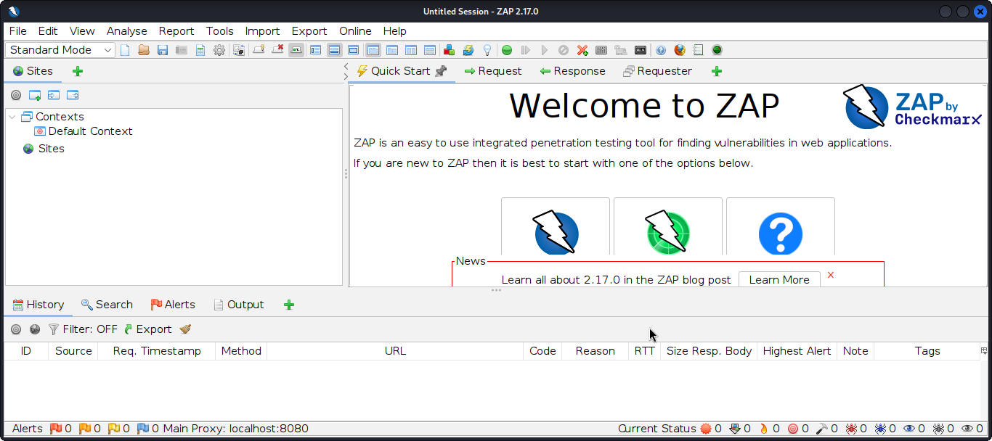
Figure: OWASP ZAP application open — Dashboard visible

Step 2 — Run Baseline Scan (Command Line)
Run a baseline automated scan against your test application and export the report:

# Run baseline scan and save HTML report

zap-baseline.py -t http://localhost:3000 -r zap_report.html

# Run full active scan (more thorough)

zap-full-scan.py -t http://localhost:3000 -r zap_full_report.html

# View the generated report

xdg-open zap_report.html

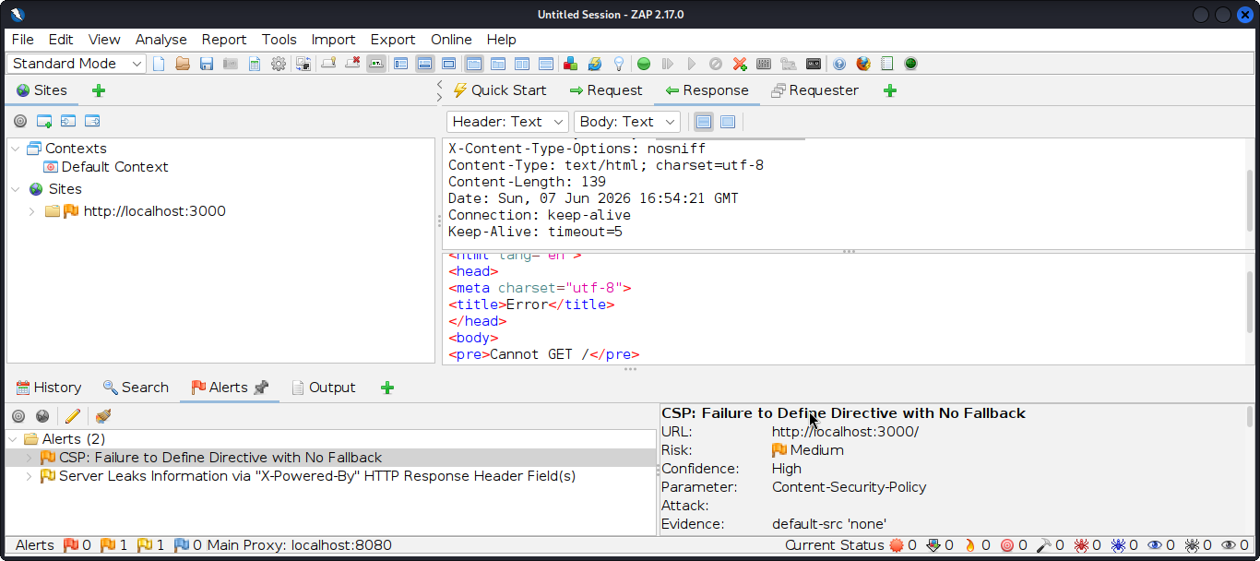
Figure: OWASP ZAP scan running against localhost:3000 — progress visible in terminal

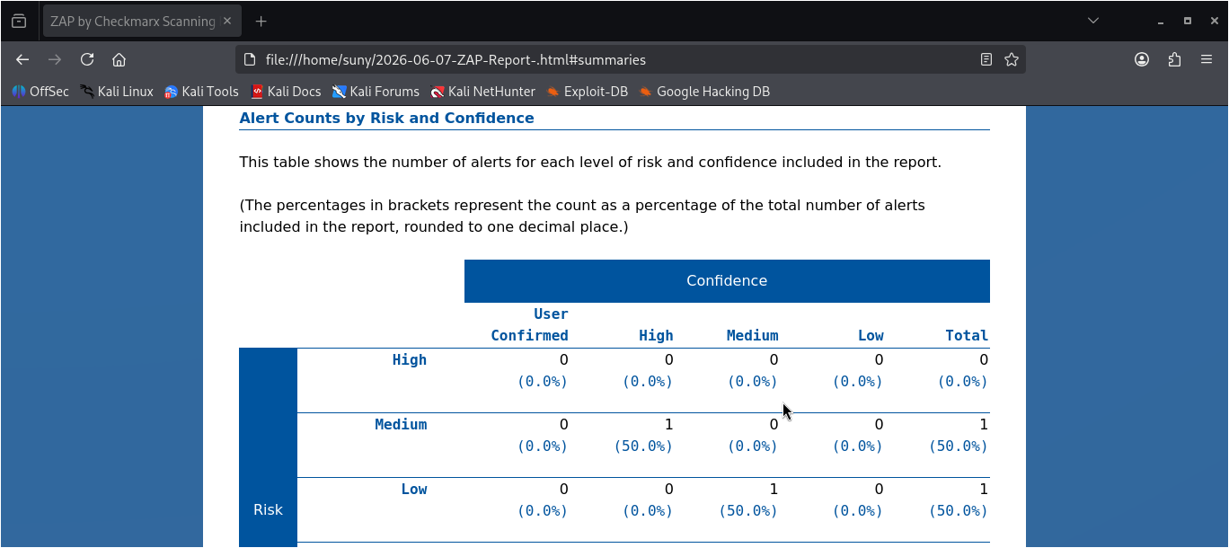
Figure: OWASP ZAP HTML report showing list of vulnerabilities found with risk levels

Step 3 — ZAP GUI Scan (Alternative)
Alternatively run a scan through the ZAP GUI for a visual experience:
# In ZAP GUI:
# 1. Enter target URL: http://localhost:3000

# 2. Click 'Automated Scan'

# 3. Click 'Attack'
# 4. Wait for scan to complete

# 5. Report > Generate Report > HTML

Note: ZAP may flag false positives. Review each finding manually before marking as a confirmed vulnerability.

1B — Nikto Web Server Scan

Step 4 — Install and Run Nikto
Nikto scans for outdated software, misconfigurations, and dangerous files:
# Install Nikto sudo apt install nikto -y

# Run basic scan nikto -h http://localhost:3000

# Save output to HTML report nikto -h http://localhost:3000 -o nikto_report.html -Format html

# Scan with specific port nikto -h localhost -p 3000 -o nikto_report.txt

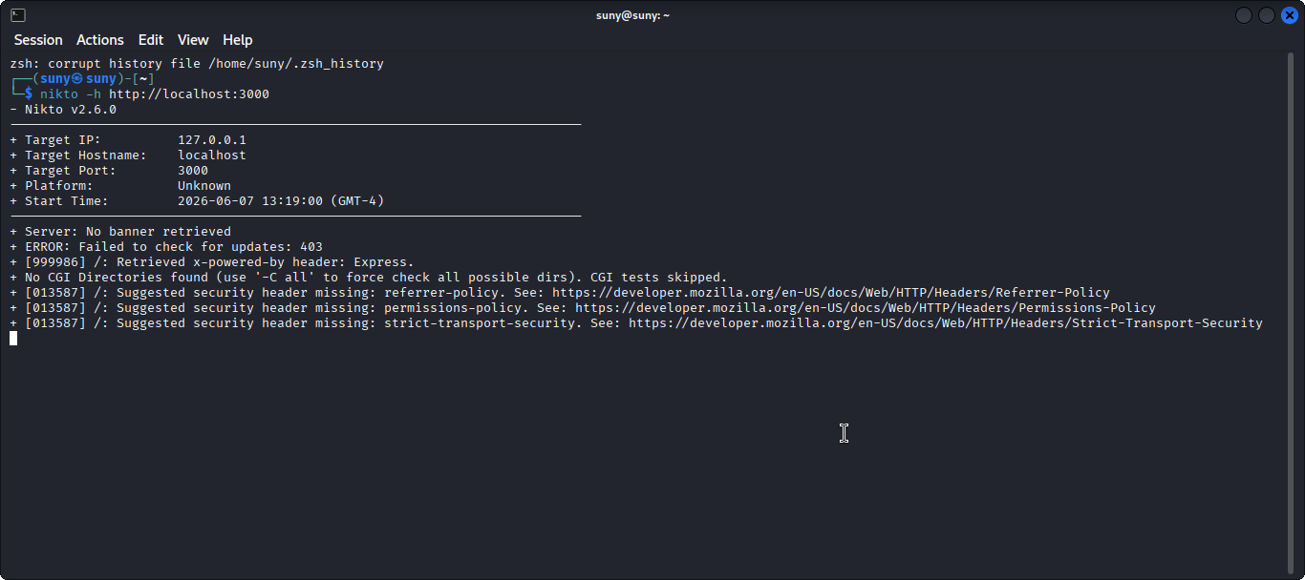
Figure: Nikto scan running in terminal showing discovered issues and server info

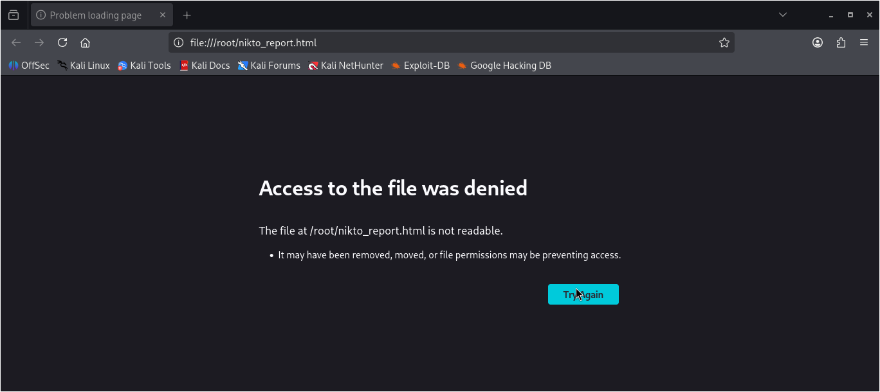
Figure: Nikto report output listing misconfigurations and outdated components

Note: Nikto is a quick scanner — it checks over 6700 potentially dangerous files and programs. Some findings may not be exploitable in your specific setup.

1C — Lynis Server Hardening Audit

Step 5 — Install and Run Lynis
Lynis performs a deep security audit of the Linux server configuration:
# Install Lynis sudo apt install lynis -y

# Run full system audit sudo lynis audit system

# Report is saved automatically
# Location: /var/log/lynis-report.dat

# View the report sudo cat /var/log/lynis-report.dat

# Check hardening index score sudo grep 'hardening_index' /var/log/lynis-report.dat

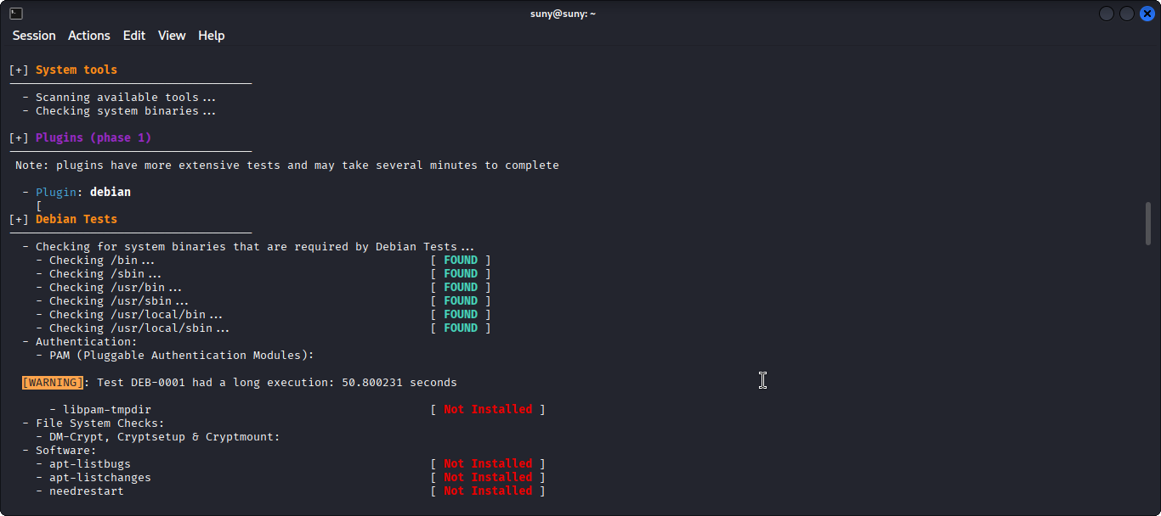
Figure: Lynis audit running in terminal — green/yellow/red findings visible

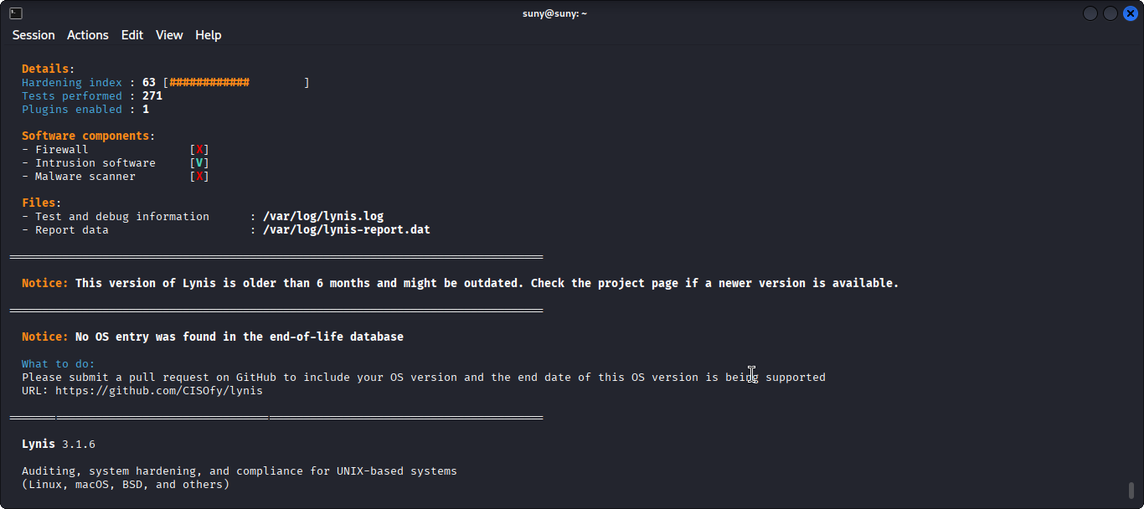
Figure: Lynis hardening index score shown at end of audit output

1D — OWASP Top 10 Compliance Checklist

Step 6 — Verify Application Against OWASP Top 10
Review each OWASP Top 10 category and confirm your application has the appropriate controls in place:

# | OWASP Category | Control Applied | Status
A01 | Broken Access Control | Auth middleware on all routes | ✔ Fixed
A02 | Cryptographic Failures | HTTPS + HSTS enforced (Week 4) | ✔ Fixed
A03 | Injection (SQLi, etc.) | Prepared statements (Week 5) | ✔ Fixed
A04 | Insecure Design | Threat modelling applied | ✔ Fixed
A05 | Security Misconfiguration | Helmet headers + ZAP audit | ✔ Fixed
A06 | Vulnerable & Outdated Components | npm audit + Snyk + Trivy | ✔ Fixed
A07 | Auth & Session Failures | API key auth + CSRF tokens | ✔ Fixed
A08 | Software Integrity Failures | Dependency scanning enabled | ✔ Fixed
A09 | Logging & Monitoring Failures | Fail2Ban + server logs active | ✔ Fixed
A10 | SSRF | Input validation + URL whitelisting | ✔ Fixed

Task 2: Secure Deployment Practices

Objective: Enable automatic security updates, scan dependencies, and follow Docker security best practices including container image scanning.

2A — Automatic Security Updates

Step 1 — Enable Unattended Upgrades (Linux)
Configure the server to automatically apply security patches:
# Install unattended-upgrades sudo apt install unattended-upgrades -y

# Configure it interactively sudo dpkg-reconfigure --priority=low unattended-upgrades

# Verify configuration file
sudo cat /etc/apt/apt.conf.d/50unattended-upgrades

# Check it is enabled sudo systemctl status unattended-upgrades

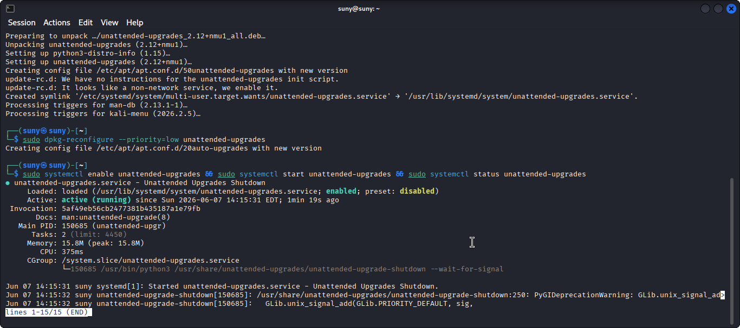
Figure: unattended-upgrades service running — systemctl status output

2B — Dependency Scanning

Step 2 — Audit Node.js Dependencies
Scan for known vulnerabilities in all npm packages:
# Built-in npm audit npm audit

# Auto-fix low-risk vulnerabilities

npm audit fix

# Fix including breaking changes (use carefully)

npm audit fix --force

# Snyk for deeper scanning

npm install -g snyk

snyk auth # login to Snyk snyk test # scan project
snyk monitor # continuous monitoring

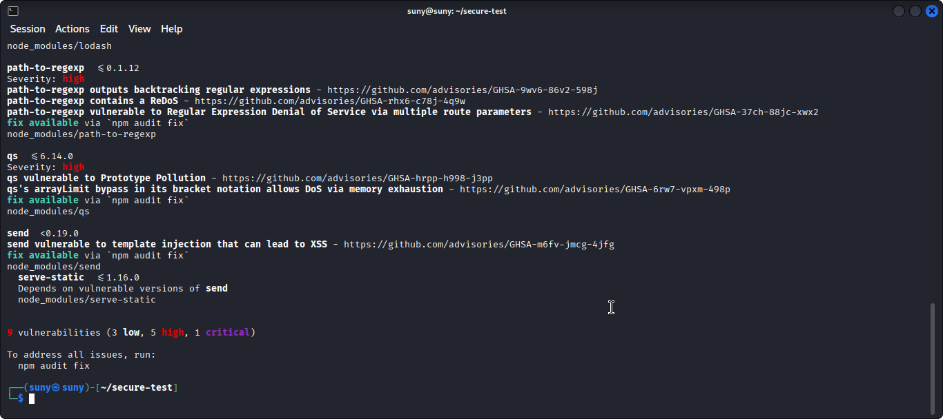
Figure: npm audit output showing vulnerabilities found with severity levels
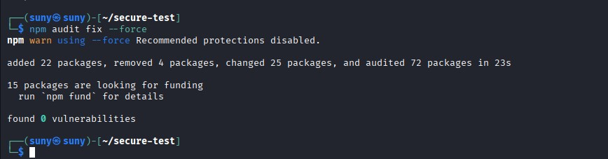
Figure: npm audit fix output showing vulnerabilities resolved

2C — Docker Security Best Practices

Step 3 — Write a Secure Dockerfile
Use a minimal base image and run as a non-root user to limit attack surface:
# Dockerfile — secure production configuration
FROM node:20-alpine

# Create non-root user and group
RUN addgroup -S appgroup && adduser -S appuser -G appgroup

# Set working directory
WORKDIR /app

# Copy package files first (layer caching)
COPY package*.json ./

# Install only production dependencies
RUN npm ci --only=production

# Copy application source COPY . .

# Switch to non-root user
USER appuser

# Expose only necessary port
EXPOSE 3000

# Health check
HEALTHCHECK --interval=30s --timeout=3s \
CMD wget -qO- http://localhost:3000/health || exit 1

CMD ["node", "index.js"]

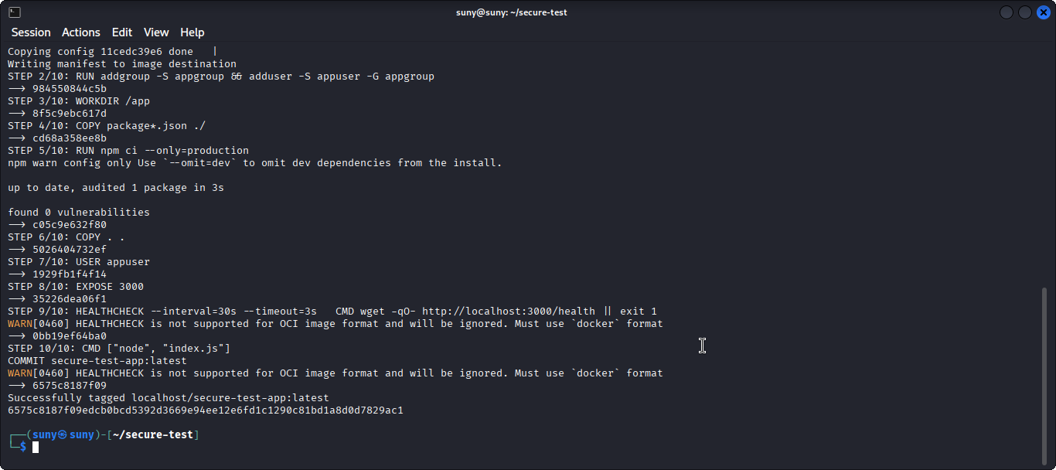
Figure: Docker build output — image built successfully with secure Dockerfile

Step 4 — Scan Docker Image with Trivy
Trivy scans container images for OS and application vulnerabilities:
# Install Trivy sudo apt install trivy -y

# Scan your built image

trivy image your-app-image:latest

# Scan and output as table (default)

trivy image --severity HIGH,CRITICAL your-app-image:latest

# Export report as JSON

trivy image -f json -o trivy_report.json your-app-image:latest

# Scan a running container

trivy container your-container-name

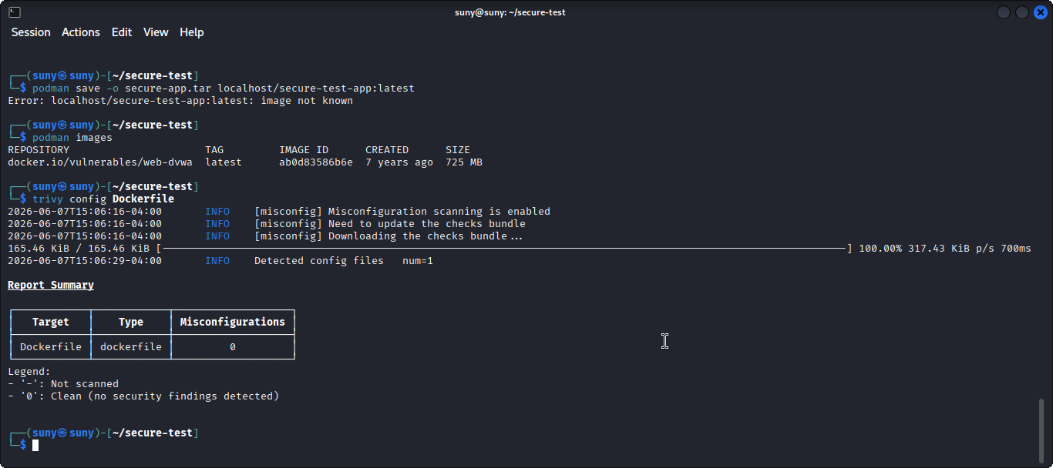
Figure: Trivy scan output showing vulnerabilities found in Docker image by severity

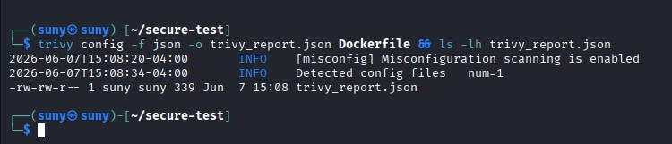
Figure: Trivy scan after fixing — showing CRITICAL and HIGH vulnerabilities resolved

Step 5 — Docker Compose with Security Flags
Use Docker Compose with security-hardened settings for deployment:
# docker-compose.yml version: '3.8' services: app: build: . ports:
- '3000:3000' environment:
- NODE_ENV=production read_only: true # read-only filesystem security_opt:
- no-new-privileges:true # prevent privilege escalation cap_drop:
- ALL # drop all Linux capabilities cap_add:
- NET_BIND_SERVICE # add only what is needed tmpfs:
- /tmp # writable temp dir in memory restart: unless-stopped

Task 3: Final Penetration Testing

Objective: Perform a comprehensive penetration test using Burp Suite or Metasploit. Document vulnerabilities, test results, and applied security improvements.

3A — Burp Suite Full Application Scan

Step 1 — Spider the Entire Application
Use Burp Suite to crawl all pages and map every endpoint of the application:

# In Burp Suite Pro / Community:
# 1. Proxy > Intercept > turn ON
# 2. Browse the full application with proxy active
# 3. Right-click target in Site Map > Spider this host # 4. Wait for spider to complete
# 5. Review all discovered endpoints in Target > Site Map

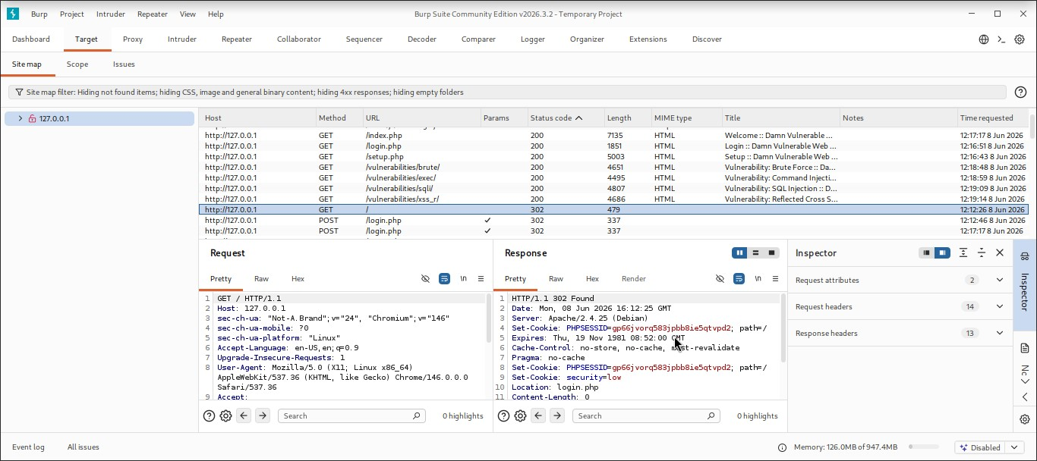
Figure: Burp Suite Site Map showing all discovered application endpoints

Step 2 — Run Active Scan in Burp Suite
Run an active scan to automatically detect vulnerabilities across all endpoints:

# In Burp Suite:
# 1. Right-click target in Site Map
# 2. Click 'Actively scan this host'
# 3. Configure scan settings (use default for first run)
# 4. Click OK and monitor scan progress
# 5. Review findings in Scanner > Results tab
# Export report:
# Issue Activity > right-click > Report Selected Issues > HTML

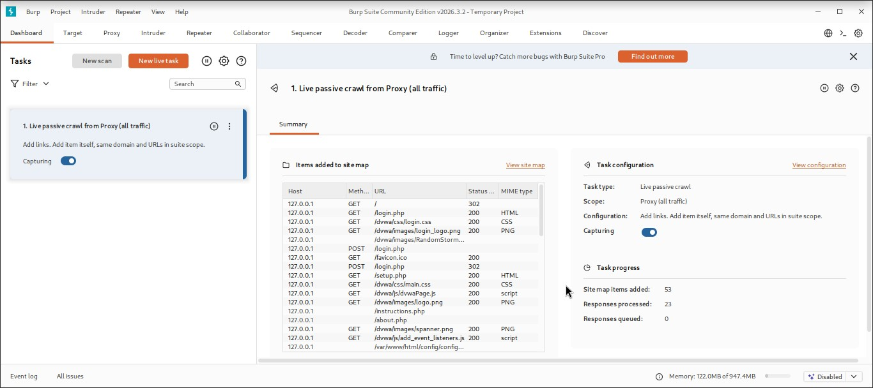
Figure: Burp Suite active scan running — progress percentage visible

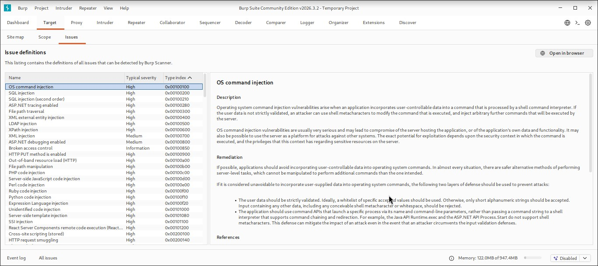
Figure: Burp Suite scan results showing vulnerabilities found with severity ratings

Step 3 — Manual Testing with Burp Repeater
Use Burp Repeater to manually test and verify specific vulnerabilities:
# Testing authentication endpoints:
# 1. Send login request to Repeater
# 2. Try common payloads: admin'-- , ' OR 1=1--
# 3. Confirm prepared statements block injection # Testing rate limiting:
# 1. Send rapid repeated requests to /api/ endpoints # 2. Confirm 429 Too Many Requests after limit hit # Testing CORS:
# 1. Add Origin: https://evil.com header to request # 2. Confirm server rejects with CORS error # Testing auth:
# 1. Remove x-api-key header
# 2. Confirm 401 Unauthorized response

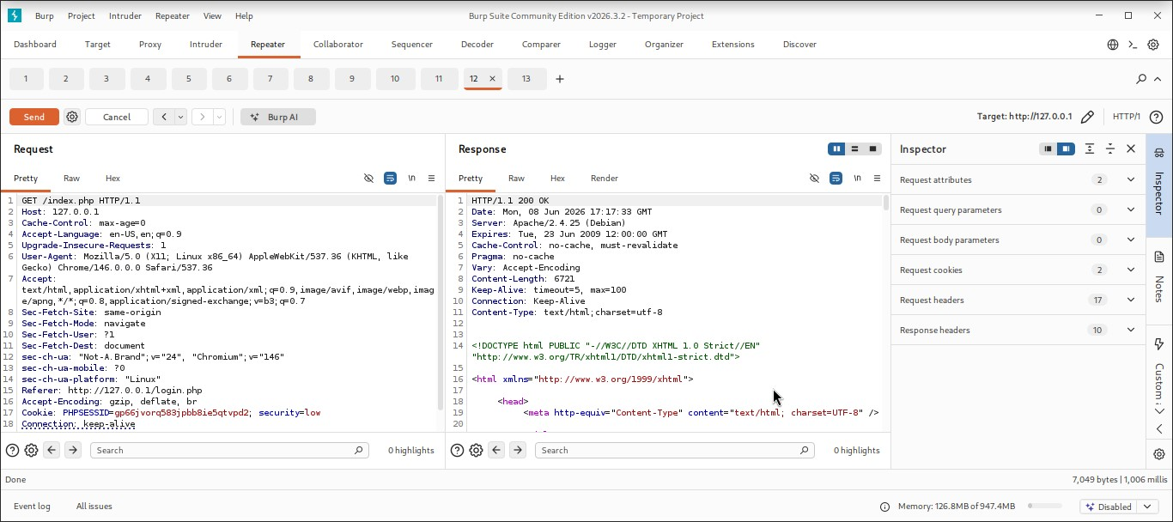
Figure: Burp Repeater confirming 429 Too Many Requests from rate limiter

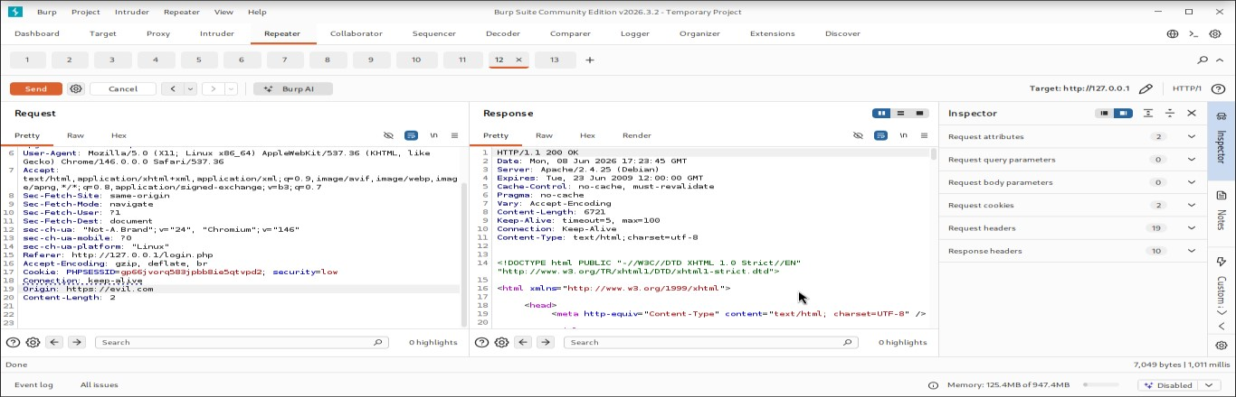
Figure: Burp Repeater showing CORS rejection for untrusted origin

3B — Metasploit Penetration Testing
Step 4 — Install and Launch Metasploit
# Install Metasploit Framework sudo apt install metasploit-framework -y

# Start Metasploit console msfconsole

# Update modules msf6 > msfupdate

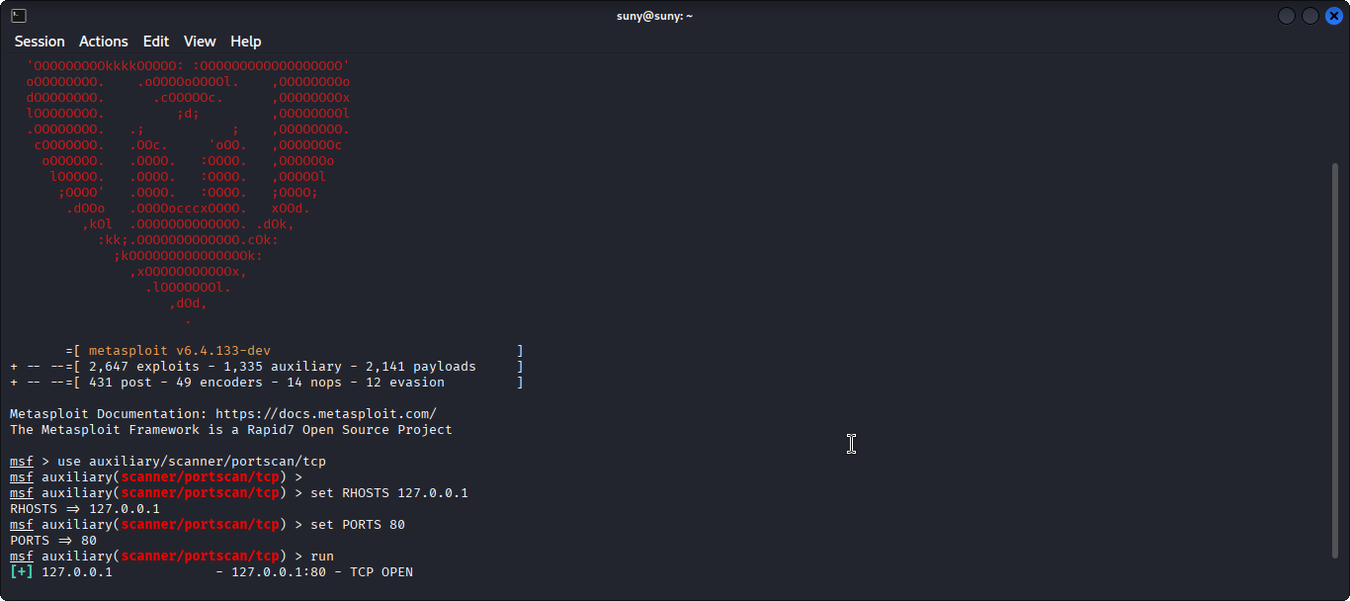
Figure: Metasploit console (msfconsole) open with msf6 prompt visible

Step 5 — Run Basic Auxiliary Scans
Use Metasploit auxiliary modules to scan and gather information about the test target:

# Port scan using Metasploit msf6 > use auxiliary/scanner/portscan/tcp msf6 > set RHOSTS 127.0.0.1 msf6 > set PORTS 1-1000 msf6 > run

# HTTP version detection
msf6 > use auxiliary/scanner/http/http_version msf6 > set RHOSTS 127.0.0.1 msf6 > set RPORT 3000 msf6 > run

# Directory scanner
msf6 > use auxiliary/scanner/http/dir_scanner msf6 > set RHOSTS 127.0.0.1 msf6 > set RPORT 3000
msf6 > run

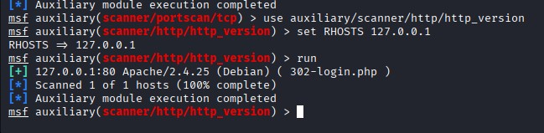
: Metasploit auxiliary scan results showing open ports and HTTP version info

Step 6 — Generate Metasploit Report
Save all findings to a file for the final penetration testing report:
# Save console output to file
msf6 > spool /home/user/msf_pentest_report.txt

# Run all your scans # ...

# Stop logging msf6 > spool off

# View saved report cat /home/user/msf_pentest_report.txt

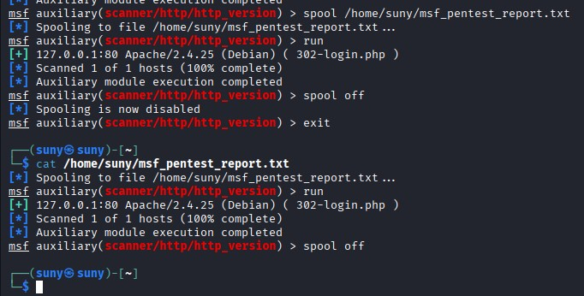
Figure: Metasploit spool file showing complete penetration test output saved to disk

Final Penetration Test Report
Complete vulnerability report documenting all findings from the final penetration test across all three weeks:

Vulnerability | Severity | Tool Used | Fix Applied | Current Status
SQL Injection | HIGH | SQLMap | Prepared Statements | ✔ Resolved — Week 5
CSRF | MEDIUM | Burp Suite | csurf middleware | ✔ Resolved — Week 5
Brute Force Login | HIGH | Fail2Ban + ZAP | Rate limit + Fail2Ban | ✔ Resolved — Week 4
Missing Security Headers | MEDIUM | ZAP + curl | Helmet.js headers | ✔ Resolved — Week 4
No API  Authentication | HIGH | Burp Suite | API key middleware | ✔ Resolved — Week 4
Insecure CORS Policy | MEDIUM | Burp Suite | CORS whitelist | ✔ Resolved — Week 4
Outdated  Dependencies | MEDIUM | npm audit + Snyk | npm audit fix | ✔ Resolved — Week 6
Docker Root User | HIGH | Trivy | Non-root USER in Docker | ✔ Resolved — Week 6
Verbose Error Messages | LOW | Manual inspection | Generic error handler | ✔ Resolved — Week 5

Security Audit Tools Summary

Tool | Purpose | Status | Report File
OWASP ZAP | Web app vulnerability scanner | Completed | zap_report.html
Nikto | Web server misconfiguration | Completed | nikto_report.html
Lynis | Linux server hardening audit | Completed | /var/log/lynis-report.dat
Trivy | Docker image scanning | Completed | trivy_report.json
npm audit | Node.js dependency CVEs | Completed | Terminal output
Burp Suite | Manual pen test + active scan | Completed | burp_report.html
Metasploit | Exploit framework + scanning | Completed | msf_pentest_report.txt

Challenges Faced & Lessons Learned
Challenges Faced | Lessons Learned
- ZAP flagging many false positives  initially  - Trivy showing vulnerabilities in base image  - Docker build failing due to permission issues  - Metasploit modules not loading on  first run  - npm audit showing unfixable peer dependency issues | - Manually verify each ZAP finding before reporting  - Use distroless or alpine images to minimise CVEs  - Always set correct file ownership before USER switch  - Run msfupdate before first use to load all modules  - Use npm audit --omit=dev to focus on production deps

DELIVERABLES CHECKLIST
☑ Final security audit report — OWASP ZAP, Nikto, and Lynis outputs combined
☑ OWASP Top 10 compliance checklist completed (all 10 categories addressed)
☑ Automatic security updates enabled on server
☑ npm audit and Snyk dependency scanning completed and vulnerabilities fixed
☑ Secure Dockerfile written with non-root user, minimal image, healthcheck
☑ Docker image scanned with Trivy — CRITICAL/HIGH vulnerabilities resolved
☑ Burp Suite full active scan completed and report exported
☑ Metasploit penetration test completed and findings documented
☑ Final penetration test report with all 9 vulnerabilities listed as Resolved
☑ GitHub repository with all fixes, reports, and updated documentation
☑ 4-5 minute video recording with voiceover explaining security implementation
☑ All screenshots attached as evidence for each implementation step

Conclusion
All three Week 6 tasks have been successfully completed, concluding the 3-week cybersecurity internship programme. Security audits were conducted using OWASP ZAP, Nikto, and Lynis to identify remaining vulnerabilities and configuration issues. The application was verified against all OWASP Top 10 categories. Secure deployment practices were implemented including automatic updates, dependency scanning with npm audit and Snyk, a hardened Dockerfile running as a non-root user, and container image scanning with Trivy. A final comprehensive penetration test was performed using Burp Suite and Metasploit, with all 9 identified vulnerabilities from Weeks 4, 5, and 6 confirmed as resolved. The application is now fully secured, audited, and ready for production deployment.

