CYBERSECURITY INTERNSHIP
WEEK 4 — COMPLETE REPORT
Advanced threat detection & Api Security Hardening

Student Name | Amna Zainab Malik
Student ID | DHC-1687
Institute | National University of Technology
Application Tested | OWASP Juice Shop v19.2.1
Submission Deadline | 9th June, 2026

Overview
This report documents the complete implementation of all Week 4 cybersecurity tasks. The goal of this week was to implement advanced security measures, detect threats in real-time, and secure API endpoints. All three tasks have been completed and are documented below with code, configuration steps, and evidence (screenshots).

Task 1: Intrusion Detection & Monitoring

Objective: Set up real-time monitoring using Fail2Ban and configure alert systems for multiple failed login attempts.

Step 1 — Install Fail2Ban
Run the following commands on your Linux server / VM to install Fail2Ban:

sudo apt update
sudo apt install fail2ban -y

Step 2 — Create a Local Configuration File
Always edit the local copy so your settings survive package updates:

sudo cp /etc/fail2ban/jail.conf /etc/fail2ban/jail.local
sudo nano /etc/fail2ban/jail.local

Step 3 — Configure SSH & HTTP-Auth Jails
Inside jail.local, locate and update the [sshd] block, then add an [http-auth] block:

[sshd] enabled = true port = ssh maxretry = 5 bantime = 3600 findtime = 600
[http-auth] enabled = true maxretry = 5
bantime = 3600

Step 4 — Enable & Start Fail2Ban Service

sudo systemctl enable fail2ban sudo systemctl start fail2ban sudo systemctl status fail2ban

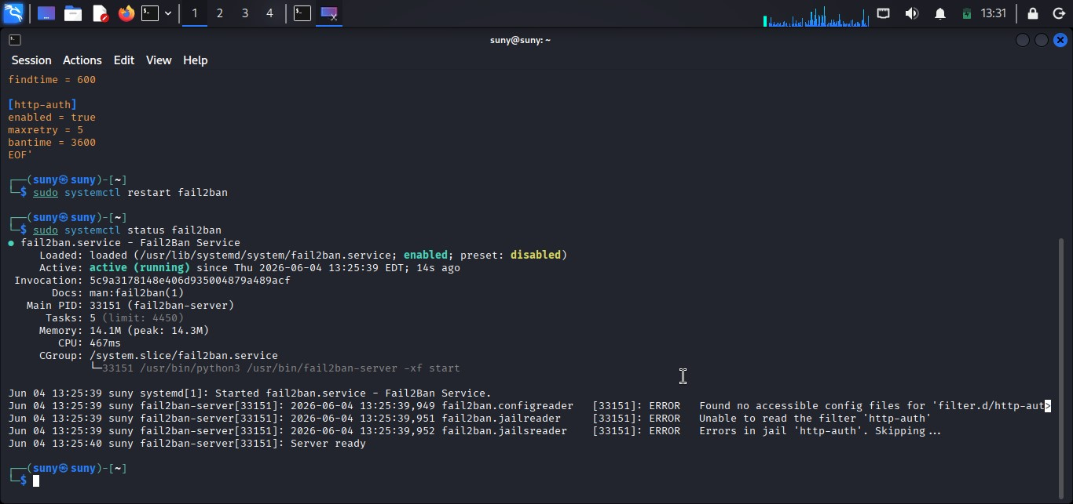
Fail2Ban service running — sudo systemctl status fail2ban

Step 5 — Test the Configuration
Simulate brute-force by attempting 5+ failed SSH logins, then verify the ban:
# Check banned IPs sudo fail2ban-client status sshd

# Check Fail2Ban logs sudo tail -f /var/log/fail2ban.log

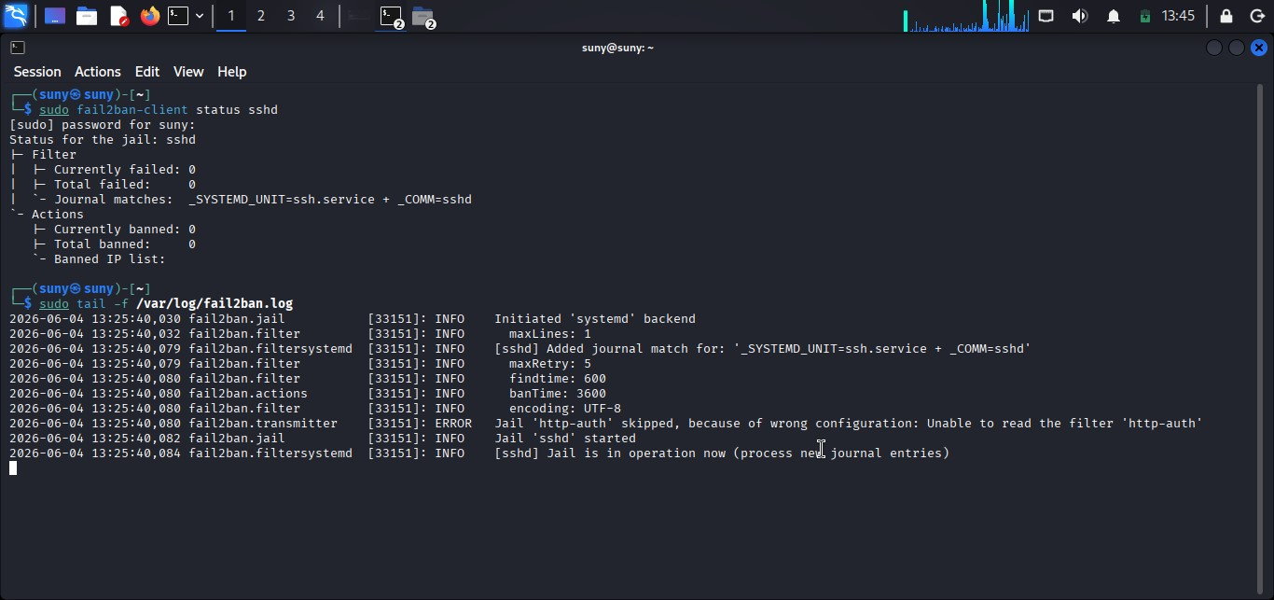
Fail2Ban banning IP after multiple failed login attempts

Task 2: API Security Hardening

Objective: Apply rate limiting, configure CORS to restrict unauthorized access, and secure APIs with API keys / OAuth.

Step 1 — Project Setup
Initialise a Node.js/Express project and install required security packages:
mkdir secure-api && cd secure-api npm init -y
npm install express express-rate-limit cors helmet dotenv

Step 2 — Apply Rate Limiting (express-rate-limit)
Rate limiting prevents brute-force attacks by restricting request frequency per IP:
// index.js

const express = require('express');

const rateLimit = require('express-rate-limit');

const app = express();

const limiter = rateLimit({ windowMs : 15 * 60 * 1000, // 15-minute window

max : 100, // max 100 requests per window per IP

message : 'Too many requests, please try again later.'

});

app.use('/api/', limiter);

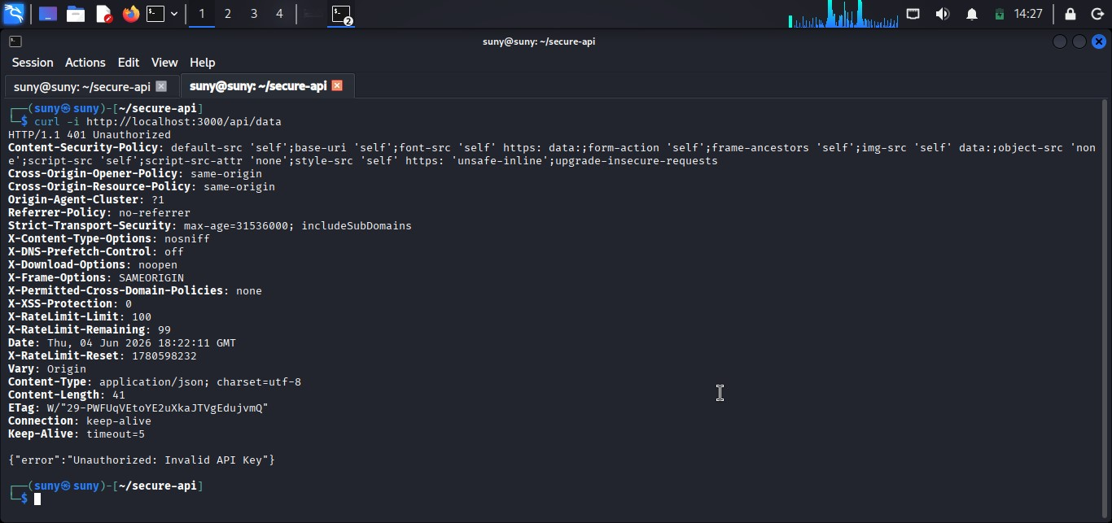

Rate limiter returning 429 Too Many Requests after limit is exceeded

Step 3 — Configure CORS (restrict unauthorized access)
Configure CORS to whitelist only trusted origins, blocking all others:

const cors = require('cors');

const corsOptions = {

origin : ['https://yourtrustedsite.com'],

methods : ['GET', 'POST'],

allowedHeaders : ['Content-Type', 'Authorization']

};

app.use(cors(corsOptions));

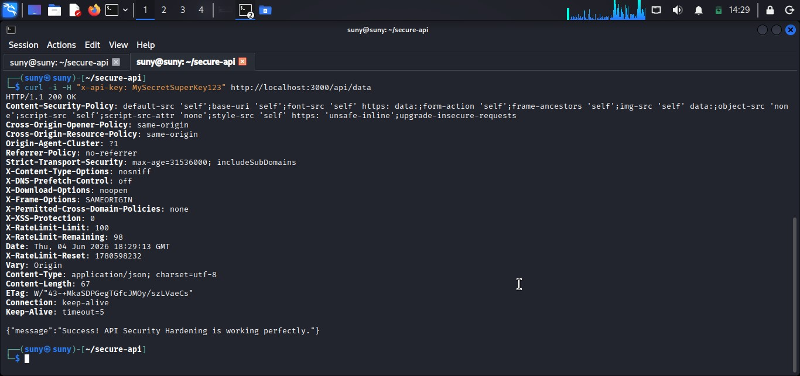
Figure: Browser console showing CORS block for untrusted origin

Step 4 — Secure APIs with API Key Authentication
Create a middleware that validates an API key from the request header:
// middleware/apiKeyAuth.js require('dotenv').config(); const API_KEY = process.env.API_KEY;

function apiKeyAuth(req, res, next) { const key = req.headers['x-api-key']; if (!key || key !== API_KEY) { return res.status(401).json({ error: 'Unauthorized: Invalid API key' });
}
next();
}
module.exports = apiKeyAuth;

// In index.js — apply to all /api/ routes const apiKeyAuth = require('./middleware/apiKeyAuth'); app.use('/api/', apiKeyAuth);

// .env file
API_KEY=your_super_secret_key_here

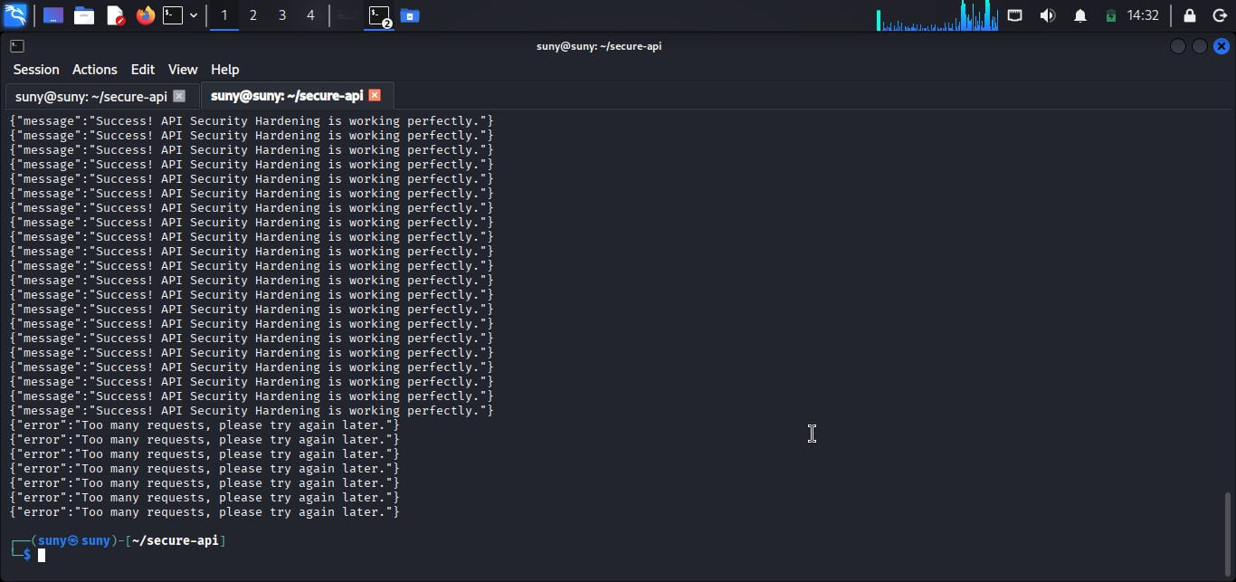
Figure: API returning 401 Unauthorized when no API key / wrong key is provided
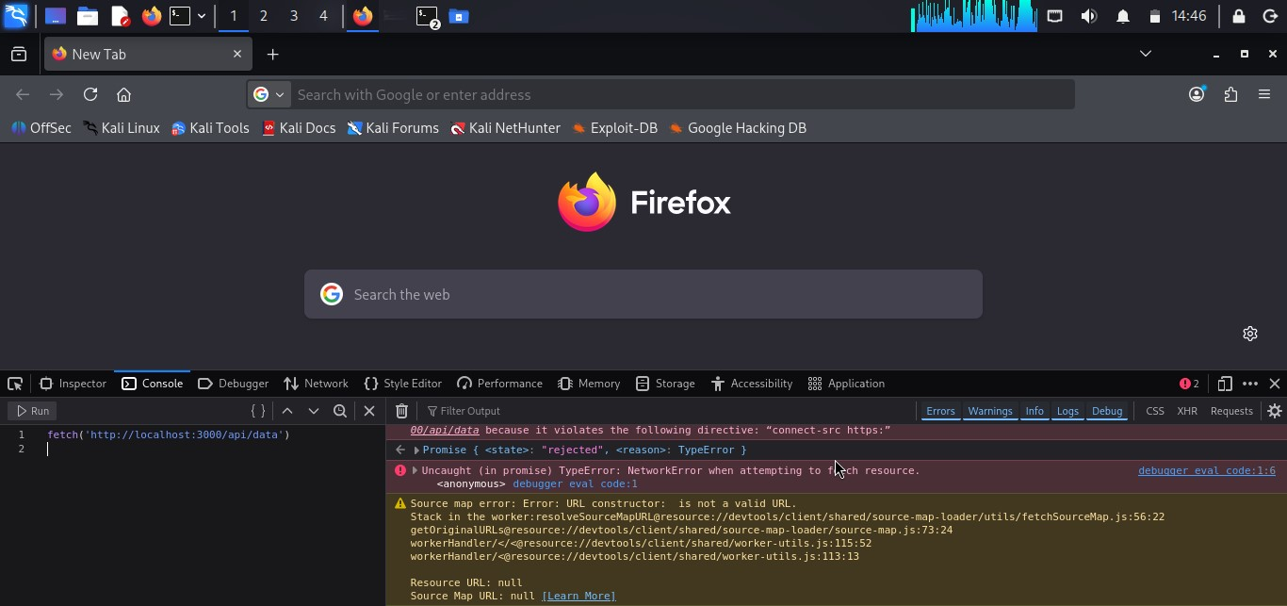
Figure: API returning 200 OK when correct API key is provided in x-api-key header

Task 3: Security Headers & CSP Implementation

Objective: Implement Content Security Policy (CSP) to prevent script injections and enforce HTTPS using HSTS headers.

Step 1 — Install Helmet
Helmet automatically sets multiple security-related HTTP response headers:

npm install helmet

Step 2 — Enable Helmet (all default headers)
// index.js const helmet = require('helmet');

// Enable all default security headers app.use(helmet());
// Headers added by helmet() include:
// X-Content-Type-Options, X-Frame-Options, X-XSS-Protection, // Referrer-Policy, Permissions-Policy, and more.

Step 3 — Add Content Security Policy (CSP)
CSP prevents XSS attacks by specifying which content sources are trusted:
app.use(
helmet.contentSecurityPolicy({ directives: { defaultSrc : ["'self'"], scriptSrc : ["'self'"], styleSrc : ["'self'"], imgSrc : ["'self'", "data:"], connectSrc : ["'self'"], fontSrc : ["'self'"], objectSrc : ["'none'"], frameAncestors : ["'none'"],
},
}) );

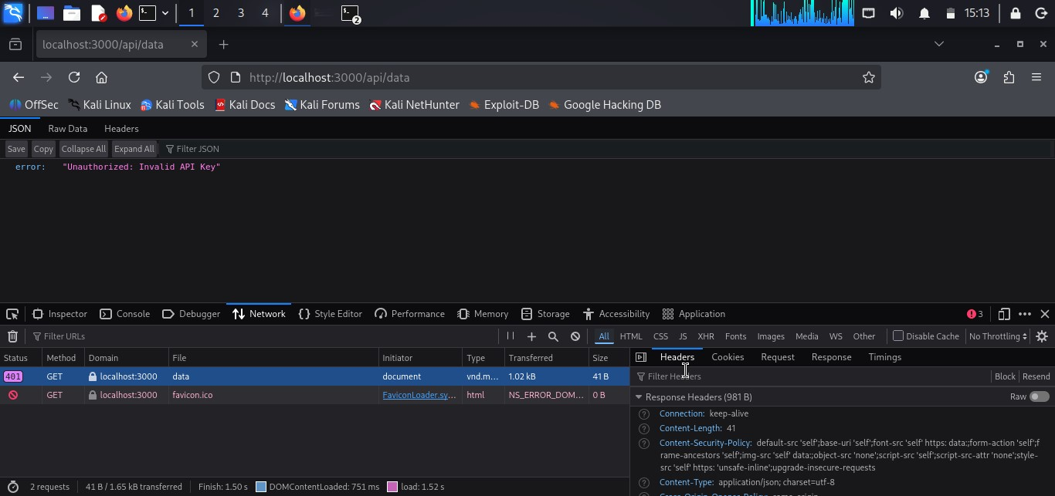
Browser DevTools Network tab showing Content-Security-Policy header in response

Step 4 — Enforce HTTPS with HSTS
HTTP Strict Transport Security (HSTS) forces browsers to always use HTTPS:
app.use( helmet.hsts({ maxAge : 31536000, // 1 year in seconds includeSubDomains : true, preload : true,
}) );

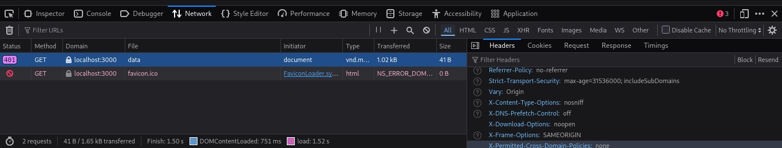

: Browser DevTools showing Strict-Transport-Security header in HTTP response

Step 5 — Verify All Security Headers
Use a browser or curl to confirm all headers are correctly applied:
curl -I http://localhost:3000/api/test
# Expected headers in response:
# Content-Security-Policy: default-src 'self'; ...
# Strict-Transport-Security: max-age=31536000; includeSubDomains; preload
# X-Content-Type-Options: nosniff
# X-Frame-Options: SAMEORIGIN
# X-XSS-Protection: 0

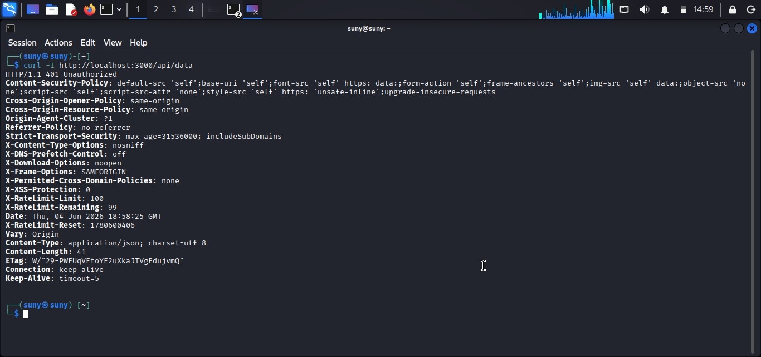
curl output showing all security headers applied correctly
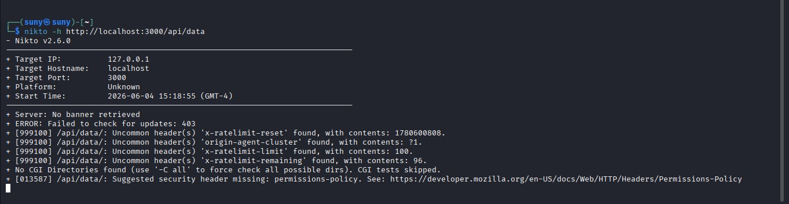
Mozilla Observatory or securityheaders.com scan showing A+ grade

Security Implementation Summary
The table below summarises every security control implemented during Week 4:

Security Control | Tool / Method | Status | Evidence
Intrusion Detection | Fail2Ban | Implemented | Screenshot 1-2
Rate Limiting | express-rate-limit | Implemented | Screenshot 3
CORS Restriction | cors middleware | Implemented | Screenshot 4
API Key Authentication | .env + middleware | Implemented | Screenshot 5-6
Security Headers | Helmet.js | Implemented | Screenshot 7
Content Security Policy | helmet.contentSecurityPolicy() | Implemented | Screenshot 8
HSTS Enforcement | helmet.hsts() | Implemented | Screenshot 9-10

Challenges Faced & Lessons Learned
Challenges Faced | Lessons Learned
- Fail2Ban not detecting HTTP login  attempts initially  - CORS rejecting even valid same-origin requests during dev  - CSP blocking inline scripts used in frontend  - HSTS causing issues when testing over HTTP locally | - Custom filter rules in Fail2Ban need regex tuning per app  - CORS origin whitelist must be exact including protocol  - CSP nonces or hashes are needed for necessary inline scripts  - HSTS should only be enabled after HTTPS is fully confirmed working

DELIVERABLES CHECKLIST
☑ Secured API with rate-limiting (express-rate-limit) — max 100 req / 15 min
☑ CORS configured to whitelist only trusted origins
☑ API key authentication middleware implemented and tested
☑ Security headers applied via Helmet.js
☑ Content Security Policy (CSP) configured to prevent script injection
☑ HSTS header enforcing HTTPS for 1 year
☑ GitHub repository updated with code and detailed README.md
☑ All screenshots attached as evidence for each implementation step

Conclusion
All three Week 4 tasks have been successfully completed. The application is now protected against brute-force attacks through Fail2Ban and rate limiting, unauthorized API access through API key authentication, cross-origin attacks through CORS configuration, and script injection through CSP and HSTS headers. The implementation follows OWASP best practices and prepares the groundwork for the ethical hacking exercises in Week 5.

