

PBL Assignment: Formal Languages & Automata

Topic: “DFA-Based Username Validator”

Name: AMNA ZAINAB MALIK
ID: F24605112
Class: CS24(B)

1. Project Overview
This project is developed under the Visualization Track of Formal Languages and Automata. It demonstrates how a Deterministic Finite Automaton (DFA) can be applied to a real-world problem: username validation.
The system provides a graphical interface (GUI) that allows users to input a username and observe:
- Step-by-step state transitions
- Final decision (Accepted / Rejected)
- Live simulation of DFA behavior
The project helps bridge the gap between theoretical automata concepts and practical implementation.

2. Objectives
- To implement a DFA-based validation system
- To visualize automata processing in real time
- To demonstrate acceptance and rejection of strings

3. Theoretical Background

3.1 Deterministic Finite Automaton (DFA)
A DFA is defined as:
M = (Q , Σ, δ, q₀, F)
Where:
- Q = Set of states
- Σ = Input alphabet
- δ = Transition function
- q₀ = Start state
- F = Set of accepting states

3.2 DFA Design for Username Validation

States:
- q0 → Start state
- q1 → Valid state (Accepting state)
- q2 → Special character state (_ or .)
- qdead → Invalid state

Alphabet (Σ):
- Letters (A–Z, a–z)
- Digits (0–9)
- Special characters: _ and .

Start State: q0

Final State: q1

3.3 Transition Table
Current State | Input | Next State
q0 | Letter | q₁
q0 | Other | q_{dead}
q1 | Letter/Digit | q₁
q1 | _ or . | q₂
q1 | Other | q_{dead}
q2 | Letter/Digit | q₁
q2 | Other | q_{dead}

4. System Design

4.1 Input
User enters a username through the GUI.

4.2 Processing
- The DFA processes each character sequentially
- Transitions are recorded and displayed live

4.3 Output
- ✔ Accepted (Valid username)
- ✖ Rejected (Invalid username)
- Transition trace displayed

5. System Implementation

5.1 Source Code
import tkinter as tk
from tkinter import ttk

# ---------------- DFA WITH TRACE ---------------- #
def validate_with_trace(username):
q0 = "START"
q1 = "VALID"
q2 = "UNDERSCORE/DOT"
qdead = "DEAD"

state = q0
transitions = [f"Start → {state}"]

if len(username) < 3 or len(username) > 20:
return False, ["Invalid length (3–20 required)"]

for ch in username:
prev = state

if state == q0:
state = q1 if ch.isalpha() else qdead

elif state == q1:
if ch.isalnum():
state = q1
elif ch in "_.":
state = q2
else:
state = qdead

elif state == q2:
state = q1 if ch.isalnum() else qdead

transitions.append(f"{prev} --({ch})--> {state}")

return state == q1, transitions

# ---------------- GUI FUNCTIONS ---------------- #
def update_live(event=None):
username = entry.get()
is_valid, transitions = validate_with_trace(username)

transition_box.config(state="normal")
transition_box.delete("1.0", tk.END)

for t in transitions:
transition_box.insert(tk.END, t + "\n")

transition_box.config(state="disabled")

if is_valid:
result_label.config(text="✔ Accepted", fg="#2ecc71")
else:
result_label.config(text="✖ Rejected", fg="#e74c3c")

def clear_all():
entry.delete(0, tk.END)
transition_box.config(state="normal")
transition_box.delete("1.0", tk.END)
transition_box.config(state="disabled")
result_label.config(text="")

# ---------------- WINDOW ---------------- #
root = tk.Tk()
root.title("DFA Username Validator (Professional GUI)")
root.geometry("850x550")
root.configure(bg="#1e1e2f")

style = ttk.Style()
style.theme_use("clam")

# ---------------- HEADER ---------------- #
header = tk.Label(root, text="DFA USERNAME VALIDATOR",
font=("Segoe UI", 20, "bold"),
bg="#1e1e2f", fg="white")
header.pack(pady=10)

# ---------------- MAIN FRAME ---------------- #
main_frame = tk.Frame(root, bg="#1e1e2f")
main_frame.pack(fill="both", expand=True, padx=20, pady=10)

# Split into LEFT (rules) and RIGHT (main UI)
main_frame.columnconfigure(0, weight=1)
main_frame.columnconfigure(1, weight=2)

# ---------------- RULES PANEL ---------------- #
rules_frame = tk.Frame(main_frame, bg="#2c2c3e", padx=15, pady=15)
rules_frame.grid(row=0, column=0, sticky="nsew", padx=(0,10))

tk.Label(rules_frame, text="VALIDATION RULES",
font=("Segoe UI", 13, "bold"),
bg="#2c2c3e", fg="#f1c40f").pack(anchor="w", pady=(0,10))

rules_text = """
1. Must start with a LETTER (A–Z, a–z)
2. Only letters, digits, _ and .
3. No consecutive _ or .
4. Must end with letter or digit
5. Length must be 3 to 20 characters
"""

tk.Label(rules_frame, text=rules_text,
justify="left",
font=("Segoe UI", 10),
bg="#2c2c3e", fg="white").pack(anchor="w")

# ---------------- RIGHT FRAME ---------------- #
frame = tk.Frame(main_frame, bg="#2c2c3e", padx=20, pady=20)
frame.grid(row=0, column=1, sticky="nsew")

frame.columnconfigure(0, weight=1)
frame.columnconfigure(1, weight=2)

# ---------------- INPUT ---------------- #
tk.Label(frame, text="Enter Username:",
bg="#2c2c3e", fg="white",
font=("Segoe UI", 11)).grid(row=0, column=0, sticky="w", pady=10)

entry = ttk.Entry(frame, width=35)
entry.grid(row=0, column=1, pady=10, sticky="ew")
entry.bind("<KeyRelease>", update_live)

# ---------------- RESULT ---------------- #
result_label = tk.Label(frame, text="",
font=("Segoe UI", 12, "bold"),
bg="#2c2c3e")
result_label.grid(row=1, column=0, columnspan=2, pady=10)

# ---------------- TRANSITION LABEL ---------------- #
tk.Label(frame, text="State Transitions:",
bg="#2c2c3e", fg="white",
font=("Segoe UI", 11)).grid(row=2, column=0, columnspan=2, sticky="w", pady=(15,5))

# ---------------- TRANSITION BOX ---------------- #
transition_box = tk.Text(frame,
height=12,
bg="#12121a",
fg="#00ffcc",
font=("Consolas", 10),
relief="flat")
transition_box.grid(row=3, column=0, columnspan=2, sticky="nsew", pady=5)

transition_box.config(state="disabled")

frame.rowconfigure(3, weight=1)

# ---------------- BUTTONS ---------------- #
btn_frame = tk.Frame(frame, bg="#2c2c3e")
btn_frame.grid(row=4, column=0, columnspan=2, pady=15)

ttk.Button(btn_frame, text="Clear", command=clear_all).grid(row=0, column=0, padx=15)
ttk.Button(btn_frame, text="Exit", command=root.destroy).grid(row=0, column=1, padx=15)

# ---------------- FOOTER ---------------- #
footer = tk.Label(root,
text="Live DFA Visualization | TOA Project",
bg="#1e1e2f", fg="#aaaaaa",
font=("Segoe UI", 9))
footer.pack(pady=5)

root.mainloop()

5.2 GUI Design
The system uses Tkinter to create a modern interface:
Components:
- Input field for username
- Transition display box
- Rules for validation
- Result label (Accepted/Rejected)
- Buttons: Clear, Exit

5.3 Screenshots

Main Interface
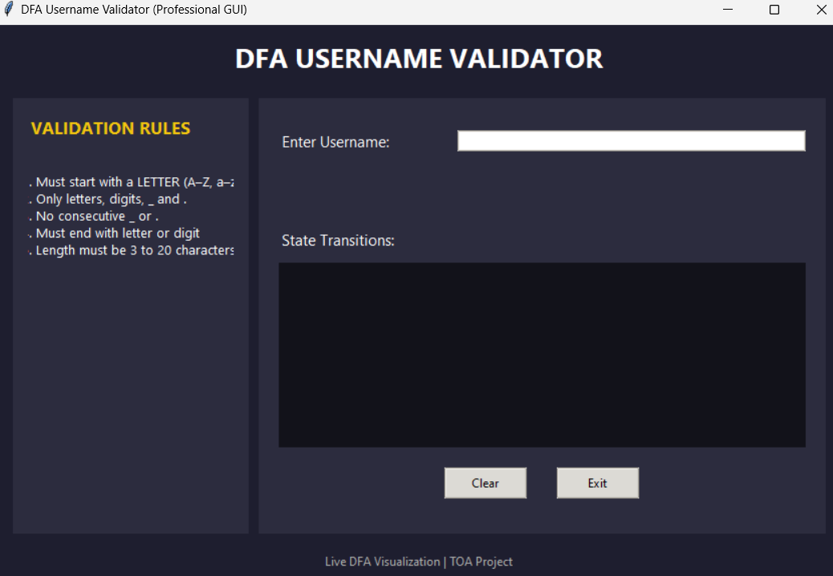
Figure 1: Main GUI layout with input field and controls.

Live DFA Transitions
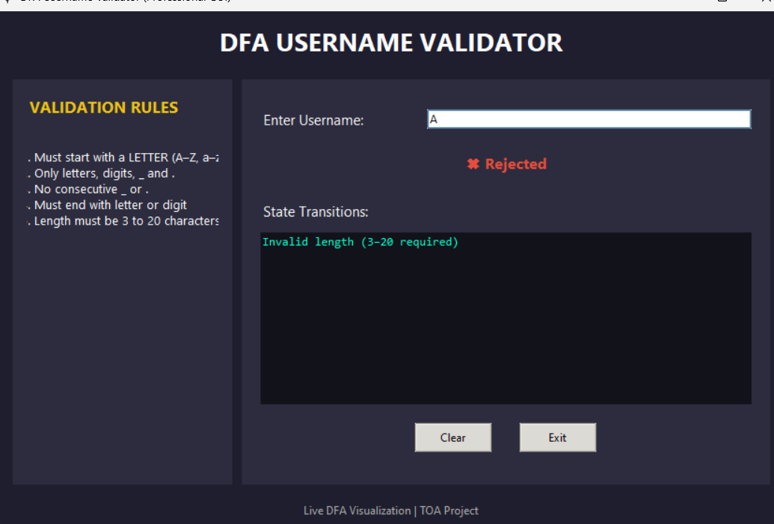
Figure 2:Shows real-time state transitions as user types.

Accepted Input
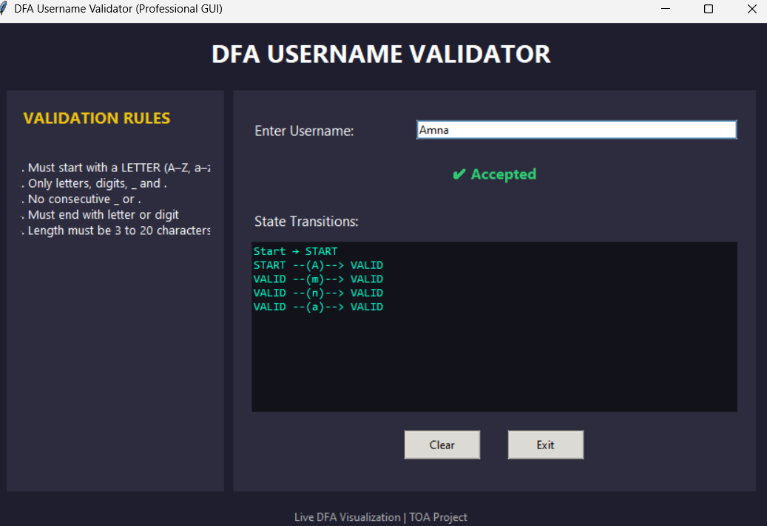
Figure 3:Valid username showing "Accepted" result.

Rejected Input
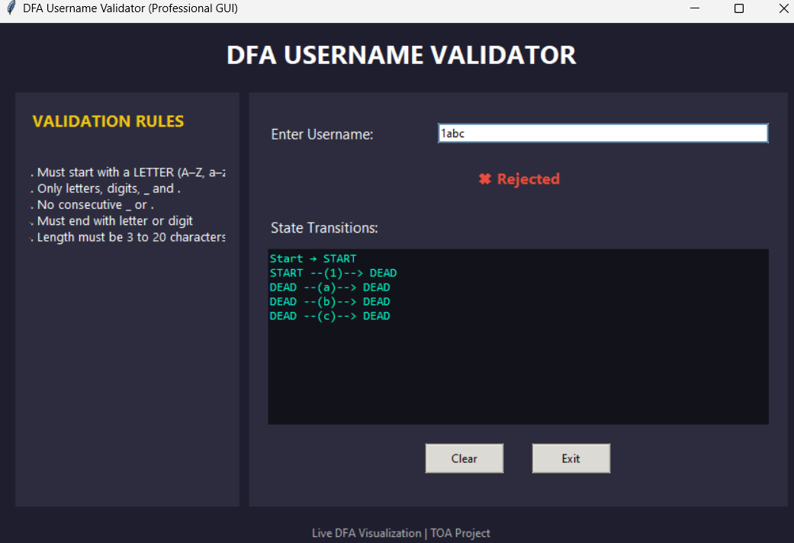
Figure 4: Invalid username showing "Rejected" result.

Edge Case
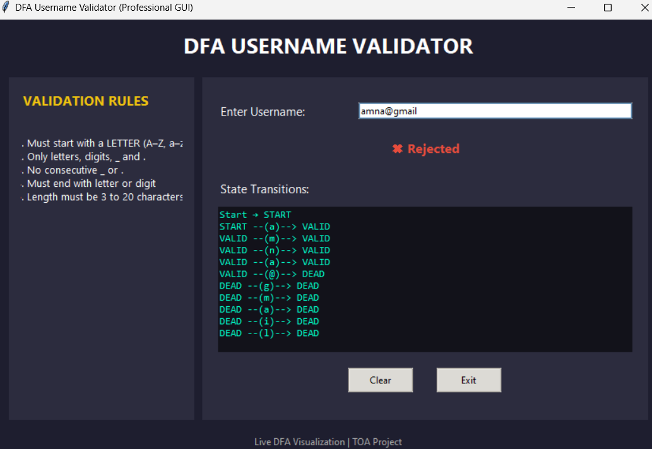
Figure 5:Example of invalid length and special character misuse.

6. Validation Rules (Language Definition)
A valid username must:
- Start with a letter
- Contain only letters, digits, _, .
- Not contain consecutive _ or .
- End with a letter or digit
- Length must be between 3 and 20 characters

7. Test Cases

7.1 Accepted Strings
Input | Expected | Output
Amna | Accept | Accept
user_name | Accept | Accept
abc.def | Accept | Accept
A1_b2 | Accept | Accept
hello123 | Accept | Accept

7.2 Rejected Strings
Input | Expected | Output
1abc | Reject | Reject
ab | Reject | Reject
a__b | Reject | Reject
abc. | Reject | Reject
user@name | Reject | Reject

8. DFA State Diagram
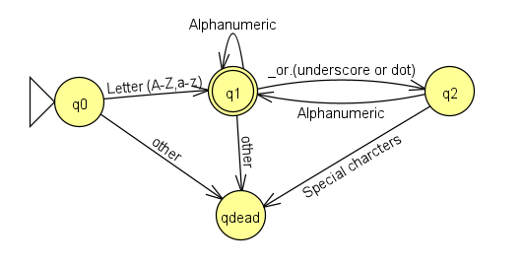
Figure 6:Graphical representation of states (q0, q1, q2, qdead) and transitions.

9. How to Run the Program
- Install Python (3.x)
- Save the code file
- Run the file
- Enter username in GUI
- Observe live transitions

10. Program Termination
The program can be ended by:
- Clicking the Exit button
- Closing the window manually

11. Tools & Technologies Used
- Python
- Tkinter
- DFA (Theory of Automata)

12. Conclusion
This project successfully demonstrates the application of DFA in real-world validation systems. The integration of GUI and live transitions enhances understanding of automata behavior and makes learning interactive.

