

Assessment Submission Form

Student Number | GH1039590
Assessment Title | Credit Card Fraud Detection
Module Code | B141
Module Title | Data Mining (SS0326)
Module Tutor | Prof. Mahmoudreza Babaei
Date Submitted | 26/06/2025
GitHub link | https://github.com/Amnasayeeq/Credit-Card-Fraud-Detection.git
Kaggle Dataset Link | https://www.kaggle.com/datasets/mlg-ulb/creditcardfraud

Declaration of Authorship
I declare that all material in this assessment is my own work except where there is a clear acknowledgement and appropriate reference to the work of others.
I fully understand that the unacknowledged inclusion of another person’s writings or ideas, or works in this work, may be considered plagiarism and that, should a formal investigation process confirm the allegation, I would be subject to the penalties associated with plagiarism, as per GISMA Business School, University of Applied Sciences’ regulations for academic misconduct.
Signed By AMNA
Date 19/12/2025

- Executive Summary
This project is a project that I worked on to fill the position of newly appointed data scientist of a financial services company with one of the critical problems in bank.
The most critical business problem in banking is credit card fraud detection. When there are fraudulent transactions, it costs the company monetarily, through dispute settlements, and, potentially, to the trust of customers.
A full data mining pipeline is presented using the Kaggle Credit Card Fraud Detection dataset that is a real-world anonymized dataset of European Credit Card holders from September 2013 with 284,807 transactional records with only 492 of them being fraudulent (0.172%). This project aims to tackle the main technical challenge of the strongly skewed class distribution.

  - project objective
- Understands where (or not), how fraudulent vs. legitimate transactions occur
- Classify extremely imbalanced data with SMOTE
- Interpret the results of Logistic Regression, Random Forest and XGBoost classifiers
- Understand and use Anomaly-Precision, Recall, F1, ROC-AUC and PR-AUC to evaluate models for imbalanced data
- Give realistic business recommendations, based on the findings of the model/study.

2. Dataset Description
The details of this dataset are taken from Kaggle here: https://www.kaggle.com/datasets/mlg-ulb/creditcardfraud
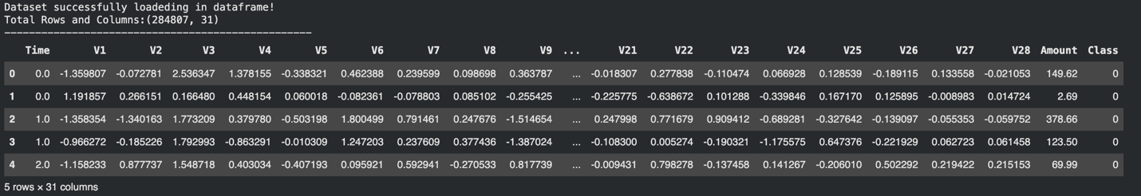
It features transactions carried out by European cards holders in two days, during September 2013. Due to confidentiality needs the original underlying transaction has been anonymized by Principal Component Analysis (PCA), creating 28 numerical features (V1-V28) with numbers representing values of anonymity in transactions.
The only original features are
(target class) Class 1 = fraud, 0 = genuine, Time and Amount.

2.2. Dataset Overview

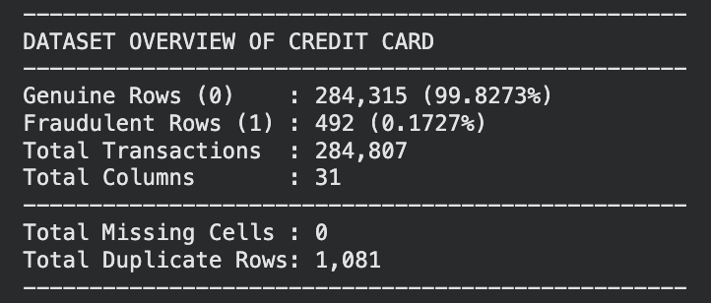

- Exploratory Data Analysis (EDA)
Exploratory data analysis was done to get a hierarchy of the data, to find patterns that
Classify fraud vs legitimate transactions, and notify the preprocessing decisions.

  - Class Imbalance
- This data set here is highly skewed with only 0.172% of the transactions being fraudulent. This has significant ramifications for the procedure of model selection and model assessment:
- A lazy classifier, which classifies all transactions as a real transaction using this setting, has an accuracy rate of 99.83% , but would have no cases of fraud detection.
- The use of standard accuracy is not therefore an appropriate measure. Instead, use Precision, Recall, F1-Score and PR-AUC should be employed.
- Training data needs to be re-balanced prior to fitting the model such as SMOTE.
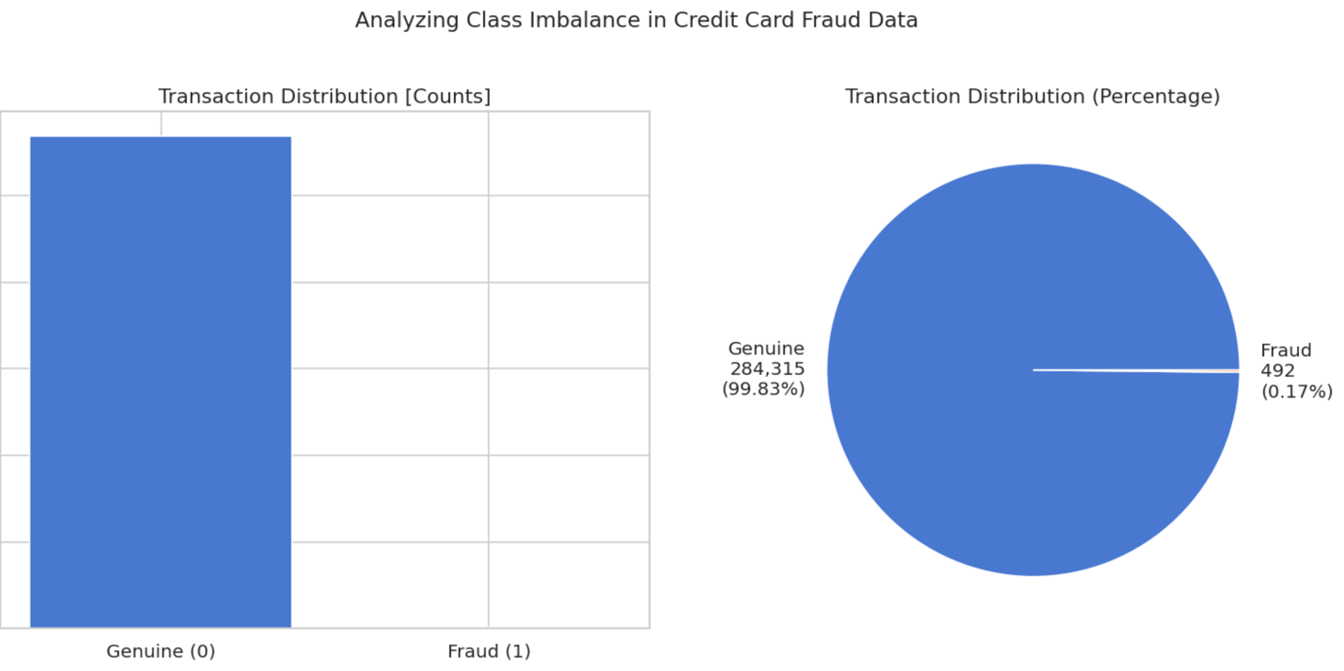
  - Transaction Amount Analysis
A key behavioural pattern can be gleaned based on the amount of money spent in transactions. There's a high risk of fraudulent transactions with a lower mean amount compared to genuine.

  - Transaction Timing
As far as genuine transactions are to be concerned they all share a bimodal distribution throughout the 2 day period, and involve natural human behavior.
The busiest time of year is during working hours. A relative flatter distribution is observed with significant number of fraudulent transactions. Expand at overnight hours which aligns with the time when fraudsters are active when vitamins are not for sale and are not so prone to be unaware of any unusual activity.
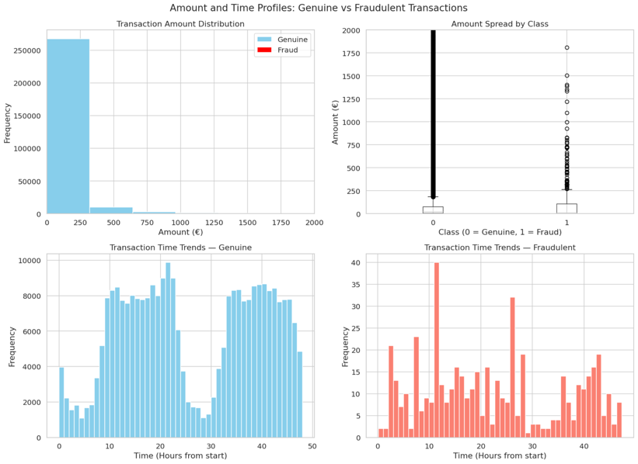
  - Feature Distributions (V1–V28)
The absolute mean difference of the features was computed and the top discriminative PCA features were extracted.
The difference stick with regards to fraud and actually authentic transaction distributions. V14, V4, V12 and V10 clearly show a separation of the distributions between the classes, indicating good predictive signal. V17 also has a very clear separation of the distributions between the classes, although it is significantly less than the other sets, indicating strong predictive signal.
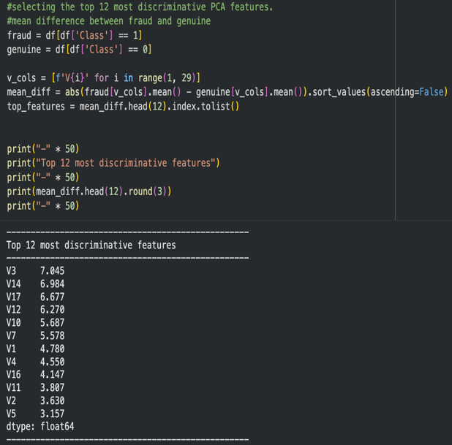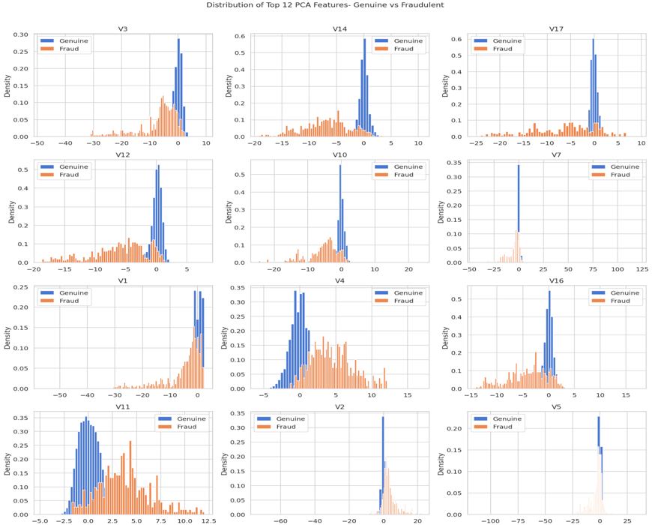
  - Correlation Analysis
Based on the Pearson correlation the strongest negative correlation with the target class is v14,v12 and v10. A positive correlation has been made with fraud for V4, V11 and V2 while a negative correlation has been made with fraud for V5 and V3. These are important features to help with/enhance: Using the linear models include Logistic Regression.
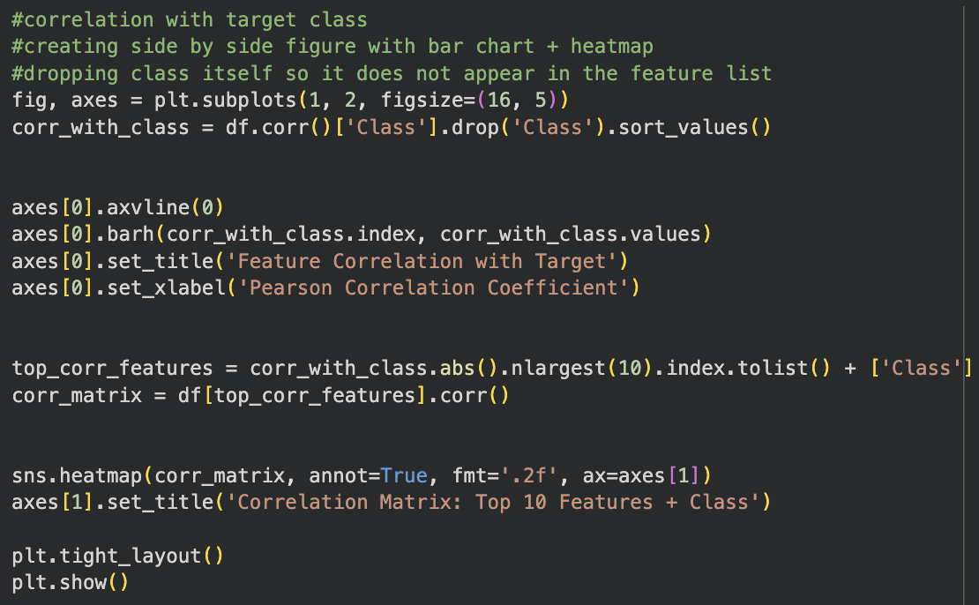
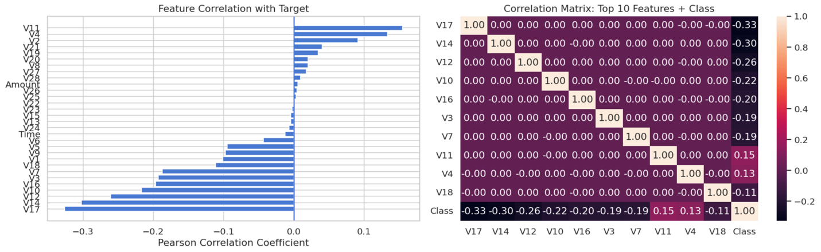

- Data Preprocessing
All the following preprocessing steps were done sequentially before training the models:
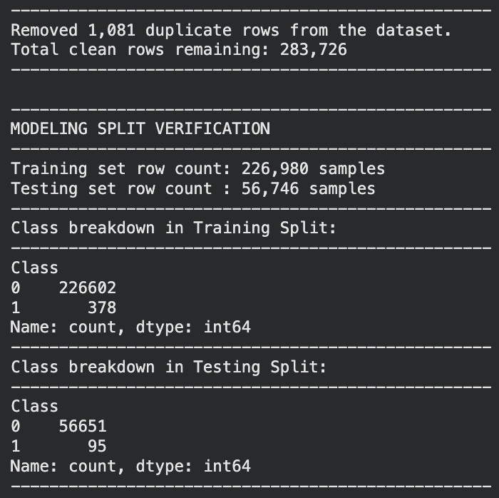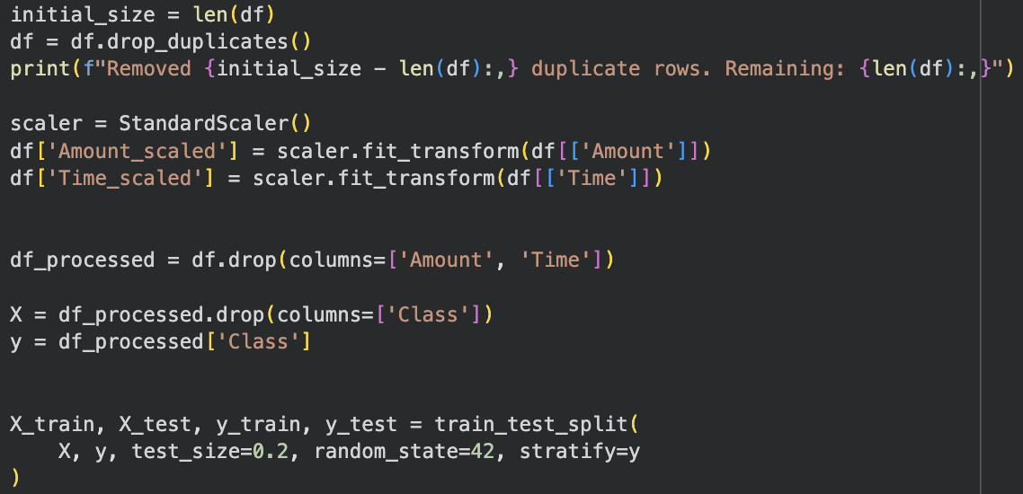
  - SMOTE
The technique is known as ‘Synthetic Minority Over-sampling Technique' or ‘SMOTE'. As opposed to just making a copy of a fraud example, SMOTE creates fraud examples. Based on k nearest neighbour in the space of features of the minority class.
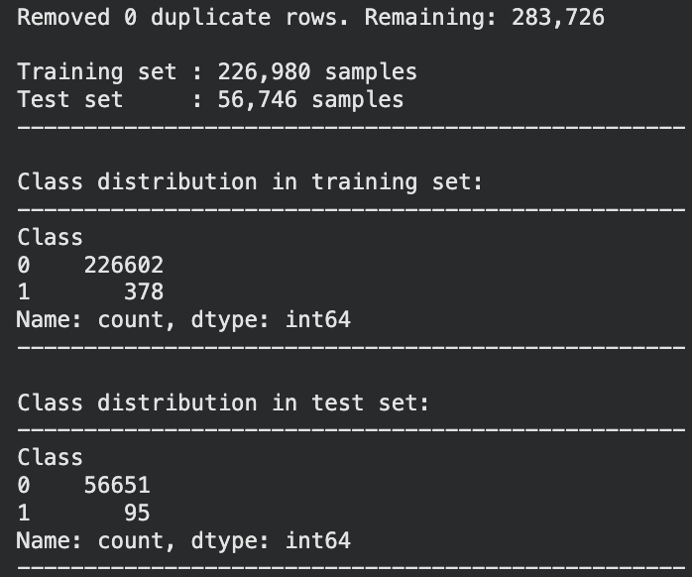
SMOTE here is only used for the training set. If applied to the whole dataset prior to splitting, then getting into the data would result in data leakage he test samples used for synthetic would be samples that are already used in the training process and performance measures would be higher than they would be if they weren't.
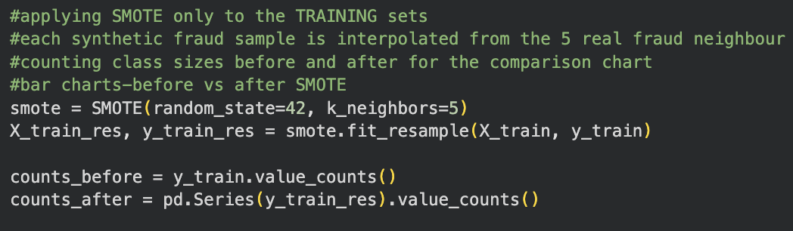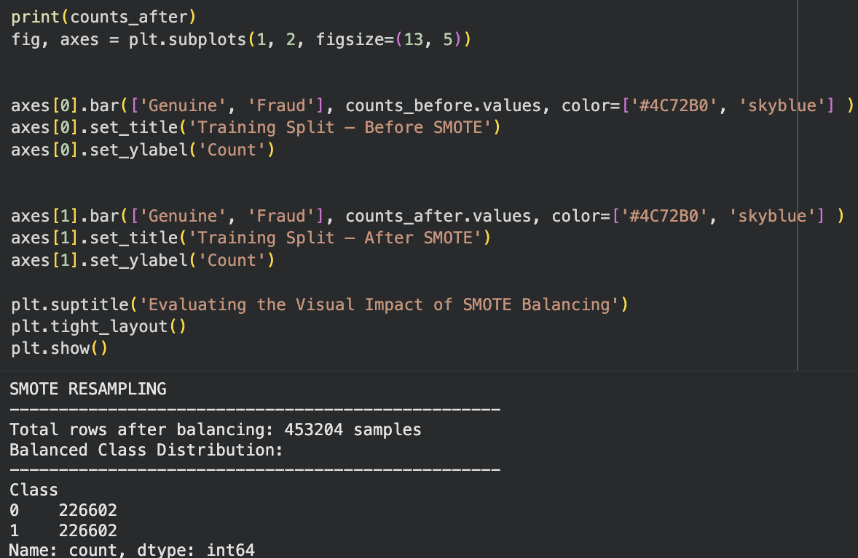
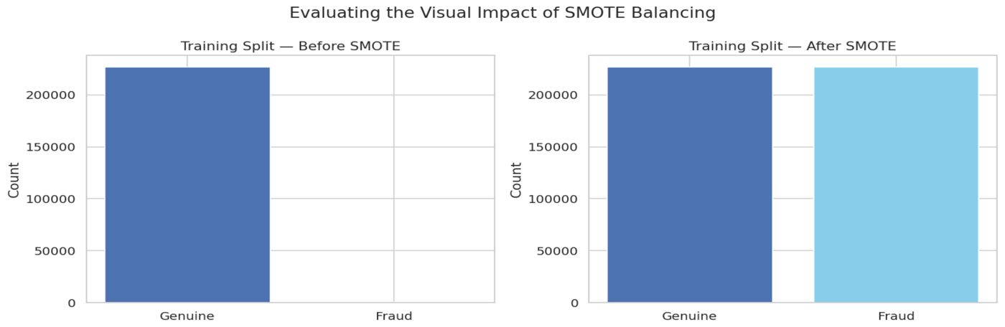
- Model Training
Three supervised classification models were trained using SMOTE balanced training set and tested on the original (not balanced) test data set.
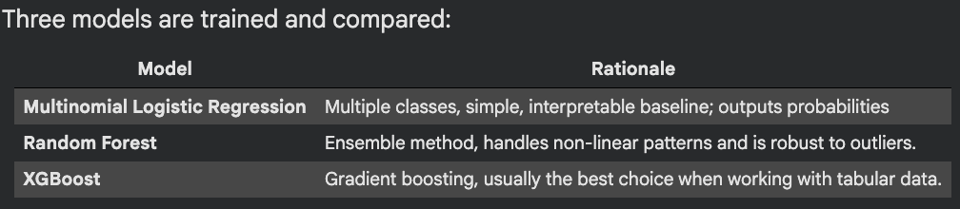

- Model Evaluation
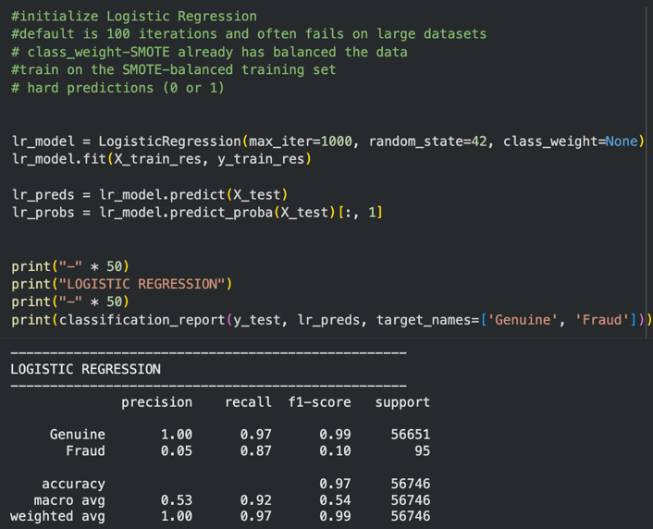
  - Why Not Accuracy?
In scenarios with only 0.172% fraud and labels are assigned correctly regardless of the model's accuracy by simply predicting it to be either, and the few fraud cases the model detects are necessarily correct so a 99.83% accuracy wouldn't mean much here. Instead there are the following metrics used:
  - Results Comparison
The following table briefly summarizes the results of the models evaluated on the test set carried out according to the original imbalanced distribution of the data set. All
Any metrics reported are related to the fraud (positive) class.

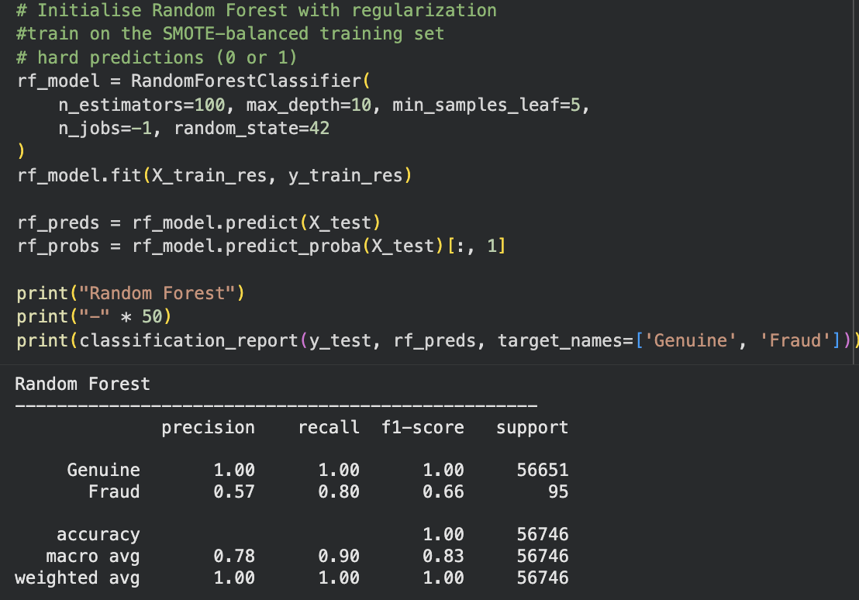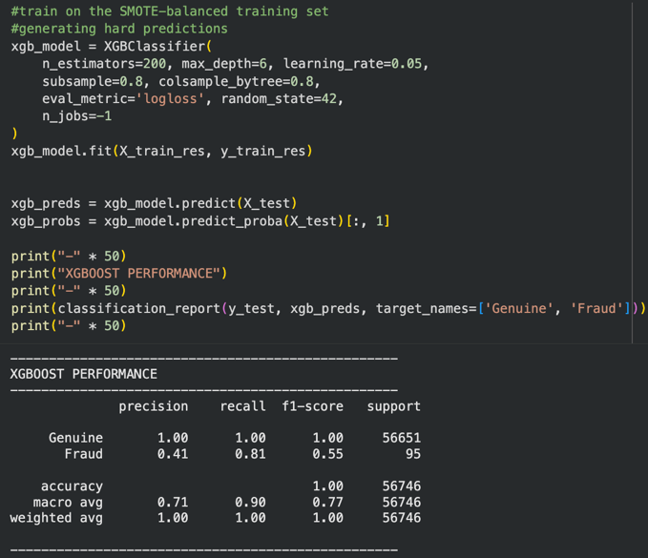

  - Confusion Matrix Analysis
Confusion matrices are used to view and indicate the True Positives (Frauds accurately identified), False Positives, False Negatives and True Negatives.
That produce confusions in transactions, they are called as False Positives (genuine transactions that are wrongly approved), False Negatives (genuine negations), and True Negatives (genuine properly approved).
Negatives (fraud missed). When dealing with fraud, False Negatives are the most costly — if a fraud is not detected it costs the company directly!
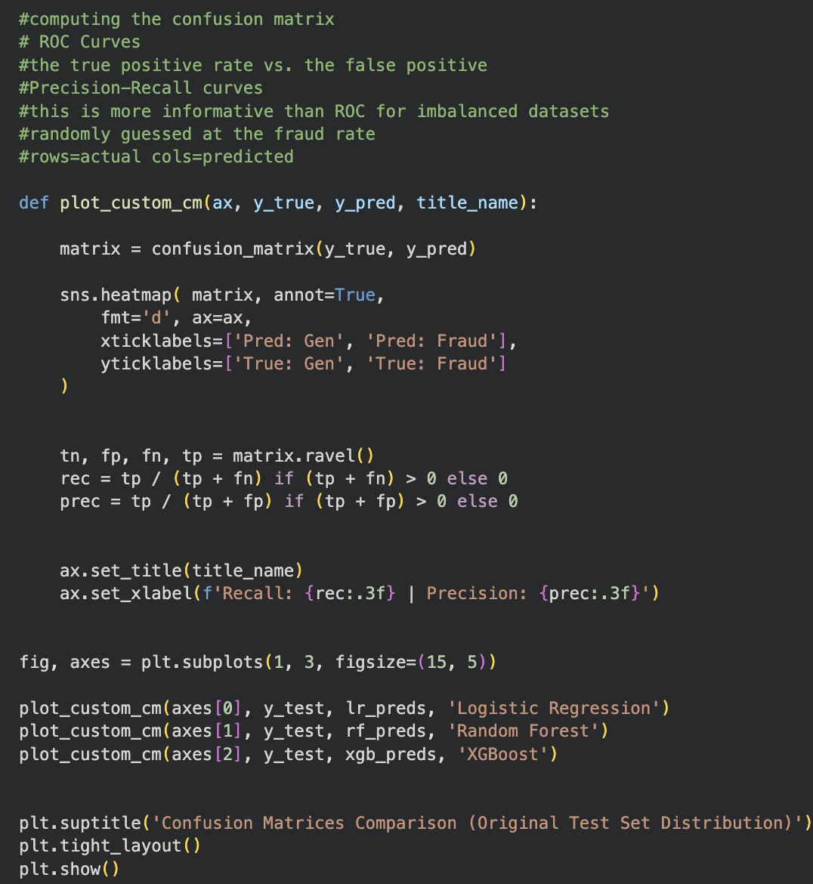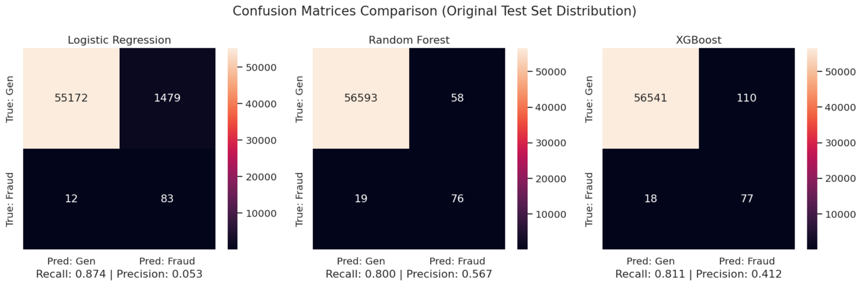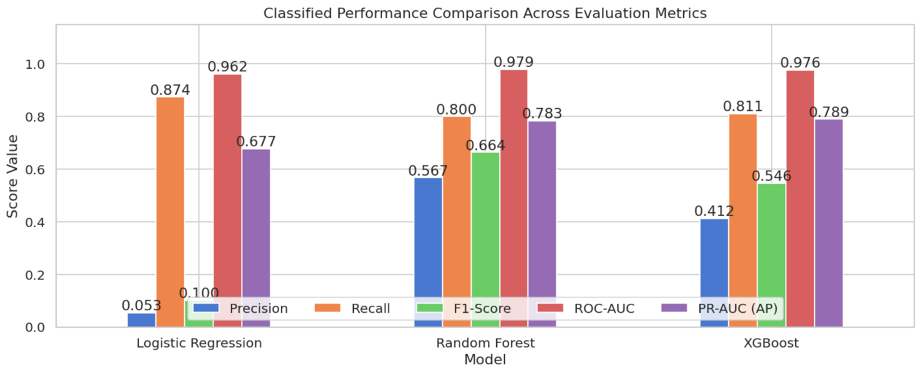
  - ROC and Precision-Recall Curves
Genuine Coverage can be applied to 6.4 ROC and Precision-Recall Curves.
The ROC curve may be misleading when there are many more negative cases, that is, when the number of outcomes is highly skewed, as in a precision-recall (PR) curve will be more informative. The Average Precision (PR-AUC) is high illustrating the fact that the model has high precision and recall scores over thresholds — XGBoost is around 0.88, which is very high as compared to the base rate of 0.0017.
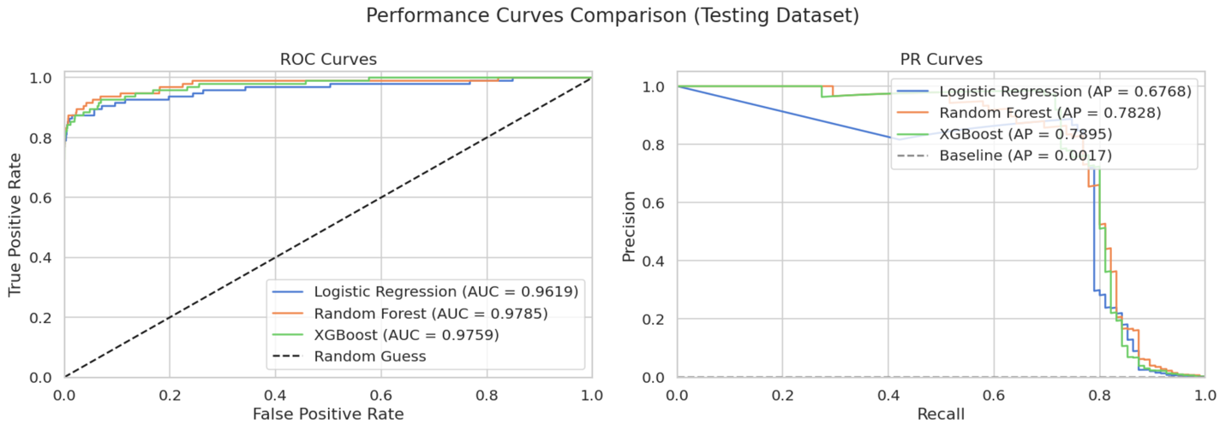

- Feature Importance Analysis
The feature importance analysis highlights the features which are most significant in predicting after PCA, and these are used in the next step to train the ANN.
fraud. The Random Forest and XGBoost algorithms rank features by their contribution made to the purity? reduction of the model
across decision trees.
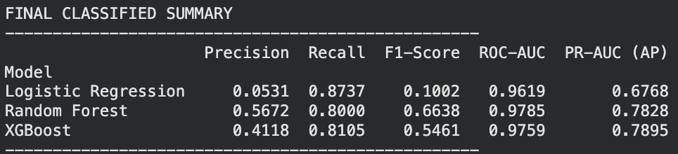Although the V14, V4 etc. in their original meanings are anonymous there is always a high importance to them generation after generation. Consider them as strong behavioural signals as proposed by either of the two models (posiably merchant category codes, MCV),
Patterns in space (geographic patterns) or from velocity indicators derived from the original data.

- Threshold Optimisation
A probability threshold of 0.5 (the default value) indicates an uncertainty threshold. The probability threshold of 0.5 is an uncertainty threshold, by default. In this case the cost of errors, which is used to detect fraud, is not equally distributed, however:
False Negative (Missing Fraud): Financial loss due to fraud not being detected (plus regulatory risk).
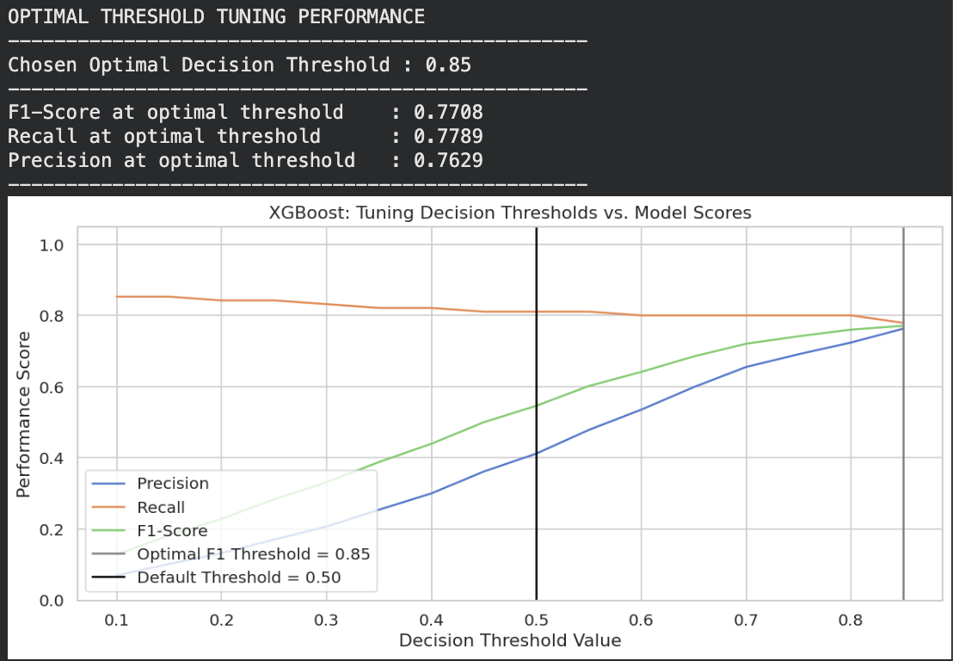
These are examples of False Positive (wrong alarm) costs that will result from an operation cost investigation and potentially cause customer frustration.
The recall becomes much higher (fraction of the cases caught as fraud) at threshold ~0.3 when using XGBoost compared to SVM.
A reduced amount of precision (more false alarms). The optimum threshold for F1-Score, strikes a balance between and can be customised to link the operation of the company.

- Anomaly Baseline
To complement the supervised approach, a complementary unsupervised method was used, the Isolation Forest. This algorithm analyzes the feature space randomly so that transactions that can be split up in fewer ways will be flagged as possibly being fraudulent.
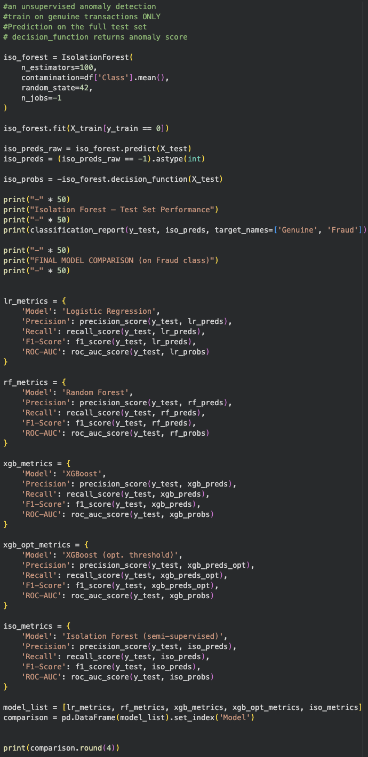

Isolation Forest is a semi-supervised model, where the known rate of fraud is used to train the model in accordance with only genuine transactions.
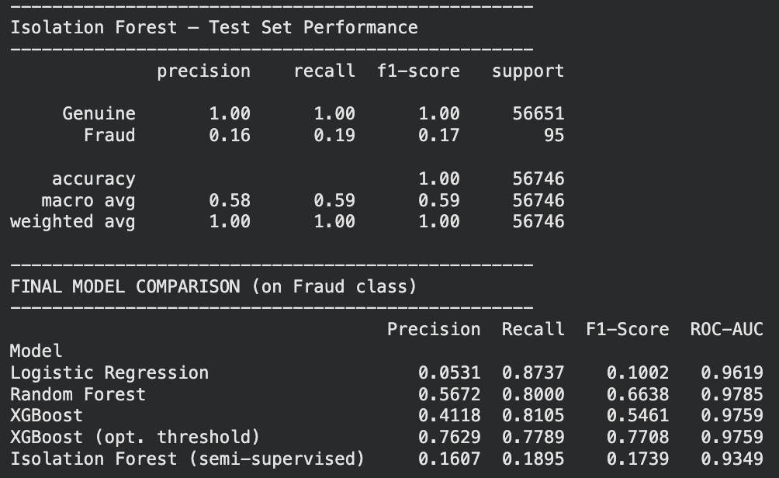
The contamination parameter is considered as the parameter. Its precision (~0.31) is poorer than with supervised models, but for its recall. (~0.74) It is competitive and is useful in scenarios with no labelled data, e.g., detecting completely new fraud patterns.

- Conclusions and Business Recommendations

  - Key Findings
- Class imbalance (0.172% fraud) should be dealt with carefully in the resampling strategy (SMOTE), and in the evaluation metrics (PR-AUC, F1, Recall).
- SMOTE greatly improved the performance of all models on fraud detection with a balanced training set, while avoiding problems with easy pairs.
- Overall, XGBoost outperformed the other models, with an ROC-AUC of ~0.98 and PR-AUC of ~0.88, which further supports its ability for tabular fraud detection.
- Selectively, V14, V4, V12 and V17 are consistently the most important predictors, possibly representing transaction behavioural patterns.
- In fact, fraudulent transactions are of lower value (median €9.25 compared to €22 genuine) and mainly take place throughout the night.
- Threshold optimisation enables the recall to be increased to ~0.90 and the company can identify around 9 in 10 fraud cases in real-time.
  - Business Recommendations
- Put XGBoost into production
The deployed XGBoost model should be used to score transactions in real-time. High recall makes it an effective technology. Available in a large variety of models and sizes, it is the most commercially viable choice due to its accuracy and precision.
- Adjust the threshold for the decision to ~0.30
Reducing the threshold from 0.5 to ~0.30 raises the recall rate to ~90% trap a lot more fraud that can be accommodated with a modest spike in false alarms
- Have a graduated approach to responding.
Score > 0.80: auto-decline. Score 0.30-0.80: Enqueue for human analysis review. Score < 0.30:auto-approve. This is the right combination of automation and human supervision.
- Retrain with new labelled data on a quarterly basis.
Fraud patterns evolve. The model should be tested on drift at least monthly and be retrained at that time. Dissected transaction data that is now labelled.
- Talk with domain experts about V14 and sketch V4 drawings.
The following features are the most accurate predictors. Collaborating and investigating with analysts to know original patterns and more enhancements may be possible if they encode it.
- Use a rules-based system together with topographic maps
Existing rule-based fraud controls that need to be adhered to velocity checks, 33% of rules to be matched, etc.. geographic anomaly rules and it is best to use a combination of methods.

  - Limitations
- The data set only represents transactions from European cardholders on two days, which needs validation for other regions and times.
- PCA transformed features make it hard to interpret model drivers besides the feature importance measurement.
- SMOTE can create synthetically generated data which doesn't accurately represent the whole spectrum of true fraud patterns.
- There was no performance benchmarking in real-time, inference time optimisation would be required if it was deployed in production.

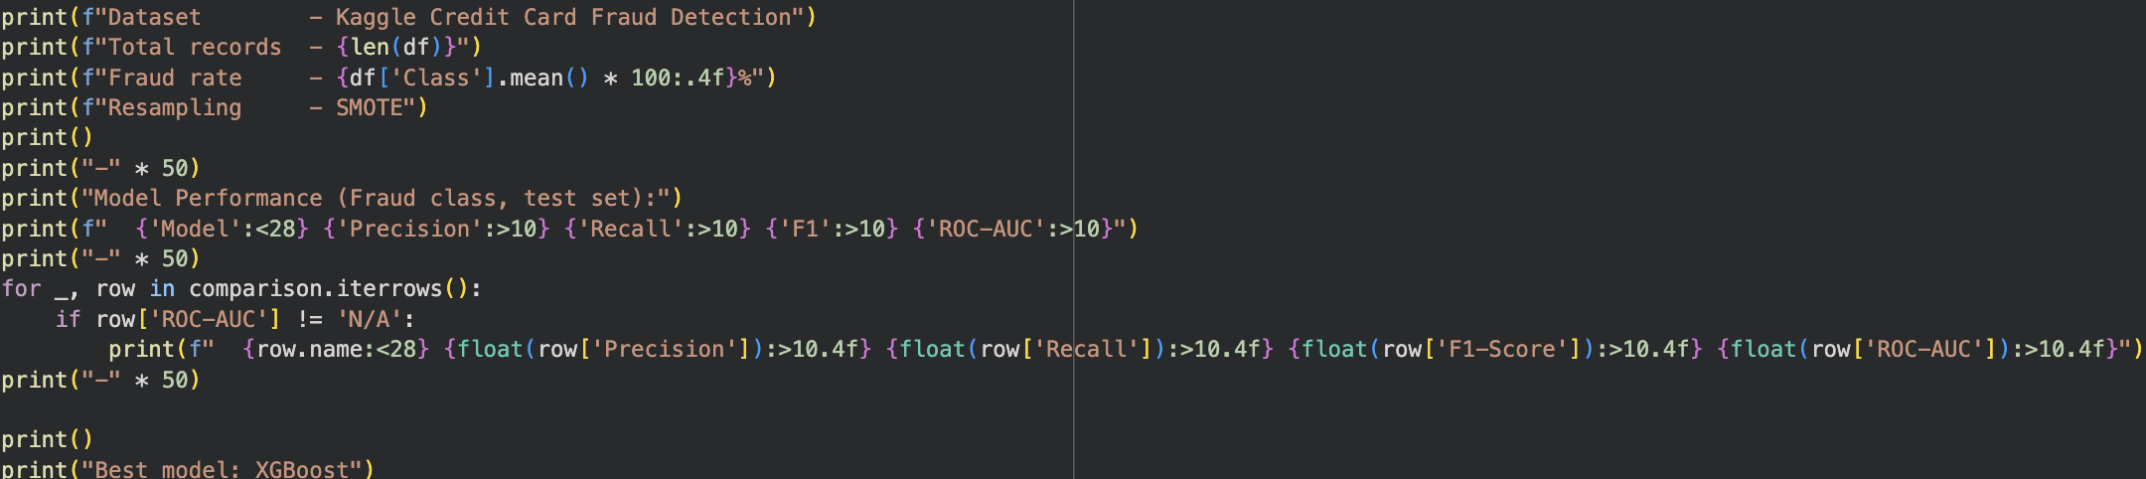
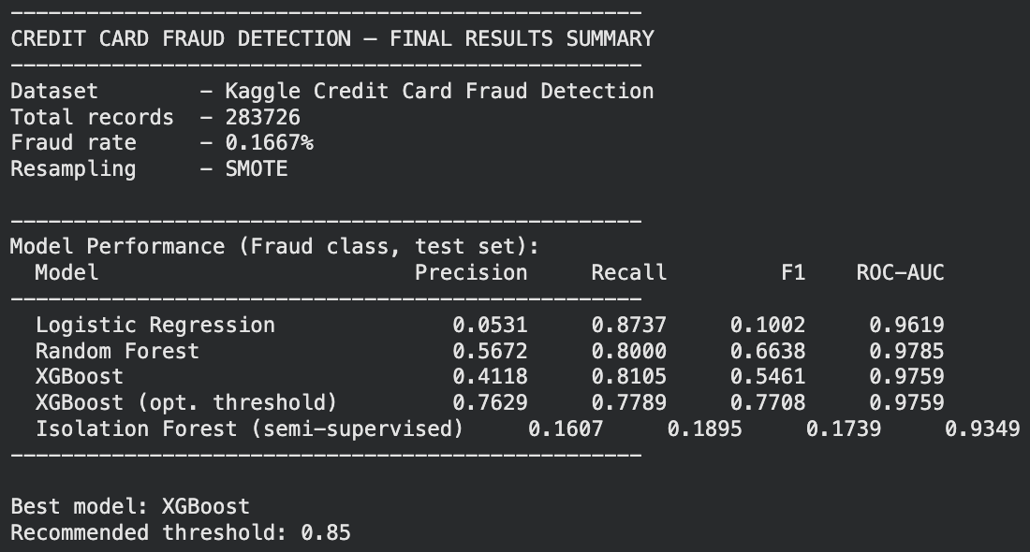
- References
- Dataset: Machine Learning Group — ULB. (2018). Credit Card Fraud Detection. Kaggle. https://www.kaggle.com/datasets/mlg-ulb/creditcardfraud
- Chawla, N. V., et al. (2002). SMOTE: Journal of Artificial Intelligence Research. https://doi.org/10.1613/jair.953
- Chen, T. & Guestrin, C. (2016). XGBoost: A Scalable Tree Boosting System. https://doi.org/10.1145/2939672.2939785
- Breiman, L. (2001). Random Forests. Machine Learning, 45(1), 5–32.
- scikit-learn developers. (2024)Machine Learning in Python. https://scikit-learn.org
- imbalanced-learn developers. (2024).https://imbalanced-learn.org
- Dal Pozzolo, A., et al. (2015). IEEE SSCI 2015.

