1. C2 – Problem Analysis & Trade-off Report
1.1 Real-World Software Problem Analysis
In the development of enterprise-level software, representing hierarchical structures like a company's organizational chart presents a significant architectural challenge. An organization is not a flat list of items; it is a recursive tree.
• The Problem: We need to manage a structure where "Containers" (Departments/Branches) and "Leafs" (Individual Employees) coexist.
• Scenario: If a user wants to calculate the total budget for the "Development Department," the system must not only look at the employees within that department but also traverse through any sub-teams or units nested inside it. Managing this manually with standard loops leads to rigid, error-prone code that is hard to maintain.
1.2 Main Design Challenges
Our team identified three primary technical hurdles that needed to be addressed in the design phase:
1.Uniform Treatment Requirement: The client code (the Main application) should be able to trigger operations like calculateSalary() without needing to distinguish whether the target object is a single person or a collection of hundreds of people.
2.Recursive Aggregation: Implementing a reliable way to aggregate data across multiple levels of nesting. Each level must be responsible for its own data and the data of its children.
3.Scalability & Depth: The solution must support an infinite depth of nesting. Today the company has "Departments," but tomorrow it might add "Regional Zones," "Divisions," and "Groups." The code should not break when the hierarchy grows deeper.
1.3 Comparative Analysis of Design Patterns
To reach the most efficient solution, we conducted a trade-off analysis between two structural design patterns:
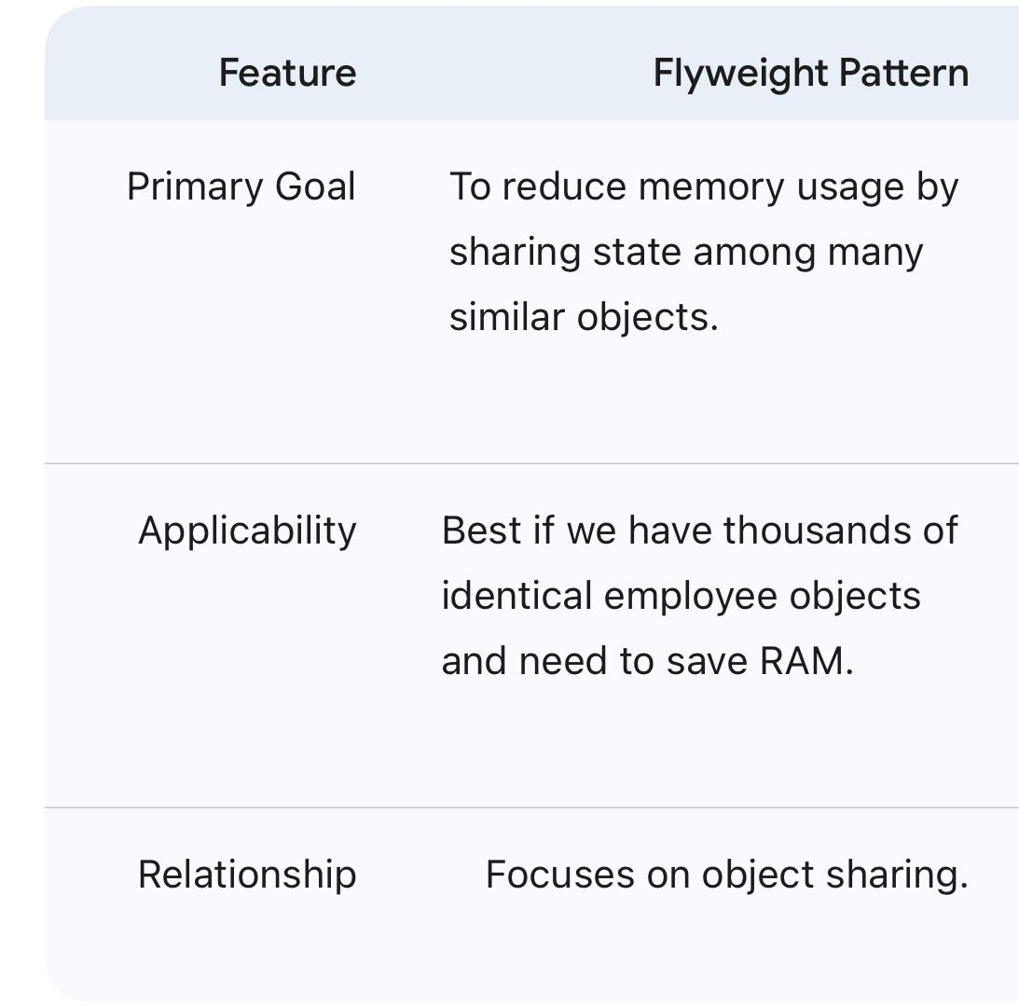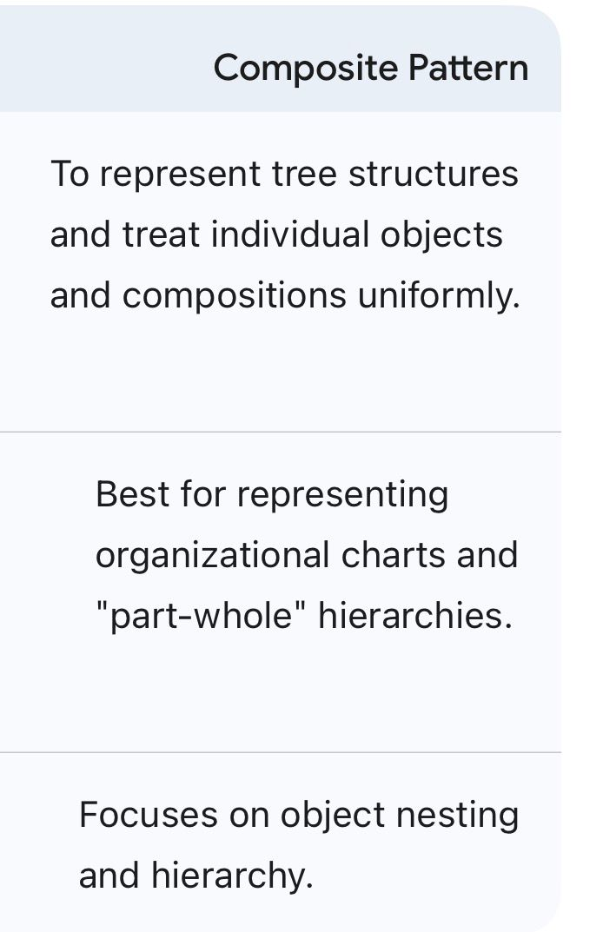
1.4 Trade-offs & Strategic Justification
• The Memory vs. Structure Trade-off: While the Flyweight Pattern is excellent for performance optimization in data-heavy applications, it provides no mechanism for representing "Containment" or "Nesting." Since our primary goal is to model the structure of the company and not just save memory, Flyweight was deemed insufficient for this specific requirement.
• The Generality Trade-off: The Composite Pattern was selected because it perfectly models the recursive nature of an organization. We accepted the trade-off that the interface (OrganizationComponent) might become slightly "fat" (containing methods that might only be relevant to certain types), but the benefit of having a clean, polymorphic, and recursive structure far outweighs this minor disadvantage.

