* 1. Class Diagram:
* User: Represents users of the system, including both readers and administrators. It includes user credentials, roles, and methods for login/logout and role retrieval.
* Article: Encapsulates the properties of news articles such as title, content, and publication metadata. It is linked to the user who created the article and provides a method to fetch the associated summary.
* Summary: Represents the summarized version of an article, generated by an NLP library.

Relationships:

* A User can author multiple Articles, establishing a one-to-many relationship.
* Each Article has a corresponding Summary, forming a one-to-one relationship.

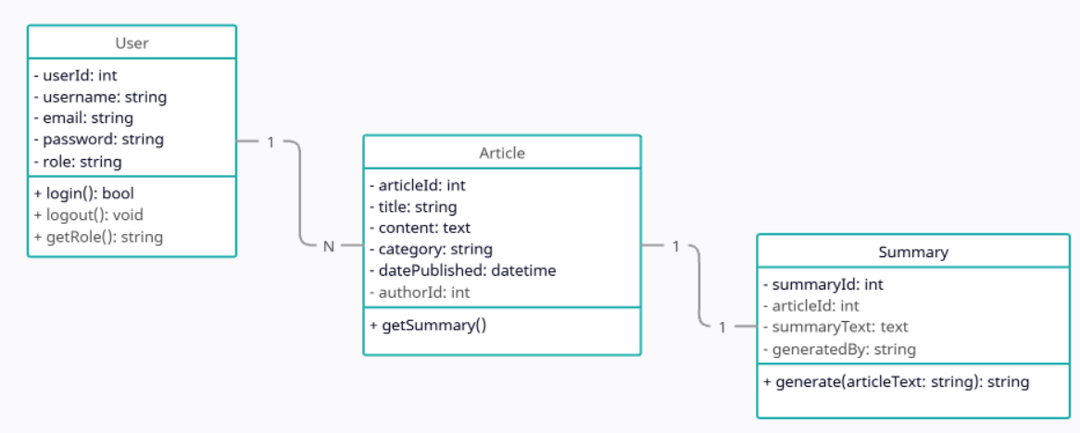

Figure 5: Class Diagram