* 1. Use Case Diagram:

The system consists of two main roles: Admin and User (Reader). Below is a list of the core use cases for each role.

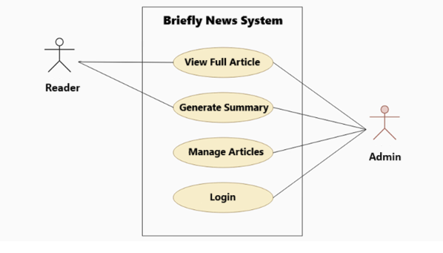

Figure 2: Use Case Diagram