**A**bstract

**P**olymorphism

**I**nheritance

**E**ncapsulation

parent



Child2

Child1 of child 2

CV

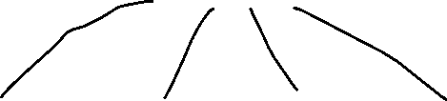

Child4

Child3

Child1

It has access to the parent methods

