IT22549136

Silva A. S

MLOM lab

**Predicting Student Performance Using Deep Learning**

1. Data Preparation

* Data loaded to the jupyter lab
* Removed duplicates (there were 2 records)
* Checked for null values (there were no null values)
* Turned categorical data into numerical using label encoder (13 categorical data columns)
* Standardized numerical data so it helps processing
* For standardizing checked for outliers there were no outliers so standardized using Minimax method
* Then split data set into training (0.8) and testing (0.2)

1. Model Design

* Use 2 dense layer network with activation function ‘relu’ and input size for the first layer was 16 since we have 16 classes
* Last dense layer was output layer and it used ‘softmax’ as activation function since we have to categorize in to mainly 3 classes

1. Training

* Use loss function as ‘sparse_categorical_crossentropy’ since it multi-class
* ‘Adam’ as the optimizer
* Used early stopping feature with monitoring validation loss to prevent overfitting
* Used 50 epochs to fine tuning

1. Evaluation

* Validation Loss: 0.48878607153892517,
* **Validation Accuracy: 0.8020833134651184**
* Train Loss: 0.43649840354919434,
* Train Accuracy: 0.8089005351066589
* Precision, recall, f1

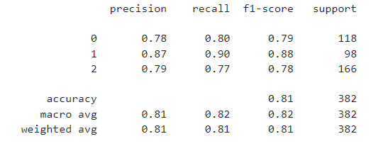

* Loss epoch graph

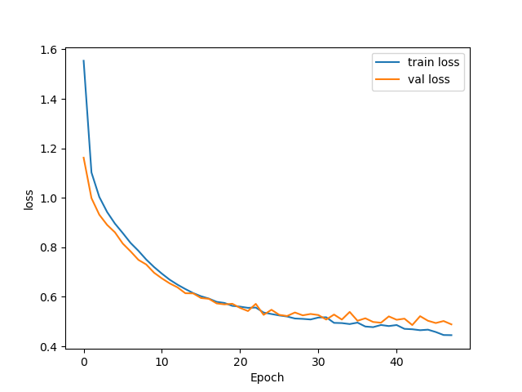

* Accuracy epoch graph

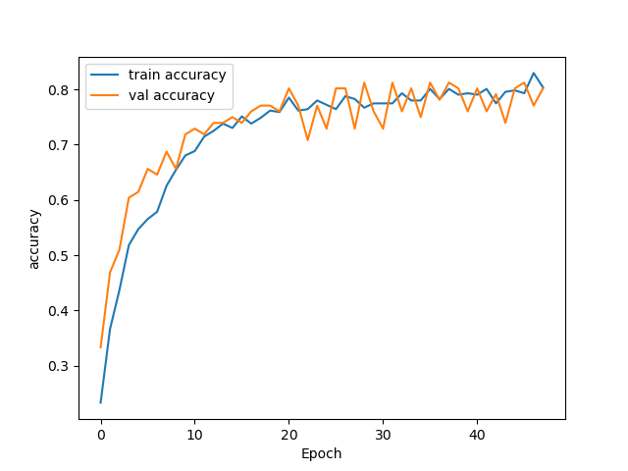

1. Hyperparameter Tuning

* Batch size increased from 16 to 32
* Epochs was increased from 20 to 50
* With help of these accuracy was gained little

**Experiments**

* When other stats keep the same and learning rate increases to 0.01 **accuracy reduced to 0.78**

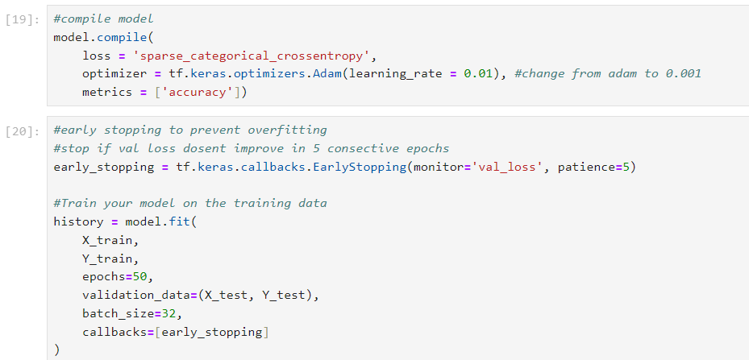

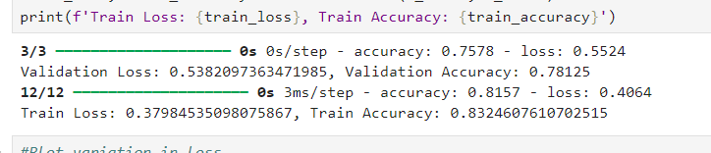

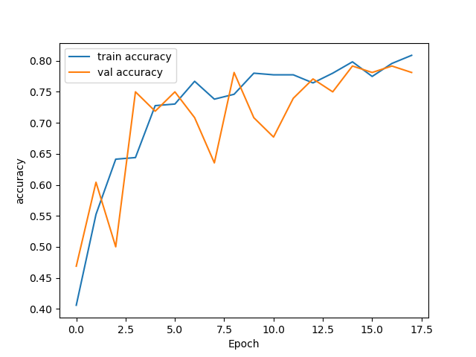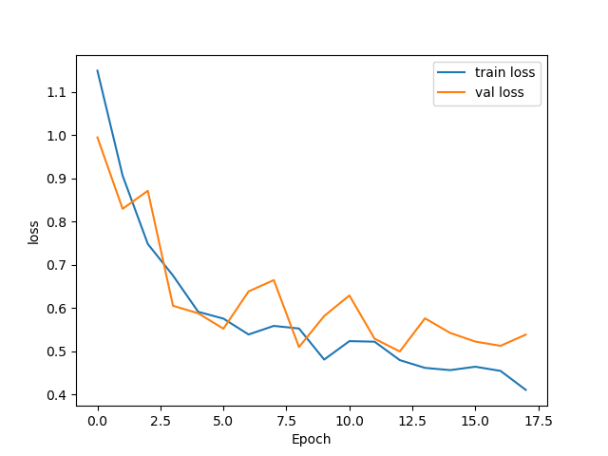

* When other stats keep the same and batch size was 16 **accuracy was 0.78**

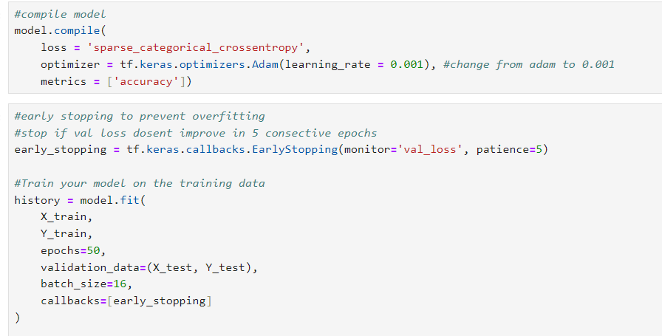

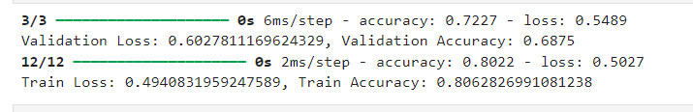

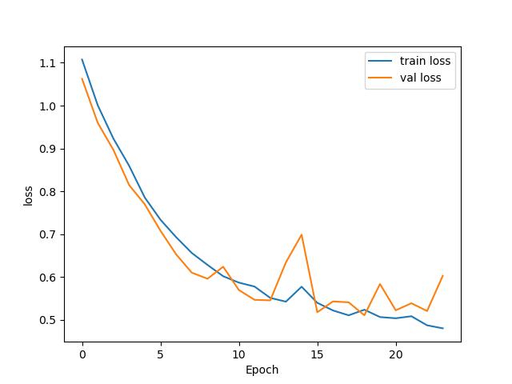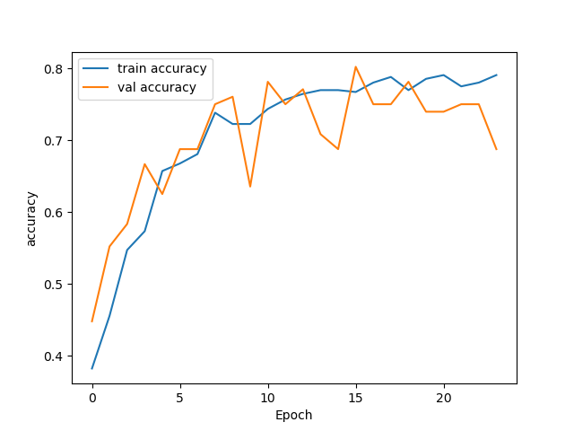

* Although a layer was added **validation accuracy didn’t increased**

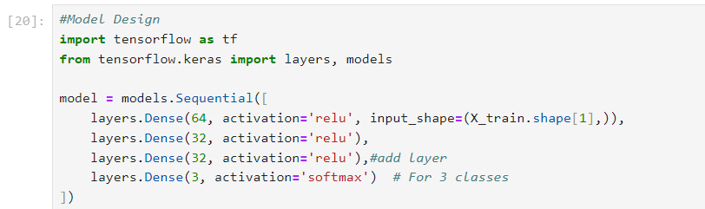

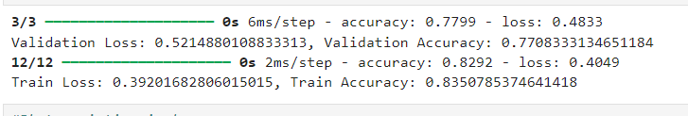

* Activation function changed to **RMSProp validation accuracy didn’t increased**

