**Experiment 6: Sketch Sequence diagram for the project**

**Learning Objective:** Students will able to draw Sequence diagram for the project

**Tools:**  Dia, StarUML

**Theory:**

A sequence diagram shows, as parallel vertical lines (*lifelines*), different processes or objects that live simultaneously, and, as horizontal arrows, the messages exchanged between them, in the order in which they occur. This allows the specification of simple runtime scenarios in a graphical manner.

**Sequence Diagram representation**

## Call Message: A message defines a particular communication between Lifelines of an Interaction.

## Destroy Message: Destroy message is a kind of message that represents the request of destroying the lifecycle of target lifeline.

## Lifeline: A lifeline represents an individual participant in the Interaction.

## Recursive Message: Recursive message is a kind of message that represents the invocation of message of the same lifeline. Its target points to an activation on top of the activation where the message was invoked from.

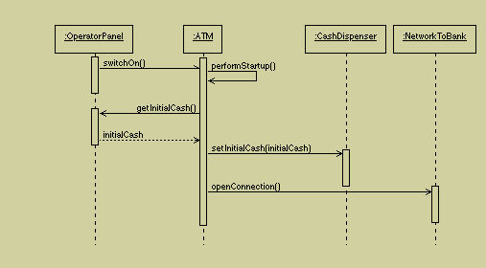**Sequence Diagram: Example for ATM System startup**

It is clear that sequence charts have a number of very powerful advantages. They clearly depict the sequence of events, show when objects are created and destroyed, are excellent at depicting concurrent operations, and are invaluable for hunting down race conditions. However, with all their advantages, they are not perfect tools. They take up a lot of space, and do not present the interrelationships between the collaborating objects very well.

**Learning Outcomes:** Students should have the ability to

LO1: Identify the classes and objects.

LO2: Identify the interactions between the objects

LO3: Develop a sequence diagram for different scenarios

**Outcomes:** Upon completion of the course students will be able to draw the sequence diagram for the project.

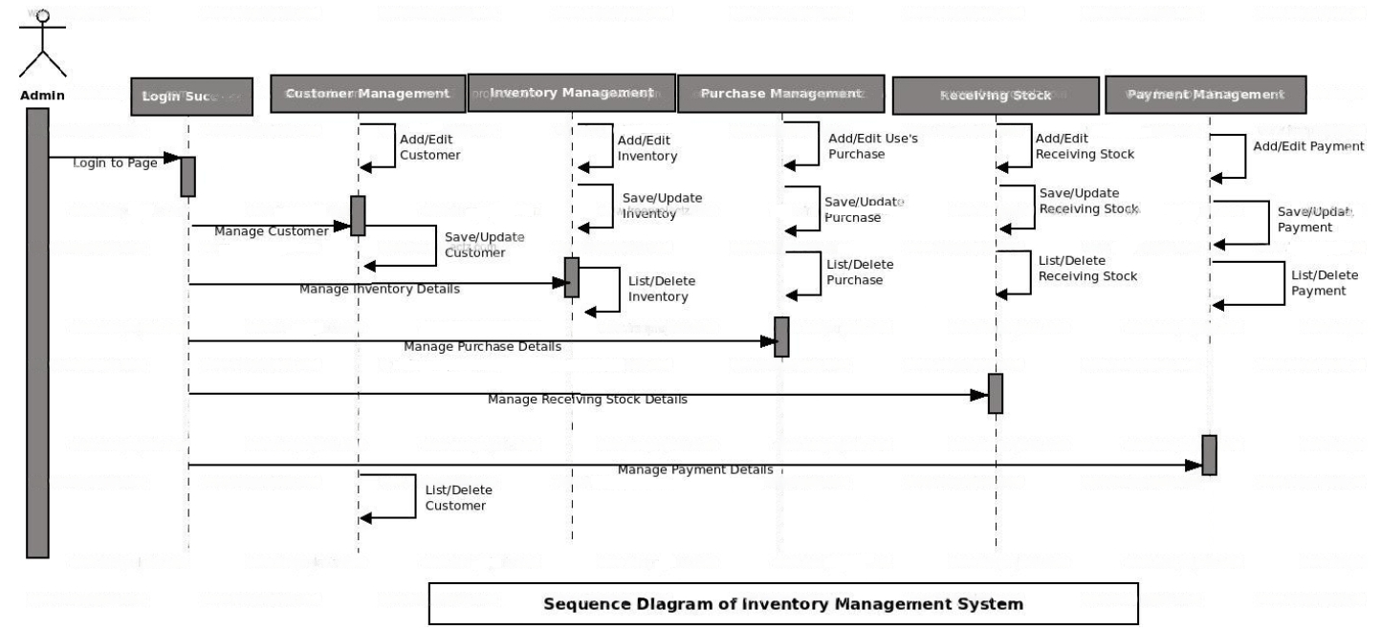

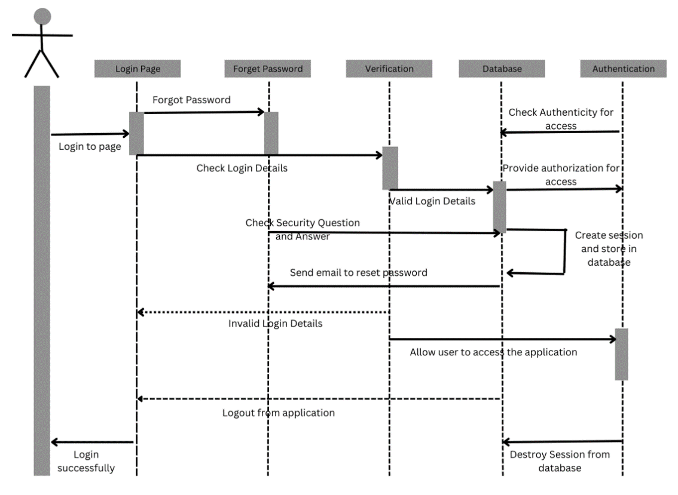

**Conclusion:** - Thus we were able to successfully complete the sequence diagram for our project “Warehouse management System”

**Viva Questions:**

1. **What is a sequence diagram?**
2. **What are advantages of sequence diagram?**
3. **What are entities in sequence diagram?**
4. **Explain its relation with the class diagram?**

For Faculty Use

|  |  |  |  |  |
| --- | --- | --- | --- | --- |
| **Correction Parameters** | **Formative Assessment [40%]** | **Timely completion of Practical [ 40%]** | **Attendance / Learning Attitude [20%]** |  |
| **Marks Obtained** |  |  |  |