# SOFTWARE ENGINEERING

**Experiment 2: Sketch a Data Flow Diagram (DFD) up to 2 levels**

**Aim:** To sketch a Data Flow Diagram (DFD) up to 2 levels.

# Theory:

1. About DFD

Data Flow Diagrams model events and processes i.e. activities which transform data within a system. A Data Flow Diagram, is a pictorial representation of data that flows from one process to another process inside a system (generally an information system) along with mentioning how data flows into the system and out of the system.



1. Why DFD is useful

A DFD shows an abstract or functional view of the system to be developed.

The graphical representation easily overcomes any gap between ’user and system analyst’ and ‘analyst and system designer’ in understanding a system.

1. Symbols used in a DFD

* Process/es: denoted by a process box.
* Data flow: denoted by a labelled arrow.
* Data store: denoted by an open rectangle or two parallel lines.
* Entity: denoted by a rectangle

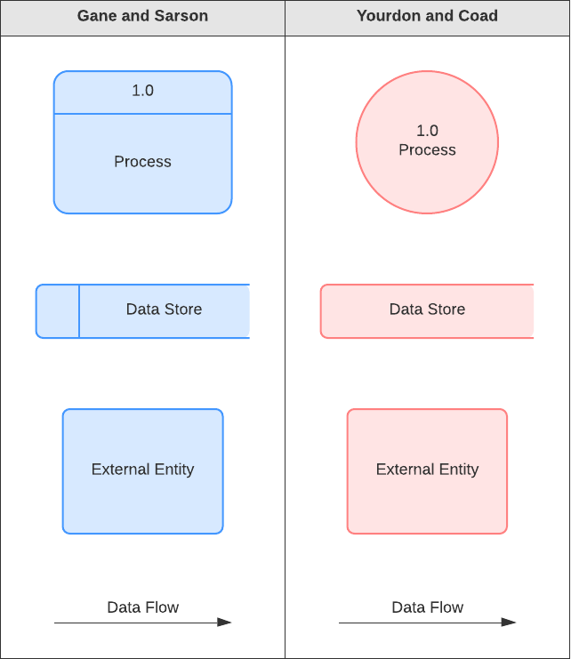

1. Rules for creating DFD’s

* Entities are either 'sources of' or 'sinks' for data input and outputs - i.e. they are the originators or terminators for data flows.
* Data flows from Entities must flow into Processes.
* Data flows to Entities must come from Processes.
* Processes and Data Stores must have both inputs and outputs (What goes in must come out!)
* Inputs to Data Stores only come from Processes.
* Outputs from Data Stores only go to Processes.
* External Entities only come at level 0 DFD.

1. Levels of DFD

* Level 0 or context diagram: represents broad overview of a system.
* The entire system is shown as single process and also the interactions of external entities with the system are represented in context diagram.
* Further we split the process in next levels into several numbers of processes to represent the detailed functionalities performed by the system (level 2, level 2 etc.).

1. Numbering of Processes

If process ‘p’ in context diagram is split into 3 processes ‘p1’, ‘p2’and ‘p3’ in next level then these are labelled as 0.1, 0.2 and 0.3 in level 1 respectively. Let the process ‘p3’ is again split into three processes ‘p31’, ‘p32’ and ‘p33’ in level 2, so, these are labelled as 0.3.1, 0.3.2 and 0.3.3 respectively and so on.

# OUR TOPIC: CANTEEN MANAGEMENT SYSTEM

**Data Flow Diagram for Warehouse Management System:**

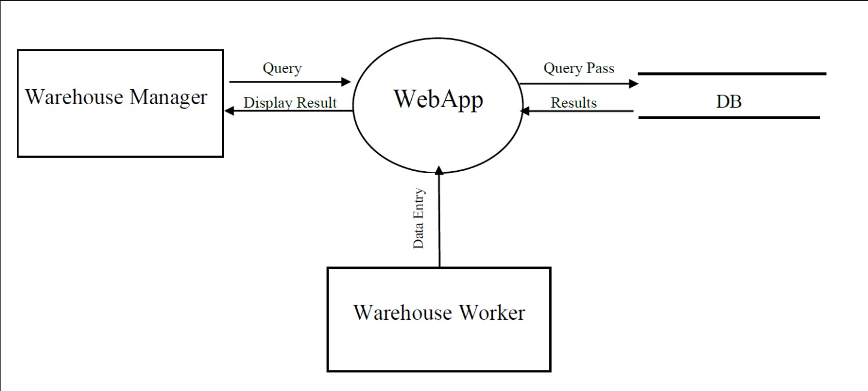

fig.1. DFD Level 0

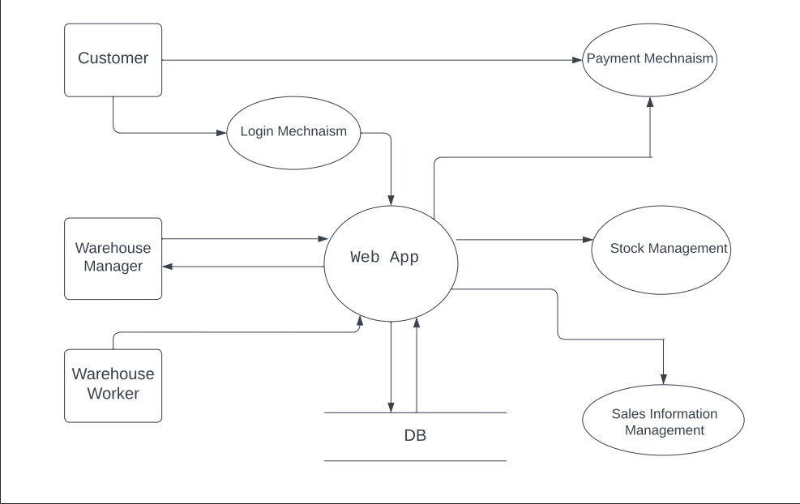

fig.2. DFD Level 1

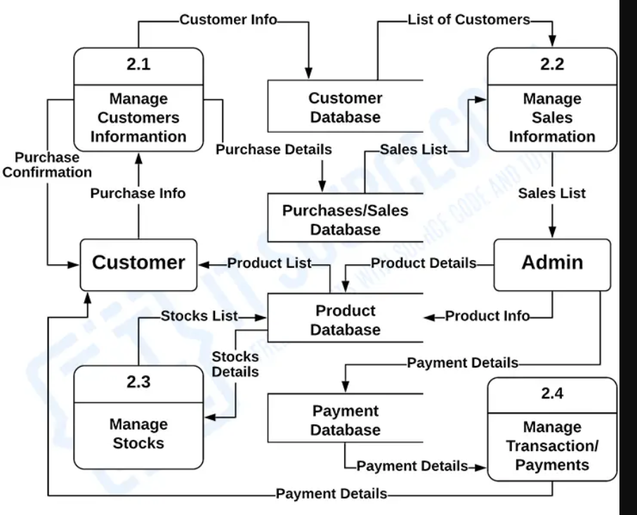

fig.3. DFD Level 2

# Conclusion:

In conclusion the creation of data flow diagram for levels 0,1 and 2 for a warehouse management system was successfully accomplished through a comprehensive iterative process. The diagrams were created with the aim of representing the flow of information and the materials within a system in a clear organized and efficient manner.

For Faculty Use:

|  |  |  |  |  |
| --- | --- | --- | --- | --- |
| Correction Parameter s | Formative Assessment [40%] | Timely completion of Practical [ 40%] | Attendance  /Learning Attitude [20%] |  |
| Marks Obtained |  |  |  |