**Amogelang Mofokeng**

**ST10463226**

**IMAD5112**

|  |  |  |
| --- | --- | --- |
| **Day** | **Morning run in Kms** | **Afternoon run in Kms** |
| 2024-04-05 | 5 | 3.5 |
| 2024-04-06 | 6 | 4 |
| 2024-04-07 | 7 | 5.4 |

1. Screen1 (Input data)
2. Screen2 (Display data)

**Documentation**

This app is designed to help users monitor and record the kind of distances they run during their morning sessions and afternoon. It stores session data for comparison, enabling users to track their progress over time.

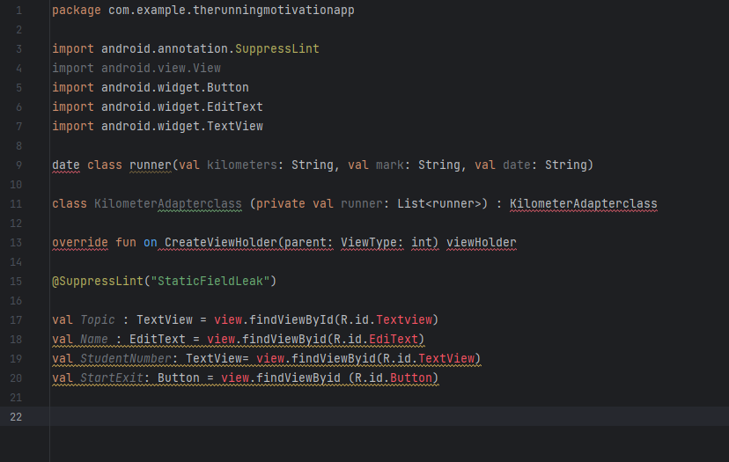

The app also features a user friendly interfacew with options to view maps of routes taken, set personalized, running goals and receive summaries for daily,weekly, or monthly perfomance. This makes it an ideal tool for fitness enthusiasts aiming to stay constistent and motivated in their running routes.

1.ST10463226

2.https://github.com/Amogelang28/AMOEXAM19/new/main?filename=README.md