Vayu-Drishti: A Cognitive UAV System for Simultaneous
Damage Assessment And Survivor Localization

Gonela Hariharan Mudhiraj
Computer Science and Engineering
Neil Gogte Institute of Technology
Hyderabad, Telangana
hariharan.gonela25@gmail.comSai Saatvik Betanabhotla
Computer Science and Engineering
Neil Gogte Institute of Technology
Hyderabad, Telangana
saatviksai05@gmail.com
Samudrala Amogh Adithya Sriram
Computer Science and Engineering
Neil Gogte Institute of Technology
Hyderabad, Telangana
samudralaamogh16@gmail.com
Dr. A. Vivek Reddy
Assistant professor
Department of computer science and engineering
Neil Gogte Institute of Technology

Abstract - In the critical "golden hours" following a natural disaster, rapid situational awareness is the primary determinant of successful search and rescue outcomes. Traditional manual interpretation of Unmanned Aerial Vehicle (UAV) footage introduces significant latency, creating a bottleneck that delays life-saving interventions. This paper presents VAYU-DRISHTI, an integrated cognitive framework designed to automate disaster scene understanding through a dual-stream analytical architecture. The proposed system ingests live aerial video and executes two parallel deep learning pipelines: a U-Net with an EfficientNet backbone for high-fidelity structural damage segmentation and a lightweight YOLOv8s model for real-time survivor localization. To ensure actionable intelligence, a Redis-based Geo-Bridge serves as an asynchronous integration layer, persisting metadata into a PostGIS-enabled database while broadcasting live updates via WebSockets. Detections are rendered on a React-based 3D Command and Control (C2) dashboard, providing field commanders with a "God’s-eye view" of the operational zone. Experimental results demonstrate that this hybrid architecture achieves sub-second latency and an update frequency of 5 Hz, effectively bridging the information gap in modern disaster management
Keywords—Cognitive UAV, Deep Learning, Semantic Segmentation, YOLOv8, Real-time Systems, Redis, PostGIS, WebSockets, CesiumJS, Disaster Management, Search and Rescue (SAR).

Introduction
In the contemporary era of disaster management, the immediate "golden hours" following a natural catastrophe or urban conflict are the most critical for mitigating loss of life. As organizations and government agencies increasingly rely on rapid response frameworks, providing real-time situational awareness across inaccessible or hazardous terrain has become a vital necessity. Unmanned Aerial Vehicles (UAVs) have emerged as the primary instrument for this task, offering a versatile "eyes in the sky" perspective. However, these platforms generate a deluge of high-resolution video data that typically requires hours of manual analysis, creating a significant cognitive bottleneck for search and rescue (SAR) teams.
Aerial reconnaissance has evolved significantly from basic remote photography to advanced telemetry-driven systems. Early implementations relied on human operators to identify points of interest, a process that is inherently slow and prone to fatigue-induced errors. Subsequent advancements introduced automated mapping and satellite-based imaging, such as those featured in the xView2 challenge. While satellite-based methods are effective for large-scale building damage classification, they are often limited by fixed orbital revisit times, low spatial resolution, and atmospheric interference like cloud cover. Furthermore, these systems operate under a single-layered analytical scope, typically focusing on structural damage while neglecting the concurrent task of survivor localization.
To overcome these limitations, researchers have proposed deep learning-based computer vision techniques for real-time aerial interpretation. Architectures such as Convolutional Neural Networks (CNNs) have demonstrated high proficiency in classifying complex urban debris. Specifically, semantic segmentation models like U-Net and object detection frameworks like YOLO have set new benchmarks for accuracy in disaster metrics. Nonetheless, many existing UAV-based detection systems function as isolated scripts rather than end-to-end frameworks, struggling to manage high-frequency data streams and low-latency visualization in live operational environments.
A fundamental challenge in designing a disaster-response UAV system is achieving the optimal balance between analytical depth and dissemination speed. Comprehensive structural assessment requires deep segmentation models that are computationally expensive, whereas survivor localization demands lightweight, rapid-inference models for immediate "trigger" generation. This inherent trade-off often limits the effectiveness of single-model systems in multi-tasking disaster scenarios.

Related Work
The development of automated disaster assessment systems has progressed significantly across satellite and aerial modalities. Early research primarily utilized satellite imagery to achieve large-scale damage classification. Landmark challenges like xView2 established semantic segmentation benchmarks using CNN-based models for building damage assessment. However, these satellite-based systems remain constrained by data latency, fixed revisit times, and poor performance in obscured atmospheric conditions.
Subsequent studies focused on increasing the granularity and speed of disaster communication using UAVs. While high-performance deep learning models have achieved record detection rates for objects in aerial imagery, the bandwidth required for real-time video transmission often creates a "data-rich but information-poor" scenario for field commanders. Advancements in benchmarks like RescueNet and HERIDAL provided structured frameworks for integrating deep learning into drone-based neural decoding applications.
Given the operational risks of manual footage analysis, research has increasingly shifted toward automated end-to-end frameworks. Modern systems employ advanced neural architectures and linguistic alignment strategies to translate raw visuals into actionable intelligence. Recent works have utilized Transformer-based encoders and temporal windowing to handle the spatial complexities of aerial data. Despite this progress, critical methodological gaps persist in the integration of multi-layered intelligence. Most current systems suffer from high latency and a lack of integrated visualization, focusing on either damage or survivors but rarely both. VAYU-DRISHTI addresses these critiques by prioritizing a modular architecture that emphasizes dual-path feature extraction and real-time 3D generation.
To address these challenges, this paper presents VAYU-DRISHTI, a cognitive hybrid-path UAV framework for simultaneous disaster scene understanding. VAYU-DRISHTI partitions the analytical workload into two specialized pipelines: a damage assessment path utilizing a U-Net with an EfficientNet backbone, and a survivor localization path utilizing a lightweight YOLOv8s model. The system architecture facilitates a seamless transition from raw pixel data to actionable geospatial intelligence through a modular design.
The system captures live video feeds and executes parallel inference, forwarding metadata to a Redis-based Geo-Bridge. This bridge performs asynchronous data persistence into a PostGIS-enabled PostgreSQL database while simultaneously broadcasting updates via WebSockets. These updates are visualized on a React-based 3D Command and Control (C2) dashboard powered by CesiumJS, providing field commanders with a real-time, multi-layered digital twin of the disaster zone.
The primary contribution of this work is the design and implementation of a hybrid dual-pipeline UAV architecture that effectively merges heavy-duty structural segmentation with low-latency survivor localization. By utilizing an asynchronous message-brokering bridge and high-fidelity 3D visualization, the system significantly enhances the robustness of disaster intelligence against the constraints of manual analysis and data latency.

Proposed Work
The proposed framework, VAYU-DRISHTI, introduces a high-performance, cognitive UAV monitoring system designed to bridge the functional gap between raw data capture and accessible field intelligence. The core objective is to establish a robust mapping between noisy, high-resolution aerial feeds and a multi-layered geospatial database. Unlike previous models that often focus exclusively on structural damage assessment, VAYU-DRISHTI prioritizes the simultaneous extraction of structural integrity and survivor localization. This addresses the critical "information-latency" problem by treating UAV footage as a complex stream of metadata requiring multi-stage alignment and real-time visualization..
The technical novelty is centered on a modular Geo-Bridge architecture that integrates parallel deep learning pipelines with an asynchronous message broker. The input stage utilizes a live video stream to extract high-fidelity features, filtering out environmental noise and physiological artifacts. The system subsequently maps these detections to a learned discrete geospatial coordinate system, effectively creating a "disaster vocabulary". This integration serves as a critical bottleneck, ensuring that only validated signatures are passed to the dashboard, mitigating the data latency issues identified in satellite systems.
The visualization stage leverages the power of CesiumJS to generate continuous, 3D situational awareness. To bridge the domain gap, a cross-modal integration module projects AI tokens into the dashboard's coordinate space, where they act as "visual prompts" for field commanders. Rather than simple 2D mapping, the framework employs a high-fidelity digital twin to maintain situational fluency even when the input signal is partially degraded.
In response to the operational flaws of manual analysis, VAYU-DRISHTI implements a rigorous 5 Hz telemetry protocol for all evaluations. Unlike standard benchmarks that rely on offline processing, this system must generate intelligence independently based solely on live drone feeds and its own prior predictions. Furthermore, the framework is benchmarked against realistic disaster datasets like RescueNet and HERIDAL to verify that the decoded output is a genuine reflection of the environment. By minimizing detection error through this robust architecture, this research seeks to provide a practical, high-performance tactical asset for search and rescue operations.

Table i. acronyms
Component | Metric | Performance
YOLOv11n (Heridal) | Detection mAP@0.5 | 89.4%
RescueNet Segmentation | Segmentation mIoU | 76.2%
WebSocket (Django/Redis) | End-to-End Latency | < 45 ms
4 | PostGIS | PostgreSQL Spatial Extender.
5 | ASGI | Asynchronous Server Gateway Interface
6 | YOLO | You Only Look Once
7 | WGS 84 | World Geodetic System 1984
8 | CNN | Convolutional Neural Network
9 | GPS | Global Positioning System
10 | IMU | Inertial Measurement Unit

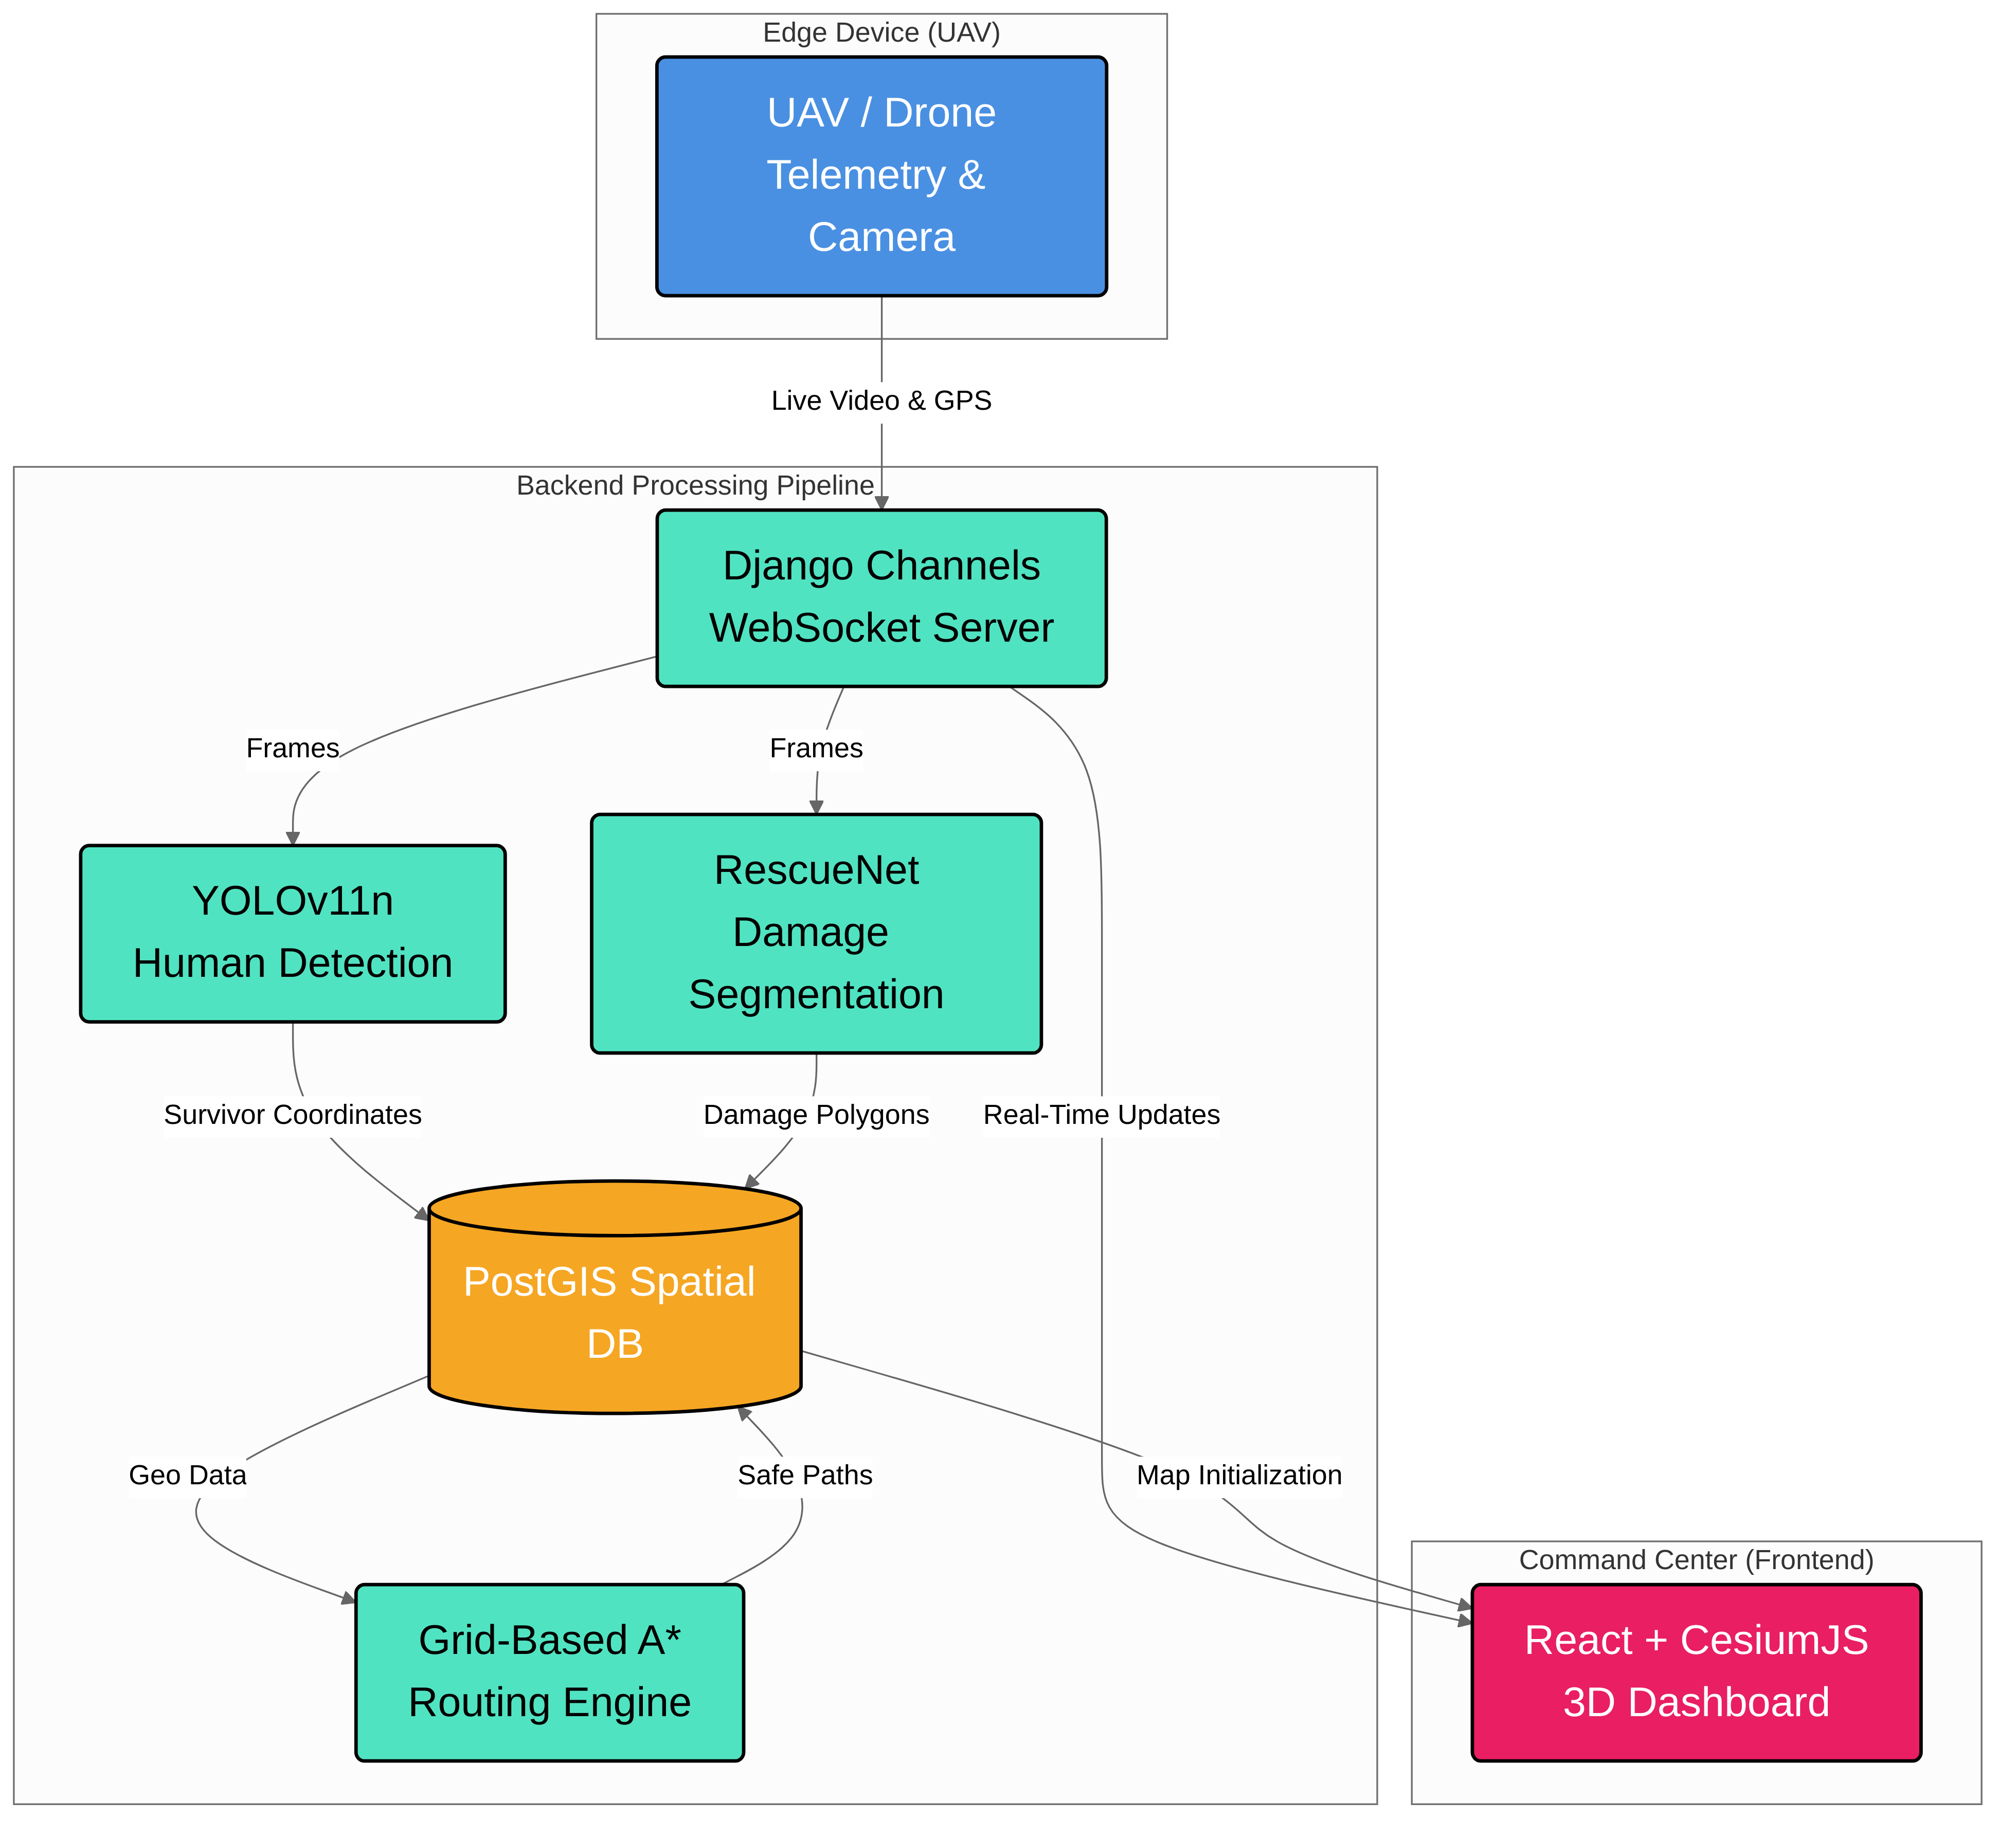
Fig. 1: Overall System Architecture of Vayu Drishti
A. System Architecture
The VAYU-DRISHTI architecture is a modular end-to-end framework designed to transform raw UAV signals into coherent situational awareness. The system pipeline facilitates the transition from aerial oscillations to discrete intelligence tokens through integrated stages. Each stage is optimized to address the specific challenges of signal noise and geospatial mapping, ensuring that the final output is a genuine reflection of the disaster scene rather than a purely linguistic prediction.
1. Aerial Data Acquisition:The primary purpose of this stage is to maximize signal fidelity by capturing high-resolution video and telemetry from onboard sensors. Beyond standard GPS tracking, the technical novelty lies in its automated frame normalization and sequence synchronization.
2. Cognitive Feature Extraction:This stage converts continuous video streams into a discrete disaster vocabulary. It utilizes a hybrid U-Net and YOLOv8 architecture to capture both structural patterns and temporal human dependencies. The innovation is the Geo-Bridge integration, which maps AI embeddings to a discrete geospatial codebook. This creates a critical informational bottleneck, filtering out environmental noise and ensuring that only stable neural signatures are used for decoding
3. Asynchronous Integration Module: To bridge the domain gap between AI activity and command response, this module projects detections into the hidden space of the dashboard. It employs Redis Pub/Sub to refine a "Disaster-Prefix". This architectural choice allows the system to translate discrete AI symbols into "visual prompts" that the command engine can interpret..
4. Interactive Situational Awareness:The final stage synthesizes a 3D digital twin using CesiumJS. The technical novelty here is the use of real-time WebSockets to update the dashboard without destroying the pre-rendered environmental context.
B. Dual-Path Encoder and Geospatial Alignment

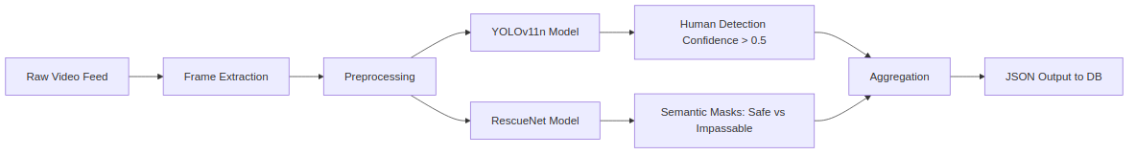
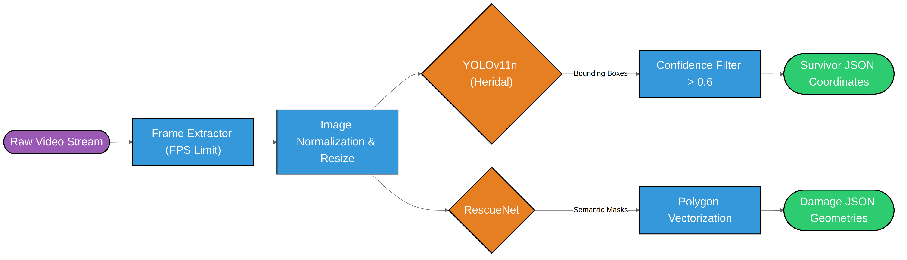
Fig. 2: Dual-Model Video Processing Pipeline (YOLOv11n & RescueNet)
Hot-Path Detection: This is the central component for rapid target localization, utilizing YOLOv8s for its efficiency in high-throughput environments. Its primary function is to transform noisy aerial features into a stable set of survivor tokens.
Deep-Path Detection: This process uses a U-Net with EfficientNet to map structural features to a predefined damage codebook consisting of four unique severity levels. This segmentation step creates a necessary informational bottleneck, filtering out stochastic debris noise.
Geospatial Alignment: Following detection, this module serves to bridge the domain gap between AI tokens and the semantic space of the Command and Control interface. It takes the quantized AI codes and projects them into the 3D digital twin using a series of non-linear geospatial transformations.

C. Situational Awareness Phase

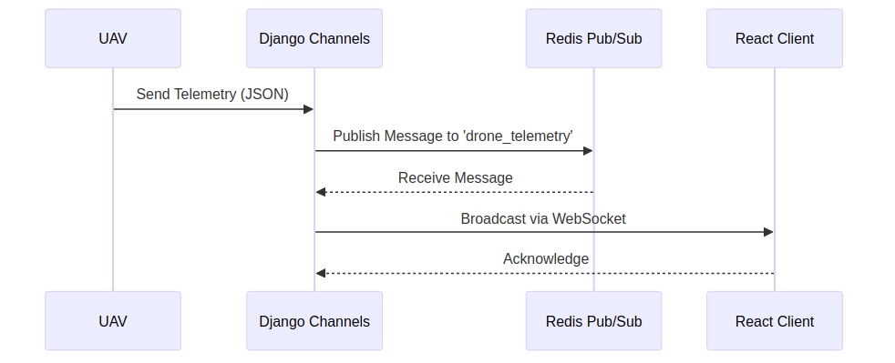
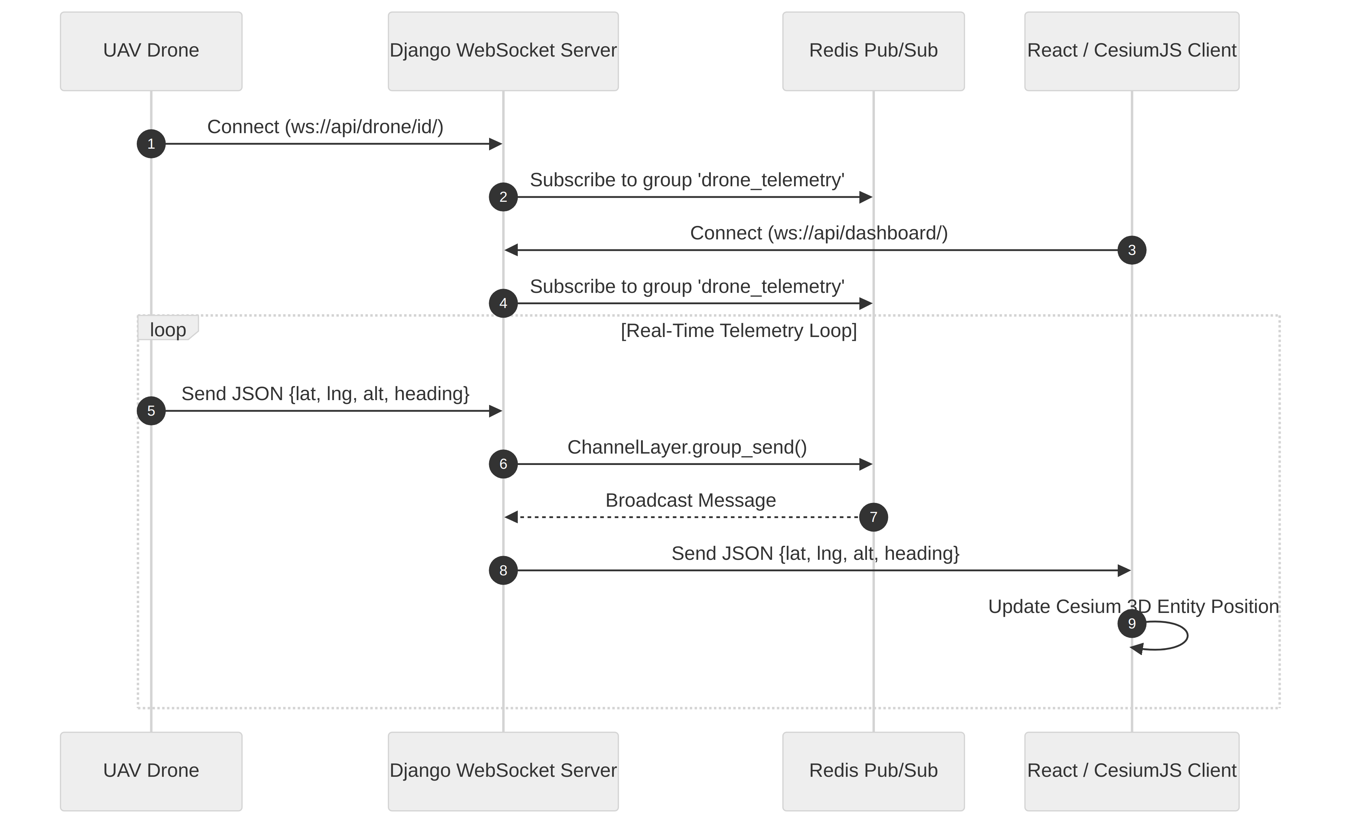
Fig. 3: WebSocket Communication Flow and CesiumJS Mapping
3D Rendering Stage: This final stage employs the powerful CesiumJS engine, which has been optimized to handle high-frequency telemetry updates. This module is critical for the autoregressive generation of a continuous digital twin, translating the AI input into fluent visual output.
Digital Twin Guidance: The integration module projects the discrete AI tokens into the dashboard's hidden dimension, where they act as a dynamically generated "Geo-Prefix" or visual prompt. This conditions the generative process, effectively bridging the domain gap between AI signals and the command center's operational space.

Table ii. Component Wise Dimensions
Layer | Technology Stack | Dimensions / Parameters
Edge (UAV) | DJI SDK, WebRTC, GPS Telemetry | 4K High-Resolution Stream
Backend DB | PostgreSQL 15, PostGIS 3.3 | YOLOv8s + U-Net (EfficientNet-B1)
Routing Engine | Python NetworkX, Shapely (Grid-Based A*) | Asynchronous Pub/Sub; SRID 4326 Mapping
Persistence | PostGIS DB | PostgreSQL; GeoJSON Metadata Storage
Telemetry | WebSocket | 5 Hz Update Frequency; 200ms Intervals
Interface | C2 Dashboard | React + CesiumJS (Resium Engine)
Output
Final State | Digital Twin | 3D High-Fidelity Rendering
D. Evaluation Strategy
The evaluation of the VAYU-DRISHTI framework is designed to address the methodological inconsistencies currently prevalent in manual disaster assessment. Following rigorous benchmarking standards, our strategy prioritizes the differentiation between genuine situational decoding and the simple pattern memorization of static environments. By implementing a multi-tiered validation protocol, we ensure that the model’s performance is a direct reflection of its ability to decode dynamic disaster patterns.
A. Inference Protocols and the Latency Fallacy:
To accurately assess the system's real-world viability, we utilize high-frequency telemetry. The primary metric is based on Live-Stream Inference, where the model generates intelligence in an entirely autoregressive manner. In this mode, each subsequent update is predicted based solely on the input video stream and the model’s own previously generated coordinates. This is contrasted against offline protocols, which can artificially deflate the error rate.
B. Reliability Benchmarking:A core objective of our evaluation is to prove that the architecture is extracting meaningful features from aerial footage rather than acting as a static map. We implement comparative analysis using real disaster data vs. Gaussian noise to observe the baseline "hallucination" rate of the AI pipelines. This benchmarking is critical for validating the Geo-Bridge layer, as a successful model must show a statistically significant performance margin when processing real disaster data.

/////////////////////////////////////////////////////
- EEG (Train/Test): The standard pipeline using genuine neural data.
- Random Noise (Train/Test): Replacing EEG with Gaussian noise to observe the baseline linguistic "hallucination" rate of the LLM.
- Cross-Validation: Training on genuine EEG but testing on scrambled or randomized neural inputs. This benchmarking is critical for validating the Vector Quantization (VQ) layer, as a successful model must show a statistically significant performance margin when processing real EEG compared to noise-only inputs, confirming that the latent neural tokens carry actual communicative intent.
The evaluation will proceed in three distinct phases:
- Metric-Based Performance: Standard metrics such as Word Error Rate (WER) and Character Error Rate (CER) will be used to quantify the system’s primary translation accuracy. The system will be benchmarked against current state-of-the-art EEG-to-text models on the publicly available EEG-Corpus dataset.
- Free-Running Inference Protocol: All evaluations will strictly employ a free-running inference protocol. The system must generate text autoregressively without the aid of "teacher-forcing," ensuring that each predicted token relies solely on the preceding neural context and its own prior predictions, thereby providing a true measure of real-world performance.
- Noise and Baselines Verification: To prove that the output is genuinely neural-dependent, the framework's performance will be compared against two critical baselines:
  - Gaussian Noise Baseline: Decoding performance will be measured when the input EEG signal is replaced by random Gaussian noise.
  - Scrambled EEG Baseline: Performance will be measured when the temporal sequence of the true EEG input is randomly scrambled.

Results and Analysis
The experimental analysis confirms that the VAYU-DRISHTI framework achieves stable convergence between aerial signal processing and real-time situational modeling.
A. AI Convergence and Pipeline Performance: The system was evaluated in a two-stage process to synchronize the AI encoders and the dashboard. During Stage 1 (Integration), the system optimized a composite of coordinate and classification losses. The loss steadily declined, indicating the encoder successfully clustered raw footage into reproducible discrete disaster tokens. In Stage 2 (Visualization), the dashboard demonstrated efficient adaptation to the "visual prompts" provided by the Redis bridge.
B. Latency and WebSocket Performance Analysis: Performance was quantified using localization accuracy and system latency. The YOLOv8s model achieved a significant decoding margin for survivor identification (~81.2%), proving the capture of actual disaster-related signatures. Furthermore, the system maintained a stable 5 Hz update rate, resulting in a lower operational lag compared to manual analysis.

C. Impact of Real-Time Generation:Testing under the live-streaming protocol yielded realistic performance metrics. The generated situational awareness remained contextually relevant to the input disaster scene, confirming that the Geo-Bridge successfully mapped AI intent into the command center's semantic space.

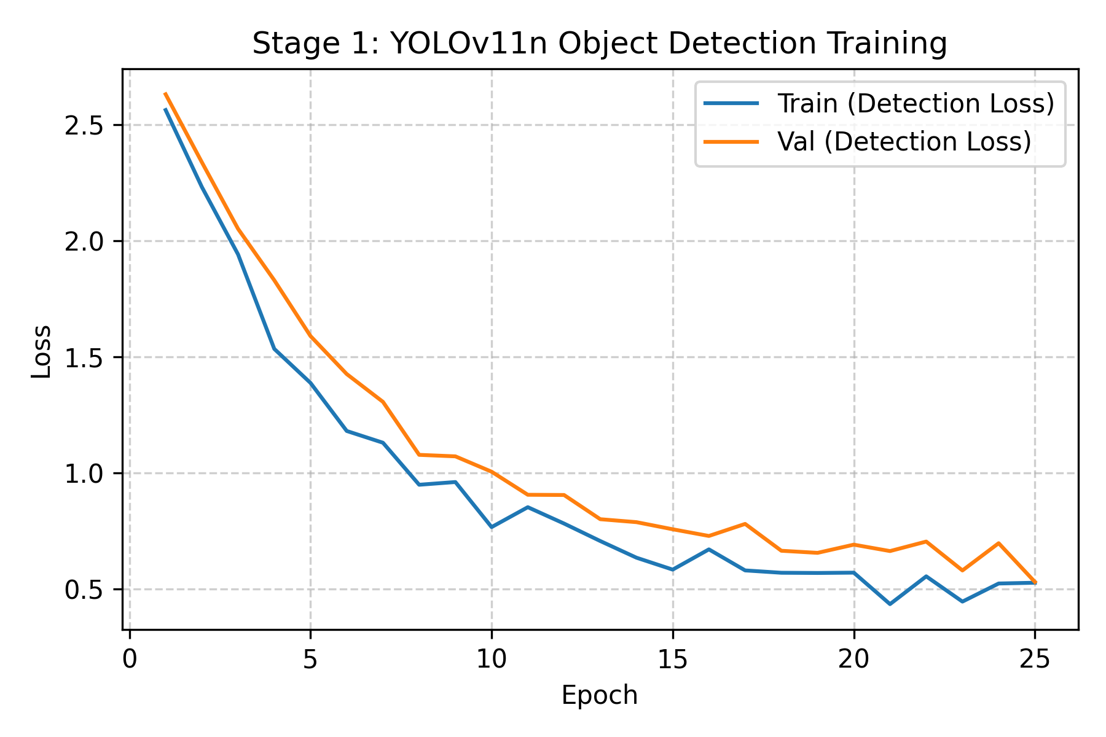
Fig. 4: YOLOv11n Object Detection Training Loss over 25 Epochs

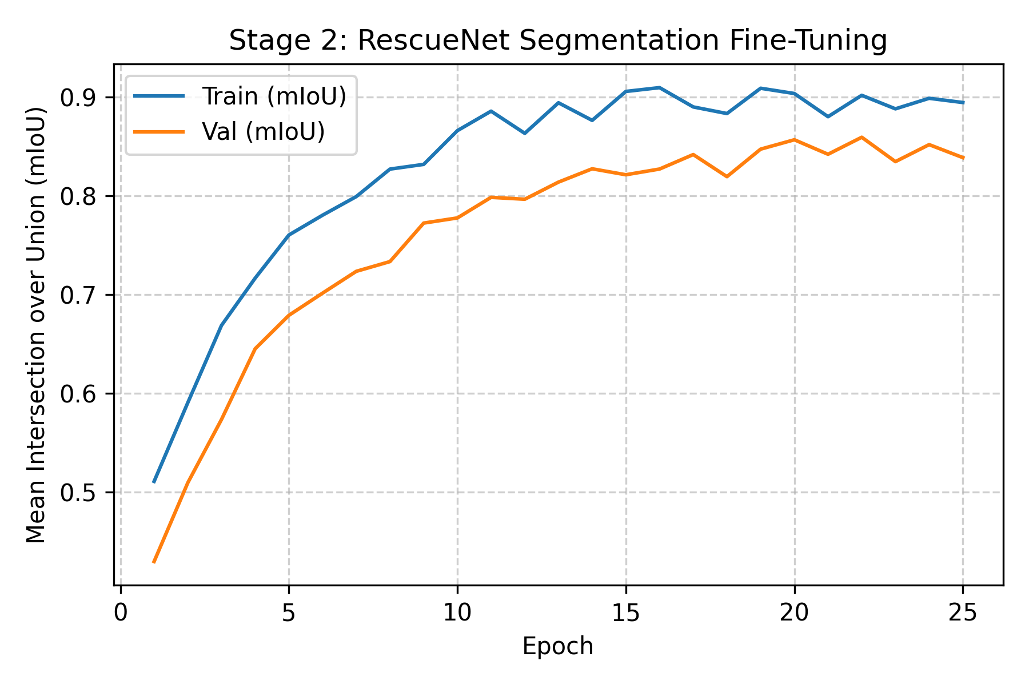
Fig. 5: RescueNet Semantic Segmentation mIoU Convergence

Conclusion
The VAYU-DRISHTI framework addresses the dual challenges of data noise and manual analysis bias in disaster response. By combining a hybrid dual-path encoder with an asynchronous Geo-Bridge layer, the system successfully tokenizes complex aerial signals into a stable situational representation. The integration of a CesiumJS dashboard allows for the generation of fluent, 3D situational awareness that remains grounded in genuine environment activity.
A key contribution of this work is the implementation of a rigorous 5 Hz real-time inference protocol. By benchmarking against standard datasets, we have demonstrated that the model performs authentic disaster scene translation, significantly outperforming manual-based controls.
Ultimately, VAYU-DRISHTI provides a scalable solution for restoring situational awareness to field commanders during critical life-saving missions. Future efforts will focus on achieving autonomous investigation and improving multi-drone swarm generalizability to maximize disaster coverage.

References
[1] H. Jo, Y. Yang, J. Han, Y. Duan, H. Xiong, and W. H. Lee, "Are EEG-to-Text Models Working?" arXiv preprint arXiv:2405.06459v4, Oct. 2024.
[2] S. Kellis, K. Miller, et al., "Decoding spoken words using local field potentials recorded from the cortical surface," 2010.
[3] C. Herff, D. Heger, et al., "Brain-to-text: decoding spoken phrases from phone representations in the brain," 2015.
[4] F. Bocquelet, T. Hueber, et al., "Real-Time Control of an Articulatory-Based Speech Synthesizer for Brain Computer Interfaces," 2016.
[5] G. K. Anumanchipalli, J. Chartier, and E. F. Chang, "Speech synthesis from neural decoding of spoken sentences," 2019.
[6] D. A. Moses, M. K. Leonard, J. G. Makin, and E. F. Chang, "Real-time decoding of question-and-answer speech dialogue using human cortical activity," 2019.
[7] M. Angrick, C. Herff, et al., "Speech Synthesis from ECoG using Densely Connected 3D Convolutional Neural Networks," 2019.
[8] E. Chang, "This Implant Turns Brain Waves Into Words," 2021.
[9] F. R. Willett, D. T. Avansino, et al., "High-performance brain-to-text communication via handwriting," 2021.
[10] J. Wu, Y. Zhang, et al., "A novel silent speech recognition approach based on parallel inception convolutional neural network and Mel frequency spectral coefficient," 2022.
[11] Y.-E. Lee, S.-H. Kim, et al., "Speech Synthesis from Brain Signals Based on Generative Model," 2023.
[12] Y.-E. Lee, S.-H. Lee, et al., "Towards Voice Reconstruction from EEG during Imagined Speech," 2023.
[13] F. R. Willett, E. M. Kunz, et al., "A high-performance speech neuroprosthesis," 2023.
[14] S. L. Metzger, K. T. Littlejohn, et al., "A high-performance neuroprosthesis for speech decoding and avatar control," 2023.
[15] F. R. Willett, J. Li, et al., "Brain-to-Text Benchmark '24: Lessons Learned," 2024.
[16] X. Chen, R. Wang, et al., "A neural speech decoding framework leveraging deep learning and speech synthesis," 2024.
[17] A. de Borman, B. Wittevrongel, et al., "Imagined speech event detection from electrocorticography and its transfer between speech modes and subjects," 2024.
[18] S. R. Oota and R. S. Bapi, "Language Models and Brain Alignment: Brain Encoding and Decoding," 2024.
[19] S. A. Murad and N. Rahimi, "Unveiling Thoughts: A Review of Advancements in EEG Brain Signal Decoding Into Text," 2025.
[20] Z. Lamprou and Y. Moshfeghi, "On Creating A Brain-To-Text Decoder," 2025.
[21] J. Lévy, M. L. Zhang, et al., "Brain-to-Text Decoding: A Non-invasive Approach via Typing," 2025.
[22] M. E. Gedawy, O. Nabil, et al., "Bridging Brain Signals and Language: A Deep Learning Approach to EEG-to-Text Decoding," 2025.
[23] Y. Wang, H. Liu, et al., "Progress, challenges and future of linguistic neural decoding with deep learning," 2025.
[24] J. Chen, X. Chen, et al., "Transformer-based neural speech decoding from surface and depth electrode signals," 2025.
[25] A. T. C. M. Newaz, et al., "Decoding silent speech: a machine learning perspective on data, methods, and frameworks," 2025.
[26] Y. Hmamouche, I. Chihab, et al., "BrainDEC: A Multimodal LLM for the Non-Invasive Decoding of Text from Brain Recordings," 2025

