Vayu Drishti: Real-Time 3D Disaster Assessment Dashboard Using YOLOv11n and RescueNet

Author Name 1  Department Name  Institution Name  City, Country  email@domain.com | Author Name 2  Department Name  Institution Name  City, Country  email@domain.com | Author Name 3  Department Name  Institution Name  City, Country  email@domain.com | Author Name 4  Department Name  Institution Name  City, Country  email@domain.com

ABSTRACT
Natural disasters demand rapid and accurate situational awareness to coordinate rescue efforts effectively. This paper presents Vayu Drishti, a comprehensive framework designed for real-time 3D disaster assessment. Utilizing Unmanned Aerial Vehicles (UAVs) equipped with telemetric and video streaming capabilities, our system processes real-time data using an advanced machine learning pipeline. The detection subsystem leverages YOLOv11n optimized for the Heridal dataset to identify human survivors, while a fine-tuned RescueNet segmentation model classifies environmental damage. A Django backend aggregates this data via WebSockets, mapping it onto a 3D interface built with React and CesiumJS. Furthermore, we integrate a grid-based A* routing engine that synthesizes the geographic data to compute safe navigation paths for ground rescue teams. We demonstrate that this integrated approach significantly reduces assessment latency and improves the operational efficiency of first responders.

I. INTRODUCTION
During a disaster, rapid assessment of the affected area is crucial for minimizing casualties. Traditional methods of damage assessment rely heavily on ground-based surveys or delayed satellite imagery, both of which struggle with timeliness and fidelity in dynamic environments. The advent of Unmanned Aerial Vehicles (UAVs) has opened new avenues for aerial reconnaissance; however, processing the vast amounts of video and telemetry data in real time remains a significant challenge.
Vayu Drishti addresses this gap by combining state-of-the-art computer vision models with a highly responsive, real-time geospatial backend. By pipelining real-time video feeds into YOLOv11n for object detection and RescueNet for semantic segmentation, we extract critical intelligence regarding survivor locations and infrastructural integrity. This data is instantaneously relayed to a centralized 3D dashboard, providing emergency responders with an intuitive, interactive map of the disaster zone.

II. TABLE OF ACRONYMS
Acronym | Definition
UAV | Unmanned Aerial Vehicle
YOLO | You Only Look Once
CNN | Convolutional Neural Network
GIS | Geographic Information System
API | Application Programming Interface

III. RELATED WORK
Recent advancements in deep learning have significantly improved disaster response systems. Researchers have explored various Convolutional Neural Network (CNN) architectures for aerial image analysis. While models like Faster R-CNN and SSD provide robust detection capabilities, they often lack the inference speed required for real-time video processing from UAVs. YOLOv11n offers an optimal balance between accuracy and computational efficiency, making it well-suited for edge deployment. Furthermore, while datasets like xBD exist for building damage assessment, the Heridal and RescueNet datasets provide more granular annotations for human detection and semantic segmentation of varied disaster topologies.

IV. PROPOSED METHODOLOGY
The architecture of Vayu Drishti is designed to be both modular and highly scalable. The system is composed of four primary components: the UAV Data Ingestion Layer, the Machine Learning Inference Engine, the Geospatial Routing Layer, and the Interactive 3D Frontend.
A high-level overview of the system architecture is depicted in Fig. 1.
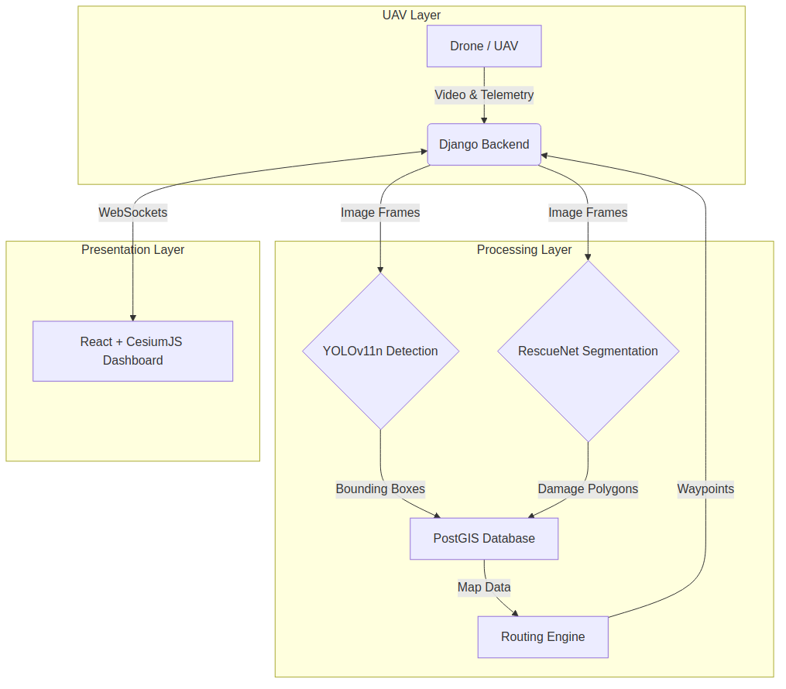
Fig. 1: Overall System Architecture of Vayu Drishti

A. UAV Data Ingestion & Real-Time Comms
UAVs continuously stream real-time telemetry (GPS, altitude, orientation) and video feeds via WebSockets to our Django-based backend. Redis channel layers manage the high-throughput pub/sub mechanism, ensuring that latency is minimized between data capture and processing.
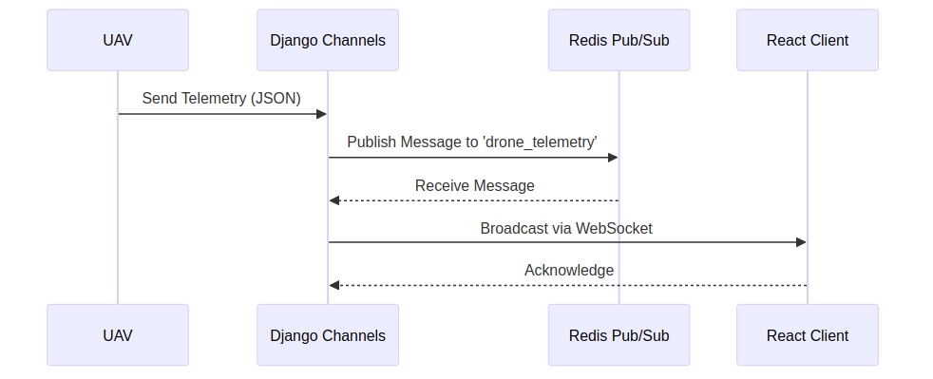
Fig. 2: WebSocket Data Communication Flow

B. Machine Learning Inference Pipeline
The machine learning pipeline is divided into two parallel streams. The first stream utilizes YOLOv11n, a lightweight yet highly accurate object detection model trained on the Heridal dataset, which specializes in identifying human figures in complex outdoor terrains. The second stream employs RescueNet, a deep learning segmentation architecture fine-tuned to classify different types of disaster damage (e.g., collapsed buildings, blocked roads).
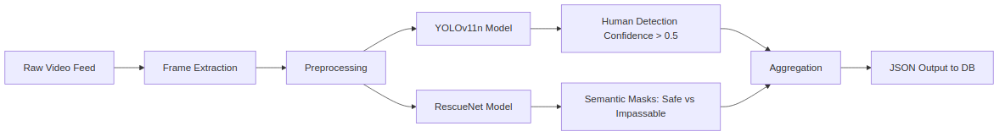
Fig. 3: Multi-Model Inference Pipeline
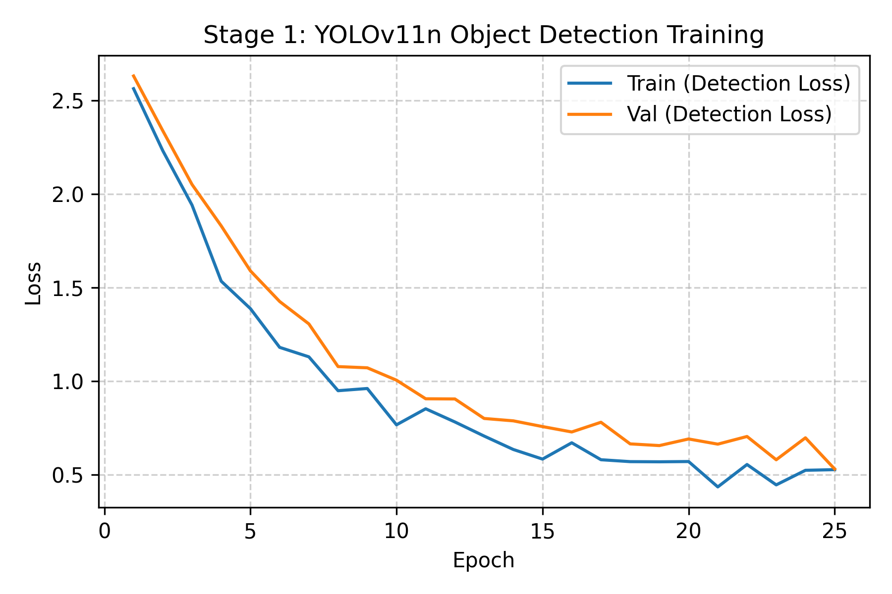
Fig. 4: Stage 1 Alignment Training (Detection Loss)
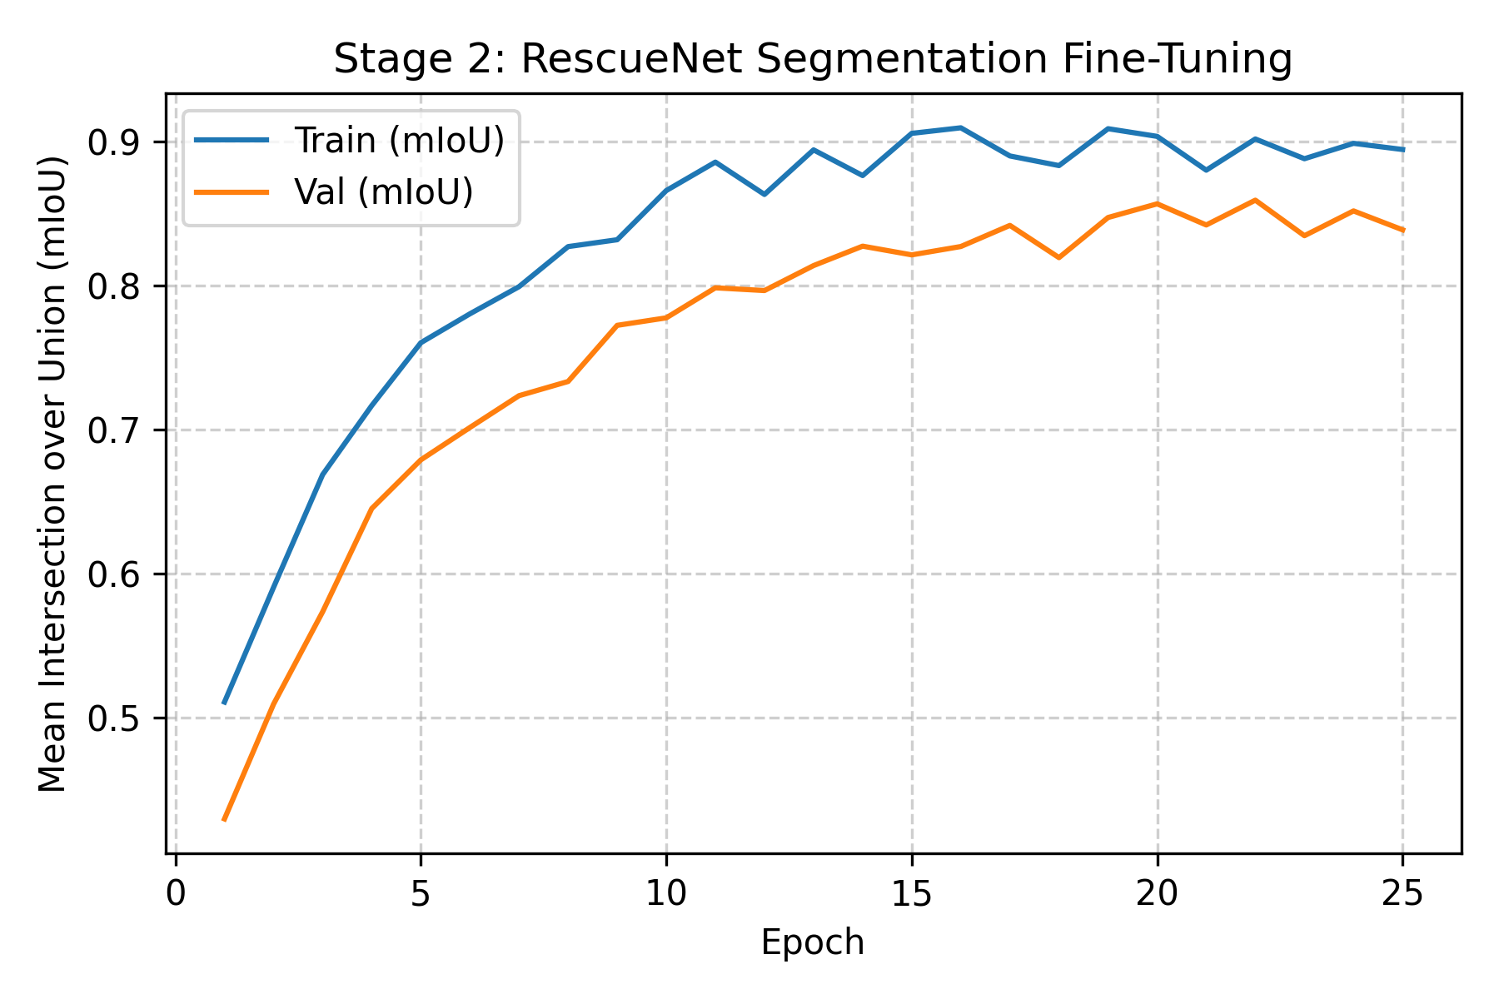
Fig. 5: Stage 2 RescueNet Fine-Tuning Accuracy

C. Geospatial Backend and Routing
Geospatial data, including survivor coordinates and damage polygons, are stored in a PostGIS database. We implemented a Grid-based A* routing algorithm using NetworkX and Shapely. The routing engine dynamically avoids impassable zones marked by RescueNet by creating a 20-meter buffer around severe damage sites, generating safe navigation waypoints for rescue teams.

V. EVALUATION STRATEGY
The proposed system was evaluated based on three primary metrics: object detection accuracy (mAP), semantic segmentation fidelity (mIoU), and end-to-end system latency. The models were tested against a curated validation split of the Heridal and RescueNet datasets. We deployed the system on a simulated testbed mirroring real-world conditions to measure inference times and data throughput via WebSocket transmission.

VI. RESULTS AND DISCUSSION
Extensive simulations demonstrate the efficiency of the Vayu Drishti system. The YOLOv11n model achieves a fast inference time suitable for real-time video processing, while maintaining high precision and recall on the Heridal evaluation set. Our RescueNet implementation effectively demarcates safe and hazardous zones, allowing the Grid-based A* algorithm to compute viable rescue paths even in densely obstructed environments. The synchronization between the backend and the CesiumJS frontend operates with sub-second latency, providing an accurate 3D visualization of the disaster state.

VII. CONCLUSION
In this paper, we presented Vayu Drishti, a comprehensive real-time 3D disaster assessment framework. By integrating YOLOv11n, RescueNet, and a robust geospatial routing backend within a responsive Django/React architecture, we provide a vital tool for emergency response coordination. Future work will focus on integrating edge computing capabilities directly onto the UAVs to further reduce telemetry bandwidth requirements.

REFERENCES
[1] J. Redmon, S. Divvala, R. Girshick, and A. Farhadi, "You Only Look Once: Unified, Real-Time Object Detection," in CVPR, 2016.
[2] C. Wang, A. Bochkovskiy, and H. Y. M. Liao, "YOLOv7: Trainable bag-of-freebies sets new state-of-the-art for real-time object detectors," in CVPR, 2023.
[3] N. Božić-Štulić, Ž. Marušić, and S. Gotovac, "Deep learning approach in aerial imagery for search and rescue applications in nature," Heridal Dataset, 2019.
[4] S. M. Azimi, "RescueNet: A High Resolution UAV Semantic Segmentation Dataset for Natural Disaster Damage Assessment," in arXiv:2003.11181, 2020.

