

**CSE3013 - Artificial Intelligence**

**( Embedded Theory )**

**AI BASED DRIVER BEHAVIOR DETECTION**

Aditya Kumar Amogh Kumar Mishra

**20BCE0833** **20BCE2347**

Kaushik Gupta Hanush Karthick V

**20BCE0823** **20BCE2127**

**Submitted to:** Sridhar Raj S

Abstract

Driving behavior is the manner by which drivers respond to actual driving environments and a major factor for road traffic safety. There are many research studies contributing to detection of driving behavior that may cause traffic crashes. The lack of attention during the driving task is considered as a major risk factor for fatal road accidents around the world. Despite the ever-growing trend for autonomous driving which promises to bring greater road-safety benefits, the fact is today’s vehicles still only feature partial and conditional automation, demanding frequent driver action. Moreover, the monotony of such a scenario may induce fatigue or distraction, reducing driver awareness and impairing the regain of the vehicle’s control. To address this challenge, we introduce a non-intrusive system to monitor the driver in terms of fatigue, distraction, and activity. The proposed system explores state-of-the-art sensors, as well as machine learning algorithms for data extraction and modeling.

**Keywords**: Behavior detection, Sensor data, Driving behavior, Vehicle motion data, driver monitoring system, intelligent transportation systems, driver distraction monitoring, driver fatigue monitoring

# **Introduction**

Human drivers have different driving styles, experiences, and emotions due to unique driving characteristics, exhibiting their own driving behaviors and habits.

Abnormal driving may cause serious danger to both the driver and the public. Driver’s inattention might be the result of a lack of alertness when driving due to driver drowsiness, fatigue and distraction.

This might result in decreased driving performance, longer reaction time, and an increased risk of crash involvement.

Gesture patterns are less distinguishable in vehicles due to in-vehicle physical constraints and body occlusions from the drivers.

Various research efforts have approached the problem of detecting abnormal human driver behavior with the aid of capturing and analysing the face of driver and vehicle dynamics via image and video processing but the traditional methods are not capable of capturing complex temporal features of driving behaviors.

This situation inspires us to rethink the abnormal driving detection problem and to apply deep architecture models.

The objective of the project is to reduce the number of road accidents caused due to driver’s errors.

Our objective of reducing accidents can be achieved by implementation of relevant driver behaviour detection mechanism.

## **Need/Motivation**

Lot of accidents happen on the public roads (see Fig.1), and most of these accidents are due to inattentive driver behaviour.

Modern driver monitoring systems evaluate driver behaviour by means of distinctive sensor technology and, if necessary, indicate undesirable driving behaviour.

However, many roadworthy vehicles do not have the possibility to implement such systems.

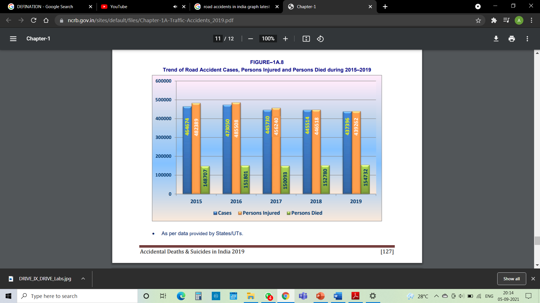

Figure 1.

Therefore, it seems to be interesting to investigate the implementation of such systems based on commodity hardware, e.g., smartphones, because nowadays almost every driver has a powerful smartphone equipped with many sensors at hand in the vehicle.

With the increase in the availability of driver’s data, their driving styles, and their trips, enhanced conclusions can be made about how the identified driver behaviour is related to safe and unsafe driving. Thus, identifying the driving behaviour can lead to an increase in overall traffic safety.

In order to achieve this goal, the evaluated driver’s behaviour should be used to warn each individual driver (and probably his/her environment, as well) about his/her condition and give reasonable recommendations towards getting the desired safe way of driving.

## **Objectives**

Dangerous driving behaviour detection can be used in video surveillance systems to identify dangerous patterns, such as Abrupt Double Lane Change (ALC), Retrograde Driving (RD), and Illegal U-Turn (IT), for traffic design, traffic management, and law enforcement.

The purpose of this is to develop a detection method of dangerous driving behaviour based on video surveillance.

Present an efficient framework for evaluating various driving patterns

Detection of Driving behaviour & Driving Scores.

Collected data can reveal the driving behaviour of a person.

Category of GOOD, NORMAL & RASHLESS based on the Driving Score earned (0 - 5 Star).

Provide feedback and confront drivers with their recorded driving actions

Personalized Notifications & Warnings.

“This is the 3rd time you have crossed your set warning limit of 100km/hr”

“Irregular acceleration & brakes decrease your engine’s life.”

“In India, 60% accidents happen due to lane change without indication light”

Classification & Probability of accidents based on Driving scores.

Over years of data, an open platform can be created which can plot the collection of Driving Scores for various drivers.

The Driving Score can become taken as a standard to identify & measure who is driving safely?

E.g., “Drivers who maintain rating above 4.0 have only 11% chance to meet an accident.”

## **1.3 Possible techniques for proposed system**

## **1.3.1 Physiological-based Techniques**

In this category the drowsiness measurement is done by attaching electronic devices like sensors to the driver’s body. The earlier stages of drowsiness can cause physiological changes in human body. Integration of ECG and EEG signals are used to detect drowsiness and improve its performance. The authors have induced a monotonous driving environment and extracted the frequency and time feature from the EEG signals and heart rate (HR), heart rate variability (HRV) from the ECG signals. The noteworthy features of ECG and EEG are used to classify the drowsiness using SVM classifier. The combination of ECG and EEG have given better performance than individual signals.

## **1.3.2 Vehicle-based Techniques**

It is a challenging task to use vehicle measures to predict the driver drowsiness. Changes in lane, steering movement and acceleration are some of the features to be considered for drowsiness detection. Five input parameters like centerline of the road, lateral acceleration, steering wheel angle, yaw rate and steering wheel velocity are considered and classification was done using a combination of CNN and LSTM deep learning algorithms.

## **1.3.3 Behavioral-based Techniques**

With a great demand in driver drowsiness detection techniques many researchers have done effective work with the help of various measures used for driver drowsiness detection. The researchers have used the physiological, behavioral and vehicle-based measures to test the different combinations of data. In both detection and prediction behavioral measure has proved its strength with a detection mean square of 0.22 and prediction mean square error of 4.18 min.

A deep drowsiness detection (DDD) network [28] is developed to learn and detect drowsiness. The network takes a RGB input video of a driver which can be used to learn the facial movements and head gestures using the three deep networks. The output of the three layers along with the SoftMax classifier helps drowsiness detection.

Both the physiological and behavioral measures were applied on the custom dataset which was captured using Logitech C920 HD Pro Webcam [26]. Multi-task Cascaded Convolutional Networks (MTCNN) is used for fast and accurate face detection. Driver Drowsiness Detection Network (DDDN) is used for detecting driver drowsiness.

Images are processed by human visual system to detect driver drowsiness [29]. The energy levels in the image frames are changed to improve the robustness of the drowsiness detection system and predicted using better decision-making algorithm. Extracting the facial feature is an important task which can be done using the Viola-Jones algorithm.

A Deep Belief Network (DBN) [30] is used to classify driver drowsiness expressions for which the high-definition camera is used to extract the landmarks and textures of the facial regions. The behavioral measures are the recent trend among the researchers. A complete and accurate is still a challenge in the recent time.

# **Literature Review**

## **2.1 Tables**

**Table 2** The evaluation results of each class of driver drowsiness measurement technologies

|  |  |  |  |
| --- | --- | --- | --- |
| Technology  Criteria | Vehicle Based (Driving) | Video Based (Driver) | Physiological Signal Based |
| Intrusiveness | -1 | -1 | -3 |
| Artefacts/Noise | -1 | -2 | -3 |
| Ease of Use | +2 | +3 | +1 |
| Accuracy | +1 | +2 | +3 |

**Table 3** Summary of the open issues to be considered for each class of drowsiness measurement technologies and the associated level of significance

|  |  |  |  |  |
| --- | --- | --- | --- | --- |
| Technology Issues | Driving Behaviour | Driver Behaviour | Physiological signal based | Significance |
| Use of standard objective measures | X | X | X | 1 |
| Environment conditions Influence | X | X |  | 3 |
| Difficulty to extract symptoms |  | X |  | 2 |
| Circadian and wake phases | X | X | X | 1 |
| Accuracy with fewer sensors |  |  | X | 2 |
| Intrusive nature of sensors |  |  | X | 1 |
| Impact of artefacts |  |  | X | 2 |
| Real-time detection support |  | X | X | 1 |

|  |  |  |  |  |
| --- | --- | --- | --- | --- |
| Author | Materials | Method/Algorithm Used | *Dataset* | *Accuracy* |
| [27] | SCANeR Studio, faceLAB, pulse plethysmography | Artificial Neural Networks | 21 participants simulated car for 110mins | 95% |
| [26] | Sensors, Logitech C920 HD Pro Webcam | Deep Neural Networks | Custom Dataset | 89.5% |
| [28] | RGB input video | Deep networks | NTHU-drowsy driver detection benchmark dataset | 73.06% |
| [29] | web-cam of the laptop | Image processing, Decision making algorithm | 55 min of video, in which 130 drowsiness events have occurred | 90% |
| [30] | HD Camera | Deep Belief Network | videos of 30 subjects (with ages ranging from 20 to 55 years) | 96.7% |

## **2.2 Detailed discussion of the literature works**

[1] Real Time Driver Fatigue Detection SystemBased on Multi-Task ConNN.In this article, a Multitasking Convolutional Neural Network (ConNN). With the proposed Multi-taskConNN model, unlike the studies in the literature, both mouth and eye information are classified into one model at an equivalent time.

[2] An Adaptive Batch-Image Based Driver Status Monitoring System on a Light weight GPU-Equipped SBC. Also, the system works with PydMobileNet, which has lower parameters and FLOPs than MobileNetV2, for facial behavior recognition. Hence this method is more efficient and robust and requires less time.

[3] A Hybrid CNN framework for behaviour detection of distracted drivers - In this paper, presentation of a hybrid CNN framework (HCF) to detect the behaviors of distracted drivers by using deep learning to process image features is done. This system detects whether the driver follows traffic rules or not.

[4] Using Asymmetric Theory to Identify Heterogeneous Drivers Behavior Characteristics Through Traffic Oscillation- This paper applies the asymmetric driving theory to capture driving characteristics of car-following behavior throughout traffic oscillation.

[5] AI for vehicle behaviour anticipation: Hybrid approach supported Manoeuvre classification and trajectory prediction. This paper proposes a hybrid approach to neural networks and trajectory prediction using Long Short-term Memory (LSTM) and Next Generation Simulation (NGSIM) public dataset that provides real driving data.

[6] Driving Behavior Using DeepLearning: Recent Advances, Requirements and Open Challenges Detecting Human Driver Inattentive and Aggressive. In this paper, first they classify and discuss Human Driver Inattentive Driving Behavior (HIDB) into two major categories, Driver Distraction (DD), Driver Fatigue (DF), or Drowsiness (DFD).

[7] A Survey on State-of-the-Art Drowsiness Detection Techniques- This paper presents a comprehensive analysis of the existing methods of driver drowsiness detection and presents a detailed analysis of widely used classification techniques in this regard. Thus, this method is done by using Top supervised learning.

[8] Dynamic Bayesian network approach to evaluate vehicle driving risk based on-road experiment driving data. In this work, they utilize a dynamic Bayesian network for an inferential analysis of driving-related risks based on our assessment of real-world driving data.

[9] Video-Based Abnormal Driving Behavior Detection via Deep Learning Fusions. In this paper, deep learning fusion techniques are emphasized, and three novel deep learning-based fusion models are introduced, to fulfil the video-based abnormal driving behavior detection task for the first time.

[10] The Influence of Different Factors on Right-turn Distracted Driving Behavior at Intersections Using Naturalistic Driving Study Data - The proposed method senses the driver's behaviour in the state of drowsiness, it gives an alert.

[11] The Influence of Different Factors on Right-turn Distracted Driving Behavior at Intersections Using Naturalistic Driving

Study Data - The proposed method senses the driver's behaviour in the state of drowsiness, it gives an alert.

[12] Integration of Ensemble and Evolutionary Machine Learning Algorithm for Monitoring Diver Behavior Using Physiological Signals. In the initiative , the performances of the K-nearest neighbors (KNN), support vector machine (SVM), and naive Bayes (NB) algorithms are improved using bagging, boosting, and voting ensemble learning techniques.

[13] An Effective Bio-Signal-Based Driver Behavior Monitoring System Using a Generalized Deep Learning Approach - Therefore, in this paper, a bio-signal-based system for real-time detection of aggressive driving behaviors using a deep convolutional neural network (CNN) model with edge and cloud technologies is carried out.

[14]  In this work, we detect and analyse driver’s state by monitoring their physiological (ECG) information. ECG is a non-invasive signal that can read the heart rate and heart rate variability (HRV). Filters are applied on the ECG data and 13 statistically significant features are extracted. The selected features are trained using three classifiers namely: Support Vector Machine (SVM), K-nearest neighbour (KNN) and Ensemble. The overall accuracy for two-classes such as: normal–drowsy, normal–visual inattention, normal–fatigue and normal–cognitive inattention is 100%, 93.1%, 96.6% and 96.6% respectively.

[15] A Comparative Study of Aggressive DrivingBehavior Recognition Algorithms Based On Vehicle Motion Data. The objective to reduce traffic accidents and improve road safety, effective and reliable aggressive driving recognition methods, which enables the development of driving behavior analysis and early warning systems, are urgently needed.

[16] Driving Stability Analysis Using Naturalistic Driving Data With Random Matrix Theory. This method can extract features, based on the random matrix theory, to reflect the statistical difference between actual driving data and the data that would be generated by a theoretically ideal driver. Using the extracted features, a driving behavior analysis application that partitions drivers into clusters to spot common driving stability characteristics is demonstrated and discussed.

[17] Analysis of road-user interaction by extraction of driver behavior features using Deep Learning. In this study, an improved deep learning model is proposed to explore the complex interactions between the road environment and driver’s behaviour throughout the generation of a graphical representation. The graphical outcomes reveal the method's ability to efficiently detect patterns of simple driving behaviors, as well as the road environment complexity and some events encountered along the path.

[18] Detecting Human driver Inattentive and aggressive driving behavior (HIADB) using deep learning. After describing the background of deep learning and its algorithms, presentation of an in-depth investigation of most recent deep learning-based systems, algorithms, and techniques for the detection of Distraction, Fatigue/Drowsiness, and Aggressiveness of a human driver.

[19] Bias Remediation in Driver Drowsiness Detection Systems Using Generative Adversarial Networks.The framework improves CNN, trained for prediction by using Generative Adversarial networks for targeted data augmentation supported a population bias visualisation strategy that groups faces with similar facial attributes and highlights where the model is failing. The proposed framework isn't limited to the driving force drowsiness detection task, but is often applied to other applications.

[20] Driving range parametric analysis by interior static magnet motors of electrical vehicles driven considering driving cycles. This paper presents a parametric analysis of the golf range by V-type interior static magnet motors of electrical vehicles driven aiming at maximum golf range . This shows that both for driving cycles, an

[21] Visualization of driving behaviour based on hidden feature extraction by using deep learning. Based on the DSAE, they propose a visualization method called adrivingcolor map by mapping the extracted 3-D hidden feature to the red green blue (RGB) color space. It shows the driving color map based on DSAE facilitates better visualization of driving behavior.

[22] RL78 MCU from Renesas Electronics of Japan is used to design a monitoring device that supports SAE. With the proposed system J1939 Bridge, the driver data from the vehicle CAN bus can be monitored, analyzed and calculated. It can yield a range of insights about drivers' behaviour. The accessed data can also be displayed on a specific LCD screen connected to the system. Besides, data can be transmitted to other devices for mobile application via Bluetooth connection.

[23] deep learning fusion techniques are emphasized, and three novel deep learning-based fusion models inspired by the recently proposed and popular densely connected convolutional network (DenseNet) are introduced, to fulfill the video-based abnormal driving behavior detection task for the first time. These three new deep learning-based fusion models are named as the wide group densely (WGD) network, the wide group residual densely (WGRD) network, and the alternative wide group residual densely (AWGRD) network, respectively. Technically, WGD takes important issues of deep learning models, i.e., the depth, the width and the cardinality, into consideration when designing its model structure based on DenseNet. For the WGRD and AWGRD, they are more sophisticated as the important idea of residual networks with superpositions of previous layers is incorporated. The extensive experiments are conducted to verify the effectiveness of three new models.

[24] State-of-the-art approaches for predicting unsafe driving styles using three common IoT-based architectures are reviewed. Major differences among multi-sensors, smartphone-based, and cloud-based architectures in multimodal feature processing are shown. The important factors of Multi-Access Edge Computing (MEC) and 5th generation (5G) networks are analysed in the context of deep learning architecture to improve the response time of DFD systems.

[25] The author utilized vision, sensors, environmental, and vehicular-based features that integrated together by fusion to predict multistage of HDx. The primary aim of this work is in algorithm and feature modeling, then compare the advantages and differences with other work. In this paper, a different study is conducted compare to state-of-the-art survey articles by statistically measuring the performance.

## **2.3 Research Gaps**

After reviewing all the research papers, we found that many of the research papers had some or the other research gaps which in a way were disadvantages.

The most common disadvantages were the performance and accuracy of their proposed systems. Like in the research papers [7], [2], [6], [3] the disadvantages were either they were not much accurate or their performance.

In [7] A Survey on State-of-the-Art Drowsiness Detection Techniques- the method seems to be not accurate. In [2] An Adaptive Batch-Image Based Driver Status Monitoring System on a Light weight GPU-Equipped SBC the disadvantage is that the Cost is higher and accuracy is less. In [6] "Detecting Human Driver Inattentive and Aggressive Driving Behavior Using Deep Learning: Recent Advances, Requirements and Open Challenges,” Detecting Human Driver Inattentive and Aggressive here also the disadvantage is that it is not much accurate. In [3] A Hybrid CNN framework for behaviour detection of distracted drivers a minor disadvantage is its performance.

Another common disadvantage in some research papers were their high cost. In research papers [2], [5], [13] the disadvantages are they are costly to implement and increases cost to the users.

In [2] An Adaptive Batch-Image Based Driver Status Monitoring System on a Light weight GPU-Equipped SBC - the disadvantage is that the Cost is higher and accuracy is less. In [5] "Artificial Intelligence for Vehicle Behavior Anticipation: Hybrid Approach Based on Maneuver Classification and Trajectory Prediction," The disadvantage is the high cost of implementation. [13] "An Effective Bio-Signal-Based Driver Behavior Monitoring System Using a Generalized Deep Learning Approach," increases cost to the users.

[2] "An Adaptive Batch-Image Based Driver Status Monitoring System on a Lightweight GPU-Equipped SBC," this method is more efficient and robust and requires less time but the disadvantage is that the Cost is higher and accuracy is less.

[3] "HCF: A Hybrid CNN Framework for Behavior Detection of Distracted Drivers," The disadvantages of CNN models is classification of images with different positions. Another minor disadvantage is performance.

[1] “Real Time Driver Fatigue Detection System Based on Multi-Task ConNN” The time taken for the process and displaying the result is much higher which is the disadvantage here.

[4] "Using Asymmetric Theory to Identify Heterogeneous Drivers’ Behavior Characteristics Through Traffic Oscillation," The disadvantage is that it seems to be complex because of machine learning algorithms, which is difficult and it needs larger samples.

[9] "Video-Based Abnormal Driving Behavior Detection via Deep Learning Fusions," The disadvantage here is it can be used only in autonomous cars.

[11] "The Influence of Different Factors on Right-Turn Distracted Driving Behavior at Intersections Using Naturalistic Driving Study Data," The disadvantage is that more accuracy is needed for the implementation of signs for ADAS.

[10] "Determination of Risk Perception of Drivers Using Fuzzy-Clustering Analysis for Road Safety," the disadvantage of this paper is that - reception of experiment is needed for acquiring accuracy.

[15] "A Comparative Study of Aggressive Driving Behavior Recognition Algorithms Based on Vehicle Motion Data," The disadvantage here is that the weight of each feature data set is much higher which is because of complex machine learning algorithms.

[12] "Integration of Ensemble and Evolutionary Machine Learning Algorithms for Monitoring Diver Behavior Using Physiological Signals," Here the disadvantage of this proposed method is , very less loss of Mortality .

[8] "Dynamic Bayesian Network Approach to Evaluate Vehicle Driving Risk Based on On-Road Experiment Driving Data," The disadvantage is that it has complex algorithms.

[24] Driver Fatigue Detection Systems Using Multi-Sensors, Smartphone, and Cloud-Based Computing Platforms: A Comparative Analysis, There is a research gap when it comes to implementing the DFD systems on MEC and 5G technologies by using multimodal features and DL architecture.

[25] "A Methodological Review on Prediction of Multi-Stage Hypovigilance Detection Systems Using Multimodal Features," The research gap is of real-time development of multistage M-HDx systems

[9] "Video-Based Abnormal Driving Behavior Detection via Deep Learning Fusions," The disadvantage here is it can be used only in autonomous cars.

# **Proposed Work**

In the proposed method, the device collects real-time vehicular sensor data, such as acceleration, lateral orientation, angular velocity, motion of objects and monitors the alcohol level of the driver. However, with the sensing technology, the data collection raises severe privacy concerns among users who may perceive the continuous monitoring by the operator as intrusive. The work flow of Driving Sense is mainly divided into three components:

1. Data collection.

2. Data processing.

3. Dangerous driving behaviour identification. For data processing, Driving Sense first determines the sensor error distribution. For data collection, control units and Wi-Fi modules are used. Speeding is identified by comparing the estimated speed with the predefined speed obtained from a navigation system. As a result, the findings of the sample test offer insights into the effects of drivers with aggressive driving behaviour and the user can access those data for future reference.

## **Proposed System**

* We have two components in our system

### **1st Component**

* In this component we store on screen activity of the user
* Then we divide the data into two components
* 70% data is used for training the model 30% data is used for testing it
* We use libraries such as pandas, DecisionTreeClassifier, train_test_split, accuracy_score
* Then we use the function predict to get score of drivers

### **2ND Component using Dash Cam**

* The other component of the system includes direct working with the 68 facial landmark detectors
* The face detector of the Dlib library.
* The 68 facial landmark detector is a robustly trained efficient detector which detects the points on the human face using which we determine whether the eyes are open or they are closed.
* Now we are taking the ratio which is described as *'Sum of distances of vertical landmarks divided by twice the distance between horizontal landmarks'*.
* Now this ratio is totally dependent on your system which we may configure accordingly for the thresholds of sleeping, drowsy, active and decide accordingly.

## **Architecture Design**

Our system mainly works in three layers:

* UI Layer
* Conversion Layer
* Application Layer

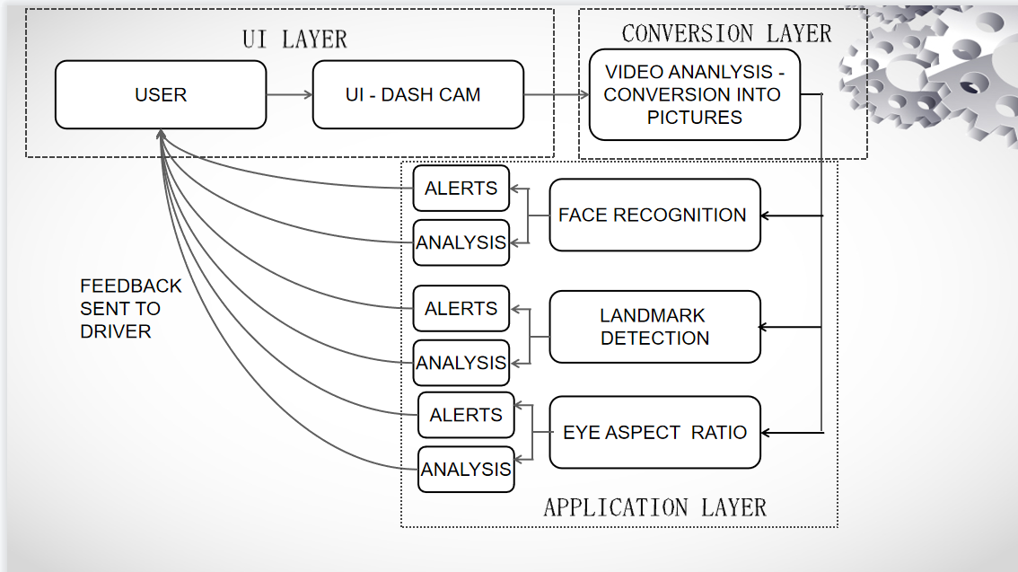

### **3.2.1 UI Layer**

* In this layer, we use dashcam to automatically collect driving data (Driver’s video) and applying a computational model to them to generate various safety scores for the driver
* This type of system uses a remotely placed camera to acquire video and computer vision methods are then applied to sequentially localize face, eyes and eyelids positions to measure ratio of closure.
* Further the video is saved and analysed in the sub levels so that necessary alerts can be given to the driver while driving.

### **3.2.2 Conversion Layer**

Here the captured video is converted into the form of set of images and this is further moved into sub layers for the detection of driver’s drowsiness.

### **3.2.3 Application Layer**

#### **Face Detection**

We use the face detector of the Dlib library which is a robustly trained efficient detector which detects the points on the human face using which we determine whether the eyes are open or they are closed.

#### **Eye Aspect Ratio Calculation**

In this eye blinking rate and eye closure duration is measured to detect driver’s drowsiness.

In this system the position of irises and eye states are monitored through time to estimate eye blinking frequency and eye close duration.

Such a system, mounted in a discreet corner of the car, could monitor for any signs of the head tilting, the eyes drooping, or the mouth yawning simultaneously

## **Flowchart**

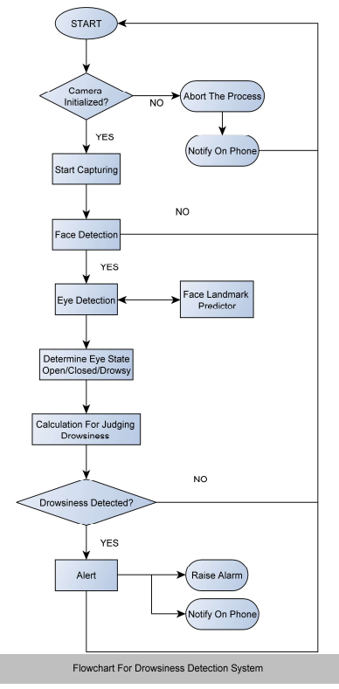

* This flowchart shows that how the drowsiness detection system works
* First it checks whether the camera is started or not. If not then it aborts the process and notifies the driver on phone
* After camera is started, start capturing the image
* Then the face is detected
* If successfully previewed, further step is taken
* Now eye detection takes place
* The state of eye is predicted using the facial landmark predictor
* Drowsiness is calculated through the data stored
* Alarm rings if the drowsiness is detected

## **Algorithm**

* Step 1: Check if dash cam is initialized
* Step 2: Look for faces in input video being recorded by dash cam
* Step 3: If face is detected, capture them as images for processing
* Step 4: Use facial landmark detection to extract the eyes region
* Step 5: Calculate Eye Aspect Ratio
* Step 6: If Eye Aspect Ratio detects that eye are shut for considerable amount of time, send an alert
* Step 7: Raise the alarm and notify if alert is sent
* Step 8: Keep the eyes tracked through the video being saved at backend
* Step 9: Obtain the graphs and plots displaying the score of drowsiness

## **Techniques Involved**

### **3.5.1 Detection of Face and Eye Tracking Through Video**

We are first trying to get a preview of the driving force through the dash camera installed inside the car. The driver’s face preview image is being captured simultaneously by the dash camera and therefore the camera forms to offer us a preview image. Now the camera starts to record the video and automatically saves it within the backend in order that it are often analysed. The recorded video is in HSV colour, grey and original form. These differing types of recording is because it helps to offer us data altogether the frames- grey scale or black and white, coloured frame and original frame. After the videos, images, frames are being recorded and saved, the eyes are detected from them then tracked.

### **3.5.2 Eye Tracking and Plot Generation**

The eye tracking involves to calculate the worth for the attention aspect ratio and provides the figures and plots to detect the data being recorded.

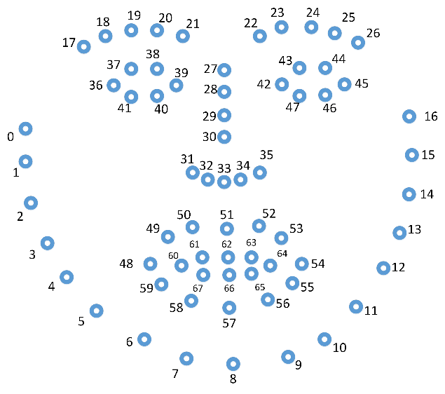

The above figure marks all the regions on the face and gives the right outlining of the face to be focused on.  
The numbers marked above as 36,37,38,39,40,41,42,43,44,45,46,47  
are the main region of focus for us in this project.

### **3.5.3 Raising the Alarm**

If the eyes are drowsy the alarm gets sound and therefore the driver is given an alert through that sound.

### **3.5.4 On-Screen Activity**

The on-screen activity consists of components which calculate the time spent by driver on phone screen while driving.

### **3.5.5 Notifying the Driver**

If the driver gets sleepy or the camera is not installed then a notification would be sent to the connected device.

## **3.6 Pseudocode**

sleep = 0

drowsy = 0

active = 0

status = ""

color = (0, 0, 0)

def compute(ptA, ptB):

dist = np.linalg.norm(ptA - ptB)

return dist

def blinked(a, b, c, d, e, f):

up = compute(b, d) + compute(c, e)

down = compute(a, f)

ratio = up / (2.0 * down)

# Checking if it is blinked

if ratio > 0.25:

return 2

elif (ratio > 0.21) and (ratio <= 0.25):

return 1

else:

return 0

while True:

_, frame = cap.read()

gray = cv2.cvtColor(frame, cv2.COLOR_BGR2GRAY)

faces = detector(gray)

# detected face in faces array

for face in faces:

x1 = face.left()

y1 = face.top()

x2 = face.right()

y2 = face.bottom()

face_frame = frame.copy()

cv2.rectangle(face_frame, (x1, y1), (x2, y2), (0, 255, 0), 2)

landmarks = predictor(gray, face)

for n in range(0, 68):

x = landmarks.part(n).x

y = landmarks.part(n).y

# Setting the radius of circles=2 pixels, colur=white

cv2.circle(frame, (x, y), 2, (255, 255, 255), -1)

landmarks = face_utils.shape_to_np(landmarks)

left_blink = blinked(landmarks[36], landmarks[37],

landmarks[38], landmarks[41], landmarks[40], landmarks[39])

right_blink = blinked(landmarks[42], landmarks[43],

landmarks[44], landmarks[47], landmarks[46], landmarks[45])

if (left_blink == 0 or right_blink == 0):

sleep += 1

drowsy = 0

active = 0

if (sleep > 6):

status = "SLEEPING !!!"

color = (255, 0, 0)

sound2.play()

time.sleep(1)

sound2.stop()

elif (left_blink == 1) or (right_blink == 1):

sleep = 0

active = 0

drowsy += 1

if (drowsy > 6):

status = "Drowsy !"

color = (0, 0, 255)

sound1.play()

time.sleep(1)

sound1.stop()

else:

drowsy = 0

sleep = 0

active += 1

if (active > 6):

status = "Active"

color = (0, 255, 0)

# **4. Results & Analysis**

The AI model which we have created, it has basically two parts. The first part is Driver Drowsiness Detection using 68 landmarks face detection” and the second part is Driver’s Activity using smartphone’s analog data.

Driver Drowsiness Detection using 68 landmarks face detection: It basically tells us whether the driver is Active, Drowsy or Sleeping. It also rings an alarm if the driver is feeling drowsy and rings a louder alarm if the driver is actually sleeping.

First the code uses shape_predictor_68_face_landmarks to detect the driver’s face with the help of 68 landmarks. Then the code calculates the ratio of the blinking of eyes. If the eyes are not at all blinking, it calculates it as a sleep. Thus, if the counter of sleep goes greater than 6, it concludes that the driver is sleeping. If the eyes blink one by one it counts it as drowsy, and as the drowsy counter goes greater than 6, it concludes that the driver is feeling drowsy. Else it concludes that the driver is active.

Through the 2nd component of our system, we can predict the driver’s activity using the existing data. Such data can be easily collected through the analogs of the smartphone. This is a cost-effective technique. We use decision tree classification algorithm to train our models. Decision tree supports automatic feature interaction and its real time execution is relatively faster.

Results obtained through the drowsiness detector. (1st component)

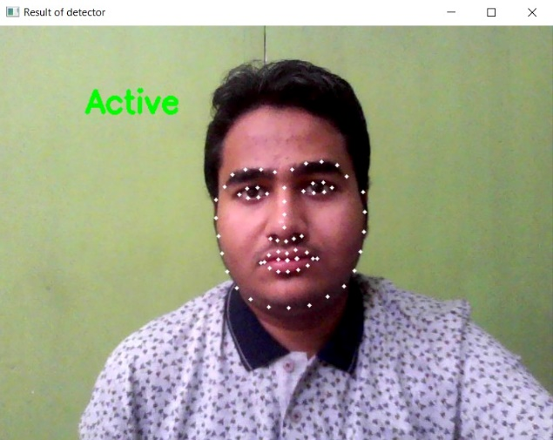

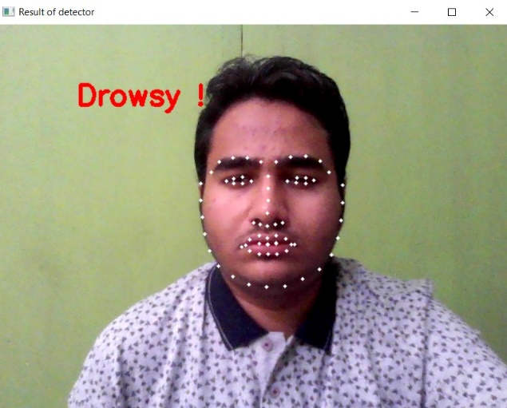

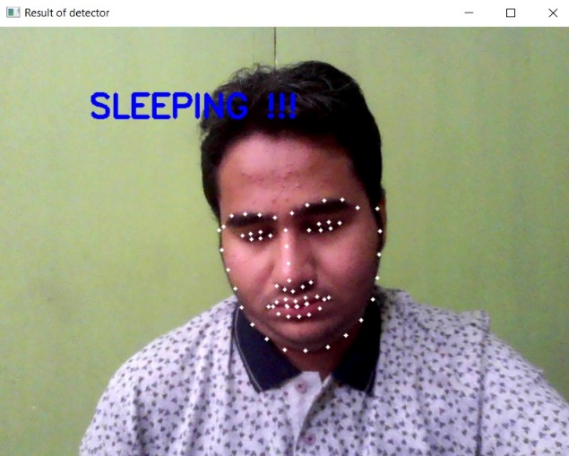

Results obtained for 2nd component

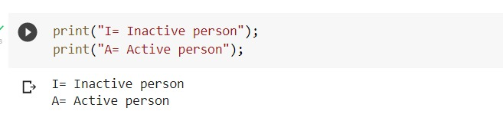

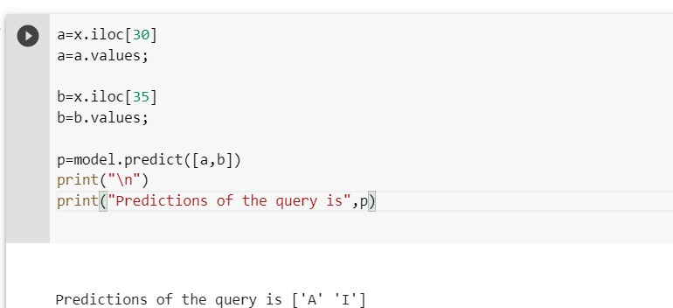

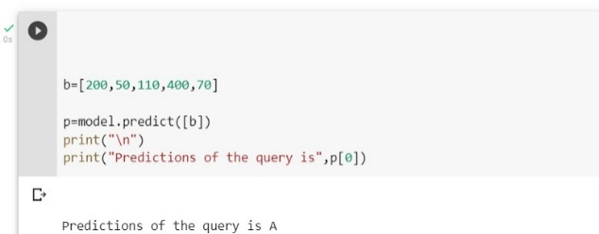

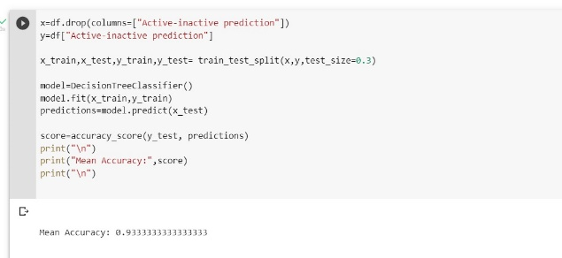

# **5. Conclusion**

Human drivers have different driving styles, experiences, and emotions which may lead to Abnormal driving which could cause serious danger to both the driver and the people.

Therefore, it becomes very essential to build a driver behaviour detection model.

Thus, we have developed an implementation of the Driver Drowsiness Detector using Python.

Our Model collected data from webcam which is used to conclude the attentiveness of the driver.

This would also help the driver to avoid accidents due to his drowsiness as our model continuously monitors the driver’s face and sends an alert if it detects any kind of distraction in the focus of the driver.

This could help in avoiding lot of accidents happening on the public roads due to driver’s inattentive behavior.

# **5. Future Scope**

* To analyse the focus of driver while driving.
* To determine concentration of drivers while driving.
* To detect whether the camera is focusing properly and the driver’s face.
* To reduce the computation time and the number of parameters
* To detect the distracted driving behavior accurately at night.

# **6. Acknowledgement**

* We are thankful to Prof. Sridhar Raj S who is the mentor of our project to guide us for this wonderful and innovative project and allowed us to complete the project smoothly within the limited time frame.
* We also thank to each of us in our team without whom the project would be impossible to be completed well.
* We thank to our Parents for allowing us and encouraging us daily to complete the project and score well through it.

# **7. References**

[1] [BURCU KIR SAVAŞ AND YAŞAR BECERİKLİ“Real Time Driver Fatigue Detection System Based on Multi-Task ConNN”](https://ieeexplore.ieee.org/document/8949469)

[2] [W. Kim, Y. -K. Lee, W. -S. Jung, D. Yoo, D. -H. Kim and K. -H. Jo, "An Adaptive Batch-Image Based Driver Status Monitoring System on a Lightweight GPU-Equipped SBC," in *IEEE Access*, vol. 8, pp. 206074-206087, 2020, doi: 10.1109/ACCESS.2020.3035393.](https://ieeexplore.ieee.org/document/9247221/)

[3] [C. Huang, X. Wang, J. Cao, S. Wang and Y. Zhang, "HCF: A Hybrid CNN Framework for Behavior Detection of Distracted Drivers," in *IEEE Access*, vol. 8, pp. 109335-109349, 2020, doi: 10.1109/ACCESS.2020.3001159.](https://ieeexplore.ieee.org/iel7/6287639/8948470/09113267.pdf)

[4] [Q. Wan, G. Peng, Z. Li, F. Inomata, Y. Zheng and Q. Liu, "Using Asymmetric Theory to Identify Heterogeneous Drivers’ Behavior Characteristics Through Traffic Oscillation," in *IEEE Access*, vol. 7, pp. 106284-106294, 2019, doi: 10.1109/ACCESS.2019.2930762.](https://ieeexplore.ieee.org/iel7/6287639/8600701/08771135.pdf)

[5] [A. Benterki, M. Boukhnifer, V. Judalet and C. Maaoui, "Artificial Intelligence for Vehicle Behavior Anticipation: Hybrid Approach Based on Maneuver Classification and Trajectory Prediction," in *IEEE Access*, vol. 8, pp. 56992-57002, 2020, doi: 10.1109/ACCESS.2020.2982170.](https://ieeexplore.ieee.org/iel7/6287639/8948470/09043491.pdf)

[6] [M. H. Alkinani, W. Z. Khan and Q. Arshad, "Detecting Human Driver Inattentive and Aggressive Driving Behavior Using Deep Learning: Recent Advances, Requirements and Open Challenges," in *IEEE Access*, vol. 8, pp. 105008-105030, 2020, doi: 10.1109/ACCESS.2020.2999829.](https://www.researchgate.net/publication/341894277_Detecting_Human_Driver_Inattentive_and_Aggressive_Driving_Behavior_Using_Deep_Learning_Recent_Advances_Requirements_and_Open_Challenges)

[7] [M. Ramzan, H. U. Khan, S. M. Awan, A. Ismail, M. Ilyas and A. Mahmood, "A Survey on State-of-the-Art Drowsiness Detection Techniques," in *IEEE Access*, vol. 7, pp. 61904-61919, 2019, doi:10.1109/ACCESS.2019.2914373](https://ieeexplore.ieee.org/ielx7/6287639/8600701/08704263.pdf)

[8] [Y. Ma, S. Qi, L. Fan, W. Lu, C. Chan and Y. Zhang, "Dynamic Bayesian Network Approach to Evaluate Vehicle Driving Risk Based on On-Road Experiment Driving Data," in *IEEE Access*, vol. 7, pp. 135050-135062, 2019, doi: 10.1109/ACCESS.2019.2941959](https://ieeexplore.ieee.org/iel7/6287639/8600701/08840844.pdf)

[9] [W. Huang, X. Liu, M. Luo, P. Zhang, W. Wang and J. Wang, "Video-Based Abnormal Driving Behavior Detection via Deep Learning Fusions," in *IEEE Access*, vol. 7, pp. 64571-64582, 2019, doi: 10.1109/ACCESS.2019.2917213.](https://ieeexplore.ieee.org/ielx7/6287639/8600701/08716668.pdf)

[10] [D. Ni, F. Guo, Y. Zhou and C. Shi, "Determination of Risk Perception of Drivers Using Fuzzy-Clustering Analysis for Road Safety," in *IEEE Access*, vol. 8, pp. 125501-125512, 2020, doi: 10.1109/ACCESS.2020.3007151.](https://ieeexplore.ieee.org/iel7/6287639/8948470/09133404.pdf)

[11] [B. Lv, R. Yue and Y. Zhang, "The Influence of Different Factors on Right-Turn Distracted Driving Behavior at Intersections Using Naturalistic Driving Study Data," in *IEEE Access*, vol. 7, pp. 137241-137250, 2019, doi: 10.1109/ACCESS.2019.2942841.](https://ieeexplore.ieee.org/iel7/6287639/8600701/08846031.pdf)

[12] [A. Koohestani, M. Abdar, A. Khosravi, S. Nahavandi and M. Koohestani, "Integration of Ensemble and Evolutionary Machine Learning Algorithms for Monitoring Diver Behavior Using Physiological Signals," in *IEEE Access*, vol. 7, pp. 98971-98992, 2019, doi: 10.1109/ACCESS.2019.2926444.](https://ieeexplore.ieee.org/iel7/6287639/8600701/08753479.pdf)

[13] [A. Alamri, A. Gumaei, M. Al-Rakhami, M. M. Hassan, M. Alhussein and G. Fortino, "An Effective Bio-Signal-Based Driver Behavior Monitoring System Using a Generalized Deep Learning Approach," in IEEE Access, vol. 8, pp. 135037-135049, 2020, doi: 10.1109/ACCESS.2020.3011003.](https://ieeexplore.ieee.org/iel7/6287639/8948470/09146560.pdf)

[14] [Murugan, Suganiya & Selvaraj, Jerritta & Sahayadhas, Arun. (2020). Detection and analysis: driver state with electrocardiogram (ECG). Physical and Engineering Sciences in Medicine. 43. 10.1007/s13246-020-00853-8.](https://www.researchgate.net/publication/339538632_Detection_and_analysis_driver_state_with_electrocardiogram_ECG)

[15] [Y. Ma, Z. Zhang, S. Chen, Y. Yu and K. Tang, "A Comparative Study of Aggressive Driving Behavior Recognition Algorithms Based on Vehicle Motion Data," in IEEE Access, vol. 7, pp. 8028-8038, 2019, doi: 10.1109/ACCESS.2018.288](https://ieeexplore.ieee.org/iel7/6287639/8600701/08590215.pdf)

[16] [L. Tian, L. Wu, X. Huang and Y. Fang, "Driving range parametric analysis of electric vehicles driven by interior permanent magnet motors considering driving cycles," in CES Transactions on Electrical Machines and Systems, vol. 3, no. 4, pp. 377-381, Dec. 2019, doi: 10.30941/CESTEMS.2019.00049.](https://ieeexplore.ieee.org/iel7/7873789/8945541/08945550.pdf)

[17] [A. Bichicchi, R. Belaroussi, A. Simone, V. Vignali, C. Lantieri and X. Li, "Analysis of Road-User Interaction by Extraction of Driver Behavior Features Using Deep Learning," in IEEE Access, vol. 8, pp. 19638-19645, 2020, doi: 10.1109/ACCESS.2020.2965940.](https://hal.archives-ouvertes.fr/hal-03363815/document)

[18] [M. H. Alkinani, W. Z. Khan and Q. Arshad, "Detecting Human Driver Inattentive and Aggressive Driving Behavior Using Deep Learning: Recent Advances, Requirements and Open Challenges," in *IEEE Access*, vol. 8, pp. 105008-105030, 2020, doi: 10.1109/ACCESS.2020.2999829.](https://ieeexplore.ieee.org/iel7/6287639/8948470/09107077.pdf)

[19] [M. Ngxande, J. Tapamo and M. Burke, "Bias Remediation in Driver Drowsiness Detection Systems Using Generative Adversarial Networks," in IEEE Access, vol. 8, pp. 55592-55601, 2020, doi: 10.1109/ACCESS.2020.2981912.](https://ieeexplore.ieee.org/ielx7/6287639/8948470/09042231.pdf)

[20] [L. Tian, L. Wu, X. Huang and Y. Fang, "Driving range parametric analysis of electric vehicles driven by interior permanent magnet motors considering driving cycles," in CES Transactions on Electrical Machines and Systems, vol. 3, no. 4, pp. 377-381, Dec. 2019, doi: 10.30941/CESTEMS.2019.00049.](https://ieeexplore.ieee.org/iel7/7873789/8945541/08945550.pdf)

[21] [H. Liu, T. Taniguchi, Y. Tanaka, K. Takenaka and T. Bando, "Visualization of Driving Behavior Based on Hidden Feature Extraction by Using Deep Learning," in IEEE Transactions on Intelligent Transportation Systems, vol. 18, no. 9, pp. 2477-2489, Sept. 2017, doi: 10.1109/TITS.2017.2649541.](https://ieeexplore.ieee.org/iel7/6979/4358928/07839988.pdf)

[22] [B. V. P. Prasad, J. Tang and S. Luo, "Design and Implementation of SAE J1939 Vehicle Diagnostics System," 2019 IEEE International Conference on Computation, Communication and Engineering (ICCCE), 2019, pp. 71-74, doi: 10.1109/ICCCE48422.2019.9010769.](https://ieeexplore.ieee.org/abstract/document/9010769)

[23] [W. Huang, X. Liu, M. Luo, P. Zhang, W. Wang and J. Wang, "Video-Based Abnormal Driving Behavior Detection via Deep Learning Fusions," in IEEE Access, vol. 7, pp. 64571-64582, 2019, doi: 10.1109/ACCESS.2019.2917213.](https://ieeexplore.ieee.org/abstract/document/8716668)

[24] [Abbas Q, Alsheddy A. Driver Fatigue Detection Systems Using Multi-Sensors, Smartphone, and Cloud-Based Computing Platforms: A Comparative Analysis. Sensors. 2021; 21(1):56. https://doi.org/10.3390/s21010056](https://doi.org/10.3390/s21010056)

[25] [Q. Abbas and A. Alsheddy, "A Methodological Review on Prediction of Multi-Stage Hypovigilance Detection Systems Using Multimodal Features," in IEEE Access, vol. 9, pp. 47530-47564, 2021, doi: 10.1109/ACCESS.2021.3068343.](https://ieeexplore.ieee.org/stamp/stamp.jsp?arnumber=9385066)

[26] [Reddy, B., Kim, Y.H., Yun, S., Seo, C. and Jang, J., 2017. Real-time driver drowsiness detection for embedded system using model compression of deep neural networks. In Proceedings of the IEEE Conference on Computer Vision and Pattern Recognition Workshops, pp. 121-128.](https://www.semanticscholar.org/paper/Real-Time-Driver-Drowsiness-Detection-for-Embedded-Reddy-Kim/8fee7b98dc06023a1b61b870e2d5060ac246d42f)

[27][de Naurois, C.J., Bourdin, C., Stratulat, A., Diaz, E. and Vercher, J.L., 2019. Detection and prediction of driver drowsiness using artificial neural network models. Accident Analysis & Prevention, 126, pp.95-104.](https://www.sciencedirect.com/science/article/pii/S0001457517304347)

[28] [Park, S., Pan, F., Kang, S. and Yoo, C.D., 2016, November. Driver drowsiness detection system based on feature representation learning using various deep networks. In Asian Conference on Computer Vision, Springer,pp. 154-16). Springer.](https://www.semanticscholar.org/paper/Driver-Drowsiness-Detection-System-Based-on-Feature-Park-Pan/ebabd1f7bc0274fec88a3dabaf115d3e226f198f)

[29] [Kholerdi, H.A., TaheriNejad, N., Ghaderi, R. and Baleghi, Y., 2016. Driver's drowsiness detection using an enhanced image processing technique inspired by the human visual system. Connection Science, 28(1), pp.27-46.](https://www.semanticscholar.org/paper/Driver's-drowsiness-detection-using-an-enhanced-by-Kholerdi-Taherinejad/7b712a49a814c618451cffba5a309567e3e95d23)

[30] [Zhao, L., Wang, Z., Wang, X. and Liu, Q., 2017. Driver drowsiness detection using facial dynamic fusion information and a DBN. IET Intelligent Transport Systems, 12(2), pp.127-133.](https://ietresearch.onlinelibrary.wiley.com/doi/10.1049/iet-its.2017.0183)