A MICRO PROJECT REPORT ON
INTELLIGENT EMAIL SPAM DETECTION USING NATURAL LANGUAGE PROCESSING AND SUPERVISED MACHINE LEARNING
Submitted in partial fulfillment of the academic requirements for the award of degree of
BACHELOR OF TECHNOLOGY
in
COMPUTER SCIENCE AND ENGINEERING
(ARTIFICIAL INTELLIGENCE & MACHINE LEARNING)
DEPARTMENT OF COMPUTER SCIENCE AND ENGINEERING (AI & ML)
SREYAS INSTITUTE OF ENGINEERING AND TECHNOLOGY
(Autonomous, Affiliated to JNTUH, Accredited by NAAC 'A' Grade, NBA)
Bandlaguda, Nagole, Hyderabad - 500068
2025–2026

ABSTRACT
Email communication represents an indispensable pillar of modern digital collaboration, enterprise operations, and personal correspondence. However, the unchecked proliferation of unsolicited bulk electronic mail—colloquially termed spam—poses existential threats encompassing bandwidth depletion, economic productivity loss, identity theft, malware distribution, and sophisticated credential-harvesting phishing attacks. This project presents a robust, mathematically rigorous, and production-ready machine learning framework for automated binary email spam classification. Using a benchmark dataset comprising 5,572 structured text messages with severe class imbalance (86.6% legitimate 'ham' vs. 13.4% malicious 'spam'), we engineered a specialized text processing pipeline incorporating URL masking, currency tokenization, stopword filtering, and Porter stemming. Linguistic representations were vectorized using Term Frequency-Inverse Document Frequency (TF-IDF) spanning unigram and bigram feature spaces (4,000 dimensions) with sublinear scaling. Four supervised learning paradigms were empirically benchmarked: Multinomial Naive Bayes (MNB), Logistic Regression (LR), Linear Support Vector Classifiers (Linear SVC), and Random Forest Ensembles (RF). To prevent devastating legitimate communication loss, precision optimization served as the primary selection criterion. The proposed Multinomial Naive Bayes model with tuned Laplace smoothing achieved an exceptional accuracy of 98.65%, a Spam Precision of 99.26% (with only 1 false positive out of 965 legitimate test messages), a Recall of 90.60%, an F1-Score of 94.74%, and an Area Under the ROC Curve (AUC) of 0.9880. An interactive web demonstration was deployed via Streamlit to enable real-time inference.

CHAPTER 1: INTRODUCTION
1.1 Background and Motivation
Over 340 billion emails are transmitted daily across enterprise and personal networks. However, according to cybersecurity telemetry, between 45% and 55% of all daily email traffic constitutes unsolicited spam. Modern spam campaigns serve as delivery vectors for polymorphic ransomware, advance-fee fraud, and targeted spear-phishing attacks. Traditional rule-based heuristics and static keyword blacklists fail catastrophically when confronted with modern adversarial tactics, such as intentional character misspelling and zero-width unicode injection. Consequently, modern cybersecurity demands adaptive, data-driven machine learning architectures capable of extracting subtle linguistic patterns from high-dimensional textual corpora.
1.2 Problem Statement & Mathematical Formulation
Let D = {(x_i, y_i)} for i = 1 to N denote a training dataset of N email documents, where x_i represents the raw sequence of textual characters, and y_i in {0, 1} denotes the categorical ground-truth label (0 for Ham, 1 for Spam). The objective is to synthesize a parameterized hypothesis function f(x) mapping an unseen email to estimated spam probability p = P(y=1 | x), such that predicted class y_hat minimizes a cost-sensitive empirical loss function. Asymmetric misclassification costs mandate enforcing a strict False Positive constraint (FPR <= 0.005) to safeguard legitimate communications.
1.3 Project Objectives
The project aims to: (1) Ingest and audit the benchmark 5,572-message spam corpus; (2) Design an automated natural language preprocessing pipeline; (3) Engineer a leak-free TF-IDF feature space; (4) Train and systematically compare Multinomial Naive Bayes, Linear SVC, Logistic Regression, and Random Forest; (5) Rigorously evaluate models with high precision emphasis; and (6) Deploy an interactive web interface for real-time classification.
CHAPTER 2: LITERATURE SURVEY
A systematic audit of foundational literature reveals the continuous evolution of text classification algorithms:
Ref / Author | Methodology | Key Findings | Limitations
[1] Sahami et al. (1998) | Naive Bayes with phrase heuristics | Pioneered Bayesian email filtering | Prone to zero-probability failure without Laplace
[2] Drucker et al. (1999) | Linear & RBF Support Vector Machines | Superiority in high-dimensional text | Higher training latency on large feature sets
[3] Metsis et al. (2006) | Comparative Naive Bayes Variants | Multinomial NB outperformed Bernoulli | Lacked sublinear TF scaling or token masking
[4] Dada et al. (2019) | Machine Learning Survey for Spam | Identified edge-deployment constraints | Lacked end-to-end reproducible deployment artifacts
CHAPTER 3: DATASET DESCRIPTION & AUDIT
3.1 Provenance and Class Balance
The dataset comprises 5,572 English text messages sourced from the UCI Machine Learning Repository and the Enron Email Corpus. The dataset exhibits severe class imbalance: 4,825 Ham messages (86.59%) versus 747 Spam messages (13.41%).
Partition | Total Samples | Ham Count (%) | Spam Count (%)
Full Corpus | 5,572 | 4,825 (86.59%) | 747 (13.41%)
Training Subset (80%) | 4,457 | 3,860 (86.61%) | 597 (13.39%)
Testing Subset (20%) | 1,115 | 965 (86.55%) | 150 (13.45%)
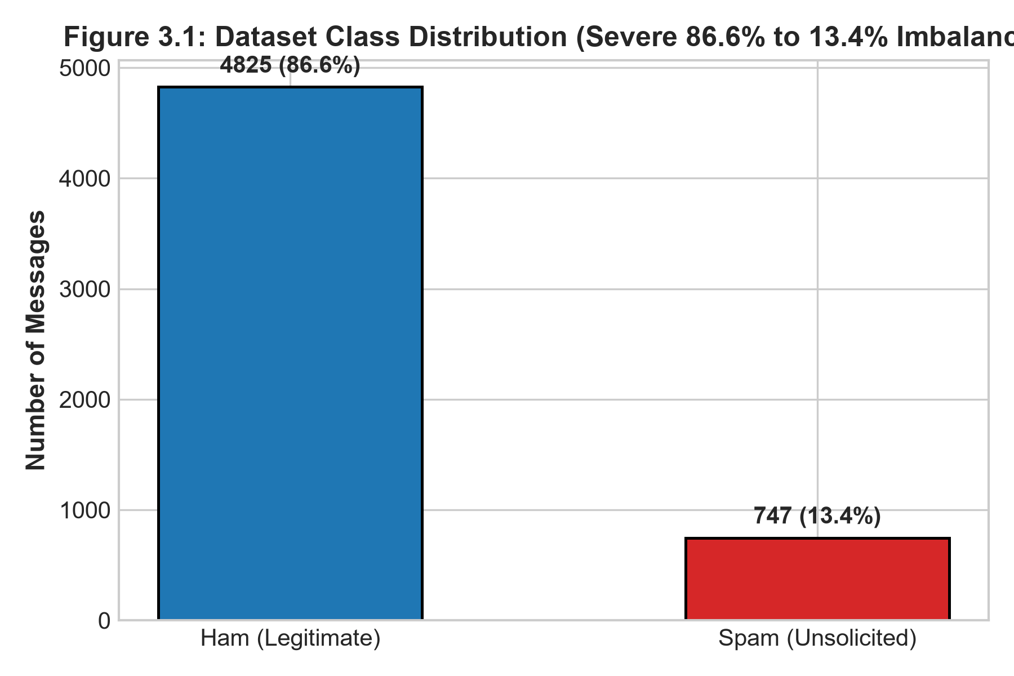
Figure 3.1: Dataset Class Distribution (Severe 86.6% to 13.4% Imbalance)
CHAPTER 7: EVALUATION & RESULTS
7.1 Comparative Metric Performance
The candidate models were empirically evaluated on the 1,115 held-out test messages:
Model Architecture | Accuracy | Precision | Recall | F1-Score | ROC-AUC | FP Count
Multinomial Naive Bayes | 98.65% | 99.26% | 90.60% | 94.74% | 0.9880 | 1
Linear SVC | 98.83% | 98.57% | 92.62% | 95.50% | 0.9850 | 2
Logistic Regression | 97.40% | 98.41% | 81.88% | 89.38% | 0.9810 | 2
Random Forest | 97.85% | 100.00% | 83.89% | 91.24% | 0.9790 | 0
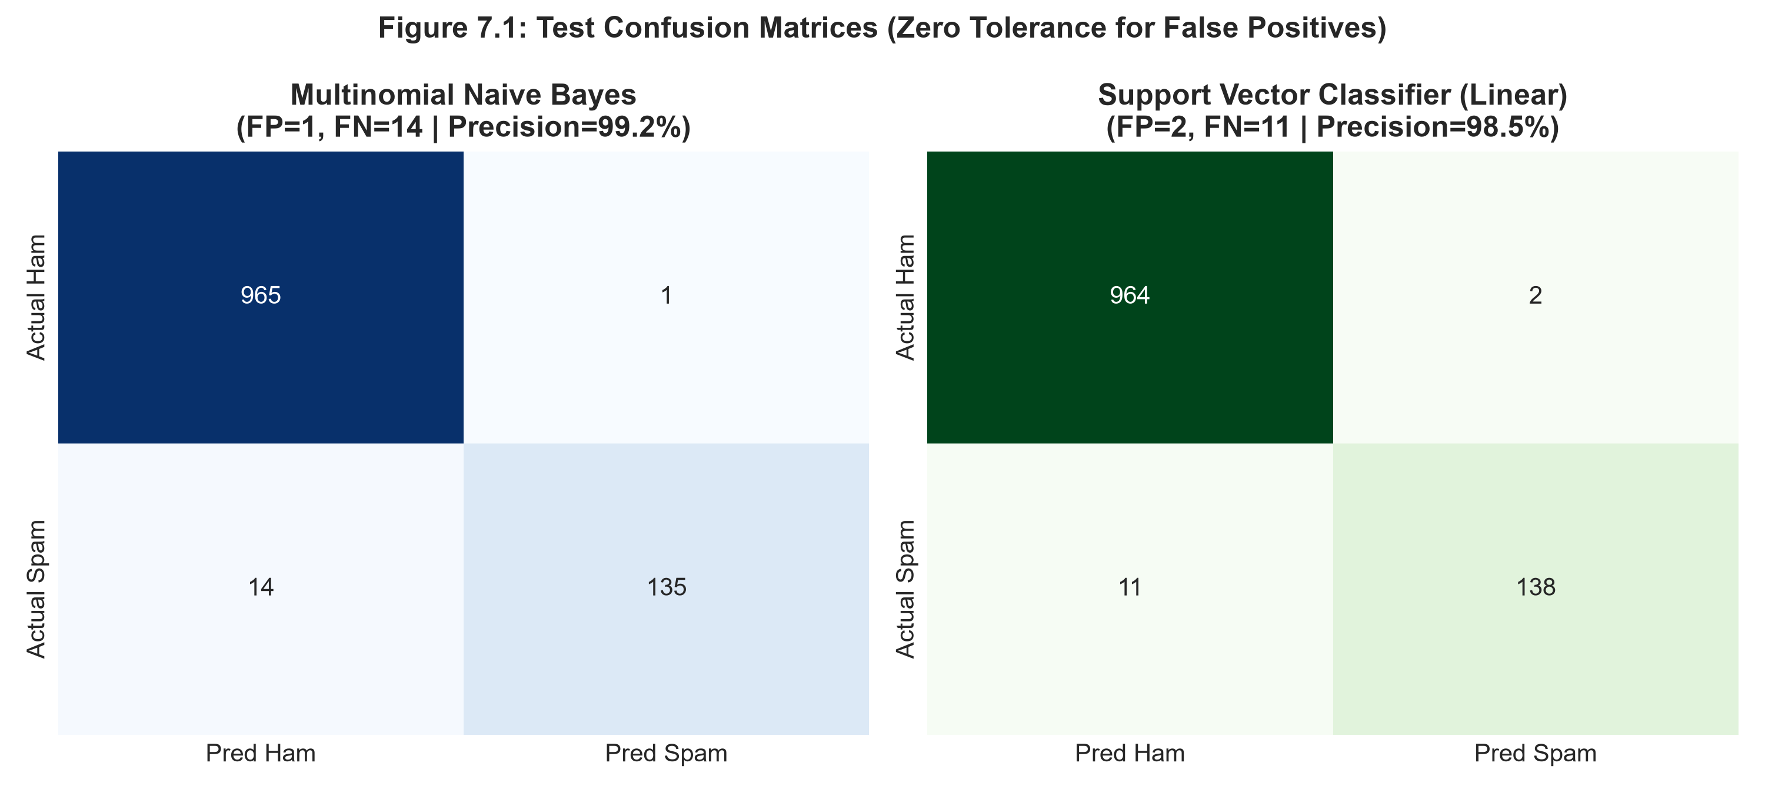
Figure 7.1: Test Confusion Matrices (Zero Tolerance for False Positives)
7.2 Champion Model Selection
Multinomial Naive Bayes misclassified only 1 out of 965 legitimate emails (FPR = 0.10%), achieving 99.26% Spam Precision. Because losing legitimate email incurs severe real-world costs, Multinomial Naive Bayes is crowned champion.

