PDSA Quiz 1 Notes

Jupyter
- If two functions are there with the same name, the function that is run last will be considered.
- Was made for Julia, Python and R.

Euclid’s algorithm for GCD (HCF)
- If d divides x and y, then it divides max(x,y) % min(x,y).
x = a*d
y = b*d
max(x,y) = q*min(x,y) + r
Therefore r = d*[max(a,b) – q*min(a,b)]
Therefore d divides r (which is equal to max(x,y) % min(x,y)).
- So, algorithm for recursion is –
- If max(x,y)%min(x,y) is 0, gcd is min(x,y)
- Otherwise, compute gcd( min(x,y), max(x,y)%min(x,y) )
- Takes time proportional to number of digits in max(m,n)

Exceptions
- Types –
- NameError: ‘x’ is not defined
- ZeroDivisionError: division by 0
- IndexError: list assignment index out of range
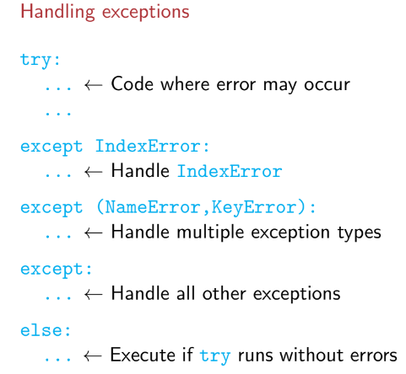
- Handling exceptions –
- We can use exceptions positively also sometimes, like while adding to a dictionary – if it exists, we can append in try block. If the key does not exist, except for KeyError and add a new entry in the Except block.
But the classical method is just to use “if key in dict.keys()”.
- If there is a sequential calling of functions, the Exception that is raised gets inherited above the ladder in a flow of control.

Classes
- In python, ‘private’ and ‘public’ are not explicitly defined, variables local to the class (that are not defined with self.) are considered as private.
- __init__() is the constructor.
- print(<class_object>) invokes a function __str__().
- Timer class uses a function of the time module (time.perf_counter()), which counts the total time elapsed since the start of the program. So, to measure how much time a piece of code takes to run, you have to subtract 2 time.perf_counter()s.

Time complexity of Algorithms
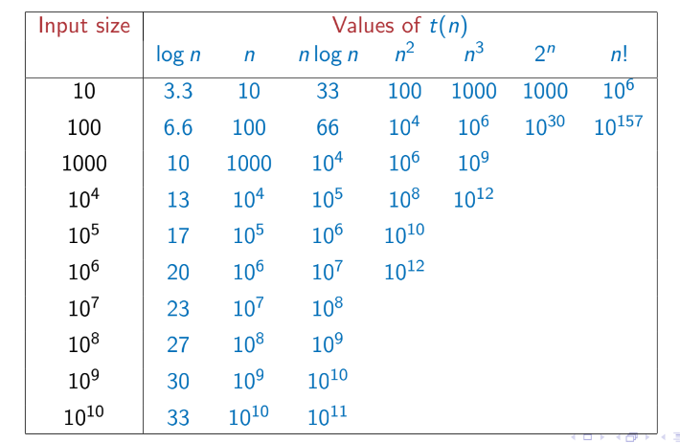
- In python, 10⁷ commands can be run per second. Number of commands vs input size for different algorithms:-
- We take worst case time because –
- It is easier to calculate than average case time complexity.
- It gives a nice upper bound (that is a worst-case scenario).
- Upper bound – f(x) is O(g(x)) means g(x) is the upper bound of f(x).
- f (x) is said to be O(g(x)) if we can find constants c and x0 such that c · g(x) is an upper bound for f (x) for all x greater than x0.
That is, f (x) ≤ cg(x) for every x ≥ x0.
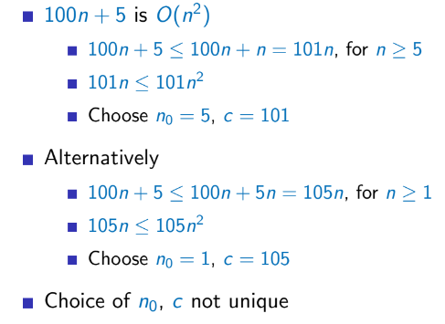
- Eg1:-
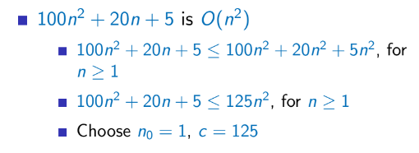
- Eg2:-
- Lower bound - f (x) is said to be Ω(g(x)) if we can find constants c and x0 such that cg(x) is a lower bound for f (x) for x beyond x0.
That is, f (x) ≥ cg(x) for every x ≥ x0.
- Tight bound - f (x) is said to be Θ(g(x)) if it is both O(g(x)) and Ω(g(x)).
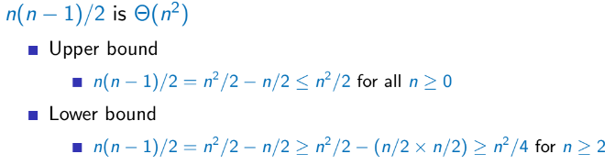
Find constants c1, c2, x0 such that c1g(x) ≤ f (x) ≤ c2g(x) for every x ≥ x0
- Time complexity of recursions –
If n = 0, it just returns. So, T(0) = 1.
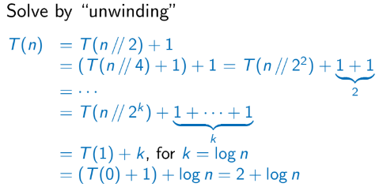
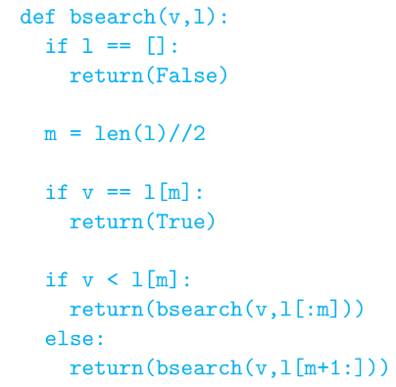
Else, T(n) = T(n//2) + 1 (for n>0).
Therefore, binary search recursive is O(n) = log n.

Selection Sort
- Find the minimum element and swap it with the first element. Find the 2nd minimum element and swap it with the 2nd element. And so on…
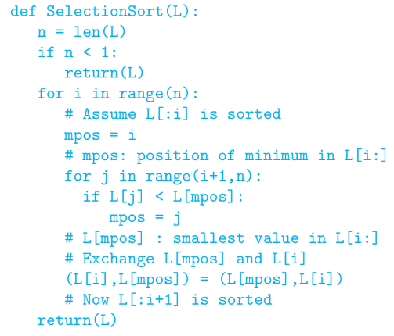
- Code:
- Complexity –
Outer loop runs n times, inner loop runs n-i times for i from (1 to n-1).
T(n) = n + (n-1) + (n-2) + … +1 = n(n+1)/2
So, T(n) is O(n²).
- All inputs take same O(n²) only.

Insertion Sort
- It sends the i^{th} number to the correct position with respect to the i-1 elements before it. If the smallest number is encountered, it is sent to the 1st position. If the 2nd smallest number is encountered, it is sent to the – 1. First position if smallest number is after it in the original list, 2. Second position (just after the smallest number) if the smallest number was to the left of it in the original list (because then the smallest number has already been encountered and sent to the 1st position).
That is, after m iterations of the for-loop, the first m elements in the list are in sorted order.
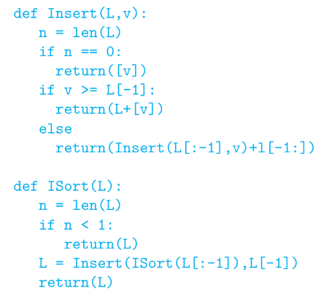
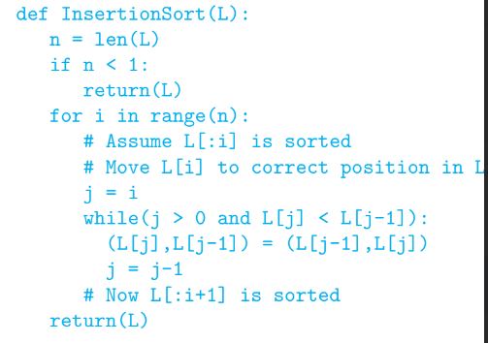
- 2 implementations – iterative and recursive
- Time complexity –
- Iterative –
Outer loop runs n times.
Inner while loop runs at most i times, for i from 0 to n-1.
So, T(n) = 0 + 1 + … + (n-1) = (n-1)*n/2
Hence, T(n) is O(n²).
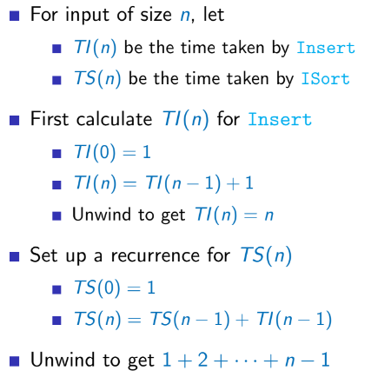
- Recursive –
- If the list is already sorted, it never enters the while loop. So, O(n).
Worst case – O(n²)

Merge Sort
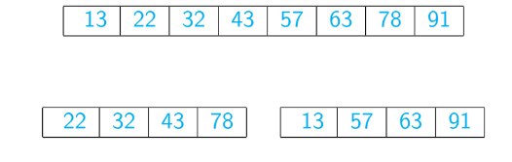
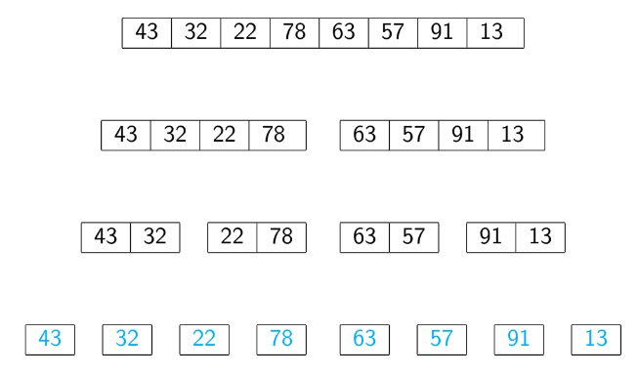
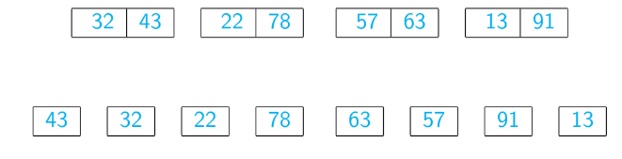
- Break the list into singletons. Merge and sort 2 singletons each to make multiple lists of length 2. Merge and sort 2 each of these lists of size 2 to make multiple lists of size 4. And so on…
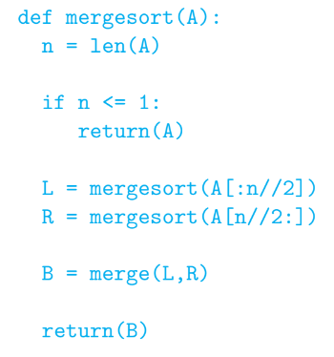
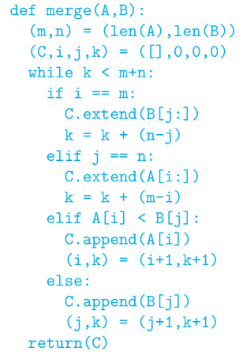
- Implementation –

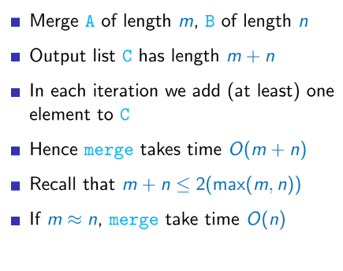
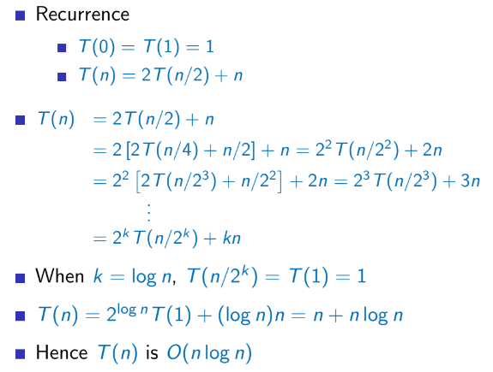
- Time complexity –
- Problems –
- Merge needs to create a new list to hold the merged elements. Extra memory is costly.
- Recursions are slow (call and ret is expensive).
- O(n log n) for all inputs (best, average and worst case).
Merge process takes O(n) and partition is O(log n).

Misc definitions (technical jargon)

Object and Class Variables
- Object variables are local to an object of the class (usually have self.). Any change made in the object variable of one object won’t reflect in any others.
Each object has a unique copy of that object variable.
- Class variables are common for all objects of that class.
Declared above the constructor in the class definition.
Can be accessed using <class_name>.<var_name>.
All objects share the same unique copy of that variable and any change reflects across all objects.

Stable Sort
- If two elements have the same value, if the sorting algorithm preserves their order (as was in the original list) in the final sorted list, the sorting algorithm is said to be stable.
- Quick sort is unstable.
Merge sort can be stable if we merge carefully.

Quick Sort
- Saves space by not needing to merge lists to come up with a final list. This allows an in-place sort.
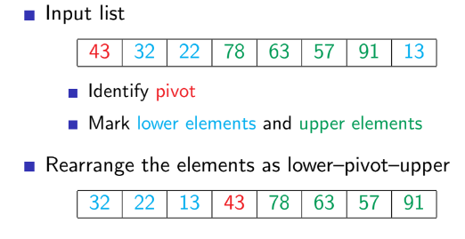
- Choose a pivot (typically the 1st element) and divide the list into 2 parts – 1 lesser than pivot, 1 more than pivot (with pivot being in the centre). Then recursively sort the left and right halves using quicksort.
How to rearrange – keep two dividers initialized to the 2nd element.
If the first few elements are less than the pivot, move both dividers 1 index to the right for each element.
If an element higher than the pivot is encountered, move only the high divider 1 index to the right.
If a lesser element is encountered after this, exchange this element with the first element in the ‘high’ segment and move both dividers by 1 index to the right.
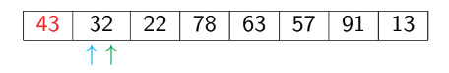
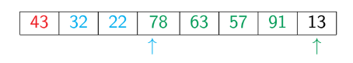
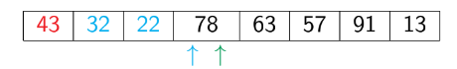
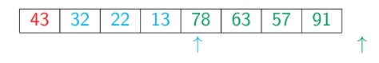
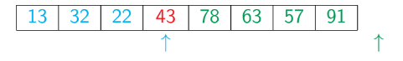
Then finally move the pivot between the low and high segments by swapping the 1st element (pivot) with the last element in the ‘less’ segment.
- Code –
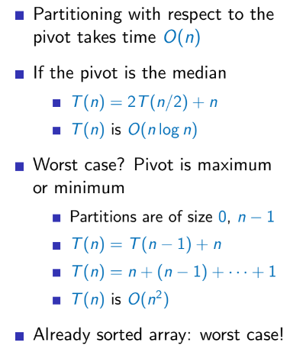
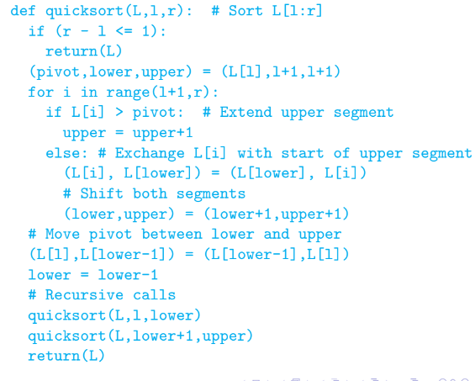
- Time complexity –
- Features –
  - Randomly choosing the pivot is a good strategy to beat worst case inputs. Worst case is when we choose the 1st element as a pivot always for an ascending or descending order array.
  - Quicksort works in-place and can be implemented iteratively.
  - Very fast in practice, and often used for built-in sorting functions.
- Worst case – O(n²) for already sorted array (with 1st element as pivot always).
Average case – O(n log n). Some complex math is there to prove it.

Comparing the above sorting algorithms

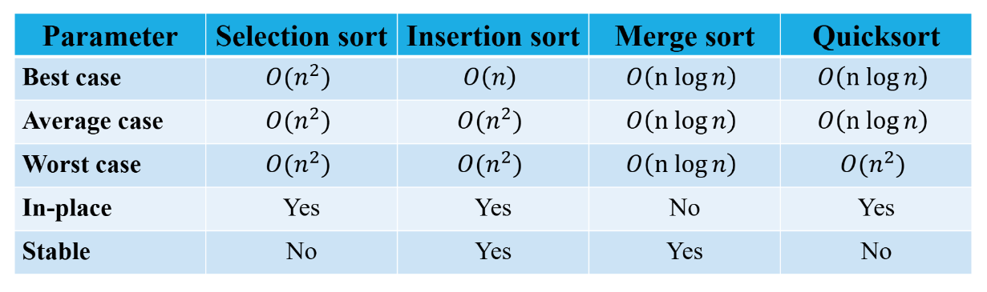
Degree of a vertex in a graph
- For an undirected graph, degree = indegree = outdegree.
- For an undirected graph, degree = indegree + outdegree.
- Indegree is the number of edges coming into the node and outdegree is the number of edges going out of a vertex.

