EXPERIMENT – 1
Title
Interfacing LED with Arduino Uno

Aim
To interface an LED with Arduino Uno and control it by writing a simple Arduino program.

Objectives
- To understand Arduino Uno hardware
- To learn basic digital input/output operation
- To control an external LED using Arduino
- To understand pin configuration and programming basics

Hardware Requirements
- Arduino Uno
- LED
- 220 Ω Resistor
- Breadboard
- Jumper Wires
- USB Cable

Software Requirements
- Arduino IDE

Theory
Arduino Uno is a microcontroller board based on the ATmega328P.
It has digital input/output pins that can be programmed to control external devices.
An LED (Light Emitting Diode) glows when forward biased.
By connecting an LED to a digital output pin of Arduino and controlling it using a program, we can turn the LED ON or OFF.

Circuit Diagram (Description)
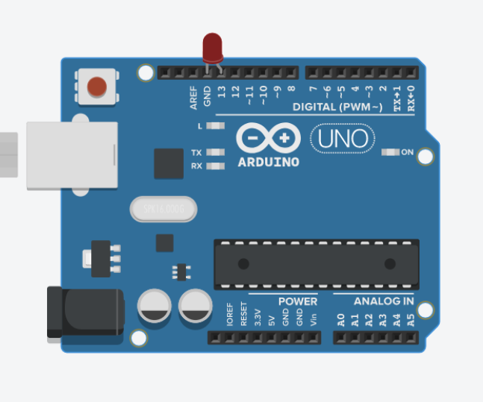

Pin Configuration
Component | Arduino Pin
LED Anode | Digital Pin 13
LED Cathode | GND

Algorithm
- Start
- Initialize digital pin as output
- Turn LED ON
- Delay for some time
- Turn LED OFF
- Delay for some time
- Repeat the process

Program
int ledPin = 13;
void setup() {
pinMode(ledPin, OUTPUT);
}

void loop() {
digitalWrite(ledPin, HIGH); // LED ON
delay(1000);

digitalWrite(ledPin, LOW); // LED OFF
delay(1000);
}

Procedure
- Connect the circuit as per the circuit diagram
- Open Arduino IDE
- Select Board → Arduino Uno
- Select correct COM Port
- Type the program
- Upload the program to Arduino
- Observe the LED blinking

Observation
The LED connected to Arduino pin 13 turns ON and OFF at regular intervals.

Result
Thus, an LED was successfully interfaced with Arduino Uno and controlled using a simple Arduino program.

EXPERIMENT NO: ___
Title
Distance Measurement Using Ultrasonic Sensor (HC-SR04) with ESP32

Aim
To measure the distance of an object using an Ultrasonic Sensor (HC-SR04) interfaced with an ESP32 microcontroller and display the distance on the Serial Monitor.

Apparatus / Components Required
- ESP32 Development Board
- Ultrasonic Sensor (HC-SR04)
- Jumper Wires
- USB Cable
- Computer with Arduino IDE

Software Required
- Arduino IDE
- ESP32 Board Package (by Espressif Systems)

Theory
Ultrasonic sensors work based on the principle of sound wave reflection.
The HC-SR04 ultrasonic sensor consists of:
- Transmitter: Sends ultrasonic sound waves
- Receiver: Receives the reflected sound waves
The ESP32 sends a short trigger pulse to the sensor. The sensor emits ultrasonic waves, which hit an object and return back. The time taken for the wave to return is measured using the ECHO pin.
Using this time, the distance of the object is calculated.
Distance Formula
Distance = (Time × Speed of Sound) / 2
Where:
- Speed of sound = 0.0343 cm/µs
- Division by 2 accounts for forward and return travel

Pin Configuration
Ultrasonic Sensor (HC-SR04) | ESP32 Pin
VCC | 5V
GND | GND
TRIG | GPIO 5
ECHO | GPIO 18
Note: ESP32 operates at 3.3V logic. For long-term safety, a voltage divider is recommended on the ECHO pin.

Circuit Diagram
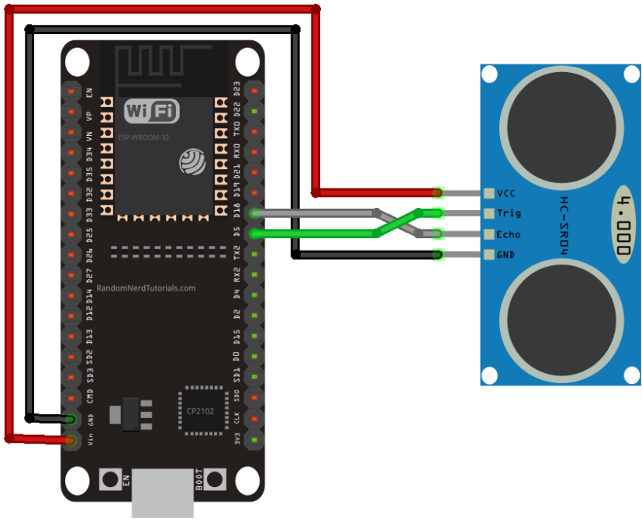
Algorithm
- Start the program
- Initialize TRIG as output and ECHO as input
- Send a 10 microsecond pulse on TRIG pin
- Measure the pulse duration on ECHO pin
- Calculate the distance using the formula
- Display the distance on Serial Monitor
- Repeat the process continuously

Program / Source Code
#define TRIG_PIN 5
#define ECHO_PIN 18

long duration;
float distance;

void setup() {
Serial.begin(115200);
pinMode(TRIG_PIN, OUTPUT);
pinMode(ECHO_PIN, INPUT);
digitalWrite(TRIG_PIN, LOW);
Serial.println("ESP32 Ultrasonic Sensor Ready");
}

void loop() {
digitalWrite(TRIG_PIN, LOW);
delayMicroseconds(2);

digitalWrite(TRIG_PIN, HIGH);
delayMicroseconds(10);
digitalWrite(TRIG_PIN, LOW);

duration = pulseIn(ECHO_PIN, HIGH, 30000);

if (duration == 0) {
Serial.println("Out of range or no object detected");
} else {
distance = (duration * 0.0343) / 2;
Serial.print("Distance: ");
Serial.print(distance);
Serial.println(" cm");
}

delay(500);
}
Procedure
- Connect the ultrasonic sensor to ESP32 as per pin configuration
- Open Arduino IDE
- Select Tools → Board → ESP32 Arduino → ESP32 Dev Module
- Select the correct COM port
- Copy and upload the program
- Open Serial Monitor
- Set baud rate to 115200
- Place an object in front of the sensor
- Observe the distance displayed

Observation
The distance of the object placed in front of the ultrasonic sensor is displayed in centimeters on the Serial Monitor.
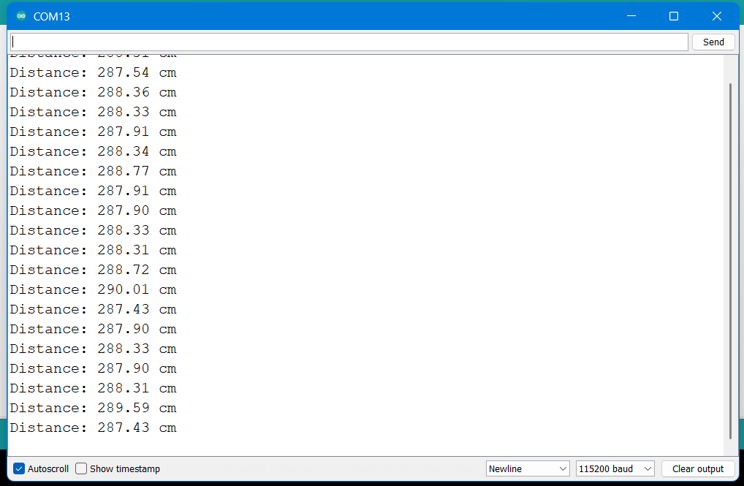

Result
Thus, the distance of an object was successfully measured using an ultrasonic sensor interfaced with ESP32.

EXPERIMENT NO: ___
Title
ESP32 Based Wi-Fi Control of LED, DC Motor, Relay and Temperature Sensor Using MIT App Inventor

Aim
To design and implement a Wi-Fi based embedded system using ESP32 for controlling LED, DC motor, and relay, and monitoring temperature using an Android mobile application developed with MIT App Inventor.

Objectives
- To interface multiple actuators with ESP32
- To interface a temperature sensor with ESP32
- To create a Wi-Fi web server using ESP32
- To control devices using HTTP commands
- To develop a mobile application using MIT App Inventor
- To understand IoT based wireless control

Hardware Requirements
- ESP32 Development Board
- LED
- 220 Ω Resistor
- Relay Module (5V)
- DC Motor
- Motor Driver (L298N / L293D)
- LM35 Temperature Sensor
- Breadboard
- Jumper Wires
- External Power Supply for Motor
- Android Mobile Phone

Software Requirements
- Arduino IDE
- ESP32 Board Package
- MIT App Inventor (Web Based)
- Mobile Hotspot / Wi-Fi Network

Theory
ESP32 is a powerful microcontroller with inbuilt Wi-Fi capability, making it suitable for Internet of Things (IoT) applications.
In this experiment, ESP32 is configured as a web server that listens for HTTP requests sent from an Android application developed using MIT App Inventor.
The Android app sends control commands over Wi-Fi to ESP32, which then performs the required actuator operation.

Pin Configuration
Actuators
Device | ESP32 Pin
LED | GPIO 2
Relay | GPIO 5
Motor IN1 | GPIO 18
Motor IN2 | GPIO 19

Circuit Connections (Description)
- LED connected to GPIO 2 through 220Ω resistor
- Relay input connected to GPIO 5
- Motor driver IN1 and IN2 connected to GPIO 18 and GPIO 19
- DC motor connected to motor driver output terminals
- All grounds are connected together

Algorithm
- Start
- Initialize GPIO pins
- Connect ESP32 to Wi-Fi network
- Start web server on port 80
- Wait for client request
- Decode HTTP command
- Control LED / Motor / Relay
- Send response to client
- Repeat continuously

ESP32 Program
#include <WiFi.h>

const char* ssid = "Abhishek_A15";
const char* password = "Abhishek12345";

WiFiServer server(80);

// Actuators
int ledPin = 2;
int relayPin = 5;
int motor1 = 18;
int motor2 = 19;

void setup() {
Serial.begin(115200);

pinMode(ledPin, OUTPUT);
pinMode(relayPin, OUTPUT);
pinMode(motor1, OUTPUT);
pinMode(motor2, OUTPUT);

WiFi.begin(ssid, password);
Serial.print("Connecting");

while (WiFi.status() != WL_CONNECTED) {
delay(500);
Serial.print(".");
}

Serial.println("\nWiFi Connected");
Serial.print("ESP32 IP Address: ");
Serial.println(WiFi.localIP());

server.begin();
}

void loop() {
WiFiClient client = server.available();
if (!client) return;

String request = client.readStringUntil('\r');
client.flush();

Serial.println(request);

// LED
if (request.indexOf("/LED=ON") != -1)
digitalWrite(ledPin, HIGH);
if (request.indexOf("/LED=OFF") != -1)
digitalWrite(ledPin, LOW);

// Relay
if (request.indexOf("/RELAY=ON") != -1)
digitalWrite(relayPin, HIGH);
if (request.indexOf("/RELAY=OFF") != -1)
digitalWrite(relayPin, LOW);

// Motor
if (request.indexOf("/MOTOR=ON") != -1) {
digitalWrite(motor1, HIGH);
digitalWrite(motor2, LOW);
}
if (request.indexOf("/MOTOR=OFF") != -1) {
digitalWrite(motor1, LOW);
digitalWrite(motor2, LOW);
}

// -------- WEB PAGE RESPONSE --------
client.println("HTTP/1.1 200 OK");
client.println("Content-Type: text/html");
client.println();
client.println("<html><body>");
client.println("<h2>ESP32 WiFi Control</h2>");

client.println("<a href=\"/LED=ON\"><button>LED ON</button></a><br><br>");
client.println("<a href=\"/LED=OFF\"><button>LED OFF</button></a><br><br>");

client.println("<a href=\"/RELAY=ON\"><button>RELAY ON</button></a><br><br>");
client.println("<a href=\"/RELAY=OFF\"><button>RELAY OFF</button></a><br><br>");

client.println("<a href=\"/MOTOR=ON\"><button>MOTOR ON</button></a><br><br>");
client.println("<a href=\"/MOTOR=OFF\"><button>MOTOR OFF</button></a>");

client.println("</body></html>");
}
MIT App Inventor Logic (Explanation)
- The Web component is used to send HTTP requests
- Each button sets a URL containing a command
- Web.Get sends the request to ESP32
- ESP32 decodes the command and performs action
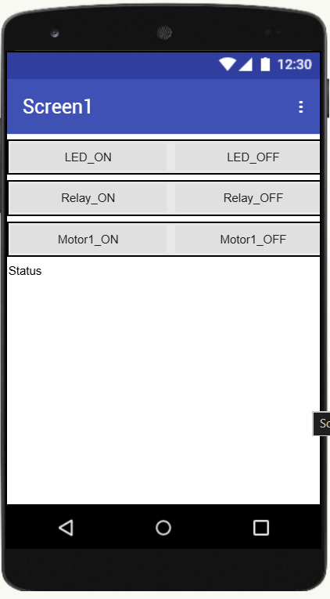
- 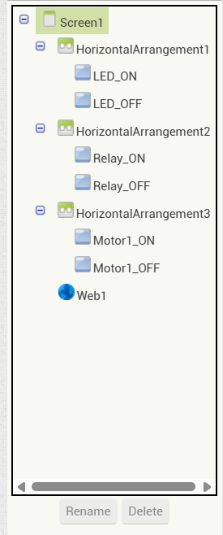
Block
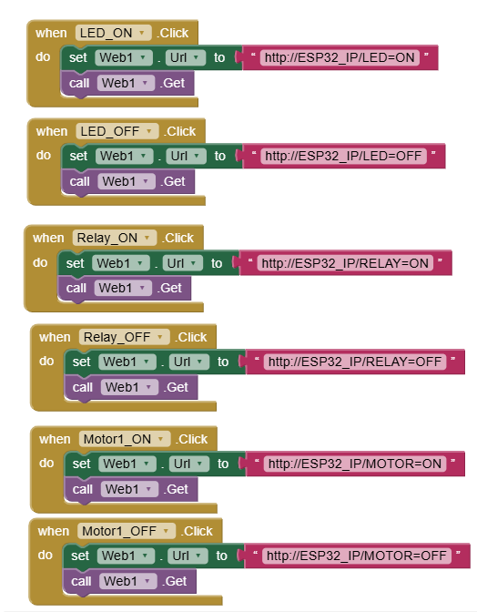

Command Mapping
Button | URL Command
LED ON | /LED=ON
LED OFF | /LED=OFF
MOTOR ON | /MOTOR=ON
MOTOR OFF | /MOTOR=OFF
RELAY ON | /RELAY=ON
RELAY OFF | /RELAY=OFF

Procedure
- Connect hardware as per circuit description
- Upload ESP32 program
- Note ESP32 IP address from Serial Monitor
- Create Android app using MIT App Inventor
- Set Web URL to ESP32 IP address
- Connect mobile to same Wi-Fi
- Control devices using app
- Observe temperature display

Observation Table
Command | Operation
LED ON | LED glows
LED OFF | LED turns OFF
MOTOR ON | Motor rotates
MOTOR OFF | Motor stops
RELAY ON | Load ON
RELAY OFF | Load OFF

Result
Thus, ESP32 was successfully used to control multiple actuators and monitor temperature using a Wi-Fi network and an Android application developed using MIT App Inventor.

