*FantastiCity*

**HOME**

*With the advent of advanced satellites and various reconnaissance airplanes, it is very difficult to maintain the secrecy of a military base on land. Underwater settlement of military base can be one of the alternative for military base.*

***PROBLEM STATEMENT***

*Design an underwater military base for a population of 3,000 personals. Construct dome modules (small air tight dome units which can withstand the water pressure at that depth) to satisfy the basic functions of a military base underwater. The military base is to be located at an average depth of 35 meters below the mean sea level. Plan out the base with all essential facilities, like air supply, water supply, waste disposal, interconnections & transportation.*

**SPECIFICATIONS OF THE PLAN**

1. *Population of the military base is about 3,000.*
2. *The plan should consist of all the components and functions of a military base.*
3. *Space plan of each type of module should be performed.*
4. *Interconnection between modules must be provided.*
5. *Transportation facilities to and fro from the shore should be provided.*
6. *A proper waste disposal system should be proposed. A water treatment plant should be provided for treatment of sewage.*
7. *There should be a nuclear power generation unit for the military base at the appropriate place. Alternative power generation plant (wind, tidal or solar) should be provided in case of emergency backup.*
8. *Air and water supply should be provided accordingly.*

*.*

**DETAILS EXPECTED IN DESIGN**

1. *All construction should adhere to by laws. New technologies can be used with proper detail and justification of its scientific feasibility.*
2. *A detail of military base plan with placement of all important components with interconnections and transportation facilities.*
3. *Cost estimate of the military base.*
4. *General description of type of construction that is followed should be given.*
5. *Space plan of various components and modules must be explained using AutoCAD.*
6. *3D Modeling can be provided as an additional feature.*

**STIPULATIONS**

1. *A project proposal should be submitted to the organizer by 20st October 2013.*
2. *An AutoCAD (2005 version) military base plan, along with the final project report must be submitted to the organizers before the presentation.*
3. *Selected teams will be required to present their idea and model in front of the jury.*
4. *All the details of the project should be provided in a MS Word (2004 .doc format) file.*
5. *The proposal found most apt, economical, well-planned and eco-friendly will be given due importance.*

***DATA PROVIDED***

1. *Contour map of the sea bed.*

***RESOURCES***

1. *Annual rainfall of area = 2000 mm*
2. *Per capita usage of water = 250 litres / day*
3. *Per capita sewage discharge = 80% of usage*
4. *Daily garbage produced = 3 kg / person*
5. *Daily power consumption = 3 kW / person*
6. *Daily power consumption of various buildings:*
   1. *Air filtration unit (extraction of dissolved oxygen) = 3 MW*
   2. *Water purification unit = 1.5 MW*
   3. *Underwater bore well = 600kW*
   4. *Waste disposal unit (causes ground and water pollution; capacity: garbage = 15 tonnes & sewage = 10 lakh litres / day) = 100kW*
   5. *Water treatment plant (capacity: 5 lakhs litres / day) = 40 kW*
   6. *Recycling unit (capacity: 20 tonnes) = 25 kW*

*(Other necessary data can be assumed appropriately.)*

**CONTOUR MAP OF SEA BED:**

*Total area of the given contour= 800m * 1000m*

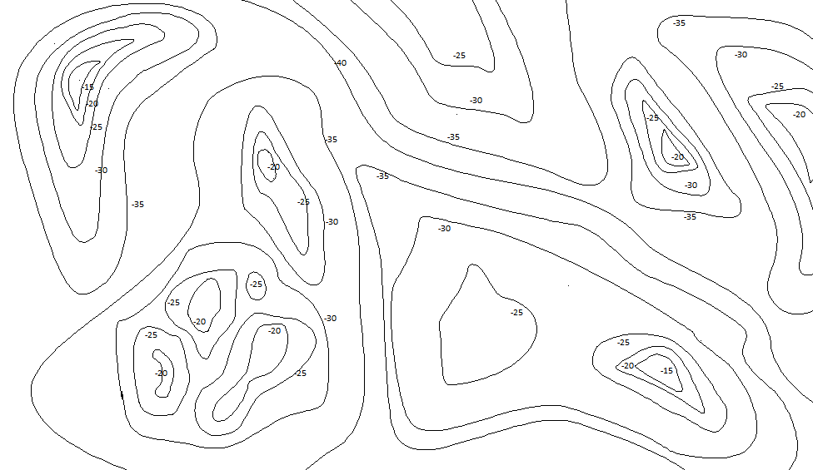

*(Not to scale)*

**COST (VALUES ARE REDUCED IN PROPORTION)**

1. *Air filtration unit = Rs.15,00,000 / month*
2. *Air refilling unit (tanks) = Rs.3,00,000 / month*
3. *Water pipeline = Rs.20 / metre*
4. *Water purification unit (capacity: 3 lakhs litres, saline water to potable water; no storage required) = Rs.20,00,000*
5. *Water silo (5 lakhs litres) = Rs.2,00,000*
6. *Underwater bore well = Rs.3,00,000*
7. *Floating solar panel (1 MW )= Rs.1,000*
8. *Tidal power turbine (6 MW; affects marine life) = Rs.4,500*
9. *Hydel power plant (200 MW) = Rs.6,00,000*
10. *Dam = Rs.2,50,000*
11. *Power transmission wires = Rs.15 / metre*
12. *Waste disposal unit = Rs.50,000*
13. *Underwater landfill = Rs.40,000*
14. *Water treatment plant = Rs.65,000*
15. *Recycling unit = Rs.1,50,000*

**JUDGING CRITERIA AND WEIGHTAGE**

1. *Report document (15%)*
2. *Planning effort involved in creation of AutoCAD file for various facilities (45%)*
3. *Feasibility, functionality of the plan, ecological impact and cost effectiveness of the project (20%)*
4. *Presentation (20%)*

*Note: The decision of judges and organizing committee would be final and binding. The organizers reserve the right to modify any of the rules and regulations from time to time in order to maintain a healthy spirit of the competition. Participating teams are requested to check this space for the latest updates*

**FORMAT**

*Stage 1: Teams are expected to send the abstract design, concisely stating ideas and techniques, in MS-word (2004 .doc format) document, AutoCAD (2005 version) drawings through email. The final teams that qualify for the presentation at Engineer 2013 will be shortlisted based on the documents submitted.*

*The last date for submission of the documents is 20th October 2013.*

*Stage 2: Selected teams will be invited to Engineer 2013 and will be required to give a presentation along with the AutoCAD plan. The presentation must include information on all aspects.*

**ELIGIBILITY**

* *Each members of the team must be an enrolled bonafide student of a recognized educational institute.*
* *No person can take part in more than one team.*
* *Maximum number of participants in a team is limited to 3.*

*.*

**CONTACT**

***B.THEJA***

***+919480435585***

[***bnmtheja@gmail.com***](mailto:bnmtheja@gmail.com)

***Sushil Kumar***

***+918867345233***

[***sushil199124@gmail.com***](mailto:sushil199124@gmail.com)