Perfect Machine

**GENERAL RULES**

* The students must carry valid student ID cards of their college which they will be required to produce at the time of registration.
* Contestants will have to register online. On spot registrations can also be done.
* A team may comprise a maximum of **FIVE** participants.
* Readymade kits are **NOT** allowed. Judges decision in this regard will be final and binding.
* The team is not permitted to compete with more than one bot.
* Teams will not be allowed to modify their bots during their trial.

**EVENT FORMAT**

* Each round will be of a maximum of **15 min** duration.
* Fig 1 portrays the arena
* Each bot must have a mechanism to lift the objects(it will be a ball or a cube) kept in rectangular container and throw them into the hoops kept at different heights
* In each hoop only a maximum of 3 objects (1 ball and 2 cubes) can be thrown.
* Hoop 1 will be at the ground level. Hoop 2 will be at the height of 15cm from the arena. Hoop 3 will be at the height of 25cm from the arena.
* A bridge will be provided at the bottom of hoop 3(hoop at the height of 25 cm). The bot is required to climb over this bridge and throw the objects in hoop 3.
* Each bot will be given **only one round** in which they need to complete the task.
* If the bot gets immobilized (unable to show minimum linear displacement of 10cm for 30 seconds) or toppled over, those teams cannot ask for restore.
* The organizers reserve the right to change any or all of the above rules as they deem fit.
* Violation of any the above rules will lead to disqualification.
* Judges' decision shall be treated as final and binding on all.

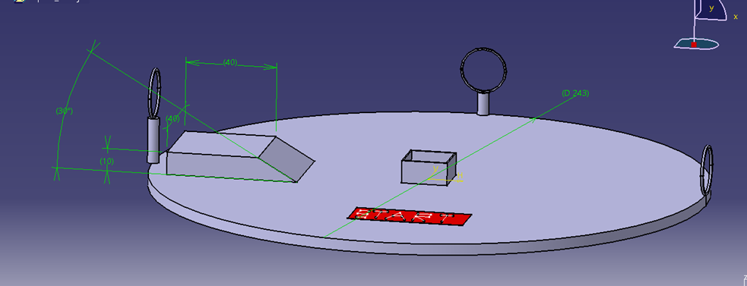

Fig 1: Arena which has to be traversed by the competing bots

**JUDGING CRITERIA & SCORING**

* A task is considered as completed only if all the objects are thrown into yhe respective hoops in.
* The score given to each team at the end of their trial as follows

**Score = ((10*h1+20*h2+40*h3) *t**

Where,

t= Time remaining after the completion of the task (in minutes) (only after 9 objects are thrown).

h1= Number of objects thrown in hoop 1(max=3).

h2= Number of objects thrown in hoop 2(max=3).

h3= Number of objects thrown in hoop 3(max=3).

* In case of a tie,
* Number of balls put will be considered. If scores are level even after that, the team to complete the task fastest will be awarded as winners.

**SPECIFICATIONS**

**BOT SPECIFICATIONS**

* The initial bot dimensions should not exceed 30 x 30 x 20 cm3 excluding the control device dimensions. This dimension excludes the dimension of lifting mechanism
* The weight of the bot should not exceed 15 kgs.
* The bot can be controlled wirelessly or with wires.
* Readymade wireless remote control units may be used.
* In case wired control is used, the wire(s) must remain slack throughout the event. If the wires are visibly taut, the team would be immediately disqualified.
* Single phase external 230V AC power will be supplied. Maximum voltage between any two points on the bot must not exceed 24 V DC or 24 V AC.

**OBJECT DIMENSION**

* Total number of objects to be thrown =9.
* The dimension of each cube=a cm*a cm*a cm
* The diameter of each ball = a cm
* The diameter of the hoop=20cm
* a = 4 to 7

**MOBILITY**

 All robots must have easily visible and controlled mobility in order to compete.

* Any machine component should not be detached (intentionally) during any point of the event.
* Methods of Mobility include:
  + Rolling (wheels, tracks or the whole robot)
  + Walking (linear actuated legs with no rolling or cam operated motion).
  + Shuffling(rotational cam operated legs)
  + Jumping and hopping is not allowed
  + Flying (airfoil using, helium balloons, ornithopters, hovercrafts etc.) is not allowed.

**ARENA SPECIFICATIONS**

* The dimensions of the bridge are as indicated

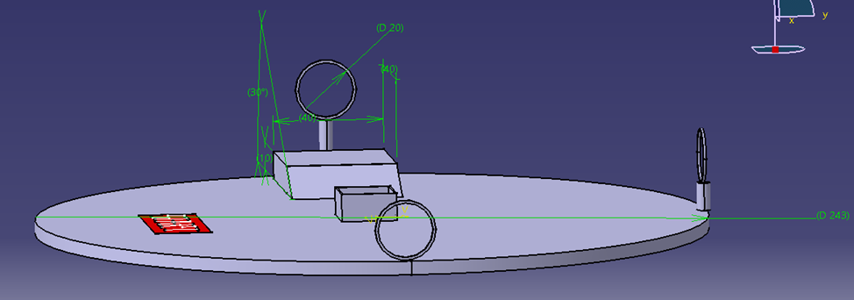

Fig 2: paths that the teams are required to use

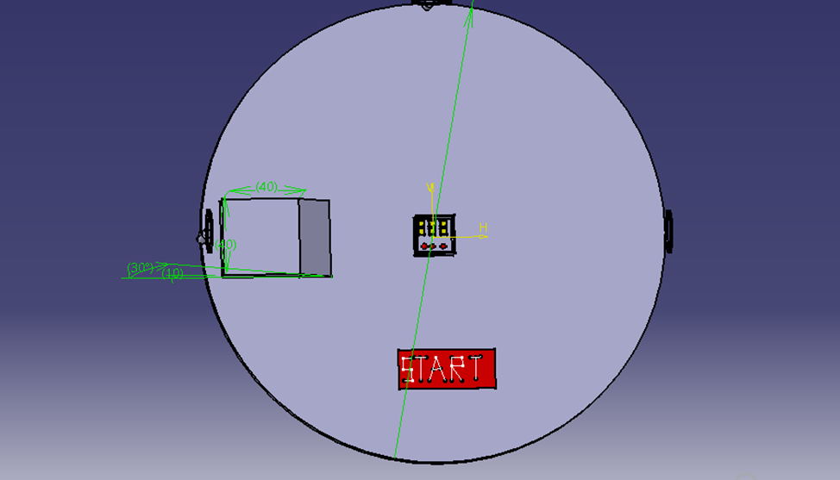

Fig 3: The dimensions of the bridge

**CONTACT DETAILS**

Vivek Shet Karthik.N.S K.R.Akshay

9620930155 8861494278 9731937661