CSCI 4144/6405 - Data

Mining/Warehousing: Project Report

Classification of Pokémon Types Based on Their Base Stats Using the Random Forest Algorithm

Based on paper:
Breiman, L. (2001). Random Forests

Group 50
Dhruv Sharma
Amogh Sharma
Date: 7th April 2026

Introduction
In this Project Report, we will discuss our work for the CSCI 4144 course project. The main problem we wanted to solve for this project was to build a highly accurate classification algorithm that would be able to predict categorical information about our data after having trained on a subset of it. After some discussion, we decided to implement the Random Forests algorithm to solve this classification problem and challenge ourselves to get the highest accuracy possible in classifying data.
As for our data, we went with a Kaggle database containing a collection of 1032 unique Pokémon with various details including their Types, Abilities, Base Statistics, etc. We believed that a highly dependent relationship exists in between the Typing of a Pokémon (Normal, Fire, Water, Electric, Grass, Ice, Fighting, Poison, Ground, Flying, Psychic, Bug, Rock, Ghost, Dragon, Dark, Steel, and Fairy), and their Base Statistics like Attack, Health, Speed, etc., which makes this data perfect for training Random Forests.
For this project, we implemented Random Forests entirely on our own, without the help of libraries with full implementations like scikit-learn. The core of our algorithm is as discussed by Breiman (2001). Our algorithm utilizes Binary Trees as its base, with which we build Decision Trees. We utilize metrics such as Gini impurity to split our data. The Random Forests algorithm then creates multiple of these Decision Trees and predicts the target field with them through majority voting, ensuring accurate results.
In this paper, we will further explore in detail the algorithm we have used, along with its implementation. Then, we will also showcase some of the experimental results we have seen when running the program on the Pokémon dataset and also some graphs showing the relationship between some of our configurable variables.

Algorithm

BinaryTree:
The algorithm begins with the standard Binary Tree class. The class is a standard tree node class with references for the left and right nodes, along with one for the parent node. Each node also stores the threshold value that is used to traverse the Decision Trees built from this class. The data variable stored in each node contains the predicted classification, given that the node is a leaf node.

DecisionTreeClassifier:
The DecisionTreeClassifier class contains the main functionality to build our decision trees. We need to input the data, as a pandas dataframe object, along with the target field that we want to predict. By default, the target is the Type of the Pokémon (so it compares with both Type 1 and Type 2 columns). Note that if the target variable does not have numerical variables that it depends on, or if it is independent, the algorithm becomes inaccurate since Random Forests expect the target to be dependent.
Next, the DecisionTreeClassifier is built recursively from the root. For each new node, we find the best split by calculating the Gini impurity and finding the threshold value for which the impurity is the lowest. Then, that threshold and the corresponding feature are added to the node. The algorithm builds the tree until the current Gini impurity of the data is less than or equal to the current threshold, the data becomes too small to further build the tree, or if only the target node is left to build.

We can then make a prediction using the tree by traversing it until we reach a node where data, i.e., the classification is not None. This means we have reached a leaf node, at which point we simply return the prediction.

RandomForests:
The functionality of the RandomForests class is comparatively simple. It keeps track of the number of trees to build and the forest itself, which is a list of DecisionTreeClassifiers. The forest is populated by building “n” trees, where n is either specified by input, or is 10 by default. For each generated DecisionTreeClassifier object, we train it on a bootstrap sample, i.e., a random sample with replacement, from the training data. The tree is then added to the list.
The prediction algorithm works by iterating over each tree in the forest, getting the prediction from each tree and aggregating the result through majority voting. The result with the most results is returned as the result.

Main:
The main file, which runs the data, does a variety of things such as splitting the original data into training and testing sets, calculating the training time and runtime for each prediction, calculating the accuracy of the predictions.
To simply run the prediction on the split and number of trees of our choice, we can modify the variables at the top of the Main.py file and run main() in the if name == " main " declaration.
Note: Our program also considers the Type 2, which is the second typing a Pokémon can have in it’s accuracy calculations. This is because we realized that when a prediction was flagged as inaccurate, the incorrect prediction actually was the correct Type 2 of the given Pokémon.

Data Preparation
The preprocessing for the database is not very complex. Since we are working with thresholds, we can only use numeric values. Therefore, we:
- Split the database into test and training. After tinkering the parameters, we found the optimal split for the Pokémon database is 7:3.
- Drop all non-numeric columns for training and prediction.

Algorithm Implementation
We have 3 classes that we made: BinaryTree.py, DecisionTreeClassifier.py and RandomForest.py. We also have a driver file called Main.py.
  - BinaryTree.py: This class is a very standard implementation of binary trees. It contains functions to attach and detach to the left and right nodes and set values to a node like its threshold and the feature it splits at that node.
  - DecisionTreeClassifier.py: This class essentially builds a binary tree where each step is either a logical node where we split according to a threshold or a decision node where we get a result. It

takes training data and filters it to only work on numeric features to build this tree. Next, it takes this training data and builds a tree.
    - The build_tree() function recursively builds left and right subtrees until all relevant features are parsed. It has to, however, find what values to put as the threshold.
    - That value comes from the find_best_split() function. This function takes the dataset of numeric features again, then it randomly takes a subset of size “m_try” out of these features. It will only return one feature from this subset depending on whatever gives the best separation.

      - It calculates the best threshold for each feature in this subset to accomplish that. To calculate optimal threshold, it first finds all unique values in the feature it is calculating for and finds the midpoint between each consecutive value. Now, our required threshold is one of these midpoint values, so we just loop over them and calculate the gini_impurity score for each threshold by splitting the data according to every threshold.

      - The Gini impurity score is calculated separately for left and right of the split and then combined using size as weight, using the gini_impurity() function and the lower this score, the lower the impurity (less mixed data) so the better prediction. Thus, we need to minimize the Gini impurity value. We keep track of the best score and the best feature that we need to return along with the threshold.
      - After looping over all features, we return the feature which gave the least impurity score at a threshold because that is the best for the different labels.
    - The gini impurity () function is very simple and just takes all probabilities of a label and calculates the impurity score, which is given by the formula:
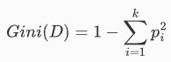
and for the weighted version (which we use):
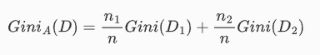
where “p_i" is the probability of each value in the feature appearing, n1 and n2 are sizes of dataset (left and right to threshold in our case) and n is total dataset size (Karabiber, 2026).
    - Finally, the predict_one() class predicts the label for a provided row of data based on the tree we built.
  - RandomForests.py: This class trains and stores a list of multiple DecisionTreeClassifier objects. We can then call the predict() function with the input numerical values from the data that we will predict the target with.

    - As a RandomForest object is initialized, the forest, which is a list of trees, is populated using the train_trees(self, train_data) function. This function initializes DecisionTreeClassifier objects and appends them to the list. The number of trees generated is decided by user input and is 10 by default.

    - The bootstrap(self, train_data) function is used to bag (bootstrap aggregation, i.e., random sampling with replacement) the data, which then trains the respective tree. This reduces overfitting and increases randomness.

    - The predict(self, data_to_predict_with) contains the core prediction functionality of RandomForests. It uses the input data and feeds it into each tree in the forest. It keeps track of each tree’s result and its number of occurrences in a dictionary, where the overall prediction is decided to be the prediction with the highest occurrences/votes. This way, we ensure high accuracy in Decision Tree results through majority voting.

Experimental Results
  - After 10 experiments, the final forest trained on the training set and predicted all rows in the test in a time of 10.30 seconds with 99.15% accuracy. We used 13 trees in each forest. With some more tinkering, we could achieve even higher accuracy, but the algorithm would run slower:

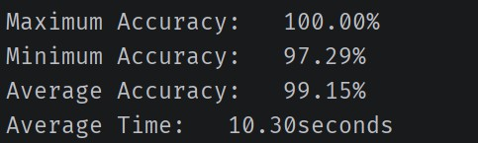
The graphs below show how accuracy changes with the 2 parameters. We clearly see diminishing return past even 5 trees, but the graph really levels out past the eleven trees mark. For data split, we can see the more training data, the higher the accuracy. But we can’t just provide all the data to it just for training. So, we can go with the reasonable number of 75% split as a good enough ratio without much compromise.
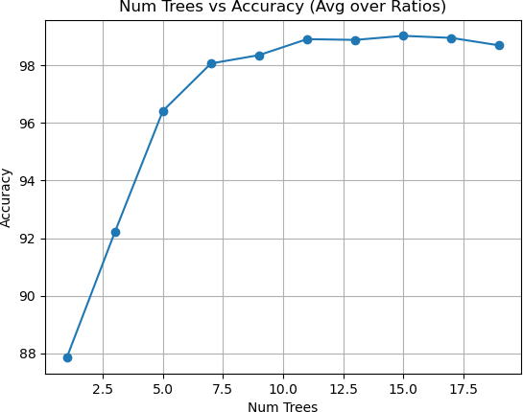
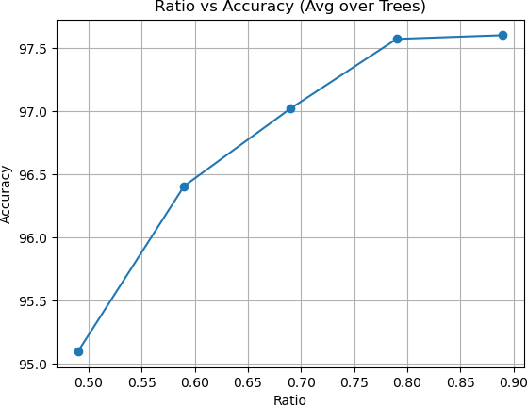

However, to learn more about which is the most optimal value for ratio of data to split, we can plot a 3D graph to see what values are favored. We clearly see that the higher the values of num_trees along with ratio, the better the accuracy. We do need to consider time and the diminishing return on investments past a certain point. For that we can calculate efficiency = (accuracy / time) and cost = (1 / efficiency) and plot that as well:
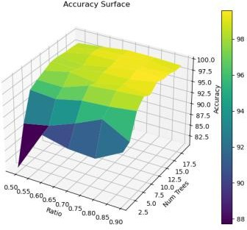
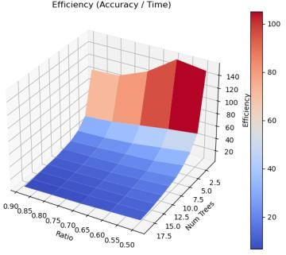

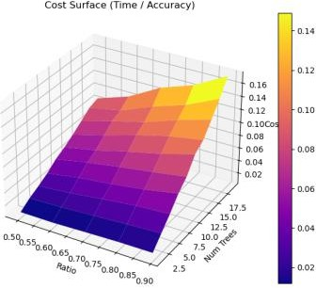
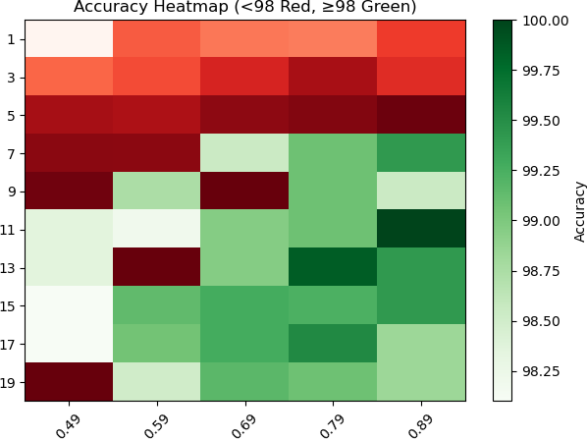

We can observe that for higher values of num_tree, the cost is very high. So, our goal is to minimize the number of trees. The ratio of the split does not have a major effect on the cost but does give a slight slope (more ratio = slightly higher cost). Also, in the heatmap graph, we notice that the first instance of green where we have a 7:3 split in data is at the “7” tree mark but this accuracy isn’t very high. Eleven trees with 90% of the data is extremely high accuracy but the ratio is not very good for testing. The optimal middle ground looking at the cost must be a value of num_trees < 14 and ratio > 0.6. Thus, we concluded that the optimal parameters can be num_trees = 13 and ratio = 0.75 for our database. These parameters will differ by the data in a database. Also values with less correlation will result in a closer to random prediction.

Conclusion
Through working on this project, we gained a better understanding of how machine learning algorithms really work. Since we challenged ourselves to implement Random Forests without using the implementation in scikit-learn, we were introduced to various concepts such as bootstrapping, Gini Impurity, Tree splitting using optimal thresholds, etc., and gained a lot of programming experience with classification algorithms.
Out of all runs of our algorithm, we came across many interesting observations, for example: more trees did not always equate to higher accuracy of predictions. The graphs generated for our algorithm also showed us some very interesting aspects such as the ratio of 0.77 being exponentially the best choice to

get the most accuracy by run time for the training data’s split. We were very satisfied with getting an average accuracy of 99% and above, sometimes achieving 100%.
The most logic intensive part of our algorithm is the splitting logic for decision trees. Consequently, that part of the code is also the most time intensive out of all classes in our algorithm.
By trying to make the program as accurate as possible, we learned of the direct relationship between code accuracy and the time complexity, as time taken by the code greatly increased if we wanted to make it more accurate. In the future, if we get the time, we want to greatly optimize the time complexity of the algorithm, so it is not only accurate but also executes in significantly less time.

References:
- Breiman, L. (2001). Random Forests. Machine Learning, 45(1), 5–32. https://doi.org/10.1023/A:1010933404324

- Karabiber, F. (n.d.). Gini impurity. LearnDataSci. https://www.learndatasci.com/glossary/gini-impurity/

- Singh, S. (2020, September 9). Under the hood – Decision tree. Towards Data Science. https://towardsdatascience.com/under-the-hood-decision-tree-454f8581684e/

- Hernández, M. (n.d.). All Pokemon dataset [Data set]. Kaggle. https://www.kaggle.com/datasets/maca11/all-pokemon-dataset

