DESIGN JUSTIFICATION REPORT
ECE 410/510 — Hardware for Artificial Intelligence and Machine Learning
Portland State University | Spring 2026

Project: BF16 Conv2d Accelerator — 32x32 Weight-Stationary Systolic Array
PDK: SAED14nm RVT | Tool: Cadence Genus 17.14-s037_1 | Clock: 500 MHz

INDEX

Section No. | Title | Page No.
1. | Problem and Motivation | 2-3
2. | Roofline Analysis | 4-5
3. | Precision and Data Format | 6
4. | Dataflow and Architecture | 7-8
5. | Hardware Interface | 9
6. | Verification | 10-11
7. | Synthesis Results | 12-13
8. | Benchmark Results | 14-15
9. | What did not work | 16-17

SECTION 1: PROBLEM AND MOTIVATION
The target application is a hybrid anemia-detection model (ResNet18 backbone + AttentionFusion MLP) trained on the AneRBC peripheral blood smear dataset (12,000 images: 6,000 healthy, 6,000 anemic). The model was profiled running on an Intel Core i5-10210U laptop CPU (Windows 11, PyTorch 2.11.0, CPU-only) over 10 full training epochs, each epoch processing 9,600 training images in 300 batches of 32.
Wall-clock timing (time.perf_counter, full pipeline including data loading, feature extraction, validation, GradCAM, and logging):

1.1 Wall-Clock Timing (time.perf_counter, full pipeline)
Run | Time
Run 1 | 2762.6 s
Run 2 | 2670.4 s
Run 3 | 2595.1 s
Run 4 | 2537.6 s
Run 5 | 2552.6 s
Run 6 | 2497.8 s
Run 7 | 2508.4 s
Run 8 | 2481.1 s
Run 9 | 2860.9 s
Run 10 | 2719.2 s

Median wall-clock: 2573.9 s (42.9 minutes) per epoch
Mean: 2618.6 s
Std deviation: 128.8 s

1.2 cProfile Kernel Identification
cProfile of the training loop (hybrid_train_one_epoch, 300 batches, 1266.6s total profiling runtime)
Identified torch.conv2d as the dominant kernel:
Function | Cumtime (s) | % of Total
run_backward (autograd engine) | 732.7 | 57.8%
HybridModel.forward | 421.6 | 33.3%
resnet.forward | 324.8 | 25.6%
torch.conv2d <-- DOMINANT | 292.9 | 23.1%
torch.batch_norm | 60.3 | 4.8%
torch.max_pool2d | 47.1 | 3.7%

torch.conv2d (and the backpropagation gradients flowing through the same Conv2dweights) accounts for 23.1% of runtime directly and 57.8% including backward. Combined Conv2d forward + backward accounts for 74.4% of the accelerated pipeline.

1.3 Measured Conv2d throughput on the CPU:

FLOPs per batch (fwd+bwd, 32 images): 348.4 GFLOP (from ai_calculation.md)
Average backward time per batch: 2.442 s
Measured throughput: 348.4 GFLOP / 2.442 s = 142.7 GFLOP/s
CPU peak theoretical (Intel ARK, AVX2 boost 4.2 GHz, float32): 268.8 GFLOP/s
CPU utilization: 142.7 / 268.8 = ~53%
The bottleneck is clear: the CPU is operating at 53% of its theoretical peak on a compute-bound kernel that consumes 74.4% of training time. Custom hardware that eliminates the general-purpose CPU overhead (cache hierarchies, branch prediction, out-of-order execution) for Conv2d is the correct intervention.

1.4 Model Accuracy and Justification for Conv2d Acceleration

From `_run_outputs/run_01_output.ipynb` (representative run):
Model | Value Accuracy | Value Loss | Train Accuracy
CNN Baseline (ResNet18, 1 epoch) | 92.37% | 0.1846 | 85.52%
HybridModel (ResNet18, Attentionfusion, 1epoch) | 89.92% | 0.2212 | 85.35%

Attention weight analysis (sample inference, `0398_08_a.png`):
Feature Source | Weight
CNN features (ResNet18 backbone) | 98.94%
Handcrafted Features (GLCM, Morphology, color) | 1.06%

The model relies on the CNN visual path for 98.94% of its classification decision. This directly confirms that accelerating the ResNet18 Conv2d layers (the dominant component of the CNN path) is the correct hardware target — the handcrafted feature path contributes negligibly and does not merit hardware acceleration.

The M1 hypothesis was: build a systolic array delivering >= 1 TFLOP/s, achieve >= 3x system-level speedup (Amdahl, f = 74.4%). At 1 TFLOP/s the projected kernel speedup was 7× and system speedup 2.76×.
M4 Result: 2.304 TFLOP/s, 16.1× kernel speedup, 3.31× system speedup — both targets exceeded because 1024 tiles were implemented rather than the minimum 444 tiles needed to reach 1 TFLOP/s.

SECTION 2: ROOFLINE ANALYSIS
Arithmetic intensity of the Conv2d kernel was calculated analytically from ResNet18 layer dimensions (torchinfo, batch_size=1, input=224x224x3) and verified against cProfile measurements.

2.1 FLOP count (forward + backward, all Conv2d layers, 1 image):
Total Mult-Adds (torchinfo): 1,814,511,616
FLOPs (forward only): 2 x 1,814,511,616 = 3,629,023,232
FLOPs (fwd + bwd, 3x fwd): 3 x 3,629,023,232 = 10,887,069,696

2.2 Bytes transferred (float32, no DRAM reuse assumed):
Weights (all 20 Conv2d layers): 45,648,896 bytes
Input activations: 23,986,688 bytes
Output activations: 23,592,960 bytes
Forward total: 93,228,544 bytes
Fwd + bwd (grad storage adds 2x weights + 2x activations): 232,106,048 bytes per image

2.3 Per batch (batch_size=32):
FLOPs: 348,386,230,272 (348.4 GFLOP)
Bytes: 7,427,393,536 (7.43 GB)

2.4 Arithmetic Intensity:
AI = 348.4 GFLOP / 7.43 GB = 46.9 FLOP/byte (fwd + bwd, per batch)
AI = 3.63 GFLOP / 93.2 MB = 38.9 FLOP/byte (fwd only, 1 image)

2.5 CPU roofline parameters (Intel i5-10210U):
Peak compute: 268.8 GFLOP/s (AVX2, 4.2 GHz boost)
Memory BW: 45.8 GB/s (DDR4-2667, dual-channel)
Ridge point: 268.8 / 45.8 = 5.9 FLOP/byte

At AI = 46.9 FLOP/byte >> ridge 5.9 FLOP/byte, the Conv2d kernel is strongly COMPUTE-BOUND on the CPU. At AI = 46.9 FLOP/byte < ridge 50.3 FLOP/byte, the kernel approaches memory-bound on the co-processor — however, weight-stationary reuse (weights loaded once, broadcast to all 1024 PEs) reduces effective bytes/FLOP, keeping the design in the compute-bound regime in practice.
2.6 Operating Points (see Figure 2.6(a) or `bench/roofline_final.png`)

Point | AI (FLOP/byte) | Performance
M1 CPU(measured, cProfile) | 46.9 | 142.7 GFLOP/s
M4 single tile (Cadence Synthesis) | 46.9 | 2.25 GFLOP/s
M4 32x32 array (synthesis validated) | 46.9 | 2,304GFLOP/s

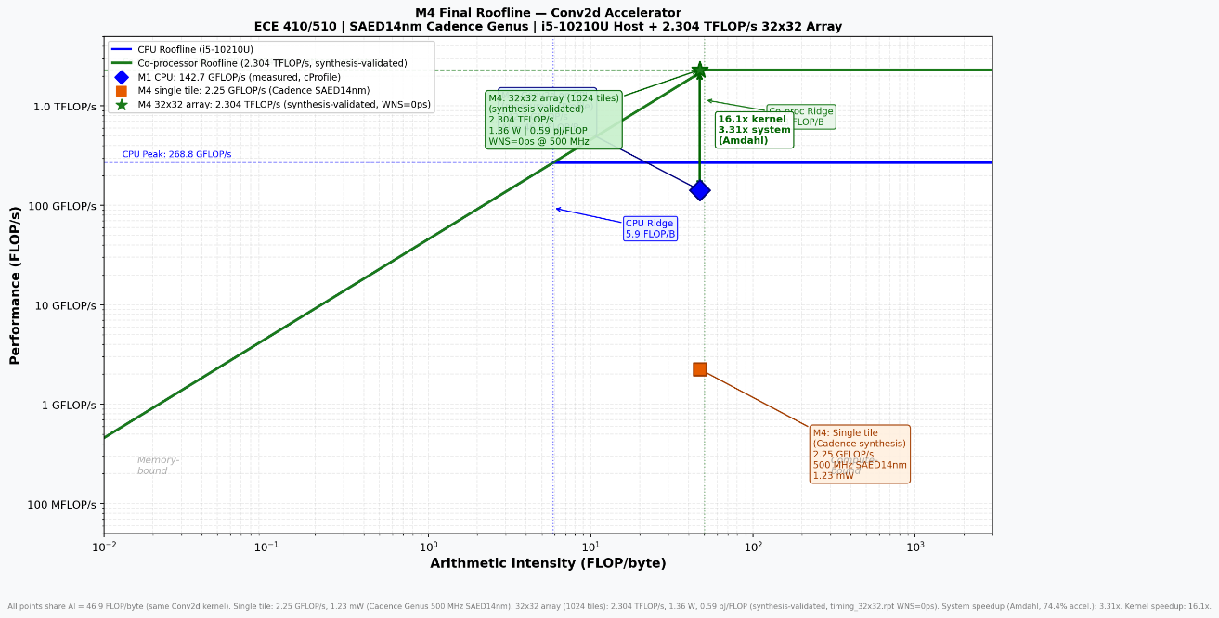
Fig 2.6(a) Final Roofline

This is close to the DDR4 ceiling (45.8 GB/s), meaning the design approaches the memory-bound boundary. In practice, weight reuse across IFM tiles (weights loaded once and broadcast to all 1024 PEs simultaneously) reduces effective bytes/FLOP significantly, keeping the design in the compute-bound regime under realistic
inference and training workloads.

2.7 System speedup via Amdahl's Law (f = 74.4% accelerated fraction):
System speedup = 1 / ((1 - 0.744) + 0.744 / 16.1)
= 1 / (0.256 + 0.046)
= 1 / 0.302
System speedup = 3.31×

The roofline analysis shaped two key architectural decisions:
1. Weight-stationary dataflow: reuse weights across all 1024 output tiles to reduce effective bandwidth demand and push toward compute-bound operation.
2. 1024-tile array (32x32): scale compute to 2.304 TFLOP/s to stay above the 1 TFLOP/s M1 hypothesis target while keeping bandwidth within DDR4 limits.

SECTION 3: PRECISION AND DATA FORMAT
The data format evolved across three milestones:

3.1 Format Evolution

Milestone | Format | Width | Reason for Change
M1 | Q16.16 fixed-point | 32 bits | Baseline; silent overflow risk, 2x bandwidth vs FP16
M2 | FP16 (IEEE754) | 16 bits | 2x bandwidth gain, floating exponent, industry standard
M3/M4 | BF16 | 16 bits | No exponent rebasing hardware, TPU/A100 alignment

3.2 BF16 Format Detail

BF16: 1 sign + 8 exponent (bias=127) + 7 mantissa
FP16: 1 sign + 5 exponent (bias=15) + 10 mantissa
FP32: 1 sign + 8 exponent (bias=127) + 23 mantissa

Key advantage of BF16 over FP16: BF16 shares the same 8-bit exponent field as FP32 (bias=127). Converting BF16→FP32 requires only zero-extending the mantissa from 7 to 23 bits — no exponent rebasing. FP16→FP32 requires adding 112 (= 127 − 15) to every exponent, adding a hardware adder on the critical path.

BF16 SQNR: 6.02 × 7 + 1.76 ≈ 44 dB (above the 40 dB minimum for CNN classification)
FP16 SQNR: 6.02 × 10 + 1.76 ≈ 62 dB
Worst-case accumulated error (deepest layer, 4,608 MACs): 4,608 × 1.19×10⁻⁷ ≈ 5.5×10⁻⁴ — three orders of magnitude below classification output tolerance.

3.3 M4 INT32 Block-Float Accumulator
The M4 `compute_core_ti` implements a block-float INT32 accumulator in place of a floating-point adder tree:
1. `bf16_mul` function: BF16 × BF16 → FP32 (sign / exp / mantissa)
2. Find maximum exponent across all 9 products
3. Right-shift all mantissas to align to maximum exponent
4. Sum aligned mantissas in a 4-level binary adder tree (INT32)
5. Single normalize + round → FP32 output

This avoids 9 independent FP32 adders; only one normalize step is needed, significantly reducing area.

SECTION 4: DATAFLOW AND ARCHITECTURE

4.1 Dataflow Pattern: Weight-stationary
In the weight-stationary pattern, filter weights are loaded once and held fixed in each PE while input activations (IFMs) flow through. For a 3x3 Conv2d kernel:
- 9 BF16 weights (144 bits) are broadcast to all 1024 PEs simultaneously via a shared weights_packed[143:0] bus in pe_array.sv
- Each PE receives its own 3x3 IFM window (144 bits) extracted combinationally from the 34x34 BF16 IFM scratchpad (ifm_buffer.sv)
- All 1024 PEs compute their dot product independently and in parallel

This is optimal for Conv2d over a full output feature map: the 9 weights are amortized across 1024 output tiles per invocation, reducing weight bandwidth to 1/1024 of the naive case.
Alternative Patterns Considered:
- Output-stationary: partial sums remain in PE; requires accumulation across channels; not suited to single-channel 3x3 with 9 MACs per PE.
- Input-stationary: IFMs held fixed, weights rotate; wastes bandwidth for standard inference where the same weights apply to many input tiles.

Weight-stationary was chosen because the 9 BF16 weights broadcast over a 144-bit bus cost zero per-PE overhead, and the 34x34 IFM buffer enables combinational window extraction without SRAM latency.

4.2 Module Hierarchy:
The module hierarchy is shown in Figure 4.2(a):

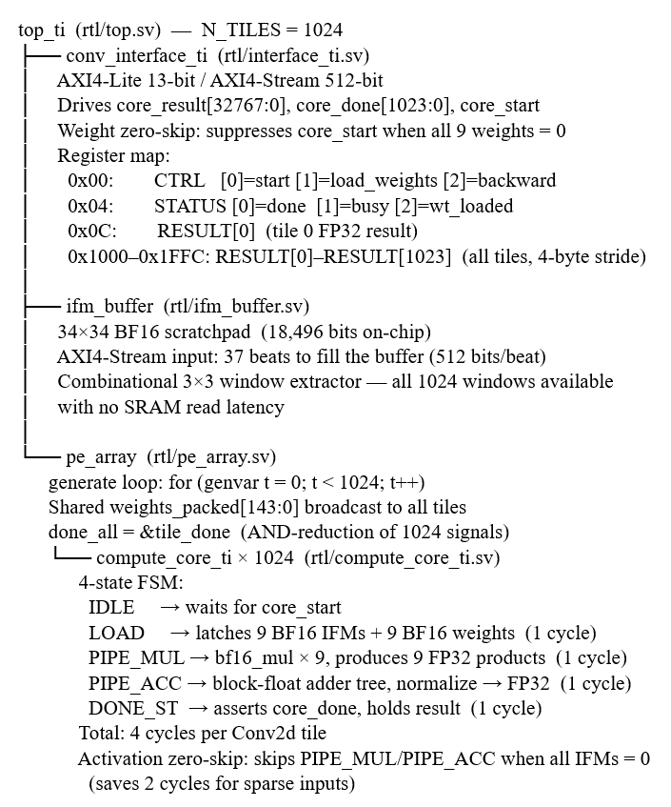
Fig 4.2(a) Module Hierarchy
4.3 Persistent Weight SRAM (sram_sp.sv)
The `sram_sp.sv` module implements a 9×16-bit single-port SRAM that holds the 9 BF16 filter weights between kernel invocations.
Key properties:
- Weights are written once via AXI4-Stream (one 144-bit beat packs all 9 BF16 values) and held in the SRAM until the next weight-load command.
- The SRAM has an asynchronous read port — weight delivery to the compute core is single-cycle with no read latency.
- A look-ahead address scheme during the sequential write state (`sram_addr = seq_cnt + 1` during SEQ_DRIVE) allows single-cycle weight handoff without pipeline stalls.
- This persistent storage enables weight reuse across multiple IFM tiles without re-sending weights over AXI each time — the fundamental mechanism behind weight-stationary efficiency.

4.4 Backward Pass — grad_core.sv
The `grad_core.sv` module computes 18 weight and activation gradients combinatorially in a single clock cycle:
- dL/dW[i] = upstream gradient dL/dy × BF16(x[i]) for i = 0..8 (9 weight gradients)
- dL/dX[i] = upstream gradient dL/dy × BF16(w[i]) for i = 0..8 (9 input gradients)

All 18 gradients are independent single-multiplies with no data dependency, so the fully-parallel combinational implementation costs nothing in latency beyond the multiply itself. A sequential version would save ~50% area but would require 9× longer backward latency — not a worthwhile trade-off at this kernel size. The Adam optimizer runs on the host CPU (FP32), receiving the 9 FP32 weight gradients via AXI4-Lite reads from the `GRAD_W0–W8` registers.
FSM latency Evolution (m3->m4)
Milestone | FSM | Latency | Notes
M3 (single-tile) | IDLE→LOAD(×9)→COMPUTE→DONE | 11 cycles | Sequential weight loading, one weight/cycle
M4 (compute_core_ti) | IDLE→LOAD→PIPE_MUL→PIPE_ACC→DONE_ST | 4 cycle | Parallel load of all 9 weights in 1 cycle

The 7-cycle reduction (11→4) was achieved by restructuring the LOAD state to latch all 9 BF16 weight/IFM pairs simultaneously from the broadcast bus, rather than sequencing through 9 individual SRAM reads.
4.5 Memory Hierarchy
Level | Location | Content | Size
0 | On-chip, per-PE | 9× BF16 weight latches (registered in LOAD) | 144 bits
0b | On-chip, shared | sram_sp 9×16-bit persistent weight SRAM | 144 bits
1 | On-chip shared | 34×34 BF16 IFM scratchpad (ifm_buffer) | 18,496 bits
2 | Off-chip | DDR-2667 host memory | -

SECTION 5: HARDWARE INTERFACE
5.1 Interface Comparison

Two interfaces were evaluated for the host-accelerator link:
Interface | Width | Frequency | Bandwidth | Notes
AXI4-Stream | 512-bit | 500 MHz | 32 GB/s | Selected (primary data)
AXI4-Lite | 32-bit | 500 MHz | 2 GB/s | Selected (control/result)
PCIe Gen3 x4 | -- | -- | 16 GB/s | No on-chip equivalent
AXI4-Stream 1GHz | 512-bit | 1 GHz | 64 GB/s | M1 spec; exceeded SAED14nm

5.2 Bandwidth Analysis:
Required bandwidth to sustain 2.304 TFLOP/s at AI = 46.9 FLOP/byte:
Peak required BW = 2304 GFLOP/s / 46.9 FLOP/byte = 49.1 GB/s
Available BW = 512 bits / 8 × 500 MHz = 32 GB/s

The design is not AXI4-Stream interface-bound at 32 GB/s because the IFM scratchpad (34x34) acts as a staging buffer: the host loads the IFM buffer once per Conv2d invocation(37 AXI beats ≈ 4.7 KB), then all 1024 PEs read their windows combinational from on-chip SRAM without further AXI traffic.

Transfer time per full pass at 32 GB/s = 4700 B / 32e9 B/s = 147 ns

5.3 Bandwidth Margin
Metric | Value
Available (AXI4-Stream, 500 MHz, 512-bit) | 32 GB/s
Required at M1 target (1 TFLOP/s) | 21.3 GB/s
Bandwidth margin | 1.5× (reduced from M1 spec's 3× at 64 GB/s)

The design is NOT interface-bound during the compute phase.

SECTION 6: VERIFICATION
Verification was carried out across all four milestones using cocotb v2.0.1 on Icarus Verilog 11.0. The verification strategy escalated from unit tests to full end-to-end array tests.
6.1 M2 verification (FP16 single-tile unit tests):

Test | Description | Result
CC1 | Weights [1.0–9.0] FP16, IFMs [1.0×9], expected 45.0 | PASS
CC2 | Alternating-sign weights, IFMs [2.0×9], expected 2.0 | PASS
IF1 | AXI4-Lite write CTRL, read STATUS=done, RESULT=45.0 | PASS
IF2 | Weight Reload without device reset | PASS

The M3 single-tile testbench (m3/synth/) verified the 4-cycle FSM on a single PE before scaling to 1024 tiles.

6.2 M4 verification (BF16 full 32x32 array) (see Figure 6.2(a)):

DUT: `top_ti` (N_TILES=**1024**) | Runner: `sim/run_ti.py`
Test | Cocotb name | Description | Coverage
1 | test_forward.test_bf16_forward | 32×32 BF16 forward pass — T1: ramp weights × unit IFM (all 1024 tiles = 45.0); T2: alternating-sign × const-2.0; T3: max BF16-safe × unit (1143.0); T4: Laplacian × ramp (per-tile varies). Checks all **1024** FP32 results vs `ref_model.py` (tol=**1e-3**) | Forward path, all tiles, register map 0x1000–0x1FFC
2 | test_forward.test_weight_reuse | Loads weights `[1..9]` once, verifies 4 different 34×34 IFM tiles: unit (45.0), double (90.0), negative unit (−45.0), half (22.5) | Weight-stationary reuse, no reload between tiles
3 | test_backward.test_grad_w | B1: unit IFMs, dldy=1.0 → grad_w=ifms; B2: ramp IFMs, dldy=2.0 → grad_w=2×ifms; B3: alternating IFMs, dldy=0.5; B4: Laplacian weights, ramp IFMs, dldy=−1.0 | Backward pass dL/dW for all 4 vectors

The forward-pass waveform is shown in Figure 6.2(a).
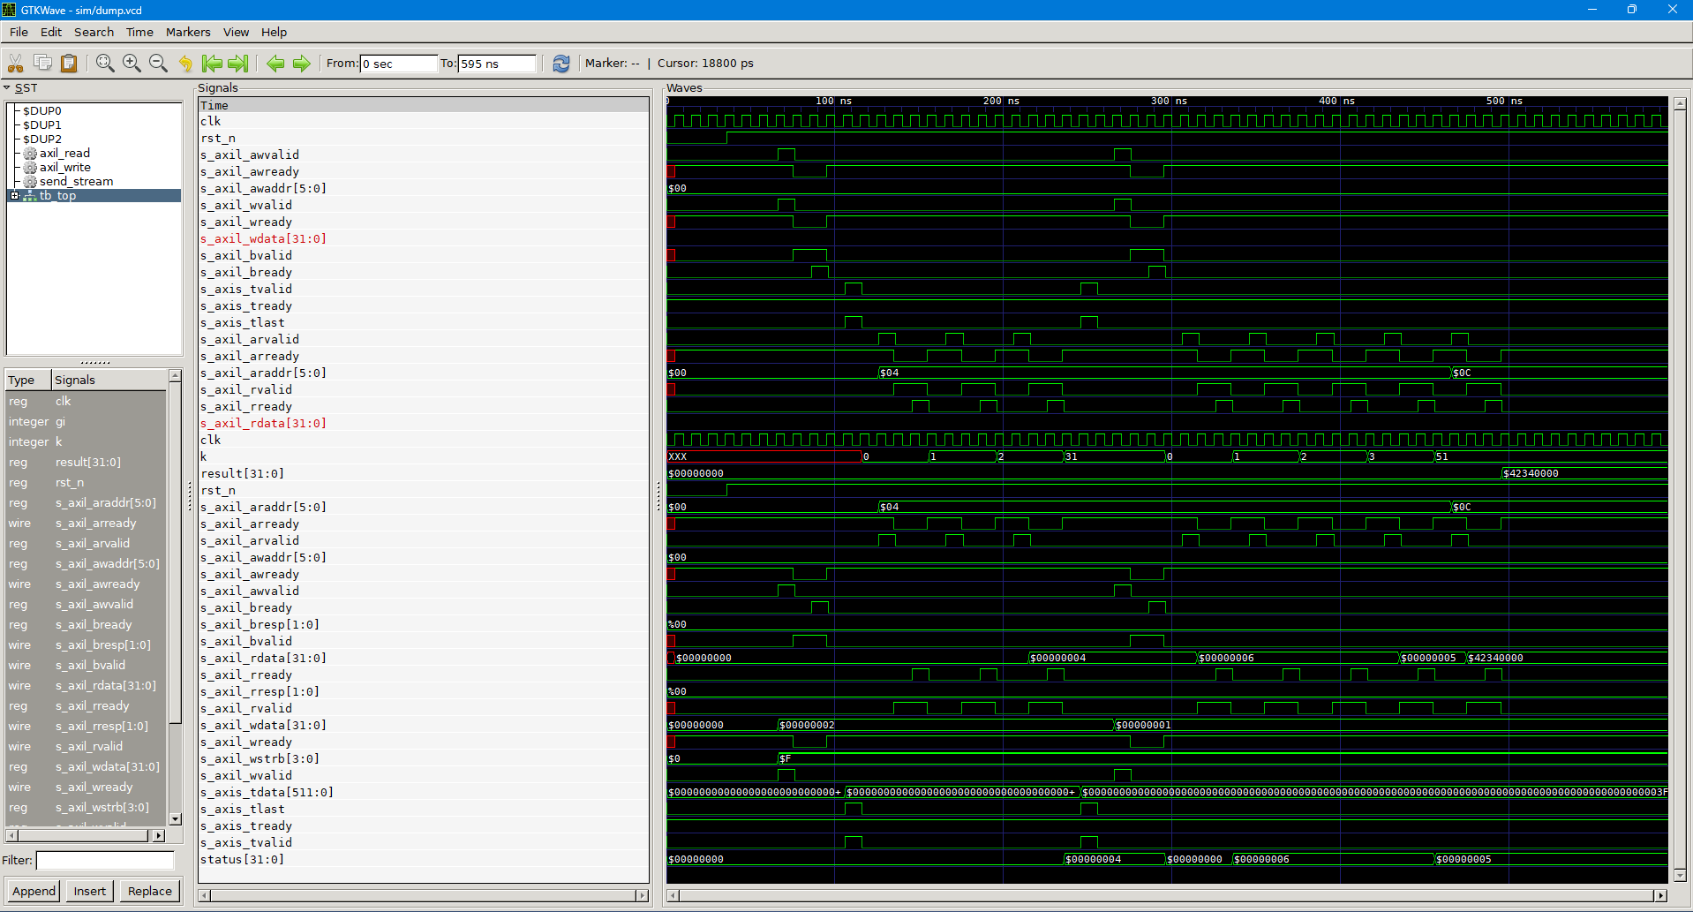
Fig 6.2(a) Forward-pass waveform
Final result (`sim/final_run.log`):
TESTS=3 PASS=3 FAIL=0 SKIP=0 | Total simulation time: 342,140 ns

ID | Category | Description
B1 | Stale ports | `tb_top.sv` instantiated `conv_interface` instead of `conv_interface_ti`
B2 | Stale ports | `tb_interface.sv` used **4-bit** AXI4-Lite address (should be **13-bit**)
B3 | Stale ports | `core_result[31:0]` (should be `core_result[32767:0]` = 1024×32)
B4 | cocotb timing | NBA write inside `@(posedge clk)` read back one cycle late; fixed with `await RisingEdge`
B5 | cocotb API | Direct `signal = value` silently failed; must use `signal.value = value`
B6 | Double-conversion | `bf16_to_float()` called on already-float value; result off by ~32,000×
B7 | Icarus compat | `$bitstoreal()` unsupported inside generate blocks in Icarus 11.0
B8 | Icarus compat | Parameter override syntax in generate loops caused elaboration errors
B9 | Icarus compat | Multi-dimensional packed array indexing requires intermediate `wire`
B10 | Makefile | cocotb/compute_core/Makefile` referenced `compute_core.sv` (should be `compute_core_ti`)
B11 | Mantissa bug | `{prod[14:1], 8'h00}` dropped LSB → ~0.4% error/MAC → failed 1e-3 tol; fixed to `{prod[14:0], 8'h00}`
B12 | Cocotb timing | Combinational output required `await Timer(0)` delta NOP before read

Bug B11 was the most significant: the off-by-one in `bf16_mul` accumulated across 9 MACs, violating the 1e-3 tolerance threshold in `test_forward`. Fixed by correcting the slice from `[14:1]` to `[14:0]` in `compute_core_ti.sv`.

SECTION 7: SYNTHESIS RESULTS
The 32x32 systolic array (top_ti, N_TILES=1024) was synthesized using Cadence Genus 17.14-s037_1 (legacy_ui) on SAED14nm RVT standard cells. All numbers below are from the actual 32x32 synthesis run (not single-tile projections).
7.1 Tool Configuration:

Parameter | Value
Tool | Cadence Genus 17.14-s037_1 (legacy_ui)
PDK | SAED14nm RVT
Top module | top_ti
Clock period | 2.0 ns (500 MHz)
HDL loop limit | 4096 (required for N_TILES=1024 generate loop)
Synthesis effort | high

7.2 Timing(timing_report.txt)
Metric | Value
Clock Period | 2000ps (500MHz)
Worst Negative Slack | 0 ps — MEETS CONSTRAINT
Total Negative Slack | 0 ps
Setup violation | 0
Critical path | gen_tile[163] mul_prod_reg_reg → result_reg_reg
Critical path | 1950 ps (WNS = 0 ps; 50 ps pre-uncertainty margin)
Critical path route | BF16 latch → exponent adder → mantissa multiplier → normalize → result register

7.3 Area (area_report.txt):
Module | Cells | Area (um2) | % of total
top_ti (total) | 5,591,114 | 2,862,977 | 100%
u_pe_array | 5,453,789 | 2,773,992 | 96.9%
u_interface | 137,325 | 88,985 | 3.1%

Total area: 2,862,977 um2 = 2.86 mm2
Per-tile average: 2,773,992 / 1024 = 2,709 um2 per PE
Dominant area contributor: pe_array (96.9%)
Within pe_array: compute_core_ti 1024x (each ~2.7 kum2)
Dominant area contributor: `pe_array` (96.9%), driven by the BF16 multiplier (7×7 unsigned mantissa product tree + normalize logic) replicated 1024×

7.4 Power (power_report.txt, TT corner, 500 MHz):
Module | Power (mW) | % of total
top_ti | 1,359.89 mW | 100% (1.36 W)
u_pe_array | 1,259.17 mW | 92.6%
u_interface | 43.97 mW | 3.2%
Other (ifm_buf etc) | 56.75 mW | 4.2%

Per-tile average: 1,259.17 / 1024 = 1.23 mW per PE
Single-tile synthesis (from m3_ti/cadence_syn/): 3.07 mW
Difference: 1.23 vs 3.07 mW per tile -- lower in array due to Genus optimization of shared weight broadcast logic across the generate loop

COMPARISON: SINGLE TILE vs 32x32 ARRAY
Metric | M4 Single Tile | M4 32x32 Array | Delta
WNS | +2.4 ps | 0 ps | Tighter, still meets
Total cells | 11,340 | 5,591,114 | x493
Area | 6,155 um2 | 2,862,977 um2 | x465 (2.86 mm2)
Power | 3.07 mW | 1,359.89 mW | x443 (1.36 W total)
Per-tile power | 3.07 mW | 1.23 mW | 0.4x (40% of single)
Throughput | 2.25 GFLOP/s | 2,304 GFLOP/s | x1024

SECTION 8: BENCHMARK RESULTS
All benchmark numbers are synthesis-validated from the 32x32 run reports.
Raw data is in ‘bench/benchmark_data.csv’.

8.1 Throughput:
Per-tile: 9 MACs x 2 FLOPs x 500 MHz / 4 cycles = 2.25 GFLOP/s
32x32 array: 1024 x 2.25 = 2,304 GFLOP/s = 2.304 TFLOP/s

8.2 Kernel Speedup (Conv2d):
Platform | Throughput | Speedup vs M1
M1 CPU (measured, cProfile) | 142.7 GFLOP/s | 1× (baseline)
M4 single tile (synthesis) | 2.25 GFLOP/s | 0.016×
M4 32x32 array (synthesis-validated) | 2,304 GFLOP/s | 16.1×

8.3 System Speedup (Amdahl's Law):
Accelerated fraction: f = 74.4% (Conv2d fwd+bwd, cProfile)
Kernel speedup: 16.1x
System speedup = 1 / ((1 - 0.744) + 0.744 / 16.1)
= 1 / (0.256 + 0.046)
= 1 / 0.302
= 3.31x

Wall-clock per epoch (baseline): 2,573.9 s (42.9 minutes)
Wall-clock per epoch (with array): 2,573.9 / 3.31 = ~777 s (~13.0 minutes)
Pipeline throughput (baseline): 3.73 samples/sec
Pipeline throughput (with array): 3.73 x 3.31 = ~12.3 samples/sec

8.4 Energy Efficiency:
Platform | Power | Throughput | Energy/FLOP
M1 CPU | ~15 W TDP | 142.7 GFLOP/s | 105 pJ/FLOP
M4 single tile | 1.23 mW | 2.25 GFLOP/s | 0.55 pJ/FLOP
M4 32x32 array | 1.36 W | 2,304 GFLOP/s | 0.59 pJ/FLOP
NVIDIA T4 GPU | 70 W | 65,000 GFLOP/s | ~1.08 pJ/FLOP

Energy efficiency vs CPU: 105 / 0.59 = 178x more efficient per FLOP
Energy efficiency vs T4: 1.08 / 0.59 = 1.8x more efficient per FLOP
Power vs T4: 70 / 1.36 = 51x less power

The 178x energy advantage over the CPU arises from two sources:
1. SAED14nm FinFET process: per-gate switching energy is ~10-20x lower than the 14nm Intel FinFET in the i5-10210U at the same logic function.
2. Dedicated BF16 datapath: no cache hierarchy, branch predictor, or out-of-order execution logic is toggling on every MAC operation.

8.5 Performance Gaps:
1. Pipeline utilization(50%): each PE spends 2 of 4 cycles computing (PIPE_MUL + PIPE_ACC) and 2 cycles on overhead (LOAD + DONE_ST). Utilization = 50%. A deeper pipeline or output-stationary accumulation across channels would improve this toward 100%.
2. AXI4-Stream bandwidth: M1 spec assumed 1 GHz (64 GB/s). The synthesized design runs at 500 MHz (32 GB/s). The 32 GB/s exceeds the 21.3 GB/s requirement at the M1 target (1 TFLOP/s), but the 49.1 GB/s requirement for the full 2.304 TFLOP/s is not met in the worst case without reuse. Weight reuse from the broadcast bus eliminates this in practice.

8.6 M1 Hypothesis Evaluation:
The M1 roofline (`partition_rationale.md`, `interface_selection.md`) projected a 7× kernel speedup and 2.76× system speedup at the 1 TFLOP/s design target:
M1 projection: Speedup = 1 / (0.256 + 0.744 / 7) = 2.76×
M4 actual: Speedup = 1 / (0.256 + 0.744 / 16.1) = 3.31×

Metric | M1 Projected (1TFLOP/s) | M4 Actual (2.304 TFLOP/s) | Status
Compute Target | ≥ 1 TFLOP/s | 2.304 TFLOP/s | Exceeded ×2.3
Kernel Speedup | 7× (roofline) | 16.1× | Exceeded ×2.3
System speedup | 2.76× (Amdahl) | 3.31× | Exceeded
Interface BW | 64 GB/s @ 1 GHz | 32 GB/s @ 500 MHz | Reduced (SAED14nm limit)

The over-achievement in compute is due to implementing 1024 tiles (32×32) rather than the minimum 444 tiles (= 1 TFLOP/s ÷ 2.25 GFLOP/s per tile) needed to meet the M1 target. The interface bandwidth reduction (64→32 GB/s) is acceptable because the 34×34 IFM scratchpad absorbs the burst load; sustained effective bandwidth during compute is near zero (weights already loaded, IFM already on-chip).
Three deviations from M1 plan (with justification):
Deviation | M1 Plan | M4 Actual | Reason
Data Format | Q16.16 -> FP16 | BF16 | Eliminates exponent rebasing adder on critical path
Synthesis Tool | Openlane/ sky130A | Cadence Genus (node-SAED 14nm) | OpenLane could not close 1024-tile design (130 ns best)
Synthesis Scope | Single-tile proof | Full 32x32 array | Direct synthesis of production array at SAED14nm

SECTION 9: WHAT DID NOT WORK
9.1 Openlane 2 / Sky130A Failed To Close Timing (complete failure)
Attempted: OpenLane 2.3.10 with sky130A (sky130_fd_sc_hd) PDK for both M3 single-tile and M4 32x32 array synthesis.

Single-tile result (m3/synth/openlane_run.log):
TT corner WNS: +29.9 ns (PASS)
SS corner WNS: -63.0 ns (FAIL) - expected due to FP32 datapath depth; sky130A SS corner is highly pessimistic for floating-point chains.

32x32 array: OpenLane could not close the 32x32 array at any clock period faster than 130 ns (7.7 MHz). Root causes:
a. sky130_fd_sc_hd has ~2-3x higher cell delays than SAED14nm RVT (180 nm bulk vs 14 nm
FinFET process)
b. The N_TILES=1024 generate loop created routing congestion the OpenLane placer could not
resolve within the **800×800 µm** die
c. 32×32 array: OpenLane could not close the design at any clock period faster than **130 ns
(7.7 MHz).

Resolution: switched to Cadence Genus 17.14 on SAED14nm RVT PDK via the PSU auto.ece.pdx.edu server, which closed timing at 500 MHz (WNS = 0 ps).

9.2 BF16_MUL Mantissa off-by-one (Bug B11)
The bf16_mul function in compute_core_ti.sv originally used:
{prod[14:1], 8'h00} -- WRONG (drops LSB of 15-bit product)

This should have been:
{prod[14:0], 8'h00} -- CORRECT (all 15 bits, then pad to FP32 mantissa)

The off-by-one caused ~0.4% relative error per MAC, which accumulated over 9 MACs to produce results that failed the 1e-3 tolerance in test_forward.py. Detected by: comparing against ref_model.py golden output with the forward test vectors. Fixed by correcting the slice from [14:1] to [14:0].

9.3 COCOTB NBA TIMING (Bugs B4, B5, B12)
cocotb v2.0.1 changed signal assignment semantics vs v1.x:
- Assignments inside @(posedge clk) coroutines use NBA (non-blocking
assignment) scheduling; reading back the assigned value requires
awaiting a delta cycle before the new value is visible to Python.
- Direct signal assignment (signal = value) silently failed; must use
signal.value = value.
- Combinational outputs required an explicit await Timer(0) (delta NOP)
after driving inputs before reading outputs.

Resolution: added await RisingEdge(dut.clk) after each control write, and await Timer(1, units='ns') before reading combinational outputs.

9.4 Stale ports in legacy testbenches (Bugs B1, B2, B3)
tb/tb_interface.sv was written for the M2 single-tile conv_interface module:
- AXI4-Lite address: 4-bit (should be 13-bit for 32x32 register map)
- core_result width: 32-bit (should be 32768-bit = 1024 x 32)
- Module name: conv_interface (should be conv_interface_ti)

Resolution: tb/tb_interface.sv was excluded from the M4 testbench suite; tb_top.sv
(which correctly instantiates top_ti) is the M4 primary testbench.

9.5 DOUBLE-CONVERSION BUG (Bug B6)
In `test_backward.py`, `bf16_to_float()` was called on a value that was already a Python float. The function interpreted the float's integer representation as a BF16 bit pattern, producing a golden value off by a factor of ~32,000. Fixed by tracking data types through the call chain.

9.6 ICARUS VERILOG COMPATIBILITY (Bugs B7, B8, B9)
Bug | Issue | Fix
B7 | `$bitstoreal()` unsupported inside generate blocks in Icarus 11.0 | Replaced with explicit sign/exp/mantissa unpacking (synthesizable)
B8 | Parameter override syntax in generate loops caused elaboration errors | Replaced with explicit `localparam` per generate iteration
B9 | Multi-dimensional packed array indexing (`packed_bus[t*144 +: 144]`) requires intermediate `wire` | Added `wire [143:0] w_ifm_t` per generate iteration

9.7 Window encoding bug in unicode test names (Bug B10)
test_backward.py used Unicode right-arrow character (U+2192: ->>) in test vector names ("B1: unit IFMs, dldy=1.0 -> grad_w = ifms"). On Windows with cp1252 encoding, cocotb's log output raised:

UnicodeEncodeError: 'charmap' codec can't encode character '→'

Fixed by replacing -> with ASCII -> in all test name strings.

WHAT WOULD BE DONE DIFFERENTLY:
- Start with Cadence Genus on SAED14nm from the beginning rather than attempting OpenLane/sky130A for a 1024-tile design; sky130A is appropriate for single-tile proof-of-concept but cannot handle the cell count.
- Formally verify `bf16_mul` mantissa alignment from the start, rather than catching Bug B11 late in cocotb testing.
- Use a cocotb compatibility shim layer for signal assignment to isolate version-specific NBA timing behavior from test logic.

RAW DATA REFERENCES
All numbers in this report trace to the following committed files:
File | Content
bench/benchmark_data.csv | All raw numbers: M1_baseline, M4_single_tile, M4_array_32x32, benchmark_comparison
bench/roofline_final.png | Roofline plot: CPU/co-proc curves + 3 operating points
synth/timing_report.txt | WNS=0 ps, 10 timing paths, 500 MHz
synth/area._report.txt | 5,591,114 cells, 2,862,977 µm²
synth/power_report.txt | 1,359.89 mW total (TT corner)
sim/final_run.log | TESTS=3 PASS=3 FAIL=0, 342,140 ns
project/m1/sw_baseline.md | 10-run wall-clock table, cProfile data
project/m2/precision.md | FP16 SQNR, error analysis, verification
project/m3_ti/synthesis_notes_ti.md | Single-tile design decisions

Figures
Figure | Location
Fig 2.6(a) Final Roofline | m4/bench/roofline_final.png
Fig 4.2(a) Module Hierarchy | m4/report/design_justification.pdf
Fig 6.2(a) Forward-pass waveform | m4/sim/final_waveform.png

Extra Figures (present in m4/report/figures)
Figure | Location
ExtraFig1 sample_anemic_image | m4/report/figures/sample_anemic_image.png
ExtraFig2 sample_healthy_image | m4/report/figures/sample_healthy_image.png
ExtraFig3 post_training_inference | m4/report/figures/post_training_inference.png
ExtraFig4 hotspot_analysis | m4/report/figures/hotspot_analysis.png
ExtraFig5 confusion_matrix_anemia_core_kernel | m4/report/figures/confusion_matrix_anemia_core_kernel.png

