YOLOv8 Image & Video Segmentation using Visual Studio Code

✅ Overview
This project demonstrates how to perform semantic segmentation using YOLOv8, applied both to local images and YouTube videos. The entire workflow was developed and executed using Visual Studio Code, leveraging Python and various tools like yt-dlp and ffmpeg.
Whether you're experimenting with object segmentation, building a computer vision pipeline, or just trying to learn YOLOv8 practically, this guide will help you through each step.
The project is divided into two parts:
- Part A: Segmenting local images using YOLOv8.
- Part B: Downloading a YouTube video, extracting its frames, segmenting them using YOLOv8, and compiling the results into a new video.
Tools and libraries used:
- YOLOv8 via ultralytics package
- opencv-python
- yt-dlp
- ffmpeg
- Visual Studio Code

🔹 Part A: Segment Local Images Using YOLOv8

1. 📁 Folder Structure
Created the following folder structure in VS Code:
project_folder/
├── imagesegmentation.py
├── images/ # Input images (.jpg/.png)
└── segmented_images/ # Output segmented images

2. 🧪 Install Required Python Libraries
Installed using VS Code terminal:
pip install ultralytics opencv-python

3. 🧾 Segmentation Script (imagesegmentation.py)
Python script to load YOLOv8 and apply it to all images in the images/ folder:
from ultralytics import YOLO
from pathlib import Path
model = YOLO("yolov8n-seg.pt")
input_folder = Path("images")
output_folder = Path("segmented_images")
output_folder.mkdir(exist_ok=True)
for image_file in input_folder.glob("*.jpg"):
results = model(image_file)
results[0].save(filename=str(output_folder / f"{image_file.stem}_seg.jpg"))
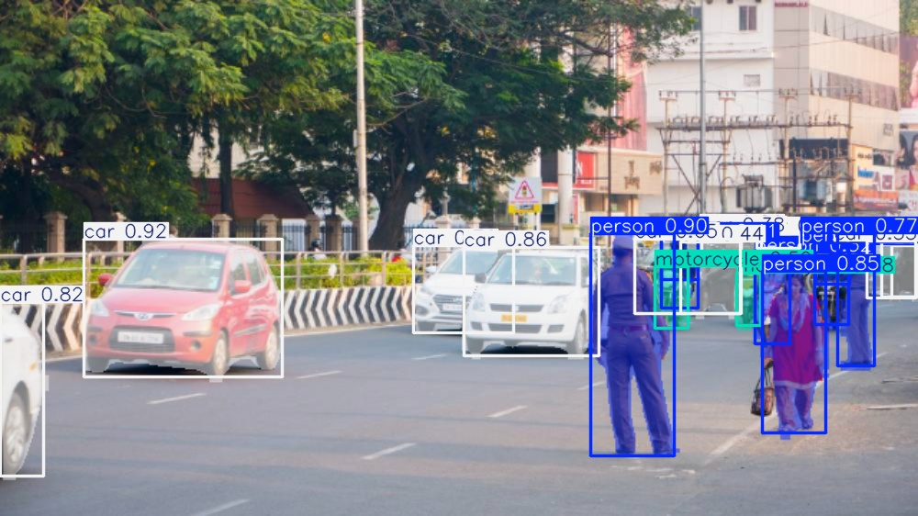
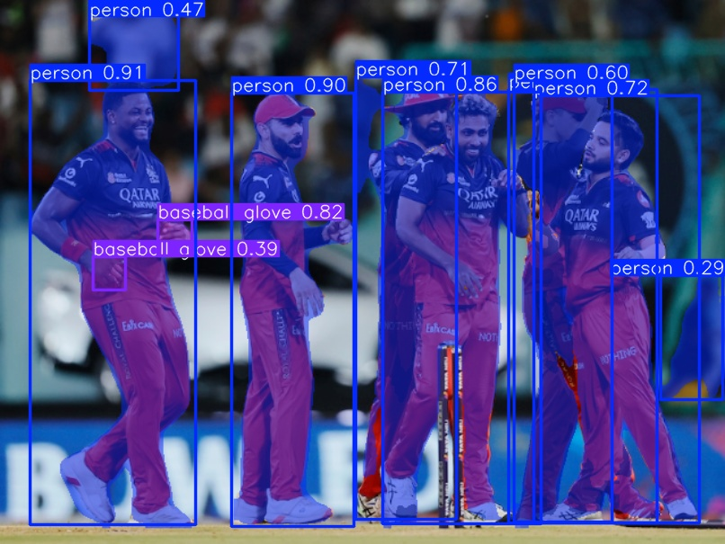
Output:
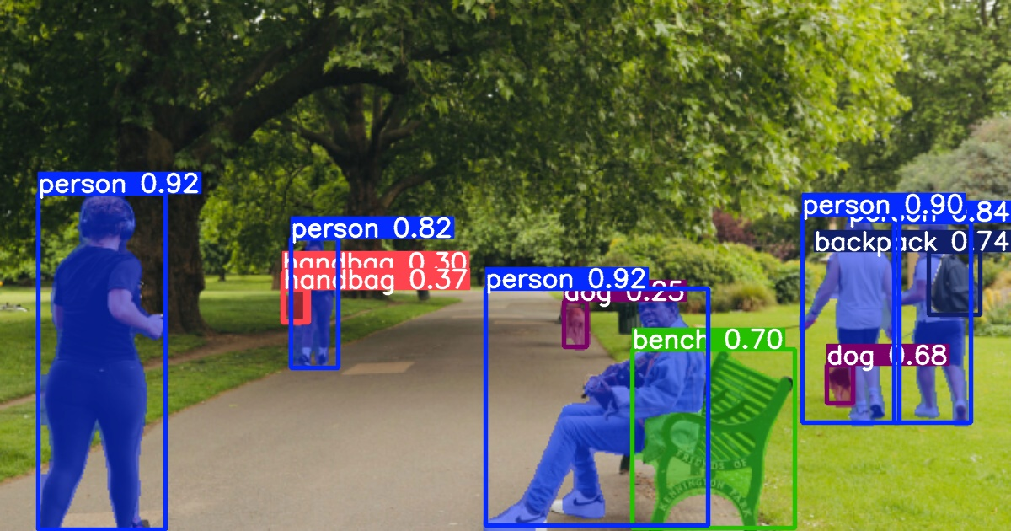

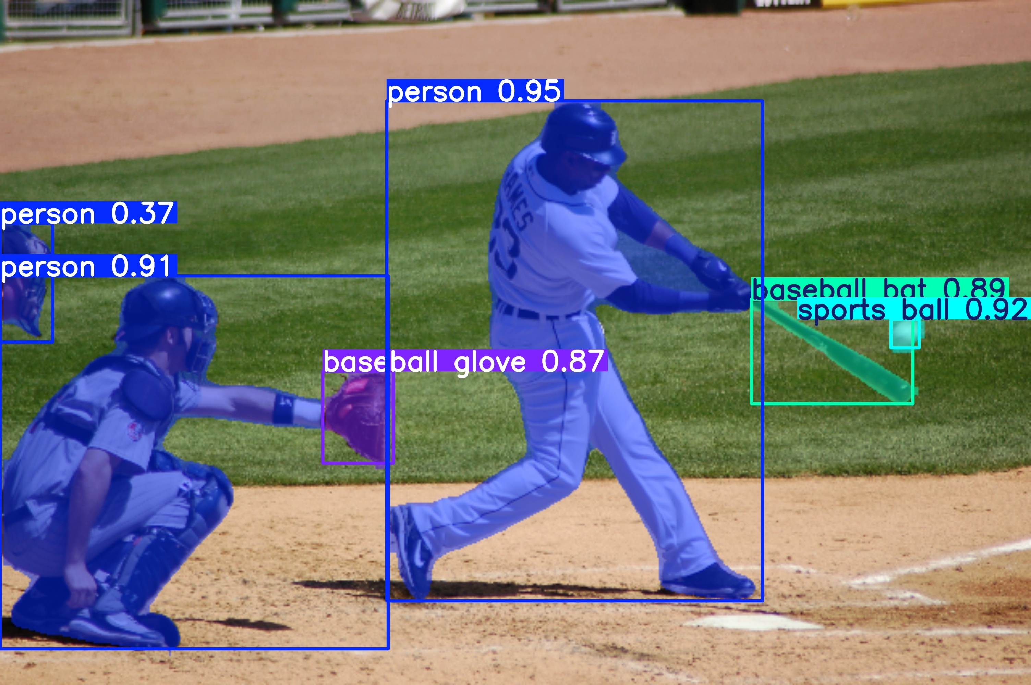
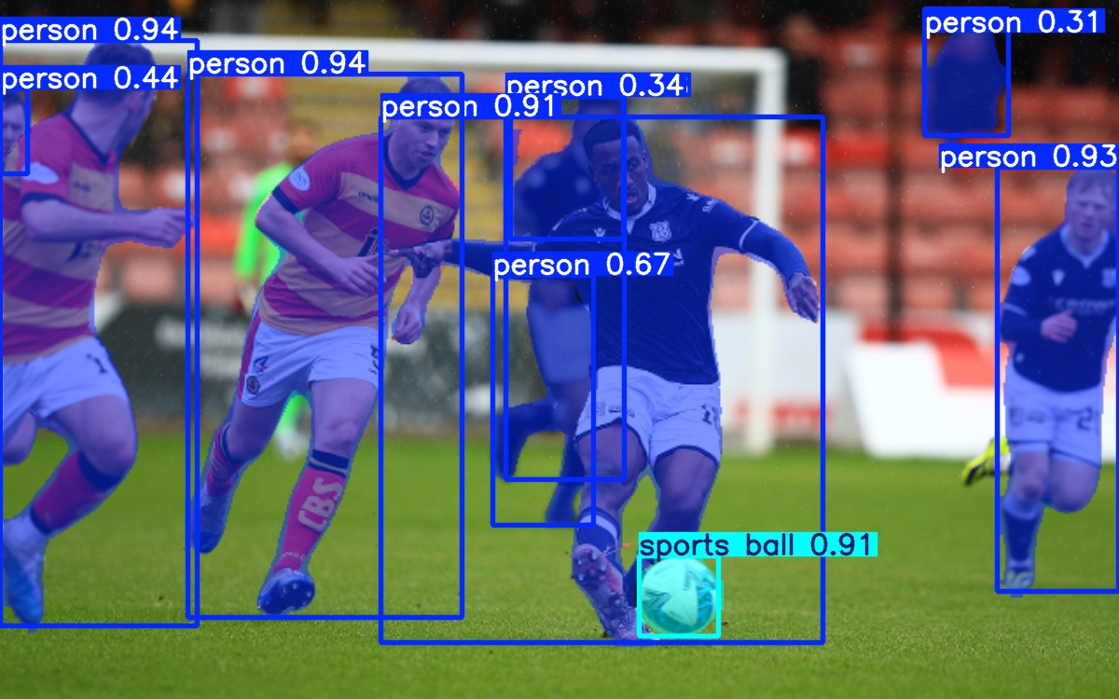

🎥 Part B: Segment a YouTube Video

1. ⚙️ Install yt-dlp and FFmpeg
Installed yt-dlp using pip and FFmpeg from gyan.dev. Added FFmpeg to system PATH.

2. 📥 Download a YouTube Video
Used yt-dlp to download video:
yt-dlp -f mp4 "https://www.youtube.com/watch?v=YOUR_VIDEO_ID" -o video.mp4

3. 🖼️ Extract Frames
Used ffmpeg to extract frames at 1 frame per second:
ffmpeg -i video.mp4 -vf fps=1 frames/frame%04d.png

4. 🤖 Segment Frames
Segmented frames using this Python script in VS Code:
from ultralytics import YOLO
from pathlib import Path
model = YOLO("yolov8n-seg.pt")
input_frames = Path("frames")
output_dir = Path("segmented_frames")
output_dir.mkdir(exist_ok=True)
for img in input_frames.glob("*.png"):
results = model(img)
results[0].save(filename=str(output_dir / f"{img.stem}_seg.jpg"))
If YOLO saves results in runs/segment/predict, copy them using:
mkdir segmented_frames
copy runs\segment\predict\*.jpg segmented_frames\

5. 🎬 Combine Segmented Frames into Video
Final output video created with:
ffmpeg -framerate 1 -i segmented_frames/frame%04d_seg.jpg -c:v libx264 -pix_fmt yuv420p output_video.mp4

💡 Final Notes
- All development was done using Visual Studio Code.
- Used Python 3.12 in a virtual environment.
- Script paths are relative to the working directory in VS Code.

📌 Conclusion
This project successfully segmented local images and a YouTube video using YOLOv8. It integrates Python scripting, video processing, and deep learning into a practical, real-world application.

