RESUME

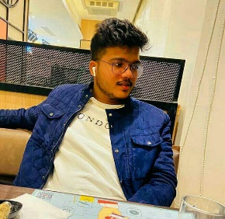

AMOGHAVARSHA B Ph no. – 6360355357

SJBIT Boys hostel, amoghvarshb2003@gmail.com

Kengeri,

Bengaluru-560060

PROFILE OVERVIEW

Young Dynamic engineer with good technical and analytical ability. Aspire to work in the field of mechanical design, manufacturing and maintainance. I have foundation knowledge on manufacturing ,design and maintainance. Willing to work in an environment where I can develop self and the organisation with knowledge gained .

PROFESSIONAL EXPERIENCE

* FRESHER

Pursuing information science engineering in SJBIT.

* ETHNOTECH

Graduate in HTML and CSS, 11 oct 2022 to 19 oct 2022.

ROLES AND RESPONSIBILITIES:

During my internship program course conducted by ETHNOTECH, I was well trained where my nature of job was

Work management at ethnotech was to instill strong foundation for fresher in html coding and css.

Ability to create innovative web pages and on given topic and to represent them creatively.

|  |
| --- |
| EDUCATIONAL QUALIFICATION |

|  |  |  |  |  |
| --- | --- | --- | --- | --- |
| **DEGREE** | **INSTITUTION** | **UNIVERSITY BOARD** | **PERCENTAGE** | **YEAR OF PASSING** |
| **BE( ISE )** | **SJBIT** | **VTU** |  | **2025** |
| **PUC** | Jnana sudha | **State Board** | **96%** | **2021** |
| 10th | Amrita vidyalayam | **CBSE** | **92%** | **2019** |