**Car Price Prediction Report**

**Name: Amogh Javali**

**ID: NN/22/2355**

**Role: Data Analytics**

**1. Introduction**

Understanding car prices is essential for both buyers and manufacturers. Various factors like **engine size, horsepower, fuel efficiency, and brand reputation** contribute to the overall price of a car. This report aims to analyze key attributes influencing car prices using **data visualization techniques** and **statistical insights**.

**2. Data Analysis & Key Findings**

**2.1 Most & Least Sold Car Brands**

* **Most sold car brand:** Toyota – Known for reliability and affordability, Toyota dominates the dataset.
* **Least sold car brand:** Mercury – A lesser-known brand, reflecting lower demand or production.

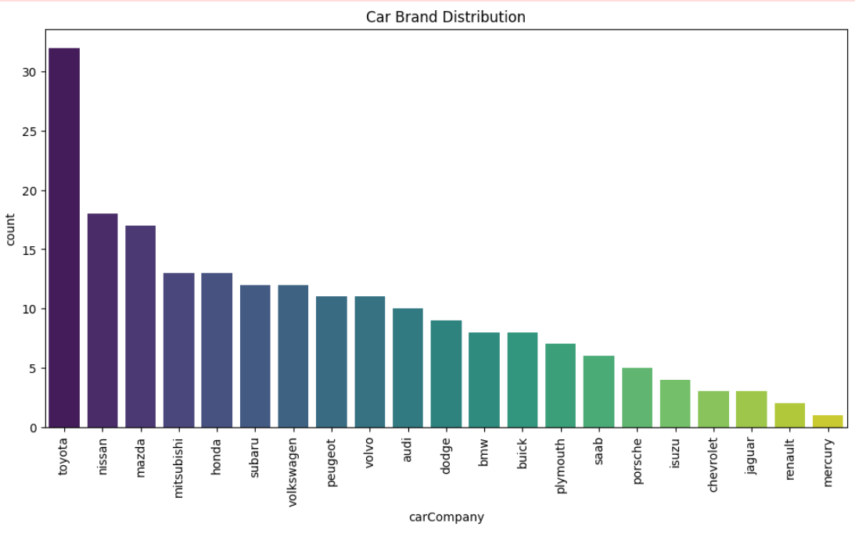

**2.2 Car Body Type Distribution**

* **Most sold car body type:** Sedan – Popular due to its comfort and balanced design.
* **Least sold car body type:** Hardtop – Less common, possibly due to its niche market appeal.

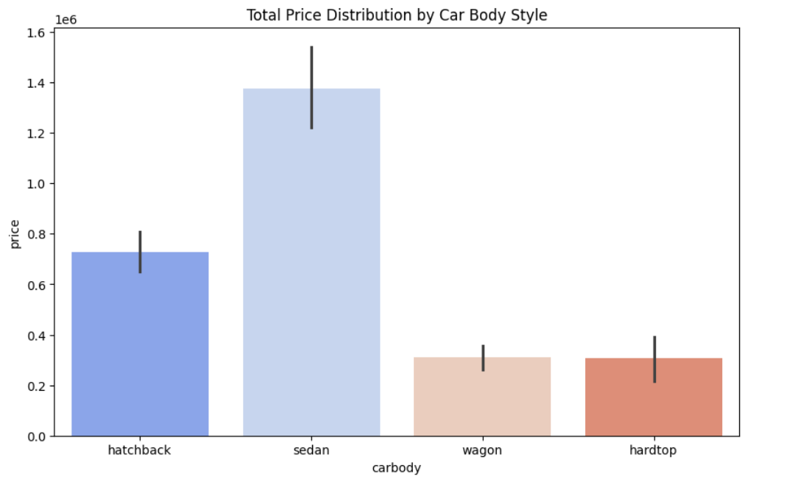

**2.3 Insights from the Heatmap**

The **heatmap visualization** helps us understand how different car features correlate with price. Key takeaways include:

* **Engine size and horsepower show a strong positive correlation with price** – Bigger engines and higher horsepower generally lead to higher car prices.
* **Fuel efficiency (MPG) has a negative correlation with price** – Fuel-efficient cars tend to be more affordable, while high-performance cars consume more fuel and cost more. 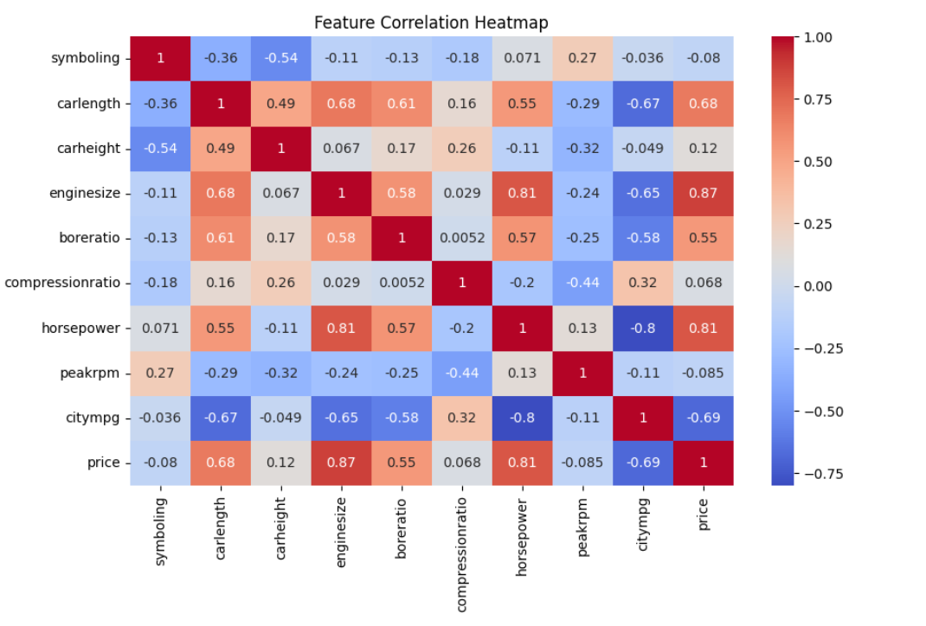

**2.4 Scatter Plot Analysis**

A scatter plot comparing **engine size and price** shows a clear trend:

* **Larger engine size → Higher price**
* **Smaller engine size → Lower price**
* **Gradient effect:** Higher horsepower further increases the price, showing the importance of performance in pricing decisions.

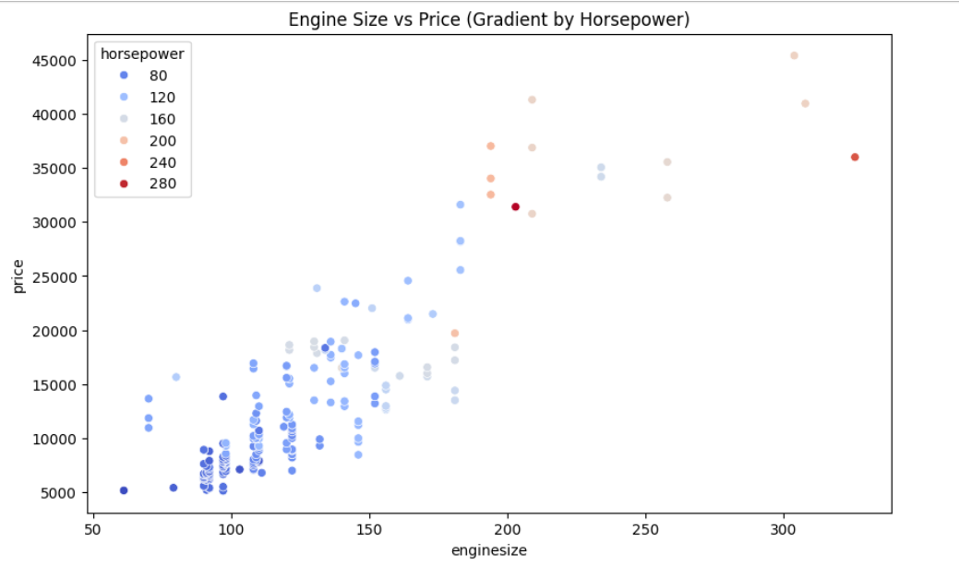

**3. Conclusion**

From the analysis, it’s evident that car pricing is influenced by multiple factors, with **engine size, horsepower, and fuel efficiency being the most significant**. Toyota emerges as the most popular brand, while sedans remain the preferred body type. The insights gained from this study can be used for **predicting car prices, optimizing manufacturing strategies, and guiding consumers in making informed purchasing decisions**.

**4. Recommendations**

* **For buyers:** Consider **fuel efficiency and performance balance** when purchasing a car.
* **For manufacturers:** Focus on **engine size and horsepower** as primary pricing factors.
* **For analysts:** Use **heatmaps and scatter plots** to identify strong price indicators in future datasets.

This report provides a clear foundation for **further exploration in predictive modelling for car price estimation**.

**5. Final Insight**

This insight is prepared by **cleaning data, handling missing values, and conducting a full analysis using statistical methods and data visualization techniques**. Every step was taken to ensure accuracy and relevance in predicting car prices.

For full details, visit

**GitHub:** [**https://github.com/Amoghjavali2003/NovaNectar_DataAnalytics_Elementary_task1**](https://github.com/Amoghjavali2003/NovaNectar_DataAnalytics_Elementary_task1)