Amogh K

PES2UG22CS061

LAB -3

SS-1

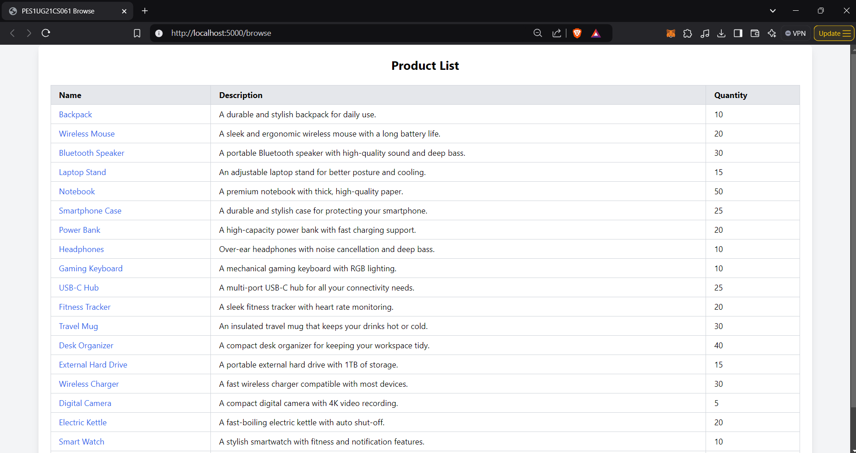

SS-2

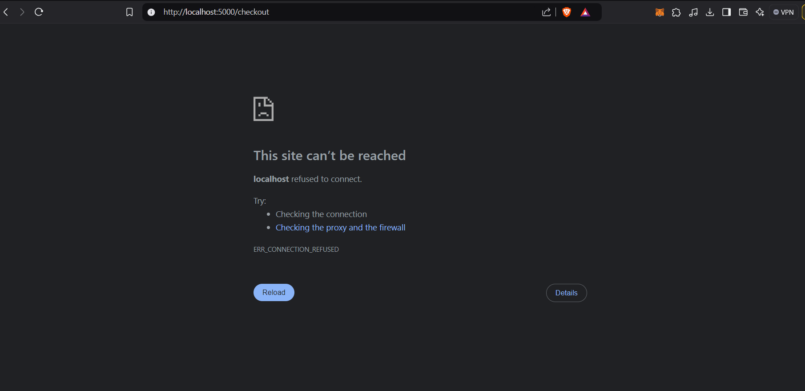

SS-3

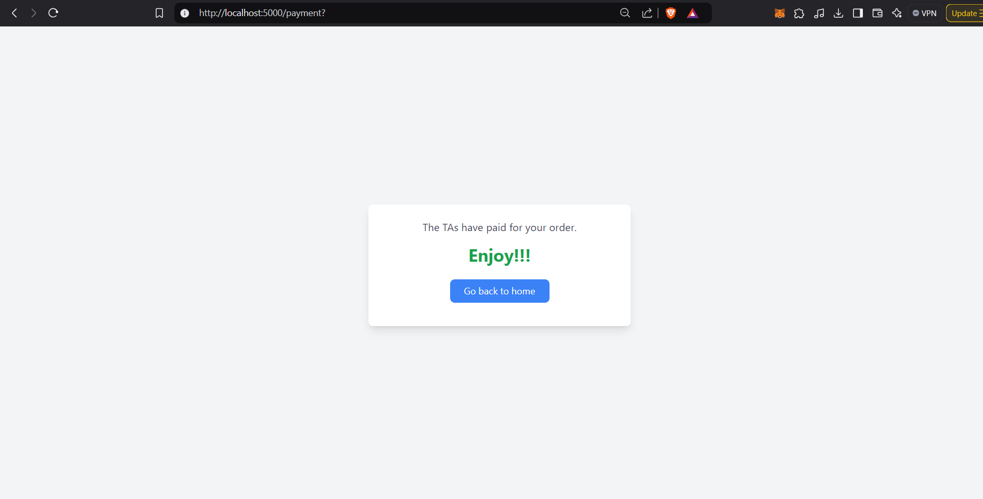

SS-4

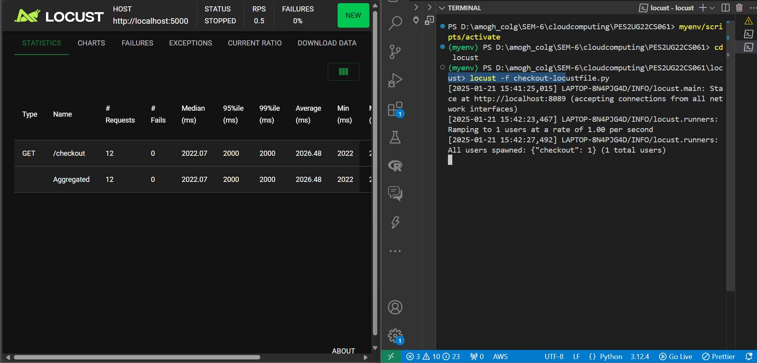

SS-5

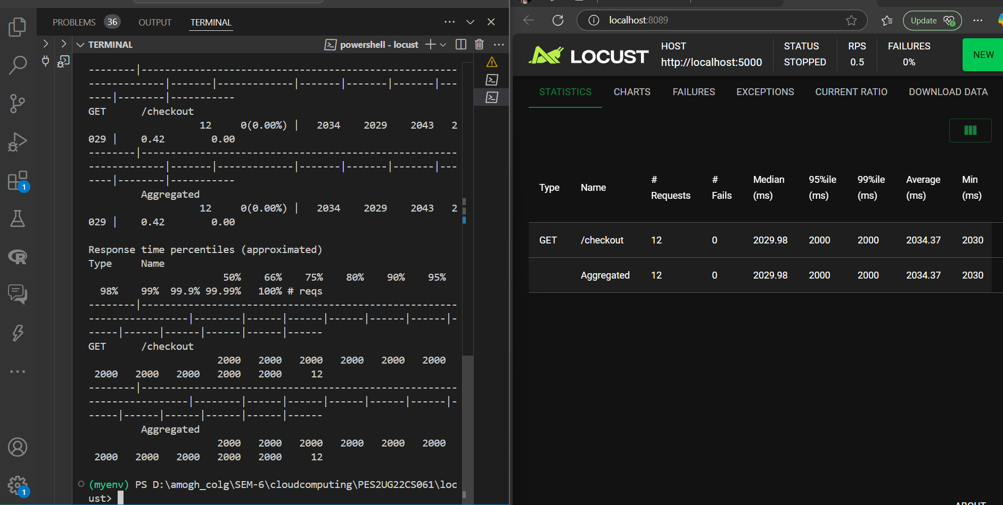

Locust optimizations

Cart optimization

Before optimization :

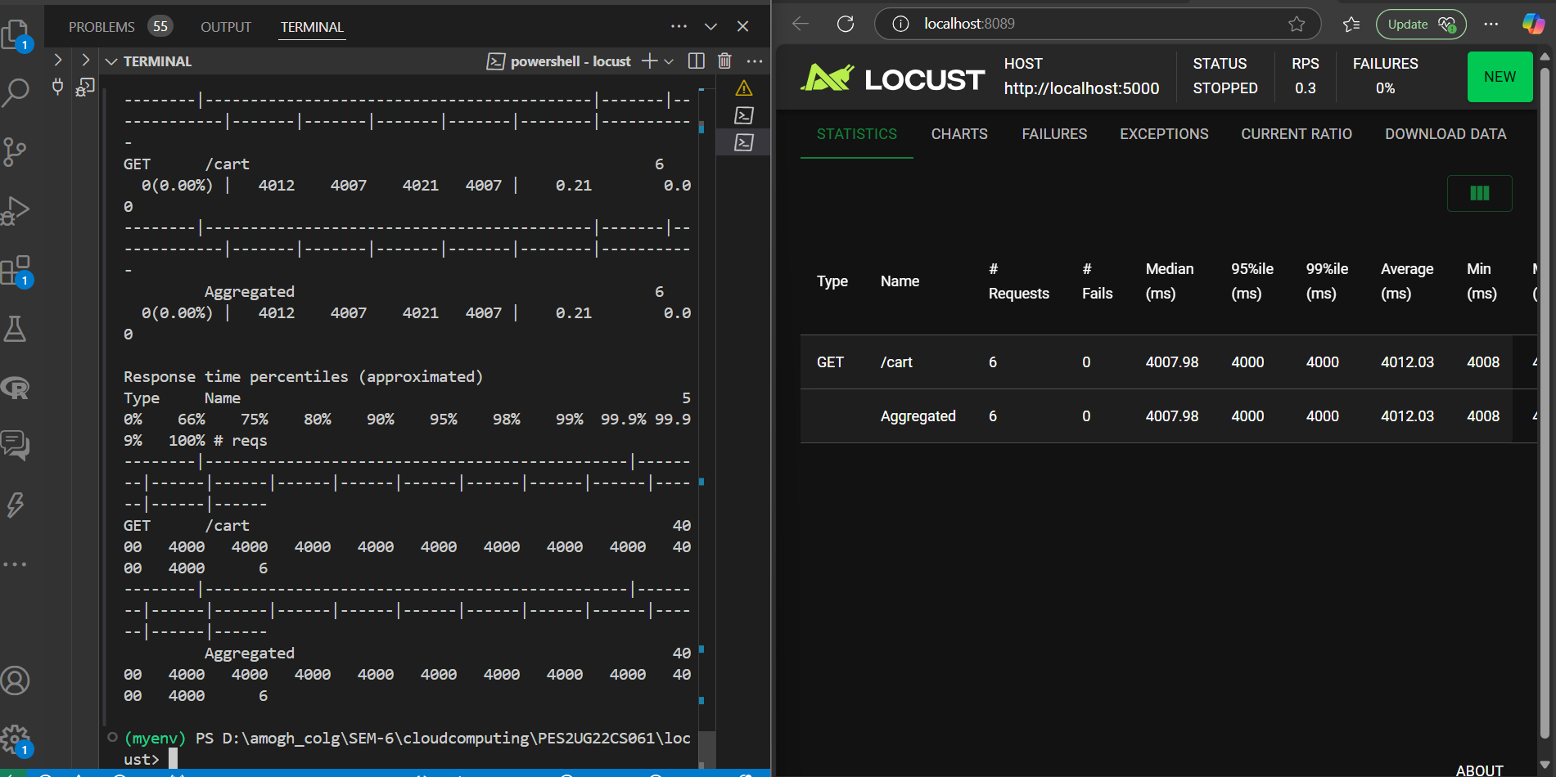

After optimization by 1.35 s :

1. Replace eval with json.loads
2. Use List Comprehension
3. Bulk Fetching Products
4. Remove Redundant Loops
5. Leverage set for Unique IDs
6. Static Method for load

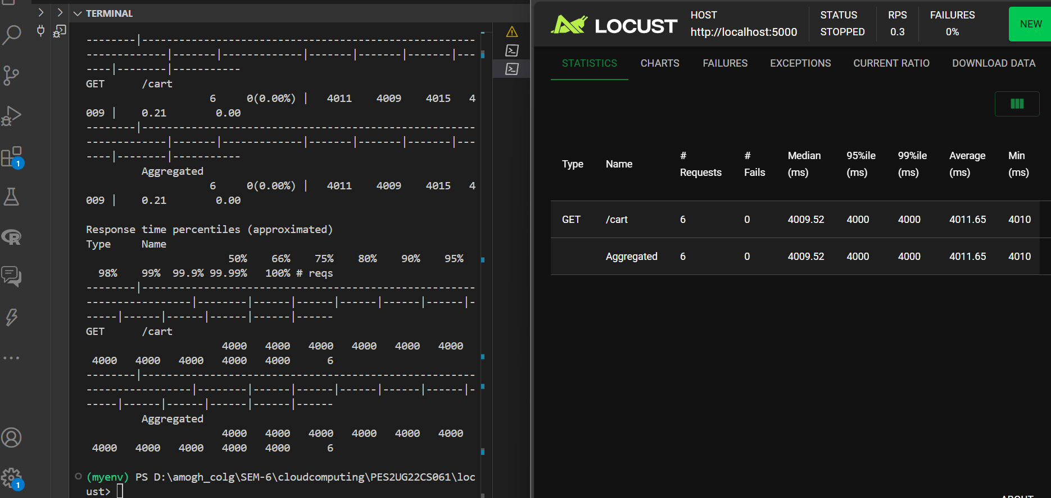

2 ) Browse

Before optimization :

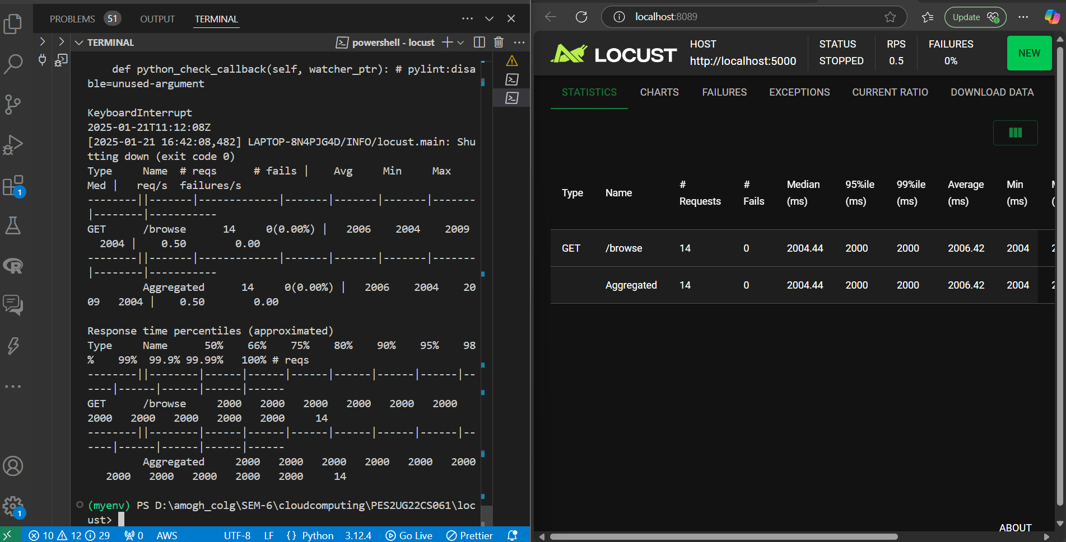

After optimization by 4 seconds :

1)removed unnecessary loops

2) Batch Processing

3) Input Validation

4) Efficient Object Construction

