TRIANGLE APPLICATION – TEST REPORT & BUG REPORT
Product: Triangle Testing Application
Version: 1.3.1
Reporter: Amogi Endurance
Date: 16.04.2026

Test Design and Strategy
Testing was designed by identifying the rules that define a valid triangle and selecting specific input values to verify and challenge those rules.
A valid triangle must satisfy:
- All sides must be positive numbers
- The sum of any two sides must be greater than the third side
Test cases were intentionally selected to either confirm correct behavior or deliberately violate these rules in order to observe how the system handles invalid and edge-case inputs.

Test Design (Using Actual Values)
To verify correct classification, valid triangle inputs were used:
- (999999, 999999, 999999) to confirm equilateral classification with very large values
- (5, 5, 9.999) to confirm a valid isosceles triangle close to the boundary
To test triangle inequality rules, boundary and invalid geometric inputs were used:
- (5, 5, 10) as an exact boundary case where the sum equals the third side
- (0.0001, 0.0001, 0.0002) to evaluate behavior at very small precision limits
To validate acceptable input ranges, invalid numeric values were introduced:
- (5, 5, 0) to test zero-length side handling
- (-5, -5, -5) to test negative values
To assess input validation, malformed and non-numeric values were used:
- (10A, 5, 10) to test alphanumeric input
- (5B, 5, 10) to test mixed invalid input
- (5.5.5, 5, 5) to test malformed numeric format
To evaluate floating-point precision handling:
- (5, 5, 4.9999999999) was used to test behavior near classification boundaries
To compare logical output with graphical rendering:
- (5, 5, 10) produced a flat line
- (-5, -5, -5) produced a red wedge
- (999999, 999999, 999999) produced a correct triangle
To assess system consistency:
- Repeated submissions of (999999, 999999, 999999) were performed
- Transitions from invalid to valid inputs were tested

Test Execution Summary
Test Scenario | Input Values | Expected Behavior | Observed Behavior
Valid Equilateral | (999999,999999,999999) | Equilateral triangle | Correct
Boundary Valid | (5,5,9.999) | Isosceles triangle | Correct
Boundary Invalid | (5,5,10) | Reject input | Flat line rendered
Zero Input | (5,5,0) | Reject input | Flat line rendered
Negative Input | (-5, -5, -5) | Reject input | Red wedge rendered
Precision Case | (5,5,4.9999999999) | Isosceles | Visual inconsistency
Small Values | (0.0001,0.0001,0.0002) | Reject input | Flat line rendered
Alphanumeric | (10A,5,10) | Reject input | Accepted
Mixed Invalid | (5B,5,10) | Reject input | Accepted
Malformed Number | (5.5.5,5,5) | Reject input | Accepted

Key Findings
Invalid inputs are accepted and processed instead of being rejected.
Examples include (10A, 5, 10), (5B, 5, 10), and (5.5.5, 5, 5).
Invalid triangles are still rendered visually, which creates misleading output.
For example:
- (5, 5, 10) produces a flat line
- (5, 5, 0) produces a flat line
- (-5, -5, -5) produces a red wedge
- (0.0001, 0.0001, 0.0002) produces a flat line
Precision issues affect consistency between classification and rendering.
The input (5, 5, 4.9999999999) shows mismatch between logical classification and visual output.
Visualization is inconsistent.
Different invalid inputs produce different shapes (line vs wedge), even when all are classified as “not a triangle.”

Risk Assessment
High risk is associated with acceptance of invalid inputs and misleading graphical outputs, as these directly affect correctness and user trust.
Medium risk is associated with floating-point precision issues and inconsistent validation behavior.

Conclusion
The application correctly handles standard valid triangle inputs but does not enforce strict validation for invalid, boundary, and malformed inputs.
There is also a clear mismatch between classification logic and graphical rendering, which results in inconsistent and misleading outputs.
These issues highlight weaknesses in input validation, numerical precision handling, and system consistency.

Visual Evidence
Bug #1
Summary | Flat line rendered despite invalid triangle
Description | When the sum of two sides equals the third, the system displays a straight line instead of rejecting the input. Instead, it should not attempt to display a triangle at all.
Steps | - Enter 5, 5, 10, in the three fields, respectively, and submit.  - Notice that a flat line is rendered, despite the “not a triangle” message also being displayed.
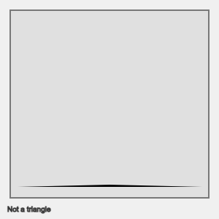

Bug #2
Summary | Negative inputs produce red wedge rendering
Description | Negative side lengths are invalid for triangle construction. However, the system processes these inputs and renders a red wedge shape, which is misleading and inconsistent with expected validation behavior.
Steps | 1. Enter -5, -5, -5, in the three fields, respectively, and submit.  2. Notice A red wedge shape is displayed; however, Input should have been rejected with no graphical output.
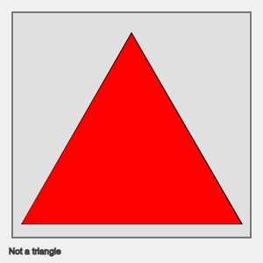

Bug #3
Summary | Zero-length side renders flat line
Description | A triangle with a side length of zero is invalid. The system does not properly reject this input and instead renders a flat line, which may confuse users
Steps | 1. Enter 5, 5, 0, in the three fields, respectively, and submit.  2. Notice A red wedge shape is displayed; however, Input should have been rejected with no graphical output.
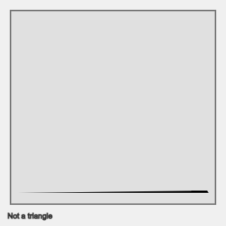

Bug #4
Summary | Precision boundary renders invalid triangle
Description | Inputs that lie exactly on the triangle inequality boundary using very small decimal values are not handled correctly. The system renders a shape instead of rejecting the input.
Steps | 1. Enter 0.0001, 0.0001, 0.0002, in the three fields, respectively, and submit.  2. Notice Flat line shape rendered; Input should be rejected as not a triangle.


Bug #5
Summary | Precision issue causes visual inconsistency
Description | Floating-point precision near classification boundaries results in mismatch between logical classification and visual rendering. The triangle appears nearly equilateral but is classified differently.
Steps | 1. Enter 5, 5, 4.999999999, in the three fields, respectively, and submit.  2. Notice Triangle appears visually equilateral; but displayed as isosceles.
