# Classifier Performance Dashboard

This dashboard highlights the performance of multiple classifiers on the [Optical Recognition of Handwritten Digits Data Set](https://archive.ics.uci.edu/ml/datasets/Optical+Recognition+of+Handwritten+Digits).

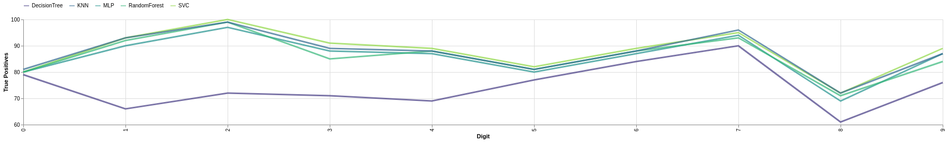

**Figure**: Global Variable Importance Graph

## MODEL PERFORMANCE SUMMARY

|  |  |  |  |
| --- | --- | --- | --- |
| **S.No** | **Item Name** | **Cost Per Unit** | **Unit Sold** |
| 1 | item1 | 6 | 467 |
| 2 | item2 | 2 | 397 |
| 3 | item3 | 12 | 151 |
| 4 | item4 | 10 | 372 |
| 5 | item5 | 15 | 316 |
| 6 | item6 | 11 | 249 |
| 7 | item7 | 3 | 147 |
| 8 | item8 | 9 | 110 |
| 9 | item9 | 5 | 434 |
| 10 | item10 | 5 | 201 |