ABC Bank ltd.

Contents

## 1 EXECUTIVE SUMMARY

This document covers the model development process for **XGBoost_2_AutoML_20210218_195405** model. The model is a classification model that uses **XGBoost** with input data consisting of **20000** observations and **70** features. The model achieves Auto of **75.84%** on validation dataset and **74.98%** on Out-of-Sample (OOS) test dataset.

## 2 MODEL PERFORMANCE SUMMARY

| Dataset | Size | Auto |
| --- | --- | --- |
| Validation | 2500 | 76.81% |
| OOS Test | 2500 | 76.91% |

## 3 DATASET

Following dataset were used for model training, tuning and OOS performance estimation:

| Dataset | Size | Features | Purpose |
| --- | --- | --- | --- |
| Train | 20000 | 70 | Model training |
| Validation | 2500 | 70 | Hyperparameter tuning |
| OOS Test | 2500 | 70 | OOS performance estimation |

## 4 EDA

Following is a summary of input data. Refer Annexure-1 for detailed EDA.

| Dataset | Rows | Columns | Numeric | Category | Time | String |
| --- | --- | --- | --- | --- | --- | --- |
| Train | 20000 | 70 | 69 | 1 | 0 | 0 |
| Val | 2500 | 70 | 69 | 1 | 0 | 0 |
| Test | 2500 | 70 | 69 | 1 | 0 | 0s |

## 5 Methodology Overview

XGBoost is a machine learning technique for regression and classification problems, which produces a prediction model in the form of an ensemble of weak prediction models, typically decision trees. It builds the model in a stage-wise fashion by optimization of a loss function.

Following is a summary of steps performed to train the model:

|  |
| --- |
| Model Development Pipeline |

### 5.1 Data Preparation

The dataset is randomly split into train, validation and holdout test datasets. Train data is used for model fitting. Validation dataset is used for model tuning i.e. finding the optimal combination of hyperparameters that provide the best fit on a given dataset. Holdout test dataset is used to arrive at an unbiased estimate of OOS performance of the model.

### 5.2 Feature Transformation

Typically all features are converted into numeric features. This is a mandatory transformation for many algorithms such as XGBoost.

### 5.3 Model Tuning

Various models are fitted to the train dataset with multiple combination of hyperparameters (HP). These HP typically control model capacity (large capacity models will provide better fit on train data but may fail to generalize to OOS dataset), model complexity (typically models with larger capacity are also more complex) and model generalization (to prevent overfitting to train data).

### 5.4 Model Performance Evaluation

Performance of trained models is compared on validation dataset using different statistics. Final HP combination and the resultant final model is selected on basis of performance on the validation dataset.

### 5.5 Model Stability

Model stability is checked by detecting drift/shift in features between train, validation and test dataset. This is done by computing Stability Index at model and individual feature level to identify if model is stable or not.

## 6 Model Details

Detailed Information regarding model.

### 6.1 Model Hyperparameters

Following is a summary of key model hyperparameters:

| Statistics | Value |
| --- | --- |
| Col sample rate per tree | 0.8 |
| Histogram type | Auto |
| Max Depth | 15 |
| Min Rows | 100 |
| Min Split Improvement | 0.00001 |
| Ntrees | 40 |
| Sample Rate | 0.8 |

### 6.2 Important Features

Following is a list of important features for the model:

|  |
| --- |
| Global Variable Importance Graph |

Partial Dependence Plots for Top-2 variables are shown below:

|  |
| --- |
| Partial Dependence Plot for Top-2 Variables |

### 6.3 Model Performance

Following are the model performance statistics on validation and OOS test dataset:

**Validation dataset**

|  |
| --- |
| Model Performance on Validation dataset |

**Test dataset**

|  |
| --- |
| Model Performance on Test dataset |

### 6.4 Model Stability

Following are model stability statistics:

**Train vs. Validation dataset** 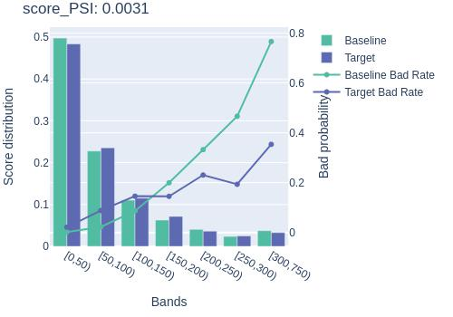

**Validation vs. Test dataset** 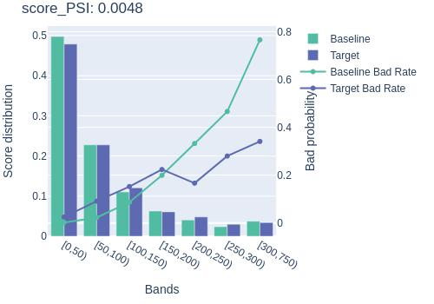

### 6.5 Model Scoring History

Following is a summary of change in model performance statistics with increase in number of trees.

|  |
| --- |
| Model Scoring History |