**Description:**

Property rental prices are a key economic indicator, often signaling significant changes in things like unemployment rate or income. Accurately predicting rental prices would help organizations offering public and commercial services with the ability to better plan for and price these services.

Monthly rental values for properties vary due to a broad mix of factors. Some measures are objective, like Location, Number of Bedrooms(BHKs), Furnished or Unfurnished, Area of the flat in SqFt’s, Age of the property and on which floor flat is.

The rental market in Bangalore is unusually diverse and difficult to predict due to the region's varied landscape and large, widely spread population.

Currently, automated valuation models are used for over 90% of residential property estimates Bangalore. Using data on location, property, zoning, past sales, and more, the goal of this project is to estimating the monthly market rental value for residential properties in the area of Bommanahalli and Whitefield area of Bangalore.

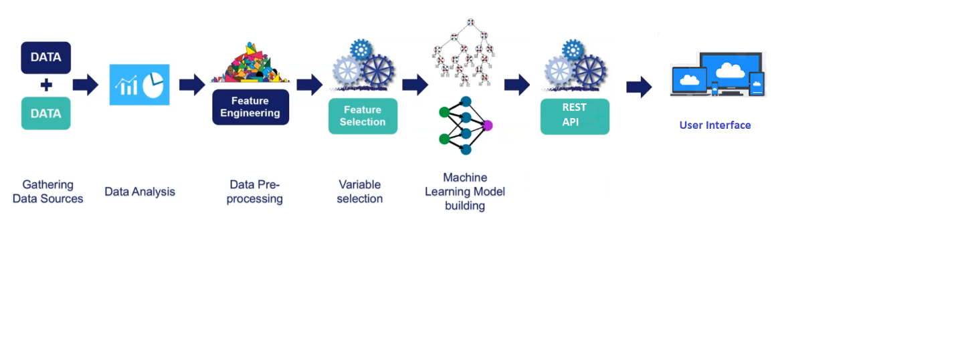

**Rolls and Responsibilities:**

Entire Work was divided between 7 teams.

1. Team 1 is dedicated toward collecting the data from different sources like from websites like

[www.99acres.com](http://www.99acres.com)

[www.magicbricks.com](http://www.magicbricks.com)

[www.nobroker.com](http://www.nobroker.com)

1. Team 2 is dedicated with responsibility of importing data from different sources and cleaning the dataset using numpy, pandas, statsmodels and sklearn and bring the dataset to ideal format Training a machine learning model.
2. Team 3 is responsible for identifying the best suitable machine learning models as per the dataset and training the model according to dataset. Team is also responsible for optimizing the model to its best accuracy using different hyperparameter training methods.
3. Team 4 is dedicated towards testing the model inoder to get the best Machine Learning model.
4. Team 5 is responsible for Creating User Interface for the models according to the fields passed into model while training.
5. Team 6 is responsible for creating backend code and connect UI to the model.
6. Team 7 is responsible for creating REST services using Flask frame work in Python and connect it to the model.

**KeySkills:**

1. Hadoop, Hive for data collection and storage
2. Python, numpy, pandas, sklearn, statmodels for data cleaning
3. Html5, Css3 and Bootstrap for UI designing
4. Python for backend coding
5. Sklearn for model training
6. Flask frame work for Creating REST api

**Problems and Troubleshooting:**

1. Collect and combine data from different sources
2. Remove missing values and irrelevant data in different columns like character value in numerical data containing columns.
3. Identifying best Character Encoding model for the converting character to machine readable format dataset for training a machine learning model.
4. Reducing the overfitting of the model giving irrelevant outputs
5. Identifying best feature selection techniques from wrapper, filter and embedded methods
6. Determining Best model for Machine Learning
7. Inserting the data from UI according to the data type required

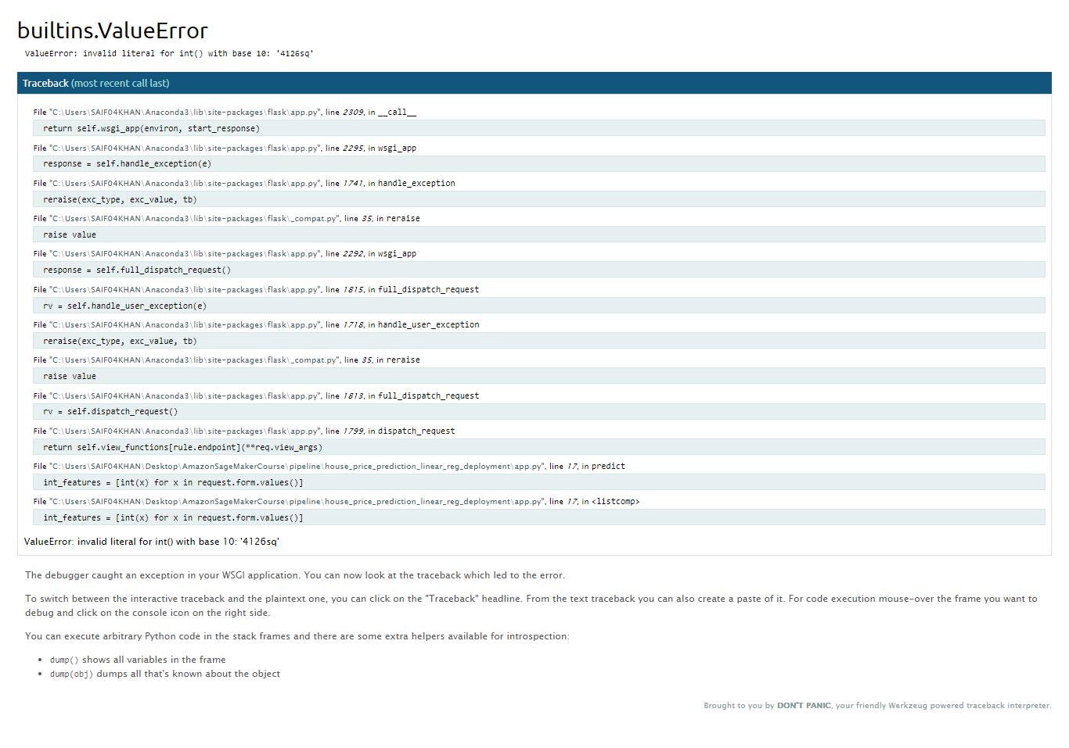

1. Manage the number of inputs from UI to the number of input actually model requires.

