To Copy
ESa-CF, ESs- | RS-OH

STaR - WinSetup Display Specification

1 General Information 3
1.1 Document History 3
1.2 References 4
1.3 Terminology 4
2 Security 5
2.1 Logon 5
2.2 Password Change 5
3 Server Operations 5
3.1 Connect New Server 5
3.2 Server Preferences 6
4 Overfill Alarm Limits 8
4.1 Alarm Limit 8
4.2 HL / OF Alarm 9
5 Manual Values 10
5.1 Spot Temperatures 11
5.2 Average Liquid Temp 11
5.3 Average Vapor Temp 12
5.4 Vapor Pressure 12
5.5 Ullage 13
5.6 Innage 13
5.7 Active Temp Box 14
5.8 Inclusion of Spot Temps in Average Calculation 15
6 Tank Operations 17
6.1 Sort Order 17
7 Device Operations 18
7.1 Sort Order 18
7.2 Reset Database 18
7.3 Device Database Operations 20
8 Device Specific Features 24
8.1 Relay Mapping on SCBs and IOT5140s 24
8.2 Pressure Sensor 25

General Information
This document defines the look and feel of the WinSetup user interface. It is based on the specification developed for the SFU project and some work is still needed to get the document up to date.

The updates applied to WinSetup in versions 5.6.0–5.8.0 are reflected in [Ref.6-9] in section 1.2 of this document.

Document History
Issue | Date | Issued by | Modification
P1A | 2004-11-15 | GU-TK-SS | Created
1 | 2004-11-23 | GU-TK-SS | Updated after review.
P2A | 2004-11-24 | GU-TK-SS | Updated after comments from GMT-AW
P2B | 2005-01-18 | GU-TK-PO | Added chap. 8. Tank sort order
P2C | 2005-01-26 | GU-TK-SS | Removed “Tank Rate” as a manual value.  Updated “HL/OF Alarm” and “HL/OF Test Mode Parameters”
P2D | 2005-01-31 | GU-TK-PO | Updated chap. 8 Tank Sort Order.  Added chap. 9 Device Sort Order
P2E | 2005-02-07 | GU-TK-PO | Updated pictures in chap 8 and 9
2 | 2005-02-15 | GU-TK-PO  GU-TK-SS | Updated after review. According to review record SFU-TM-0061.doc
P3A | 2005-02-21 | GU-TK-SS | Updated chapter 4.8 after comments from GMT-AW
3 | 2005-03-09 | GU-TK-SS | Updated after review
P4A | 2005-05-13 | GU-P-PK | Added chapter Server Preferences
P4B | 2005-11-07 | GU-P-PK | Chapter 5.8: the “Blocked” option removed
4 | 2006-01-31 | GU-SS | Released document.
P5A | 2006-04-07 | GU-P-EE | Added reference to “WinSetup, TGU-specific Windows” document. TGU-specific windows mover there.
P5B | 2006-04-10 | GU-P-PK | Description of “Setting Multiple Devices Offline” added.  Renamed the document from “SFU – “ to “STaR 5.x – “
5 | 2006-05-31 | GU-P-EE / GU-MKA | Added chapter describing IOT5140/SCB relay mapping property page. Reviewed without comments.
6 | 2006-11-13 | GU-MKA | Added Security chapter.
P7A | 2007-04-13 | EPC-MK | General cleanup and chapter re-organization. New contents:  - New Server Connection  - Reset Database  - Device Database Operations
P8A | 2019-06-10 | ESs-PK-R | Changes for versions including 5.7.7, 5.7.8 and 5.8.0
P9A | 2025-12-17 | EICP-AG | Updated document for new containment system

References
Ref | Document | ID | Issue
 | SFU Functional Specification | G5-04-0010 | 5
 | WinSetup, TGU-specific Windows | G5-SP-0014 | 3
 | STaR 5.1.0 - Software Requirements Document | G5-06-0063 | 1
 | STaR 5.2.0 – Software Requirements Specification | G5-06-0165 | 2
 | CMS SCC 5.5.1 Software Functional Specification | G5-10-0074 | 1
 | CMS SCC 5.6.0 Software Functional Specification | G5-12-0001 | 1
 | SCC SW Functional Specification for AXE-TGU | G5-14-0022 | 1
 | SCU - SCC Software - Functional Specification 5.7.8 (includes the changes made in 5.7.7.) | SharePoint link | 1
 | SCU - SCC Software - Functional Specification 5.8.0 | EMRRTR-1206244399-207 | 1

References to requirements in Doors can be found in the STaR\Desktop Software\Service Tools\WinSetup Software Requirements module.

Terminology
Term | Explanation
SCC | Supply and Communications Computer
SCD | Supply and Communications Display
SFU | STaR Functionality Upgrade
TGE | Tank Gauge Electronics
TGU | Tank Gauge Unit
WSU | Workstation Unit

Security
Requirement trace: Ref. 4, reqs. 520-301, -302

Logon
When the application starts, the logon dialog is shown:

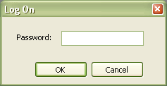

To be able to use the application the correct password (default: “star”) has to be entered. An error message is shown if an incorrect password is entered but there is no limit on the number of invalid password attempts. Pressing the Cancel button closes the application without allowing access.

Password Change
The user may choose to customize the logon password. This can be done through the Change Password dialog which can be displayed by selecting “Change Password” on the “Tools” menu:

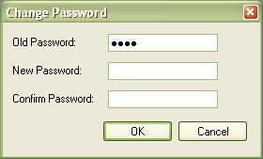

If the password is lost, the default password may be restored by deleting the StmSetup.ini file.

Server Operations

Connect New Server
Requirement trace: Doors, 149

A new server connection can be established by right-clicking on the “Network Connections” node (root node) in the tree view and selecting “New Connection” from the context menu. The following dialog is displayed:

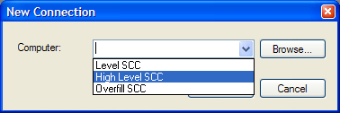

There are three pre-defined entries in the combo box, one for each type of SCC (level, high level or overfill). It is also possible to enter a different computer name in the combo box manually, or to browse to a specific computer by pressing the Browse button.

SCC SW 5.6.0, 5.8.0 Updates:
- Secondary Level and Density SCCs have been added to the Computer list
- WinSetup shall display the SCC type (Level, Secondary Level, High Level, Overfill or Density) for the connected SCC.
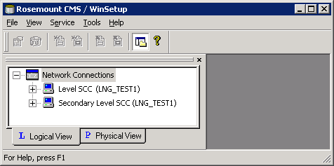

Server Preferences
The value unit for trim is displayed in degrees, and also in meters as it is in WSU.

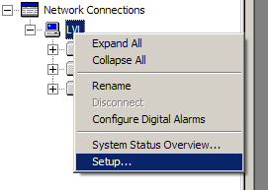

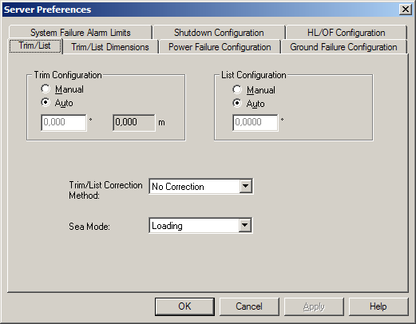

SCC SW 5.6.0 Updates:
- The additional tab for Test Cable configuration is described in section 2.4.3 of [Ref.6].
- The additional tab for System Units configuration (the choice of the system pressure unit and the choice of the number of decimals for temperature) is described in section 2.9.6 of [Ref.6].

SCC SW 5.7.x/5.8.0 Updates:
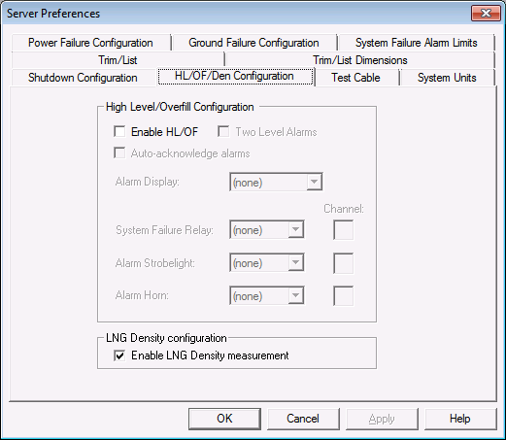
Support of new node types added:
- Level with integrated Alarm support
See [Ref.8]
- Density
See [Ref.9]

Overfill Alarm Limits
HLOF UpperLimit, HLOF LowerLimit, HLOF AmplitudeThreshold and HLOF Config values per tank, shall be possible to modify in WinSetup.
Alarm limits shall be configured as ullage values.

Alarm Limit
“Alarm Limit” is accessed by right-clicking on a tank and selecting “HL/OF Alarm Limits”. (See screen-dumps below)

Only a user of Supervisor level is allowed to change the “Alarm Limit”.

Depending on whether the TankServer is level- or ullage-based, there are two ‘versions’ of the “HL/OF Alarm Limits” dialog:

Ullage-based version of TankServer
The following needs to be changed in the existing dialog, “HL/OF Alarm Limits”:
- The describing text should inform the user that the alarm limit is configured as an ullage value.
- The edit box “Alarm Limit” should be changed so that it handles ullage values.
- A change of the value in “Alarm Limit” shall be sent to the TankServer and -if the version of the TGU is newer than 2.A3- to the TGU.

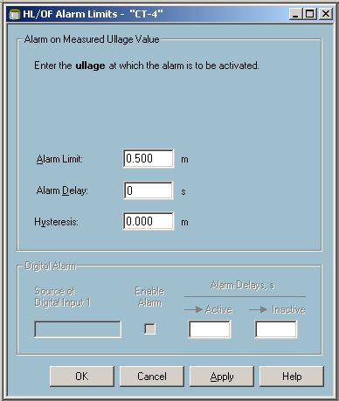
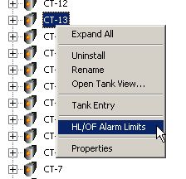

SCC SW 5.7.7 Updates:
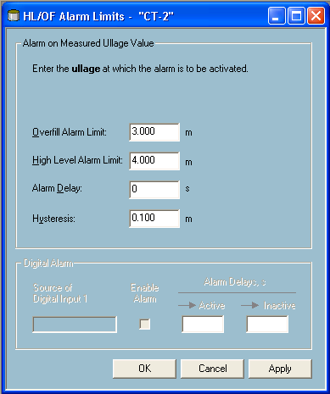
See [Ref.8]

Innage-based version of TankServer

The “HL/OF Alarm Limits” dialog must be changed so that it can detect if it shall display “Alarm Limit” as a level value.

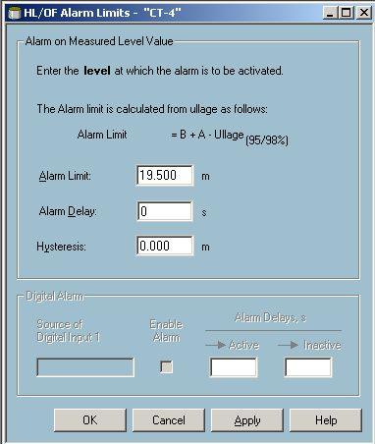

HL / OF Alarm
See Description of the “HL/OF Alarm” page in Ref. 2]. It allows the user to:
- switch the Overfill Handler in TGU on and OFF
- configure HL/OF zone Upper Limit
- configure HL/OF alarm Amplitude Threshold.

Manual Values
Manual values per tank shall be possible to modify in WinSetup. It shall also be possible to set any manual value back to its automatic handling.
Manual values shall be marked with a yellow background in WinSetup.

The following parameters shall be able to set manually:

Parameter | Chapter | Manual value to be set | Comment
Spot temperatures 1-6 | 5.1 | Value | The temp value can be altered.
Average Liquid Temp | 5.2 | Value | The temp value can be altered.
Average Vapor Temp | 5.3 | Value | The temp value can be altered.
Vapor Pressure | 5.4 | Value | The pressure value can be altered.
Ullage | 5.5 | Value | A change in the ullage value immediately affects the innage value.
Innage | 5.6 | Value | A change in the innage value immediately affects the ullage value.
Active temp box | 5.7 | “Primary” or “Secondary” | Synonymous to nominal/redundant
Inclusion of spot temps in average calculation | 5.8 | “Average Liquid Temp”, “Average Vapor Temp” or in none. | It shall not be possible to set both of them.

Spot Temperatures
Manual value handling of Spot Temperatures 1-6 is accessed by right-clicking on a tank and selecting “Properties”.
No update in WinSetup GUI is needed to handle manual value for Spot Temps.

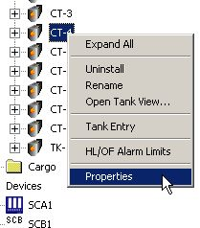
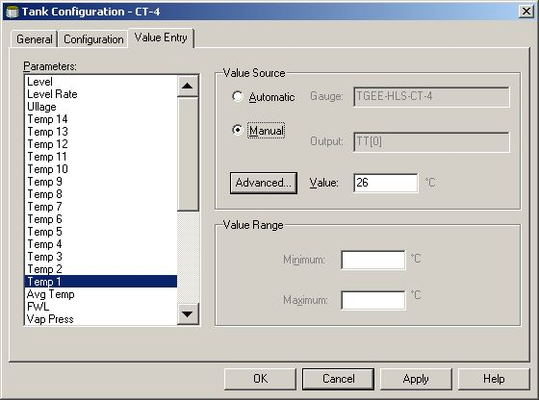

Average Liquid Temp
Manual value handling of Average Liquid Temp is accessed by right-clicking on a tank and selecting “Properties”.
No update in WinSetup GUI is needed to handle manual value for Average Liquid Temp.
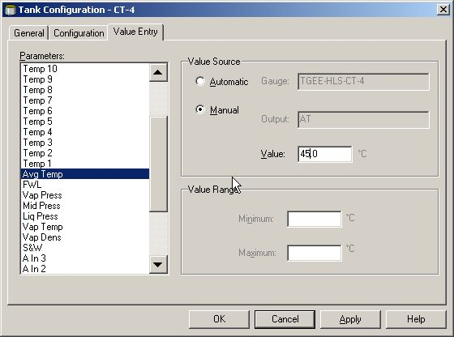

Average Vapor Temp
Manual value handling of Average Vapor Temp is accessed by right-clicking on a tank and selecting “Properties”.
No update in WinSetup GUI is needed to handle manual value for Average Vapor Temp.
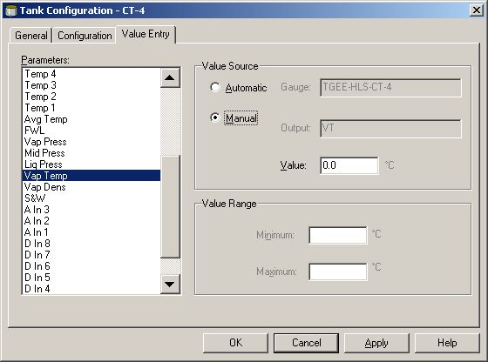

Vapor Pressure
Manual value handling of Vapor Pressure is accessed by right-clicking on a tank and selecting “Properties”.
No update in WinSetup GUI is needed to handle manual value for Vapor Pressure.

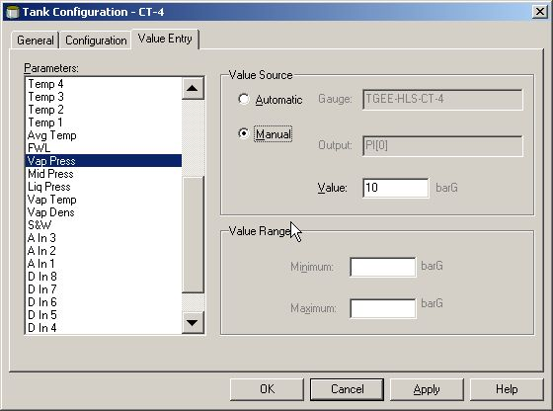

Ullage

Manual value handling of Ullage is accessed by right-clicking on a tank and selecting “Properties”.
No update in WinSetup GUI is needed to handle manual value for Ullage.

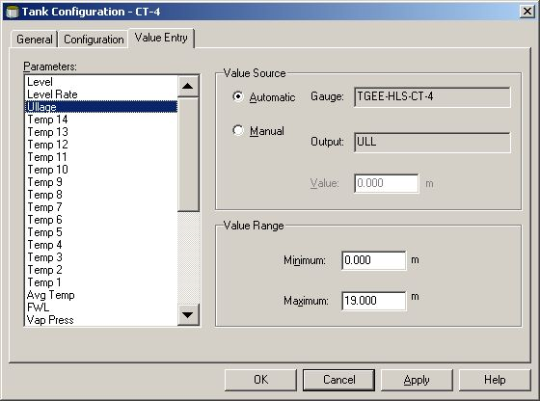

Innage

Manual value handling of Innage is accessed by right-clicking on a tank and selecting “Properties”.
No update in WinSetup GUI is needed to handle manual value for Innage.

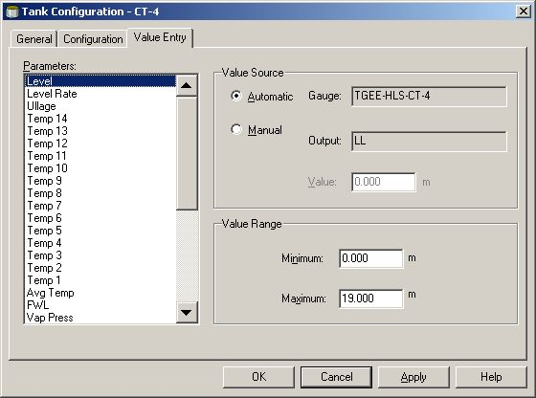

Active Temp Box
Manual value handling of Active Temp Box is accessed by right-clicking on a TGE and selecting “Properties”, “External Devices” and pressing “Configure…” for temperature sensors.
No update in WinSetup GUI is needed to handle manual value for Active Temp Box.

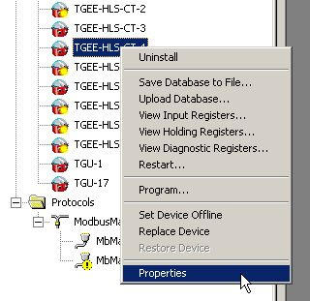

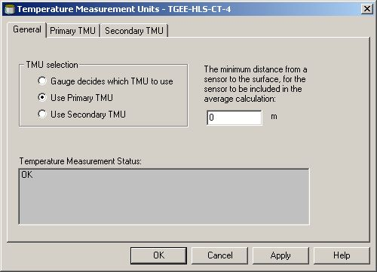

Inclusion of Spot Temps in Average Calculation
Manual value handling of ‘Inclusion of Spot Temps in Average Calculation’ is accessed by right-clicking on a tank, selecting “Properties”, “Value Entry” and selecting a spot temp. A button called “Advanced…” is then displayed. By pressing the button, a new window is displayed where the user can include the spot temp in average calculations.

The existing dialog, “Tank Configuration” needs to be changed in order to handle:
- Manual Inclusion Average Liquid
- Manual Inclusion Average Vapor

Control
“Advanced…” button | The button in the “Value Entry” property page is shown only for spot temps. When pressed, a new dialog is opened where the user can include the spot temp into average calculation. (See screen shot below).

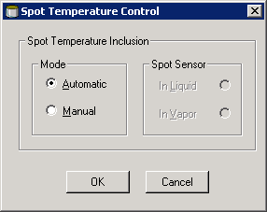
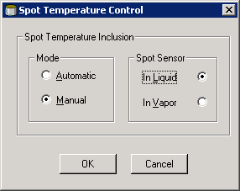

”Automatic” selected
”Manual” selected

Control
“Automatic” radio button | The inclusion of the spot temp in average calculation is handled automatically. The two radio buttons to the right are grayed (disabled). (See the picture to the left).
“Manual” radio button | The inclusion of the spot temp in average calculation is handled manually. The two radio buttons to the right are accessible.
“In Liquid” radio button | If selected, the spot temp is included in average liquid calculation.
“In Vapor” radio button | If selected, the spot temp is included in average vapor calculation.

Tank Operations

Sort Order
The sort order of tanks presented in the GUI in other applications, such as the SCD screen should be possible to change from the WinSetup program.

The dialog is accessed by right-clicking the “Tank” folder and selecting “Tank Sort Order…”.

NOTE: Tanks added after the sort order has been set should show up in the end of the list. There is no connection between the sort order of tanks and devices.

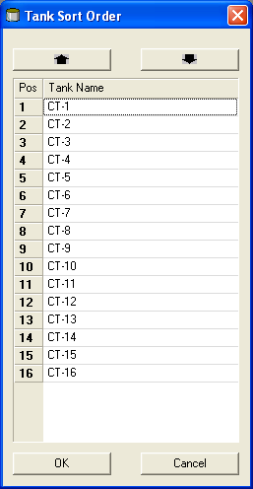

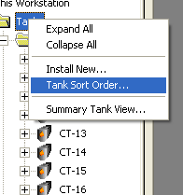

Control
“Up Arrow” button | Move the selected tank up one step. If the selected tank is in the top position this button should be inactive (disabled).
“Down Arrow” button | Move the selected tank down one step. If the selected tank is in the bottom position this button should be inactive (disabled).

Device Operations

Sort Order
The sort order of devices presented in the GUI in other applications, such as the SCD screen should be possible to change from the WinSetup program.

The dialog is accessed by right-clicking the “Devices” folder and selecting “Device Sort Order…”.

NOTE: Devices added after the sort order has been set should show up in the end of the list. There is no connection between the sort order of devices and tanks.

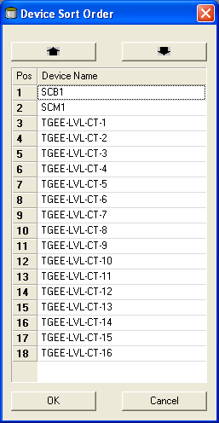

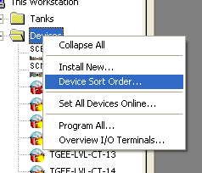

Control
“Up Arrow” button | Move the selected device up one step. If the selected device is in the top position this button should be inactive (disabled).
“Down Arrow” button | Move the selected device down one step. If the selected device is in the bottom position this button should be inactive (disabled).

Reset Database
Requirement trace: Doors, 33, 35, 141, 115, 116

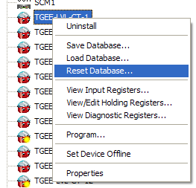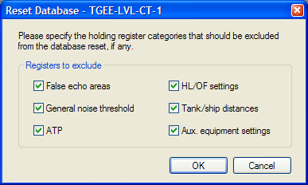

This feature enables the user to reset holding register values in the device to their default values, as specified in the device INI file. The first dialog (above, right) contains options for excluding pre-defined categories of holding registers from being reset. If the user goes on with the operation by pressing the OK button, the following dialog is shown:

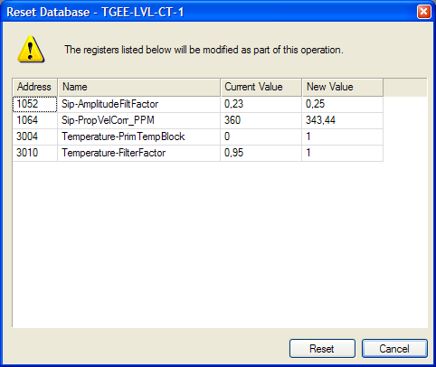

When this dialog is shown, the following operations are performed by the application:

- Read all holding registers not excluded by the user or for other reasons (e.g. factory calibration registers).
- Compare the value of each register read with the default value for the register as specified in the device INI file.
- If the values differ, show the register information in the grid in the dialog.

When the Reset button is pressed, the default values are written to the device and the dialog is automatically closed when the write operation has completed.

Device Database Operations

Set Single Device Online
Requirement trace: Doors, 26, 29

This feature is available from the device context menu as depicted in chapter Error: Reference source not found, under the condition that the device is currently offline. The following dialog is shown:

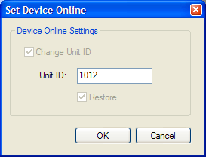

In case there is a unit ID already recorded for the device in the device database, the “Change Unit ID” entry is optional (this is not the case in the picture above).

If the “Restore” check box is left unchecked, no changes are made to the physical device but it is only marked as online in the database.

If the “Restore” check box is checked when the OK button is pressed, the device is set online according to standard procedure:

- Change the address.
- Re-program the device to match the version specified in the device database.
- Reset the holding register database.
- Upload holding register values as specified in the device database to the device.
- Restart the device.

During the above operations, progress is indicated in the following dialog:

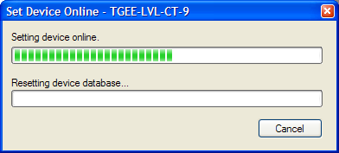

Set Single Device Offline
Requirement trace: Doors, 31

This feature is available from the device context menu as depicted in chapter Error: Reference source not found, under the condition that the device is currently online. The following dialog is shown:

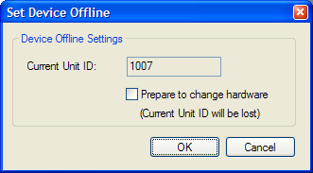

If it is certain that the device is to be removed, the “Prepare to change hardware” check box should be checked by the user. Doing so will erase the unit ID from the device database and no specific physical device will be associated with the device listed in the database.

Set Multiple Devices Online
This feature is available from the “Devices” context menu. The following dialog is shown:

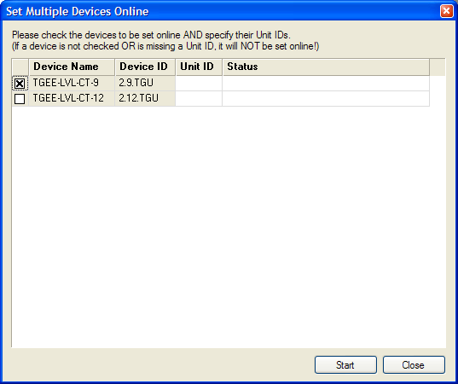

The user has the possibility so select multiple devices to set online by checking the appropriate check boxes in the leftmost column of the grid and entering the corresponding unit ID. When the Start button is pressed, each selected device is set online.

Set Multiple Devices Offline
Requirement trace: Doors, 117, 118, 119

This feature is available from the “Devices” context menu. The following dialog is shown:

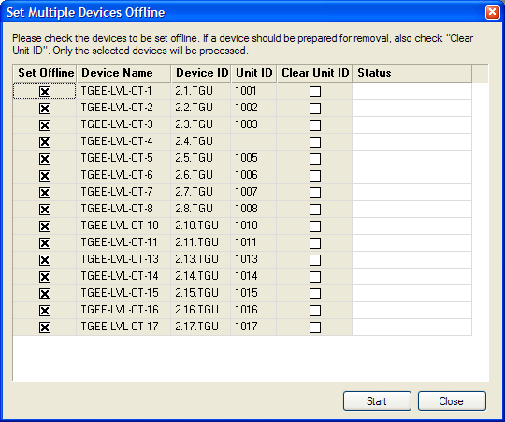

The window displays information in the grid about devices currently online. The records are ordered in the sequence of Device Names set in the “Device Sort Order” window.

The user selects the devices to be set offline checking in the first column. If the device should be prepared for removal, the check-box in the “Clear Unit ID” column should be checked also.

Operation is started with the Start button. The results for every device are shown in the Status column.

The Cancel button interrupts unfinished operations and closes the window.

Device Specific Features

Relay Mapping on SCBs and IOT5140s
Requirement trace: Ref. 3, reqs. 510-401, -402, -403, -404

Relay mappings for SCB and IOT5140 devices can be configured by right-clicking on the respective device in the “Devices” folder in the workspace. Then choose “Properties…”. The configuration is done in the “Channel Mapping” property page:
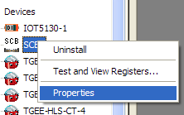 |  | 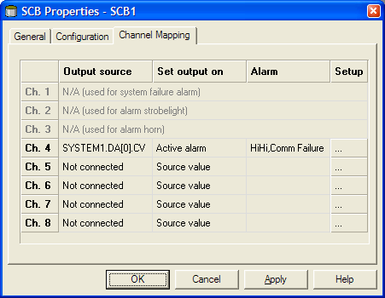

Note: For SCBs the first 3 relays are used for system needs and are never configurable. Other relays are configurable if they are not disabled.

The “…” (Setup) button opens the following dialog:
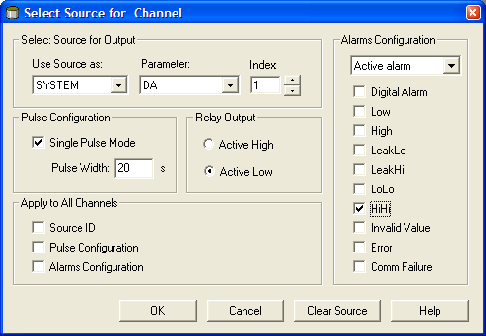

The property page allows the user to connect the relays on the device to system digital alarms or tank alarms.

Control | Description
Use Source as | Used to specify which data source to trigger the relay on, for example a system digital alarm or a tank alarm.
Parameter
Index
Single Pulse Mode | Select to output change the relay output for <Pulse Width> seconds before restoring its original state.
Pulse Width
Active High / Active Low | Specifies whether the relay output shall be active when the alarm is active, or the inverse.
Alarms Configuration | The checkboxes are available when a value different from “Source value” in the combo box is selected. This makes the relay trigger on the alarm status of the source. By checking the appropriate checkboxes alarm status filtering can be done.
Apply to All Channels | By checking one or more of these checkboxes, the selected configuration is copied to all other relays when the OK button is pressed.

SCC SW 5.7.7/5.7.8 Updates
See [ref.8]

Pressure Sensor
It shall be possible to see in WinSetup whether a pressure sensor is configured for absolute or relative pressure measurement.
The pressure sensor configuration is accessed by right-clicking on a tank, selecting “Properties” and “Configuration”.
A “barG” value unit means relative.
A “barA” value unit means absolute.

