**Topics: Descriptive Statistics and Probability**

1. Look at the data given below. Plot the data, find the outliers and find out $μ, σ, σ^{2}$

|  |  |
| --- | --- |
| **Name of company** | **Measure X** |
| Allied Signal | 24.23% |
| Bankers Trust | 25.53% |
| General Mills | 25.41% |
| ITT Industries | 24.14% |
| J.P.Morgan & Co. | 29.62% |
| Lehman Brothers | 28.25% |
| Marriott | 25.81% |
| MCI | 24.39% |
| Merrill Lynch | 40.26% |
| Microsoft | 32.95% |
| Morgan Stanley | 91.36% |
| Sun Microsystems | 25.99% |
| Travelers | 39.42% |
| US Airways | 26.71% |
| Warner-Lambert | 35.00% |

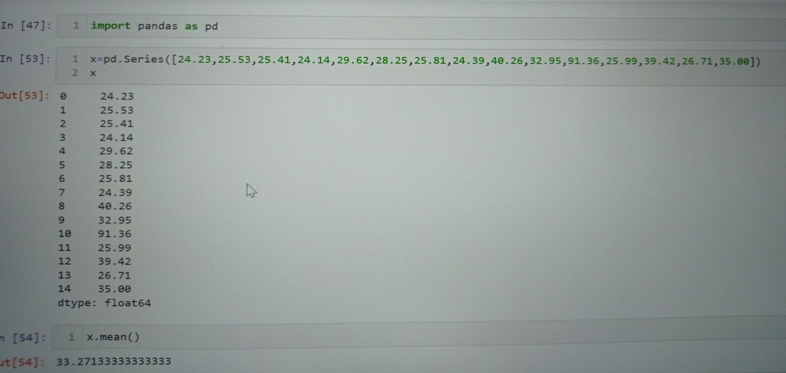

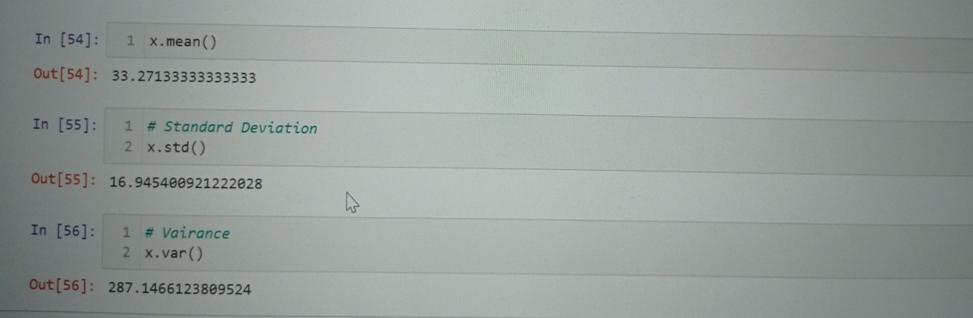



Answer the following three questions based on the box-plot above.

* What is inter-quartile range of this dataset? (please approximate the numbers) In one line, explain what this value implies.

-> 5-12.5=7.5

* What can we say about the skewness of this dataset?

->right skewed data,positive skewness

* If it was found that the datahe m edian is affet point with the value 25 is actually 2.5, how would the new box-plot be affected?

->1.The median move sligthly to left

2.The boxplot does not contain the outliers



Answer the following three questions based on the histogram above.

* Where would the mode of this dataset lie?

**-> 4 to 8 contain the mode**

* Comment on the skewness of the dataset.

**->negative skew most of data is lies in left side**

* Suppose that the above histogram and the box-plot in question 2 are plotted for the same dataset. Explain how these graphs complement each other in providing information about any dataset.

**-> they both are similar us to visualize the numeric data**

**(1)histogram- its show the data is normalize or not and help to identify the skewness of data,and outlier but it contain large area while visualize**

**(2)boxplot-outliers can easily identify ,its can compare multiple data set**

**at a time,it does not contain large area while visualize**

1. AT&T was running commercials in 1990 aimed at luring back customers who had switched to one of the other long-distance phone service providers. One such commercial shows a businessman trying to reach Phoenix and mistakenly getting Fiji, where a half-naked native on a beach responds incomprehensibly in Polynesian. When asked about this advertisement, AT&T admitted that the portrayed incident did not actually take place but added that this was an enactment of something that “could happen.” Suppose that one in 200 long-distance telephone calls is misdirected. What is the probability that at least one in five attempted telephone calls reaches the wrong number? (Assume independence of attempts.)

**Ans-**

**probabililty of misdirectional call = 1/200**

**probability of wrong call = 1-1/200=199/200**

**n=5(five attempt)**

**p(x)=nCxp^xp^n-p**

**n=5**

**=1-P(0)**

**=1-5C0(1/200)^0(100/200)^5-0**

**=1-(199-200)^5**

**=0.02475**

**=2.4%**

1. Returns on a certain business venture, to the nearest $1,000, are known to follow the following probability distribution

|  |  |
| --- | --- |
| x | P(x) |
| -2,000 | 0.1 |
| -1,000 | 0.1 |
| 0 | 0.2 |
| 1000 | 0.2 |
| 2000 | 0.3 |
| 3000 | 0.1 |

1. What is the most likely monetary outcome of the business venture?

**->$2000**

1. Is the venture likely to be successful? Explain

**->proability is non negative return is more the 0.5 which is 50% the venture will be successfull**

**0.2+0.3+0.1=0.6**

1. What is the long-term average earning of business ventures of this kind? Explain

**->p(x)=(-2000*0.1)+(-1000*0.1)+(0*0.2)+(1000*0.2)+(2000*0.3)+(3000*0.1)**

**=800**

1. What is the good measure of the risk involved in a venture of this kind? Compute this measure

**->Standard deviation**